***Solution Section* 4.1 – Antiderivatives, Substitution and General Power Rule**

***Exercise***

Find indefinite integral 

***Solution***



***Exercise***

Find indefinite integral 

***Solution***



***Exercise***

Find indefinite integral 

***Solution***



***Exercise***

Find indefinite integral 

***Solution***





***Exercise***

Find indefinite integral 

***Solution***





***Exercise***

Find indefinite integral

***Solution***





***Exercise***

Find indefinite integral

***Solution***





***Exercise***

Find indefinite integral

***Solution***

 



***Exercise***

Find indefinite integral

***Solution***





***Exercise***

Find indefinite integral

***Solution***







***Exercise***

Find the integral

***Solution***





***Exercise***

Find indefinite integral

***Solution***









***Exercise***

Find indefinite integral

***Solution***



***Exercise***

Find the integral 

***Solution***











***Exercise***

Evaluate: 

***Solution***







***Exercise***

Find the integral

***Solution***









***Exercise***

Find the integral

***Solution***

 











***Exercise***

Find the integral

***Solution***

 











***Exercise***

Find the integral

***Solution***









***Exercise***

Find the integral

***Solution***













***Exercise***

Find the integral

***Solution***















***Exercise***

Find the integral

***Solution***













***Exercise***

Find the integral

***Solution***













***Exercise***

Find the integral 

***Solution***





 ***Substitute for x and dx***







***Exercise***

Find the integral

***Solution***













***Exercise***

Derive the position function if a ball is thrown upward with initial velocity of 32 ft per second from an initial height of 48 ft. When does the ball hit the ground? With what velocity does the ball hit the ground?

***Solution***























 







The ball hits the ground in 3 seconds

The velocity: 



***Exercise***

Suppose a publishing company has found that the marginal cost at a level of production of *x* thousand books is given by



And that the fixed cost (the cost before the first book can be produced) is a $25,000. Find the cost function .

***Solution***













 Before the first (*x* = 0) costs 25,000





***Exercise***

If the marginal cost of producing x units of a commodity is given by



And the fixed cost is $2,000, find the cost function  and the cost of producing 20 units.

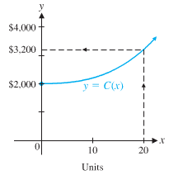***Solution***

*Given*: 





 





***Exercise***

A satellite radio station is launching an aggressive advertising campaign in order to increase the number of daily listeners. The station currently has 27,000 daily listeners, and management expects the number of daily listeners, , to grow at the rate of



Listeners per day, where *t* is the number of days since the campaign began. How long should the campaign last if the station wants the number of daily listeners to grow to 41,000?

***Solution***

*Given*: 

















The advertising campaign should last approximately 50 days.

***Exercise***

In 2007, U.S. consumption of renewable energy was 6.8 quadrillion Btu (or  Btu). Since the 1960s, consumption has been growing at a rate (in quadrillion Btu’s per year) given by



Where *t* is years after 1960. Find  and estimate U.S. consumption of renewable energy in 2020.

***Solution***

From 1960 to 2007 ⇒ 47 years

*Given:*  quadrillion Btu









In 2020, *t* = 60



***Exercise***

The graph of the marginal revenue function from the sale of *x* sports watches is given in the figure.

1. Using the graph shown, describe the shape of the graph of the revenue function  as *x* increases from 0 to 1.000.
2. Find the equation of the marginal revenue function. (linear function)
3. Find the equation of the revenue function that satisfies . Graph the revenue function over the interval [0, 1,000]. Check the shape of the graph relative to the analysis in part (*a*).
4. Find the price-demand equation and determine the price when the demand is 700 units.

***Solution***

1.   is increasing

  is decreasing

Therefore, the graph of  has a local maximum at 

1. 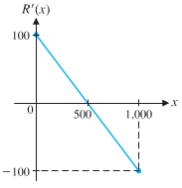The equation of  is 







1. 



Given: 





1. 



So the price is $30 per sports watch when the demand is 700.

***Exercise***

The rate of change of the monthly sales of a newly released football game is given by



Where *t* is the number of months since the game was released and  is the number of games sold each month. Find . When will monthly sales reach 20,000 games?

***Solution***







*Given*: 











***Exercise***

If the rate of labor is given by: 

And if the first 8 control units require 12,000 labor-hours, how many labor-hours, , will be required for the first *x* control units? The first 27 control units?

***Solution***







*Given*: 







 ***labor hours***

***Exercise***

The area *A* of a healing wound changes at a rate given approximately by



Where *t* is time in days and . What will the area of the wound be in 10 days?

***Solution***







*Given*: 

 





***Exercise***

The marginal revenue (in thousands of dollars) from the sale of *x* gadgets is given by the following function 

1. Find the total revenue function if the revenue from 115 gadgets is $55,581.
2. How many gadgets must be sold for a revenue of at least $50,000.

***Solution***

1. 

 

















1. 











101 gadgets must be sold to generate a revenue of at least $50,000.

***Solution Section* 4.2 – Exponential and Logarithmic Integrals**

***Exercise***

Find the integral

***Solution***









***Exercise***

Find the integral

***Solution***













***Exercise***

Find the integral

***Solution***

 













***Exercise***

Find the integral

***Solution***















***Exercise***

Find the integral

***Solution***







***Exercise***

Find the integral

***Solution***













***Exercise***

Find the integral

***Solution***













***Exercise***

Find the integral

***Solution***













***Exercise***

Find the integral

***Solution***













***Exercise***

Find the integral

***Solution***













***Exercise***

Find the integral

***Solution***





***Exercise***

Find the integral

***Solution***















***Exercise***

Find the integral

***Solution***









***Exercise***

Find the integral

***Solution***









***Exercise***

Find the integral

***Solution***





 



***Exercise***

Find the indefinite integral.

***Solution***

Let 









***Exercise***

Find the indefinite integral.

***Solution***

Let 









***Exercise***

Evaluate the integral 

***Solution***



  
 







***Exercise***

Evaluate the integral 

***Solution***

Let: 







***Exercise***

Under certain conditions, the number of diseased cells *N*(*t*) at time *t* increases at a rate , where *A* is the rate of increase at time 0 (in cells per day) and *k* is a constant.

1. Suppose *A* = 60, and at 4 days, the cells are growing at a rate of 180 per day. Find a formula for the number of cells after *t* days, given that 200 cells are present at *t* = 0.
2. Use the answer from part (*a*) to find the number of cells present after 9 days.

***Solution***

1. 



























1. 

***Solution Section* 4.3 – Integration by Parts**

***Exercise***

Find the integral 

***Solution***















***Exercise***

Find the integral 

***Solution***















***Exercise***

Find the integral 

***Solution***













***Exercise***

Find the integral 

***Solution***











***Exercise***

Find the integral 

***Solution***

Let: 





















***Exercise***

Find the integral 

***Solution***

Let: 



 











Let: 













***Exercise***

Find the integral 

***Solution***



















***Solution Section* 4.4 – Fundamental Theorem of Calculus**

***Exercise***

Find the integral 

***Solution***





= 12

***Exercise***

Find the integral 

***Solution***









***Exercise***

Find the integral 

***Solution***



 is a semi-circle with center (0, 0) and radius = 2

Since *x* from 0 to 2

⇒ Area = (Area of this circle) = 

***Exercise***

Evaluate 

***Solution***













***Exercise***

Evaluate the integrals 

***Solution***









***Exercise***

Evaluate the integrals 

***Solution***







***Exercise***

Evaluate the integrals 

***Solution***







***Exercise***

Evaluate the integrals 

***Solution***







***Exercise***

Evaluate the integrals 

***Solution***











***Exercise***

Evaluate the integrals 

***Solution***













***Exercise***

Evaluate the integral 

***Solution***















***Exercise***

Evaluate the integral 

***Solution***

Let 













***Exercise***

Evaluate the integral 

***Solution***

Let 











***Exercise***

A company manufactures *x* HDTVs per month. The monthly marginal profit (in dollars) is given by



The company is currently manufacturing 1,500 HDTVs per month, but is planning to increase production. Find the change in the monthly profit if monthly production is increased to 1,600 HDTVs.

***Solution***











Increasing monthly production from 1,500 units to 1,600 units will increase the monthly profit by $1,000.

***Exercise***

An amusement company maintains records for each video game installed in an arcade. Suppose that  and  represent the total accumulated costs and revenues (in thousands of dollars), respectively, *t* years after a particular game has been installed. Suppose also that



The value of *t* for which  is called the ***useful life*** of the game.

1. Find the useful life of the game, to the nearest year.
2. Find the total profit accumulated during the useful life of the game.

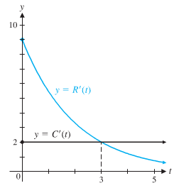***Solution***

1. 







The game has a useful life of 3 years.

1. The total profit during the useful life of the game is



















***Exercise***

The total cost (in dollars) of printing x dictionaries is 

1. Find the average cost per unit if 1,000 dictionaries are produced.
2. Find the average value of the cost function over the interval [0, 1,000}
3. Discuss the difference between parts (***a***) and (***b***)

***Solution***

1. Average cost per unit: 





1. Average 





1.  is the average cost per unit at a production level of 1,000 units.

 is the average value of the total coast as production increases from 0 unit to 1,000 units.

***Exercise***

If the rate of labor is , then approximately how many labor−hours will be required to assemble the 9th through the 27th.

***Solution***

The number labor−hours to assemble the 9th through the 27th control units is











***Solution Section* 4.5 – The Area between Two Curves**

***Exercise***

Find the area of the region bounded by the graphs of  and *x*-axis

***Solution***

Determine the intersection points:











= 4.5 *unit*2

***Exercise***

Find the area of the region bounded by the graphs of  and 

***Solution***

























***Exercise***

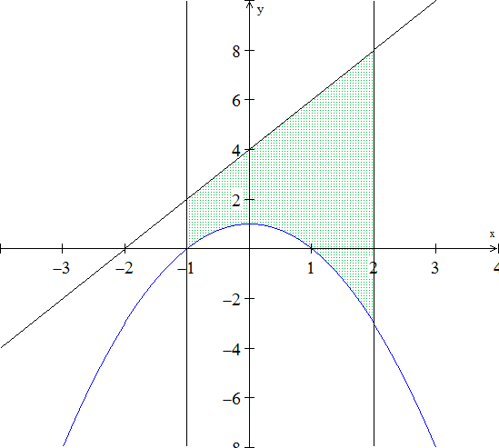Find the area bounded by , , , and 

***Solution***

























***Exercise***

Find the area between the curves 

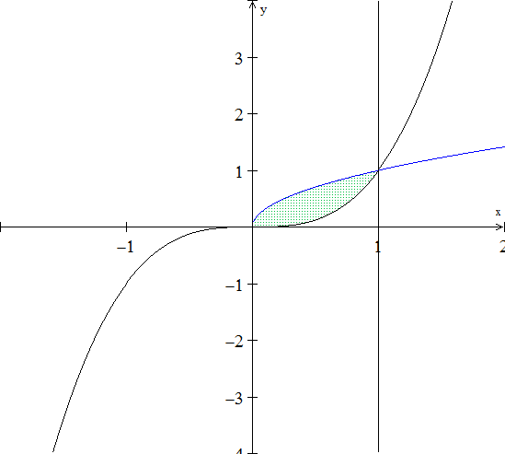***Solution***

 ***Square both sides***





















***Exercise***

Find the area of the region bounded by the graphs of  and  on [0, 4].

***Solution***

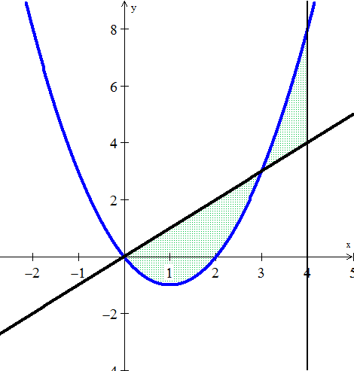



















***Exercise***

Find the area between the curves 

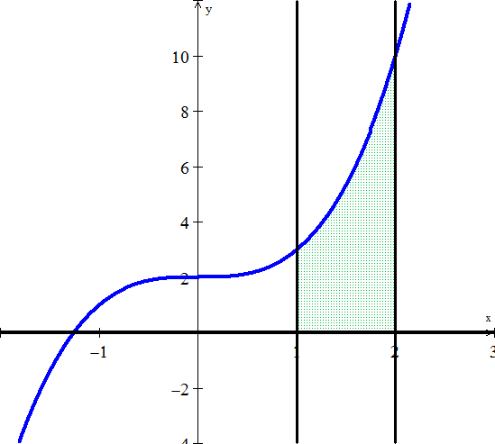***Solution***











***Exercise***

Find the area between the curves 

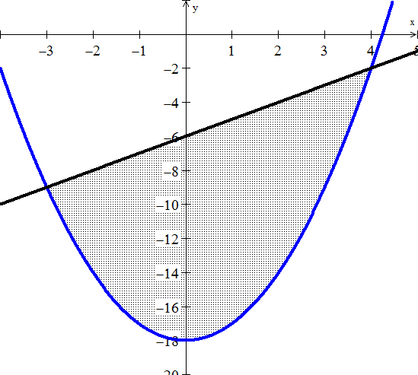***Solution***

















***Exercise***

Find the area between the curves 

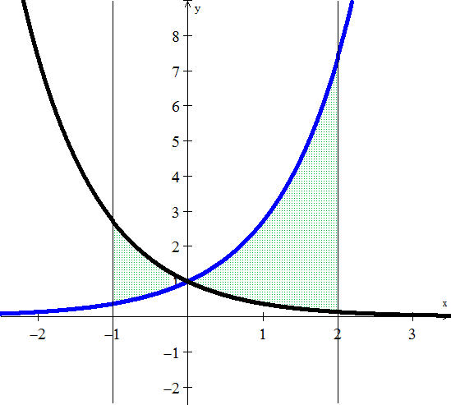***Solution***











  








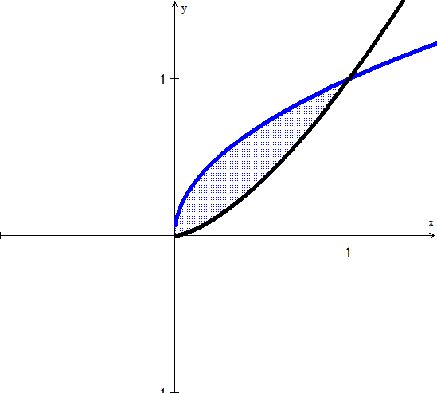***Exercise***

Find the area between the curves 

***Solution***























***Exercise***

A company is considering a new manufacturing process in one of its plants. The new process provides substantial initial savings, with the savings declining with time *t* (in years) according to the rate-of-savings function



where  is in thousands of dollars per year. At the same time, the cost of operating the new process increases with time *t* (in years), according to the rate-of-cost function (in thousands of dollars per year)



1. For how many years will the company realize savings?
2. What will be the net total savings during this period?

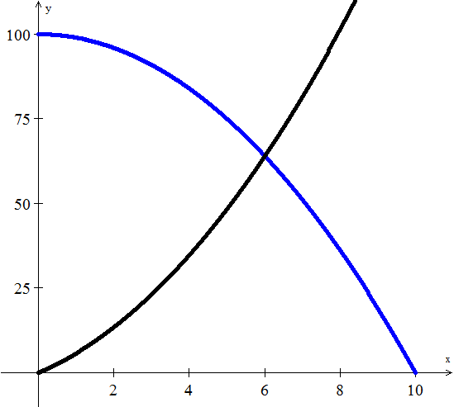***Solution***

1. 











The company should use this type for 6 years.

***b***) What will be the net total savings during this period?

Total savings 









The company will save a total of $372,000. Over the 6-year period

***Exercise***

Find the producers’ surplus if the supply function for pork bellies is given by



Assume supply and demand are in equilibrium at 

***Solution***

The equilibrium price: 

Producer’s surplus 











The producers’ surplus is 12,931.66

***Exercise***

Suppose the supply function for concrete is given by



And that supply and demand are in equilibrium at  Find the producers’ surplus.

***Solution***



Producers’ surplus 











The producers’ surplus is 1999.54

***Exercise***

Find the consumers’ surplus if the demand function for grass seed is given by



Assuming supply and demand are in equilibrium at 

***Solution***



Consumers’ surplus 



 













***Exercise***

Find the consumers’ surplus if the demand function for olive oil is given by



And if supply and demand are in equilibrium at 

***Solution***



Consumers’ surplus 



 







