**Math 2413 – Calculus I** ***Exam* 2 *Review***

*Instructor*: Fred Khoury

1. Find the derivative

|  |  |
| --- | --- |
|  |  |

1. Find the derivative

|  |  |
| --- | --- |
|  |  |

1. Find the following corresponding derivative
2. 
3. 
4. 
5. Find the derivative of

|  |  |
| --- | --- |
|  |  |

1. Find  by implicit differentiation

|  |  |
| --- | --- |
|  |  |

1. Find  by implicit differentiation
2. The parabola  is to be tangent to the line . Find *C*.
3. Find equations for the lines that are tangent and normal to the curve  at the point (1, 2).
4. Carlos is blowing air into a soap bubble at the rate of 8 *cm*3/*sec*. Assume that the bubble is spherical . How fast is the radius changing at the instant of time when the radius is 10 *cm*?
5. The position function for an amusement ride moving on a horizontal track is where *x* is in feet and *t* is in seconds. What is the velocity at 20 seconds?
6. The population of Americans age 55 and older as a percent of the total population is approximated by the function



where t is measured in years, with *t* = 0 corresponding to the year 2000. At what rate will the percent of Americans age 55 and older be changing in 2010?

1. The total surface area *S* of a right circle cylinder is related to the base radius *r* and height *h* by the equation 
2. How is  related to  if *h* is constant?
3. How is  related to  if *r* is constant?
4. How is  related to  and  if neither *r* nor *h* is constant?
5. A particle moves along the curve  in the first quadrant in such a way that its distance from the origin increases at the rate of 11 units per second. Find  when *x* = 3.
6. Water drains from the conical tank at the rate of 5 .
7. What is the relation between the variables *h* and *r* in the figure?
8. How fast is the water level dropping when *h* = 6 *ft*?

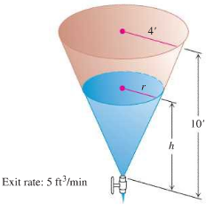

1. As television cable is pulled from a large spool to be in layers of constant radius. If the truck pulling the cable moves at a steady 6 *ft/sec* (a touch over 4 *mph*), use the equation  to find how fast (*rad./sec*.) the spool is turning when the layer of radius 1.2 *ft* is being unwound.

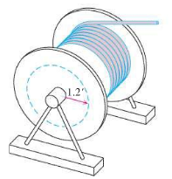

***Answers***



|  |  |
| --- | --- |
|  |  |

|  |  |
| --- | --- |
|  |  |

1. *a)*  *b)*  *c)* 
2. 









1.    
2. 
3. 
4. 
5. 
6.  
7.  
8. *a*) 

*b*) 

*c*) 

1. 
2. *a*)  *b*) 
3. 