**Math 2413 – Calculus I** ***Exam* 3 *Review***

*Instructor*: Fred Khoury

1. Find the critical numbers of the following function on the given intervals. Identify the absolute maximum and absolute minimum values (if possible).

|  |  |
| --- | --- |
|  |  |

1. Find the critical numbers and the open intervals on which the function is increasing or decreasing

|  |  |  |
| --- | --- | --- |
|  |  |  |

1. Find the open intervals on which the function is increasing and decreasing. Then, identify the function’s local extreme values, if any, saying where they occur. Find where the graph of  is concave up and down. Then, identify the points of inflection. Then sketch the curve
2. 
3. 
4. 
5. 
6. 
7. 
8. 
9. Use L’Hôpital Rule to find

|  |  |  |
| --- | --- | --- |
|  |  |  |

1. Sketch
2. 
3. 
4. 
5. Let . Show that the equation  has a solution in the interval [3, 4] and use Newton’s method to find it.
6. Find the height and radius of the largest right circular cylinder that can be out in a sphere of radius 
7. An isosceles triangle has its vertex at the origin and its base parallel to the *x*-axis with the vertices above the axis on the curve . Find the largest area the triangle can have.
8. The sum of two nonnegative numbers is 20. Find the numbers
9. If the product of one number and the square root of the other is to be large as possible
10. If one number plus the square root of the other is to be as large as possible
11. A customer has asked you to design an open-top rectangular stainless steel vat. It is to have a square base and a volume of 32 *ft*3, to be welded from quarter-inch plate, and to weigh no more than necessary. What dimensions do you recommend?
12. The figure shows two right circular cones, one upside down inside the other. The two bases are parallel, and the vertex of the smaller cone lies at the center of the larger cone’s base. What values of *r* and *h* will give the smaller cone the largest possible volume?

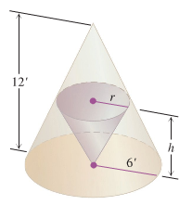

1. A right triangle has legs of length *h* and *r* and a hypotenuse of length 4. It is revolved about the leg of length *h* to sweep out a right circular cone. What values of *h* and *r* maximize the volume of the cone? (Volume of the cone )

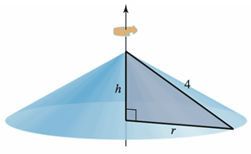

1. Suppose the resident population *P*(in millions) of the United States can be modeled by

; ,

where *t* = 0 corresponds to 1800. Analytically find the minimum and maximum populations in the U.S. for 

1. The number of milligrams *x* of a medication in the bloodstream *t* hours after a dose is taken can be modeled by ; *t* > 0. Find the maximum value of *x.* Round your answer to two decimal places
2. A rectangular box with a square base is to be formed from a square piece of paper with 42” sides. If a square piece with side a is cut from each corner of the paper and the sides are folded up to from an open box the volume of the box is . What value of ***x*** will maximize the volume of the box?
3. Determine the dimensions of a rectangular solid (with a square base) with maximum volume if its surface area is 400 square feet.

***Answers***

1. ***a*)** CN  Abs. MIN: 2; Abs. MAX: 4

***b*)** CN  Abs. MIN: None; Abs. MAX: None

***c*)** CN  Abs. MIN: −24; Abs. MAX: 3.026

***d*)** CN  Abs. MIN: ; Abs. MAX: None

***e*)** CN  Abs. MIN: −11.112; Abs. MAX: 11.112

***f)*** CN  Abs. MIN: 1; Abs. MAX: 2

***g*)** CN  Abs. MIN: None; Abs. MAX: None

1. ***a***) CN: *x* = ± 1; 

***b***) CN: *x* = 0, ±3; 

***c***) CN: *x* = ± 1, ; 

***d***) CN: *x* = 0; 

***e***) CN: *x* = 0, ±2; 

***f***) CN: *x* = 2; 

***g***) CN:  ; 

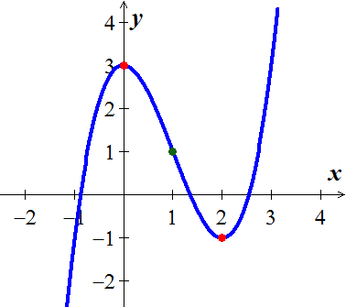

1. ***a***) 







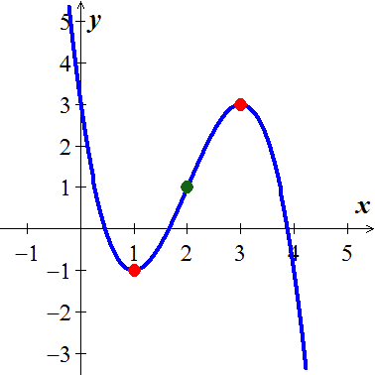

***b***) 







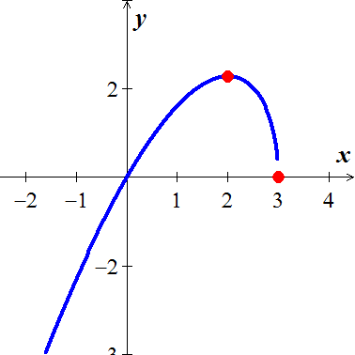

***c***) 







***d***) 







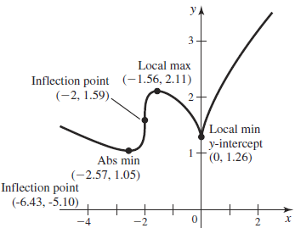

***e***) 











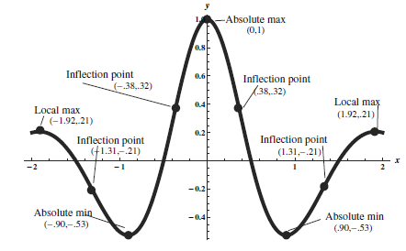

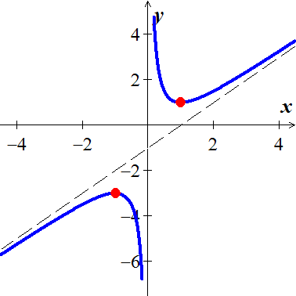***f***) 









***g***) 









1. 



1. .

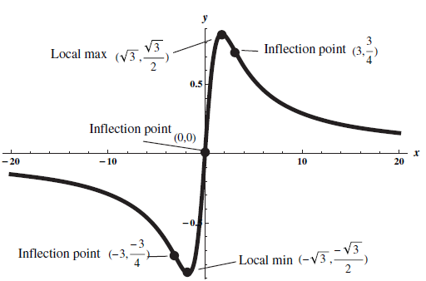 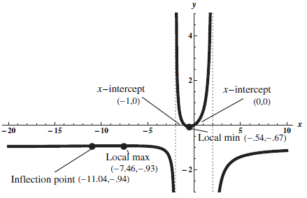

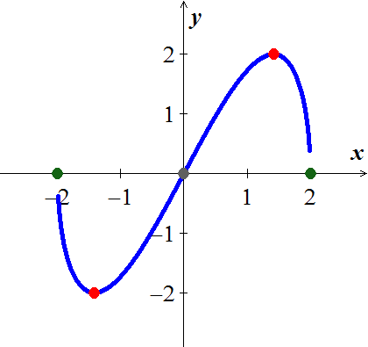

1. 
2. 
3. 
4. ***a***)  ***b***) 
5. 4 *ft* by 4 *ft* by 2 *ft*.
6. 
7. 
8. The population is minimum at *t* = −4 and maximum at *t* = 197
9. 577.35 mg
10. 7
11. Square base side ; height 

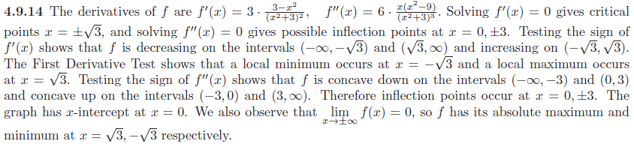

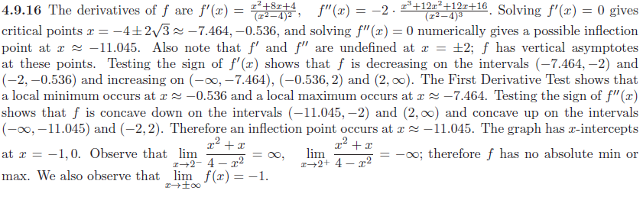

 





 

 

 

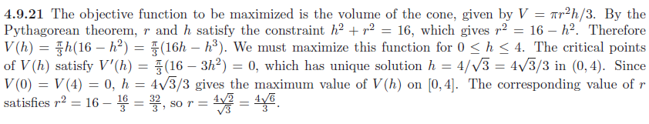

**Suppose the resident population *P*(in millions) of the United States can be modeled by**

**; ,**

**where *t* = 0 corresponds to 1800.Analytically find the minimum and maximum populations in the U.S. for **





 But since t is 

That imply the population is minimum @ t = −4 and maximum @ t =197

**The number of milligrams *x* of a medication in the bloodstream *t* hours after a dose is taken can be modeled by ; t > 0. Find the maximum value of *x.* Round your answer to two decimal places**







**A rectangular box with a square base is to be formed from a square piece of paper with 42” sides. If a square piece with side a is cut from each corner of the paper and the sides are folded up to from an open box the volume of the box is V = (42 – 2x)2 x. What value of x will maximize the volume of the box?**







For x = 21 ⇒  is not a solution

For x = 7 

**Determine the dimensions of a rectangular solid (with a square base) with maximum volume if its surface area is 400 square feet.**

Area for the base = x2.

Area of each side = xh



 











