***Lecture One –* Limits and Derivatives**

***Section* 1.1 – Idea of Limits**

***Position Function***

An object that is falling or vertically projected into the air has its height above the ground, *s*(t), in feet, given by



** is the original velocity (initial velocity) of the object, in feet per second

*t* is the time that the object is in motion, in second

** is the original height (initial height) of the object, in feet

The average rate is given by: 

***Example***

A rock breaks loose from the top of a tall cliff. What is its average speed

1. During the first 2 *sec* of fall?
2. During the 1-*sec* interval between second 1 and second 2?

***Solution***

Since the rock falls free (*down*) without any initial velocity or height. 

1. For the first 2 *sec*: 









1. From 1 *sec* to 2 *sec*: 





***Example***

Find the speed of a falling rock  over a time interval . Then find the average speed at 1 *sec* and 2 *sec*.

***Solution***











If 

The average speed has the limiting value 32 *ft/sec* as *h* approaches 0.

If 

The average speed has the limiting value 64 *ft/sec* as *h* approaches 0.

**Average Rates of Changes and Secant Lines**

The average rate of change of  with respect to *x* over the interval  is



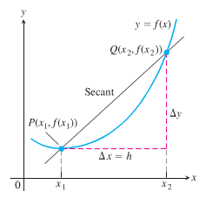

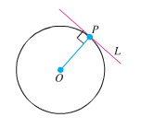

***Defining the Slope of a Curve***

The slope of a line is the rate at which it rises or falls.

To define the tangency for general curves, we need an approach that makes the behavior of the secants through *P* and points *Q* as *Q* moves toward *P* along the curve:

1. Find the slope of the secant *PQ*.
2. Investigate the limiting value of the slope as *Q* approaches *P* along the curve.
3. If the limit exists, take it to be the slope of the curve at *P* and define the tangent to the curve at *P* to be the line through *P* with this slope.



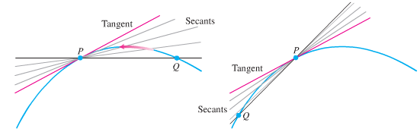

***Example***

Find the slope of the parabola  at the point . Write an equation for the tangent to the parabola at this point.

***Solution***

***Secant slope*** = 











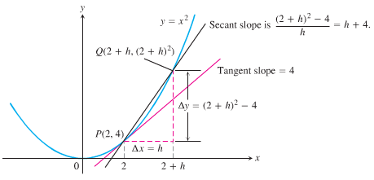

As *Q* approaches *P*, *h* approaches 0. Then the secant slope 







***Exercises Section* 1.1 – Idea of Limits**

1. Find the average rate of change of the function  over the interval 
2. Find the average rate of change of the function  over the interval 
3. Find the average rate of change of the function  over the interval 
4. Find the slope of  at the point  and an equation of the tangent line at this *P*.
5. Find the slope of  at the point  and an equation of the tangent line at this *P*.
6. Find the slope of  at the point  and an equation of the tangent line at this *P*.
7. Make a table of values for the function  at the points



1. Find the average rate of change of  over the intervals  for each  in the table
2. Extending the table if necessary, try to determine the rate of change of  at .
3. The accompanying graph shows the total amount of gasoline A in the gas tank of an automobile after being driven for *t* days.

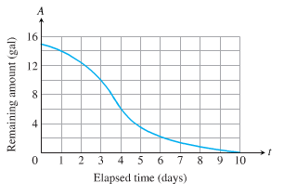

1. Estimate the average rate of gasoline consumption over the time intervals



1. Estimate the instantaneous rate of gasoline consumption over the time 

***Section* 1.2 – Definitions / Techniques of Limits**

**Definition of the Limit of a Function**

If  becomes arbitrary close to a single number *L* as *x* approaches  from either side, then



Which is read as “the limit of  as *x* approaches  is *L.*”

|  |  |
| --- | --- |
| ***Notation*** | ***Terminology*** |
|  | ***x*** approaches ***a*** from the left (through values ***less*** than *a*) |
|  | ***x*** approaches ***a*** from the right (through values ***greater*** than *a*) |

***Example***

How does the function  behave near ?

***Solution***



For :



 

|  |  |  |  |  |  |  |
| --- | --- | --- | --- | --- | --- | --- |
| ***x*** | .9 | .99 | .999 | 1.001 | 1.01 | 1.1 |
|  | 1.9 | 1.99 | 1.999 | 2.001 | 2.01 | 2.1 |





***Example***

Discuss the behavior of the following function as .



***Solution***

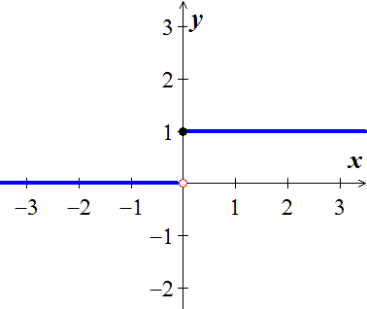

The unit step function  has no limit as , it jumps, because the values jump at *x* = 0.

To the left of zero  . For the positive values of *x* close to zero 

***One-Sided Limits***

To have a limit *L* as *x* approaches *c*, a function *f* must be defined on ***both sides*** of *c* and its values  must approach *L* as *x* approaches *c* from either side. Because of this, ordinary limits are called ***two-sided***.

If *f* fails to have two-sided limit at *c*, it may still have one-sided limit.

If the approach is from the *right*, the limit is a ***right-hand limit***. 

If the approach is from the *left*, the limit is a ***left-hand limit***. 

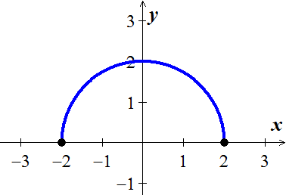***Example***

The domain of  is ; its graph is the semicircle.

We have: 

The function doesn’t have a left-hand limit at  or a right-hand limit at . It does not have ordinary two-sided limits at either −2 or 2.

***Theorem***

A function  has a limit as *x* approaches *c* if and only if it has left-hand and right-hand limits there and these one-sided limits are equal:



***Properties of Limits***

***Constant function*** : 

***Identity function*** : 

***Example***

Given the function graphed:

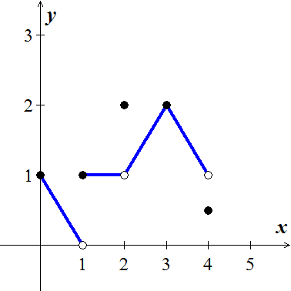

At *x* = 0: 

 don’t exist. The function is not defined to the left of *x* = 0

At *x* = 1:  

 doesn’t exist. The right-hand and left-hand limits are not equal.

At *x* = 2:  

 even though 

At *x* = 3: 

At *x* = 4:  even though 

 do not exist.

The function is not defined to the right of *x* = 4

***Definitions***

We say that  has right-hand limit *L* at  and 

If for every number *ε* > 0 there exists a corresponding number *δ* > 0 such that for all *x*



We say that  has left-hand limit *L* at  and 

If for every number *ε* > 0 there exists a corresponding number *δ* > 0 such that for all *x*



***Example***

****Prove that 

***Solution***

Let *ε* > 0 be given. 



or 





If we choose , we have



According to the definition, this shows that 

***Example***

Discuss the behavior of the following function as .

 

***Solution***

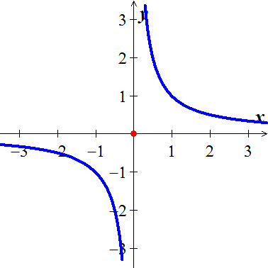

 has *no limit* as  because the values of  grow arbitrary large (negative and positive) value as  and do not stay close.

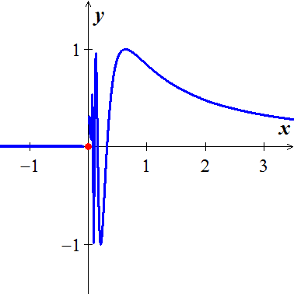

 has *no limit* as  because the function’s values oscillate between −1 and +1 in every open interval containing 0. The values do not stay close to any one number as .

***Limit Laws***

If 

*Constant Multiple Rule:* 

*Sum and Difference Rules:* 

*Product Rule*: 

*Quotient Rule:*  

*Power Rule:* 

*Root Rule:* 

***Example***

Find the following limits:

  

***Solution***

1.  ***Sum and Difference Rules***



1.  ***Quotient Rule***

 ***Sum and Difference Rules***



1.  ***Root Rule***

 ***Difference Rule***







***Theorem* – Limits of Polynomials**

If , then 

***Theorem* – Limits of Rational Functions**

If  and  are polynomials and , then 

***Example***

Find the limit: 

***Solution***







***Eliminating Zero Denominators Algebraically***

***Example***

Evaluate: 

***Solution***













***Example***

Evaluate: 

***Solution***



 

















***The Sandwich (Squeeze) Theorem***

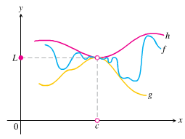

Suppose that  for all *x* in some open interval containing *c*, except possibly at *x* = *c* itself. Suppose also that



***Example***

Given that , find the , no matter how complicated *u* is.

***Solution***





The Sandwich theorem implies that 

***Theorem***

Suppose that  for all *x* in some open interval containing *c*, except possibly at *x* = *c* itself, and the limits of *f* and *g* both exist as *x* approaches *c*, then



***Example***

Show that  has no limit as *x* approaches zero from either side.

***Solution***

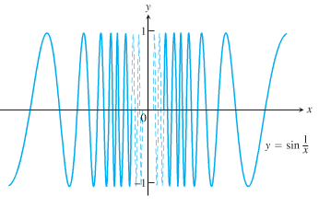

As *x* approaches zero, its reciprocal, , grows without bound and the values of  cycle repeatedly from −1 to 1. There is no single number *L* that the function’s values stay increasingly close to as *x* approaches zero.. The function has neither a right-hand limit nor a left-hand limit at *x* = 0.

***Limit Involving ***

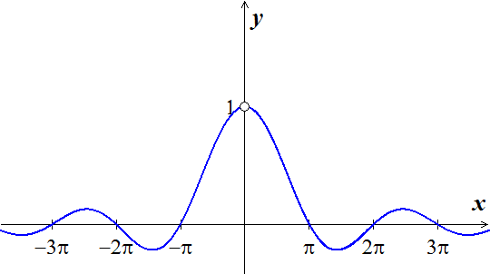

A central fact about  is that in radian measure it limit as *θ* → 0 is **1**.

***Theorem***



***Proof***

We need to show that the right-hand limit is 1, 

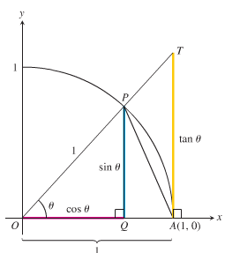Notice that:













 ***Taking reciprocals reverses the inequalities***



Since , then 

So 

***Example***

Show that 

***Solution***

Using the half-angle formula: 



 ***Let*** 









***Example***

Show that 

***Solution***

 ***Since we need* 2*x in the denominator***







***Example***

Show that 

***Solution***



 





***Exercises*** ***Section* 1.2 – Definitions / Techniques of Limits**

Find the limit:

|  |  |  |
| --- | --- | --- |
|  |  |  |

|  |  |  |
| --- | --- | --- |
|  |  |  |

1. For the function  graphed, find the following limits or explain why they do not exist.

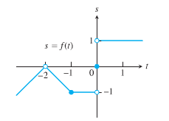



1. Suppose . Find

|  |  |
| --- | --- |
|  |  |

1. Explain why the limits do not exist for 

Evaluate the limit using the form  for

|  |  |
| --- | --- |
|  |  |

1. If, find 
2. If, find 
3. If  and . At what points *c* do you automatically know ? What can you say about the value of the limits at these points?
4. Let 

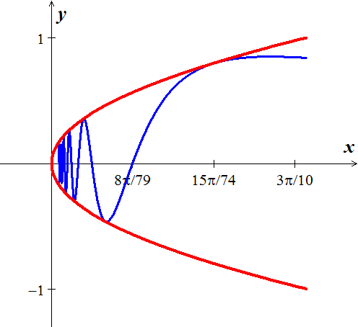

1. Does  exist? If so, what is it? If not, why not?
2. Does  exist? If so, what is it? If not, why not?
3. Does  exist? If so, what is it? If not, why not?

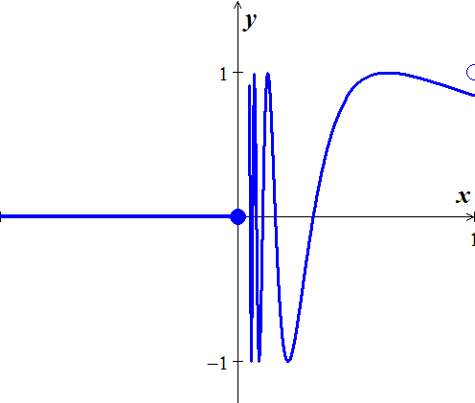

1. Let 
2. Does  exist? If so, what is it? If not, why not?
3. Does  exist? If so, what is it? If not, why not?
4. Does  exist? If so, what is it? If not, why not?
5. Which of the following statements about the function  graphed here are true, and which are false?

|  |  |
| --- | --- |
|  |  |

***Section* 1.3 – Infinite Limits**

***Definitions***

We say that  has the **limit *L* as *x* approaches infinity** and write 

If,  

We say that  has the **limit *L* as *x* approaches *minus* infinity** and write 

If,  

***Basic Facts*:** 

***Example***

Find 

***Solution***

 ***Divide by***

 



***Example***

Find 

***Solution***

 





**Vertical Asymptote (*VA*) - *Think Domain***

The line  is a ***vertical asymptote*** for the graph of a function  if



As ***x*** approaches ***a*** from either the left or the right



***Example***

Find 

***Solution***









***Example***

Find 

***Solution***

 



***Example***

Let , determine the following limits and find the vertical asymptotes of *f*.

|  |  |  |
| --- | --- | --- |
|  |  |  |

***Solution***

1. 





The vertical asymptote: , while the hole is 

1. 



1. 



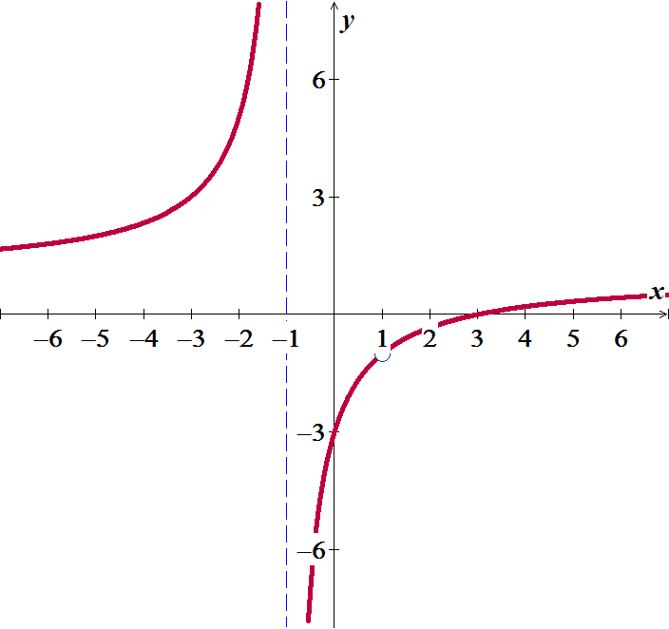

***Example***

Find 

***Solution***

,

As   

As   

***Exercises Section* 1.3 – Infinite Limits**

***Find***

|  |  |  |
| --- | --- | --- |
|  |  |  |

1. Let 
2. For what values of *a*, if any, does  equal a finite number?
3. For what values of *a*, if any, does ?
4. For what values of *a*, if any, does ?
5. Analyze  and 

***Section* 1.4 – Limits at Infinity**

|  |  |
| --- | --- |
| ***Notation*** | ***Terminology*** |
|  | increases without bound (can be made as large positive as desired) |
|  | decreases without bound (can be made as large negative as desired) |

**Horizontal Asymptote (*HA*)**

The line  is a ***horizontal asymptote*** for the graph of a function  if



Let  be a rational function. (***Proof*** !)

1. If the degree of numerator is less than of denominator (*n* < *m*) ⇒ *y* = 0



1. If the degree of numerator is equal of denominator (*n* = *m*) ⇒



1. If the degree of numerator is greater than of denominator (*n* > *m*) ⇒ No horizontal asymptote



***Example***

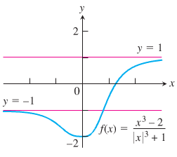Find the horizontal asymptotes of the graph of 

***Solution***





The ***HA*** are  and .

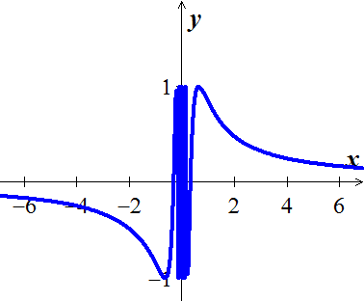***Example***

Find 

***Solution***

Let 



***Example***

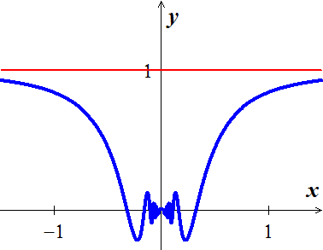Find 

***Solution***

Let 





***Example***

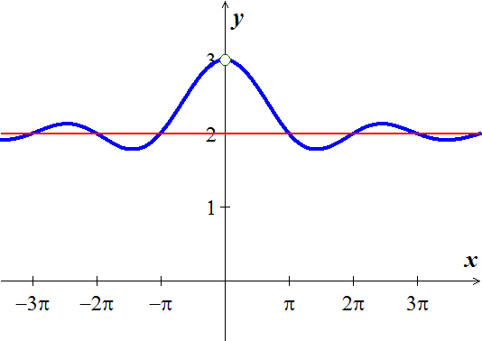Find the horizontal asymptote of 

***Solution***

Since 





The ***HA*** are 

***Example***

Find 

***Solution***

 















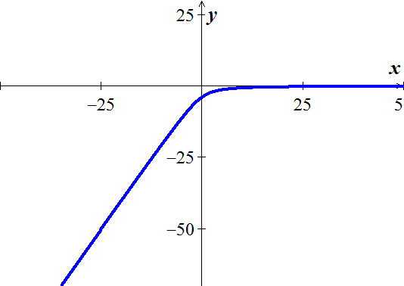

***Slant* or *Oblique* Asymptotes**

When the degree of the numerator is one greater than the degree of the numerator, the graph has a ***slant*** or ***oblique*** asymptote and it is a line . To find the slant asymptote, divide the fraction using long division. The quotient (not remainder) is the slant asymptote.

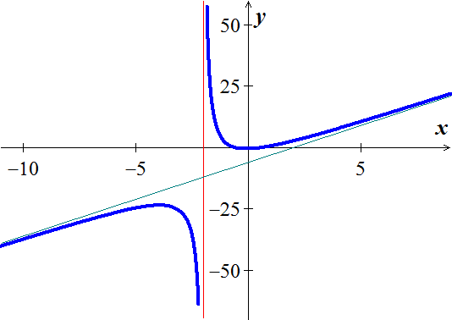****





The ***oblique*** ***asymptote*** is the line ***y* = 3*x* - 6**

***Example***

Find the horizontal and vertical asymptotes of the curve 

***Solution***

***HA***:  ***VA***: 

***Example***

Find the horizontal and vertical asymptotes of the curve 

***Solution***

***HA***: 

***VA***: 



**Infinite Limits**

The limit has a value of infinity or minus infinity, such a function . It is convenient to describe the behavior of  by saying that  approaches ∞ as .

***Definition***

We say 

That  doesn’t exist because  becomes arbitrary large and positive as .

We say 

That  doesn’t exist because  becomes arbitrary large and negative as .

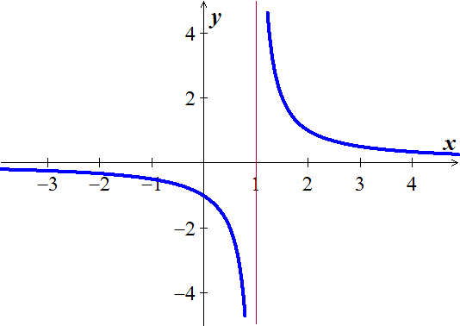***Example***

Find 

***Solution***

As 





* 
* 
* 
* 
* 

***Exercises*** ***Section* 1.4 – Limits at Infinity**

Find the limit as  and as  of

|  |  |  |
| --- | --- | --- |
|  |  |  |

***Evaluate***

|  |  |
| --- | --- |
|  |  |

Graph the rational function and include the equations of the asymptotes

|  |  |  |  |
| --- | --- | --- | --- |
|  |  |  |  |

1. Let 
2. Analyze ,, , and 
3. Does the graph of *f* have any vertical asymptotes? Explain?

Find the vertical, horizontal, hole, and oblique asymptotes (if any) of

|  |  |  |
| --- | --- | --- |
|  |  |  |

***Section* 1.5 – Continuity**

**Definition of Continuity**

Let *c* be a number in the interval (*a*, *b*), and let *f* be a function whose domain contains the interval (*a*, *b*). The function *f*  is continuous at the point *c* if the following conditions are true.

1. is defined
2. 
3. 

If *f* is continuous at every point in the interval (*a*, *b*), then it is continuous on an open interval (*a*, *b*)

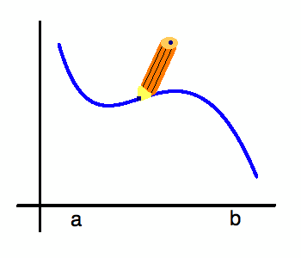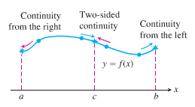

***Definition***

***Interior point***: A function  is **continuous at an interior point *c*** of its domain if



***Endpoint***: A function  is **continuous at a left point *a*** or is **continuous at a right point *b*** of its domain if



* If a function  is not continuous at a point *c*, we say that  is ***discontinuous*** at *c*. (is a ***point of discontinuity***)

***Example***

Find the points at which the functionis continuous and the points at which  is not continuous

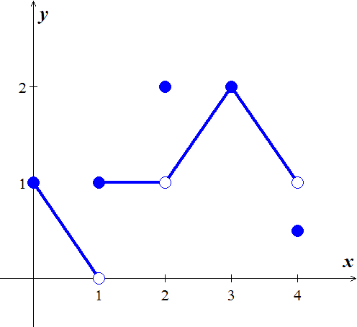

***Solution***

The function  is continuous at every point in its domain [0, 4] except at   and .

At these points, there are breaks in the graph.

   is continuous 

  doesn’t exist  is discontinuous 

   is discontinuous 

   is continuous 

   is discontinuous 

 These points are not in the domain of *f*.  is discontinuous

 

***Example***

At what points the function is continuous?

***Solution***

The function is continuous at every point of its domain [−2, 2].

Including, where  is right-continuous, and , where  is left-continuous.

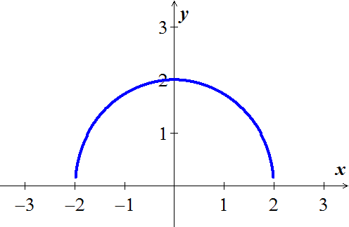

***Continuous Functions***

A function is ***continuous on an interval*** iff it is continuous at every point of the interval. A ***continuous function*** is one that is continuous at every point of its domain. A continuous function need not be continuous on every interval.

***Example***

Determine at which points do the function  is continuous and discontinuous

**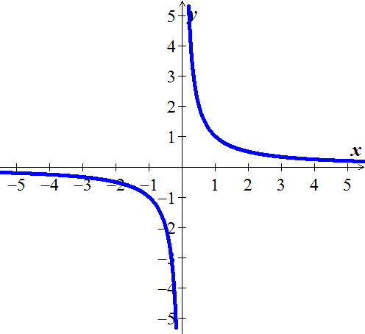*Solution***

The function  is a continuous function because

it is continuous at every point of its domain.

It has a point of discontinuity at , however, because it is not defined.

It is discontinuous on any interval containing 

***Theorem* – Properties of Continuous Functions**

If the functions  are continuous at , then the following combinations are continuous at .

*Sums and Differences* 

*Constant multiples* , for any number *k*.

*Products* 

*Quotients *

*Powers *

*Roots ,* provided it is defined on an open interval containing *c*, where *n* is a positive integer

***Proof***









This shows that  is continuous

***Composites***

All composites of continuous functions are continuous.

If  is continuous at  and  is continuous at , then  is continuous at 

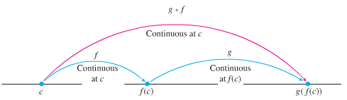

***Example***

Show that  is continuous everywhere on its domain

***Solution***

Let 

∴ The function *y* is continuous on 

***Example***

Show that  is continuous everywhere on its domain

***Solution***

Let 

∴ The function is the composite of a quotient continuous functions with the continuous absolute value function.

***Theorem***

If *g* is continuous at the point *b* and , then



***Proof***

Let *ε* > 0 be given. Since *g* is continuous at *b*, there exists a number  such that





If we let , we then have that 

Which implies from the first statement that  whenever . From the definition of the limit, this proves that 

***Example***

Find the 

***Solution***











***Example***

Show that  has a continuous extension to , and find that extension.

***Solution***



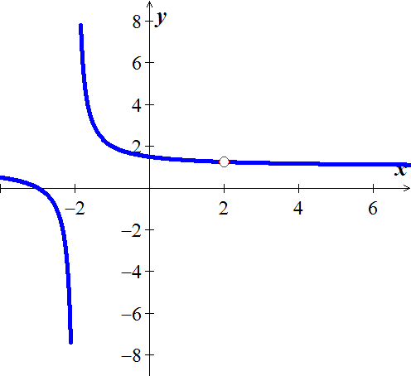 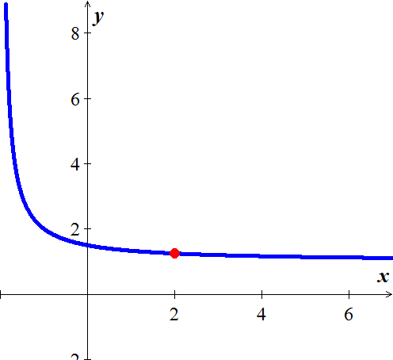

After simplification the function is continuous at 



The new function is the function *f* with its point of discontinuity at  removed.

***Theorem* − the Intermediate Value Theorem for Continuous Functions**

If *f* is a continuous function on a closed interval [*a*, *b*], and if  is any value between  and , then  for some ***c*** in [*a*, *b*].

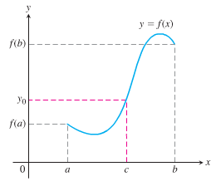

**A Consequence for Root Finding**

We call a solution of the equation  a ***root*** of the equation or zero of the function *f*. The Intermediate Value Theorem said that if ***f*** is continuous, then any interval on which *f* changes sign contains a zero of the function.

***Example***

Show that there is a root of the equation  between 1 and 2.

***Solution***





Since is continuous, the Intermediate Value Theorem says there is a zero of *f* between 1 and 2.

***Example***

Use the Intermediate Value Theorem to prove that the equation  has a solution.

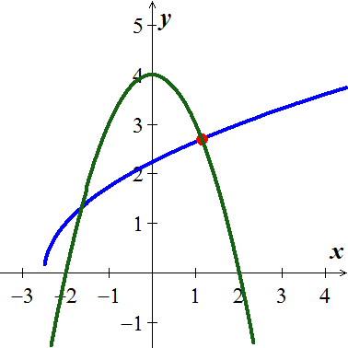

***Solution***

The function  is continuous on the interval  since it is the composite of the square root function with nonnegative linear function . Then the function  is the sum of the function  and . It follows that  is continuous on the interval .

By trial and error:





 is continuous on the interval .

Since the value  is between  and 7, by the Intermediate Value Theorem there is a number . That is, the number *c* solves the original equation.

***Exercises*** ***Section* 1.5 – Continuity**

1. Given the graphed function 
2. Does  exist?
3. Does  exist?
4. Does ?
5. Is  continuous at ?
6. Does  exist?
7. Does  exist?
8. Does ?
9. Is  continuous at ?

At what point(s) is the given function continuous?

|  |  |  |
| --- | --- | --- |
|  |  |  |

1. Find , then is the function continuous at the point being approached?
2. Find , then is the function continuous at the point being approached?
3. Find , then is the function continuous at the point being approached?
4. Explain why the equation  has at least one solution.

Show that the equation has three solutions in the given interval

|  |  |
| --- | --- |
|  |  |

1. Show that the equation has six solutions in the given interval 
2. If functions  and  are continuous for , could  possibly be discontinuous at a point of [0, 1]? Give reason for your answer.
3. Suppose that a function  is continuous on the closed interval [0, 1] and that  for every *x* in [0, 1]. Show that there must exist a number *c* in [0, 1] such that  (***c*** is called a ***fixed point*** of ).
4. Use the Intermediate Value Theorem to show that the equation  has a solution in the interval .
5. The amount of an antibiotic (in *mg*) in the blood *t* hours after an intravenous line is opened is given by



1. Use the Intermediate Value Theorem to show that the amount of drug is 30 *mg* at some time in the interval  and again at some time in the interval 
2. Estimate the times at which 
3. Is the amount of drug in the blood ever 50 *mg*?

Determine whether the following functions are continuous at *a*.

|  |  |
| --- | --- |
|  |  |

Find the intervals on which the following functions are continuous. Specify right- or left- continuity at the endpoints

|  |  |  |  |
| --- | --- | --- | --- |
|  |  |  |  |

1. Let 

Determine values of the constants *a* and *b* for which  is continuous at 

***Section* 1.6 – Precise Definition of a Limit**

***Example***

Consider the function  near . Intuitively it appears that *y* is close to 7 when *x* is close to 4, so . However, how close to  does *x* have to be so that  differs from 7 by, say less than 2 units?

**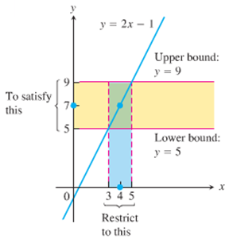*Solution***

We need to find the values of *x* for .



















Keeping *x* within 1 unit of  will keep *y* within 2 units of 

***Definition***

Let  be defined on an open interval about , except possibly at  itself. We say that **the limit of  as *x* approaches is the number *L***, and write



If, for every number , there exists a corresponding number  such that for all *x*,



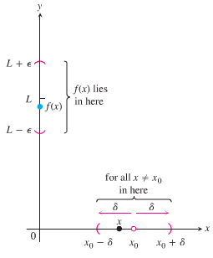

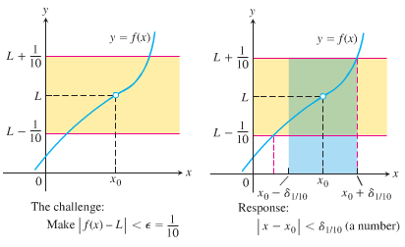

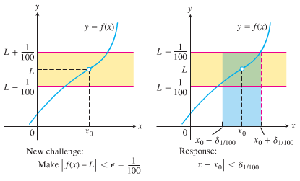

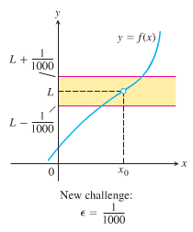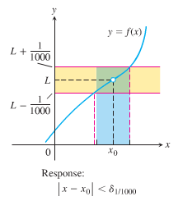

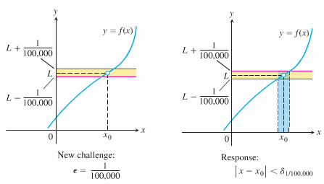

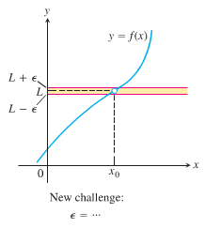

***Example***

Show that 

***Solution***

Let .

For any given , there exists a  so that  and *x* is within distance *δ* of , that is

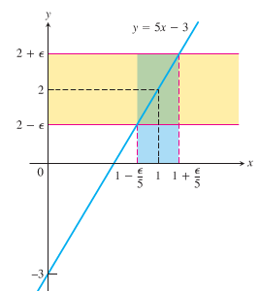 









Thus, we can take: 

If 



Which proves that 

***Example***

Prove the results presented graphically 

***Solution***

Let *ε*  > 0 be given, we must find *δ* > 0 such that for all *x*



This implication will hold if *δ* = *ε* or any smaller number.

***Example***

For the limit , find a *δ* > 0 that works for *ε* = 1. That is, find a *δ* > 0 such that for all *x*:

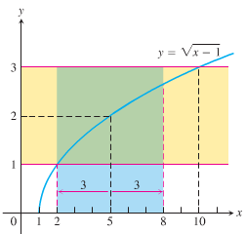

***Solution***







 ***Square all sides***







The inequality holds for all *x* in the open interval.

So it holds for all  in the interval as well.

Finding *δ* value.

 Centered at  inside the interval

 (***to be centered***)



**How to Find *Algebraically* a *δ* for a Given *f*, *L*,  , and *ε*  > 0**

The process of finding a *δ* > 0 such that for all *x*:



Can be accomplished in two steps

1. Solve the inequality  to find an open interval  containing  on which the inequality holds for all .
2. Find a value of *δ* > 0 that places the open interval  centered at  inside the interval . The inequality  will hold for all  in this *δ* −interval.

***Example***

Prove that if



***Solution***

We need to show that given *ε* > 0 there exists a *δ* > 0 such that for all *x*:



1. *Solve the inequality  to find an open interval containing  on which the inequality holds for all .*

For , , and the inequality to solve is :

**

 ***Add 4 to all sides***

 ***Square root***

 ***Assume ε* < 4**



The inequality  holds for all  in the open interval 

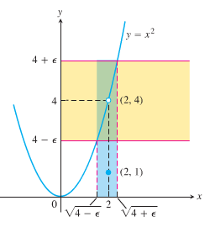

1. *Find a value of δ > 0 that places the open interval  inside the interval*.

Take δ to be the distance from  to the nearer endpoint of .

.











***Example***

Given that , prove that 

***Solution***

We need to show that given *ε* > 0 there exists a *δ* > 0 such that for all *x*:





 ***Triangle Inequality*** 



Since , there exists a number  such that for all *x*:



Similarly, since , there exists a number  such that for all *x*:



Let , the smaller of . If  then , so  and , so  . Therefore



This show that 

***Exercises*** ***Section* 1.6 – Precise Definition of Limits**

Sketch the interval (*a, b*) on the *x*-axis with the point inside. Then find a value of δ > 0 such that for all *x*, for

|  |  |
| --- | --- |
|  |  |

1. Use the graph to find a *δ* > 0 such that for all *x* 

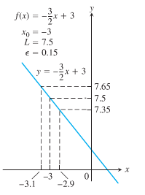

Find an open interval about  on which the inequality holds. Then give a value for *δ* > 0 such that for all *x* satisfying  the inequality  holds.

1. 
2. 
3. 
4. 
5. 

Give a formal proof that

|  |  |
| --- | --- |
|  |  |

1. Prove that 

