***Lecture Three –* Applications of Derivatives**

***Section* 3.1 – Maxima and Minima**

***Definition***

Let be a function with Domain *D*. Then has an ***absolute maximum*** value on *D* at a point *c* if



And an ***absolute maximum*** value on *D* at a point *c* if



Maximum and minimum values are called ***extreme values*** of the function.

Absolute maxima or minima are also referred to as ***global*** maxima or minima.

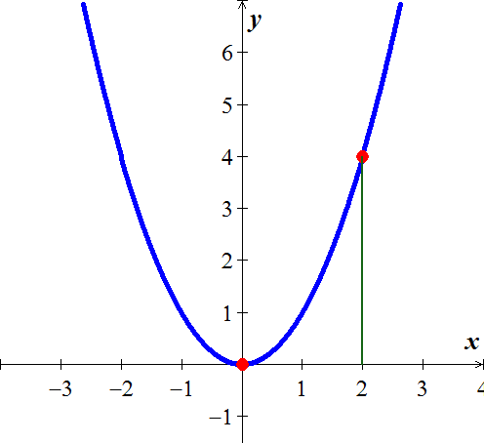

|  |  |  |
| --- | --- | --- |
| ***Function rule*** | ***Domain D*** | ***Absolute extrema on D*** |
|  |  | No absolute maximum.  Absolute minimum of 0 at *x* = 0. |
|  |  | Absolute minimum of 0 at *x* = 0.  Absolute minimum of 4 at *x* = 2. |
|  | (0, 2] | No absolute minimum.  Absolute minimum of 4 at *x* = 2. |
|  | (0, 2) | No absolute extrema. |

***Theorem* − The Extreme Value Theorem**

If  is continuous on a closed interval [*a*, *b*], then  attains both an absolute maximum value *M* and an absolute minimum value *m* in [*a*, *b*]. That is, there are numbers  and  in [*a*, *b*] with  and  for every other *x* in [*a*, *b*].

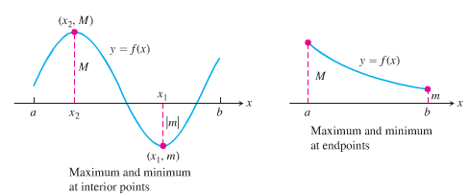

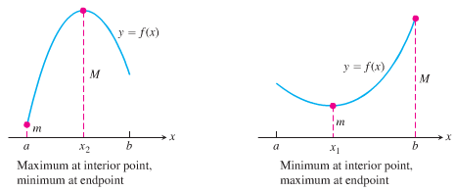

***Definitions***

A function  has a ***local maximum*** (***LMAX***) value at a point *c* within its domain *D* if  for all  lying is some open interval containing *c*.

A function  has a ***local minimum*** (***LMIN***) value at a point *c* within its domain *D* if  for all  lying is some open interval containing *c*.

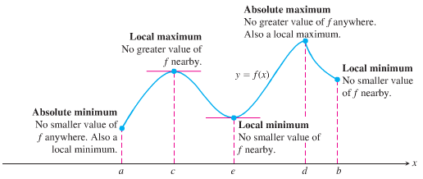

An absolute maximum is also a local maximum. Being the largest value overall, it is also the largest value in its immediate neighborhood.

**Finding Extrema**

***Theorem* − The First Derivative Theorem for Local Extreme Values**

If has a ***local minimum*** or ***local maximum*** value at a point *c* of its domain *D*, and  is defined at *c,* then



***Proof***

For  at a local extremum, we need to show that  can’t be positive or negative at *c*.



***Definition***

An interior point of the domain of a function  where  is zero or undefined is a critical point of .

**How to find the Absolute Extrema of a continuous Function on a Finite Closed Interval**

1. Evaluate  at all critical points and endpoints.
2. Take the largest and smallest of these values.

***Example***

Find the absolute maximum and minimum values of  on [−2, 1].

***Solution***





***Check***: 



The function has an absolute maximum value of 4 at *x* = −2 and an absolute minimum value of 0 at .

***Example***

Find the absolute maximum and minimum values of  on [−2, 1].

**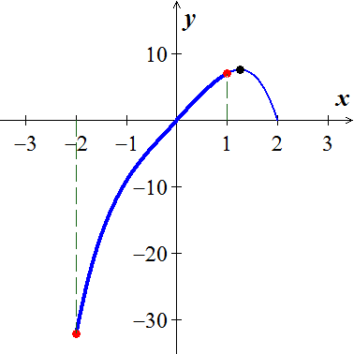*Solution***



***Check***: 



The function has an absolute maximum value of 7 at *x* = 1

and an absolute minimum value of −32 at .

***Example***

Find the absolute maximum and minimum values of  on [−2, 3].

**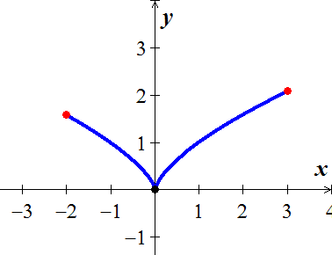*Solution***



Critical point: 

Endpoint values: 



Absolute ***MIN***: (0, 0)

Absolute ***MAX***: 

**Critical Points (*CP*) or *Critical Numbers***

The critical points for a function  are those numbers in the domain of  for which  or  doesn’t exist. A critical point is a point whose *x*-coordinate is the critical point , and whose *y*-coordinate is 





 is a Critical Number  


Critical Point: 

If  undefined

***Exercises*** ***Section* 3.1 – Maxima and Minima**

Find the absolute maximum and minimum values of each function. Then graph the function. Identify the points on the graph where the absolute extrema occur, and include their coordinates.

|  |  |
| --- | --- |
|  |  |

Find the absolute maximum and minimum values of each function

|  |  |
| --- | --- |
|  |  |

Determine all critical points of each function

|  |  |
| --- | --- |
|  |  |

Find the extreme values (absolute and local) of the function and where they occur

|  |  |  |
| --- | --- | --- |
|  |  |  |

1. Let 
2. Does exist?
3. Show the only local extreme value of  occurs at *x* = 2.
4. Does the result in part (*b*) contradict the Extreme Value Theorem?
5. When a telephone wire is hung between two poles, the wire forms a U-shape curve called a Catenary. For instance, the function   models the shape of the telephone wire strung between two poles that are 60 *ft.* apart (*x* & *y* are measured in *ft*.). Show that the lowest point on the wire is midway between two poles. How much does the wire sag between the two poles?
6. You are sitting in a classroom next to the wall looking at the blackboard at the front of the room. The blackboard is 12 *ft* long and starts 3 *ft* from the wall you are sitting next to.
7. Show that your viewing angle is If you are *x* *ft* from the front wall
8. Find *x* so that α is as large as possible

***Section* 3.2 – Graphing Functions**

**Increasing and Decreasing Functions**

***Corollary***

Suppose that  is continuous on [*a, b*] and differentiable on (*a, b*).

1. If for all *x* in (*a, b*), then *f* is increasing on (*a, b*)
2. If for all *x* in (*a, b*), then *f* is decreasing on (*a, b*)
3. If for all *x* in (*a, b*), then *f* is constant on (*a, b*)

***Example***

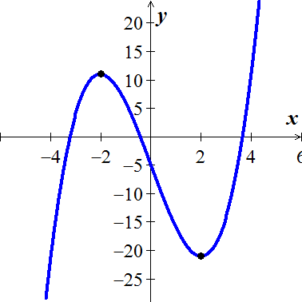Find the open intervals on which the function  is increasing or decreasing

***Solution***



 (***CN***)

|  |  |  |
| --- | --- | --- |
| −∞ −2 2 ∞ | | |
|  |  |  |
| ***Increasing*** | ***Decreasing*** | ***Increasing*** |

***Increasing***: (-∞, −2) and (2, ∞)

***Decreasing***: (−2, 2)

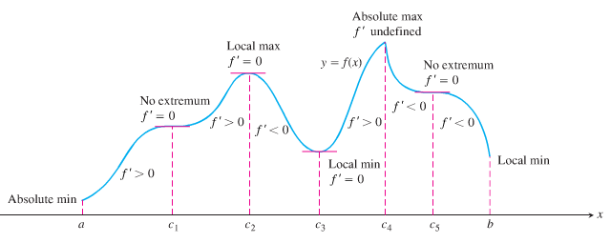

**First Derivative Test for Local Extrema**

Suppose that *c* is a critical point of a continuous function .

1. If  changes from negative to positive at *c*, then  has a local minimum (***LMIN***).
2. If  changes from positive to negative at *c*, then  has a local maximum (***LMAX***).
3. If doesn’t change sign at *c*, then  has no local extremum at *c*.

***Example***

Find the open intervals on which the function  is increasing or decreasing

**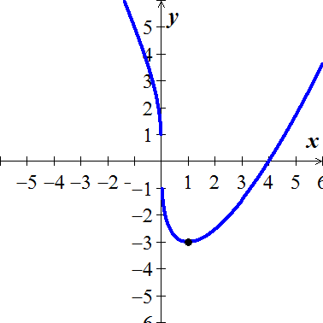*Solution***









 (***CN***)

|  |  |  |
| --- | --- | --- |
| -∞ 0 1 ∞ | | |
|  |  |  |
| ***Decreasing*** | ***Decreasing*** | ***Increasing*** |

***Increasing***: (1, ∞)

***Decreasing***: (−∞, 1)

***Concavity***

***Definition***

Let *f* be differentiable on an open interval *I* . The graph of *f*  is

1. **Concave *upward*** on *I* if is increasing on the interval.
2. **Concave *downward*** on *I* if is decreasing on the interval.

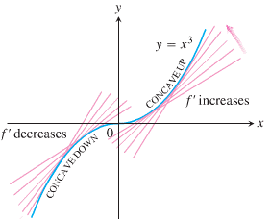

**Test for Concavity**

Let *f* be function whose second derivative exists on an open interval *I*.

1. If for all *x* in *I*, then *f* is ***concave up*** on *I*.
2. If  for all *x* in *I*, then *f* is ***concave down*** on *I*.
3. Locate the *x* values @ which  or undefined
4. Use these test *x*-value to determine the test intervals
5. Test the sign of  in each interval

***Example***

Determine the intervals on which the graph of the function is concave upward or concave downward.

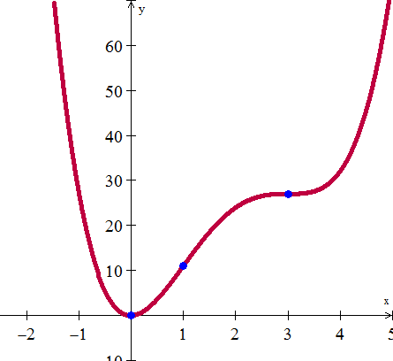

***Solution***



 

|  |  |  |
| --- | --- | --- |
| −∞   ∞ | | |
| ***upward*** | ***downward*** | ***upward*** |

*f* is concave upward on 

*f* is concave downward on 

**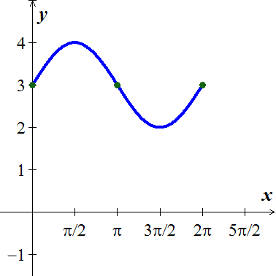*Example***

Determine the concavity of 

***Solution***





|  |  |
| --- | --- |
| 0 | |
| ***downward*** | ***upward*** |

The graph *y* is ***concave down*** on 

The graph *y* is ***concave up*** on 

**Points of Inflection**

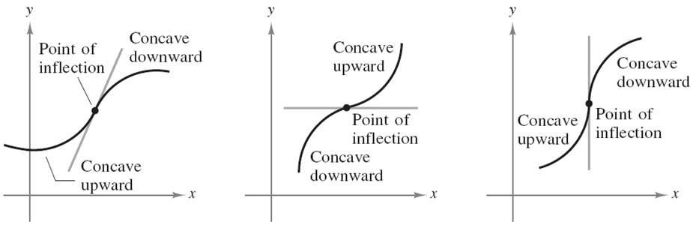

***Definition***

If the graph of a continuous function has a tangent line @ a point where its concavity changes from upward to downward (or down to upward) then the point is a ***point of inflection***.

At a point of inflection , either  fails to exist.

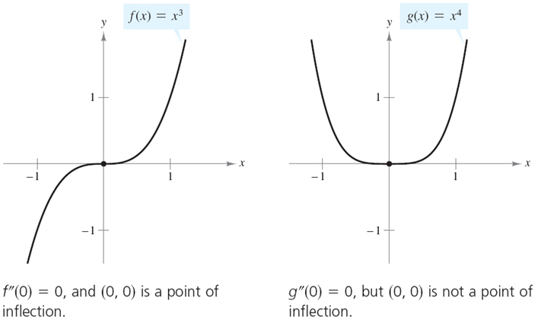

***Example***

A particle is moving along a horizontal coordinate line (positive to the right) with position function



Find the velocity and acceleration, and describe the motion of the particle.

***Solution***

The velocity is:  

The acceleration is: 

|  |  |  |  |
| --- | --- | --- | --- |
| 0 | | | |
| ***Increasing***  ***right*** | ***Decreasing***  ***left*** | | ***Increasing***  ***right*** |
| ***Concave down*** | | ***Concave up*** | |

The particle starts moving to the right while slowing down, and then reverses by moving to the left at  under the influence of the leftward acceleration over the time interval . The acceleration then changes direction changes direction at  but the particles continues moving leftward, while slowing down under the rightward acceleration. At  the particle reverses direction again; moving to the right in the same direction as the acceleration.

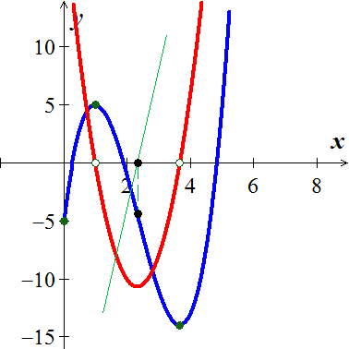

**Second Derivative Test for local Extrema**

Let  and let  exist ()

1. If  ⇒ is a local Minimum at 
2. If  ⇒ is a local Maximum at 
3. If  ⇒ Test fails → use  to determine Max, Min.

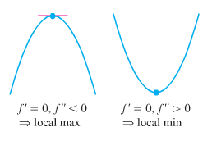

***Example***

Sketch a graph of the function  using the following steps

1. Identify where the extrema of  occur
2. Find the intervals on which  is increasing and decreasing
3. Find where the graph of  is concave up and down
4. Sketch the general shape of the graph for 
5. Plot some specific points, such as local maximum and minimum points, points of inflection, and intercepts. Then sketch the curve.

***Solution***



 (***CN***)

|  |  |  |
| --- | --- | --- |
| −∞   ∞ | | |
| ***decreasing*** | ***decreasing*** | ***increasing*** |

1. 

|  |  |  |
| --- | --- | --- |
| −∞   ∞ | | |
| ***Concave up*** | ***Concave down*** | ***Concave up*** |

A local minimum at (3, −17)

1.  is ***decreasing***: 

 is ***increasing***: 

1. 

 

 is ***concave up***: 

 is ***concave down***: 

1. 

***Example***

Sketch the graph of 

***Solution***

***Domain*** of  is  ***Horizontal Asymptotes*** 

 







  (***CN***)



 

|  |  |  |  |  |  |
| --- | --- | --- | --- | --- | --- |
| −∞   **0** 1  ∞ | | | | | |
| **−** | | **+** | | **−** | |
| ***Decreasing*** | | ***Increasing*** | | ***Decreasing*** | |
| **−**  ***Concave down*** | **+**  ***Concave up*** | | **−**  ***Concave down*** | | **+**  ***Concave up*** |







 ***Point of inflections***

|  |  |  |
| --- | --- | --- |
| ***RMAX***:  ***RMIN***: | ***Decreasing***:  ***Increasing***: | ***Concave down***:  ***Concave up***: |

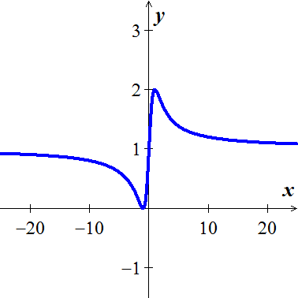 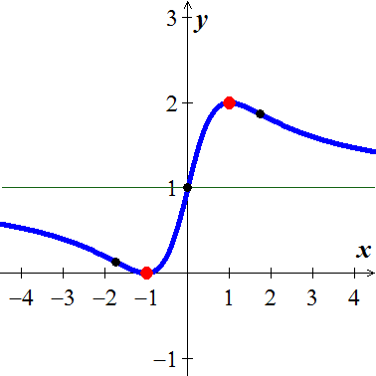

***Exercises*** ***Section* 3.2 – Graphing Functions**

Find the critical numbers and the open intervals on which the function is increasing or decreasing.

|  |  |  |
| --- | --- | --- |
|  |  |  |

Find the open intervals on which the function is increasing and decreasing. Then, identify the function’s local and absolute extreme values, if any, saying where they occur.

|  |  |
| --- | --- |
|  |  |

Find all relative Extrema as well as where the function is increasing and decreasing

|  |  |
| --- | --- |
|  |  |

Find the local extrema of each function on the given interval, and say where they occur

|  |  |
| --- | --- |
|  |  |

Determine the intervals on which the graph of the function is concave upward or concave downward.

|  |  |  |
| --- | --- | --- |
|  |  |  |

1. Find the points of inflection. 
2. Find the second derivative of  and discuss the concavity of the graph
3. Find the extrema using the second derivative test
4. Discuss the concavity of the graph of *f* and find its points of inflection. 
5. Find all relative extrema of 

Sketch the graph

|  |  |
| --- | --- |
|  |  |

1. The revenue *R* generated from sales of a certain product is related to the amount *x* spent on advertising by



Where *x* and *R* are in thousands of dollars.

Is there a point of diminishing returns for this function?

1. Find the point of diminishing returns (*x*, *y*) for the function



where represents revenue in thousands of dollars and *x* represents the amount spent on advertising in tens of thousands of dollars.

1. A county realty group estimates that the number of housing starts per year over the next three years will be



Where *r* is the mortgage rate (in percent).

1. Where is  increasing?
2. Where is  decreasing?
3. Suppose the total cost  to manufacture a quantity *x* of insecticide (in hundreds of liters) is given by . Where is  decreasing?
4. A manufacturer sells telephones with cost function  and revenue function . Determine the interval(s) on which the profit function is increasing.
5. The cost of a computer system increases with increased processor speeds. The cost *C* of a system as a function of processor speed is estimated as , where *x* is the processor speed in MHz. Determine the intervals where the cost function is decreasing.
6. The percent of concentration of a drug in the bloodstream *t* hours after the drug is administered is given by . On what time interval is the concentration of the drug increasing?
7. Coughing forces the trachea to contract, this in turn affects the velocity of the air through the trachea. The velocity of the air during coughing can be modeled by:  where *k* is a constant, R is the normal radius of the trachea (also a constant) and *r* is the radius of the trachea during coughing. What radius *r* will produce the maximum air velocity?
8.  is an approximation to the total profit (in thousands of dollars) from the sale of *x* hundred thousand tires. Find the number of hundred thousands of tires that must be sold to maximize profit.
9.  is an approximation to the number of salmon swimming upstream to spawn, where *x* represents the water temperature in degrees Celsius. Find the temperature that produces the maximum number of salmon.

***Section* 3.3 – Applied Optimization**

**Solving Applied Optimization Problems**

1. Read the problem
2. Draw a picture
3. Introduce variables
4. Write an equation for the unknown quantity
5. Test the critical points and endpoints in the domain of the unknown

***Example***

An open-top box is to be made by cutting small congruent squares from the corners of a 12-*in*. by 12-*in*. sheet of tin and bending up the sides. How large should the squares cut from the corners be to make the box hold as much as possible?

***Solution***

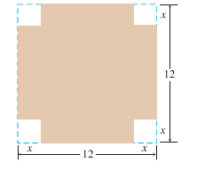 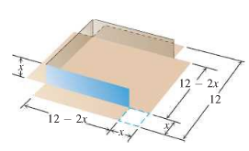



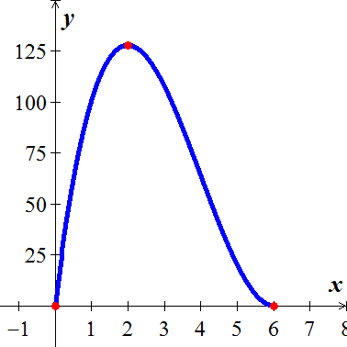 







 (***CP***)





The maximum volume is 128 . The cutout squares is 2 in.

***Example***

You have been asked to design a one-liter can shaped like a right circular cylinder.

What dimensions will use the least material?

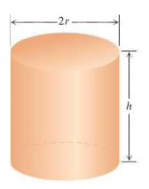***Solution***

Volume of can: 

Surface area of can: 







 ***Solve for r***

|  |  |
| --- | --- |
| 0 5.42 | |
| ***decreasing*** | ***increasing*** |







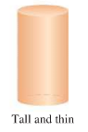

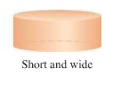The graph is concave up on its domain.

The on 2-liter can that uses the least material has height equal to twice its radius.



***Example***

A rectangle is to be inscribed in a semicircle of radius 2. What is the largest area of the rectangle can have, and what are its dimensions?

***Solution***

The equation of the circle is given by the equation: 

Therefore, the semicircle is: 

The dimensions of semicircle: 

Area: 

 

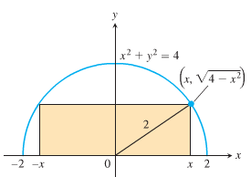 

 ***Solve for x***







The area has a maximum value of 4 when the height is ***unit*** and length  ***unit***

**Example from *Economics***

 Revenue from selling *x* items

 Cost of producing the *x* items

 Profit from producing and selling *x* items

At a production level yielding maximum profit, marginal revenue equals to marginal cost.

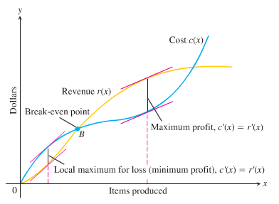

***Marginal Analysis***

Profit = *P* Revenue = *R* Cost = *C* *P = R - C*

The derivatives of these quantities are called ***Marginal***

Marginal Profit

Marginal Revenue

Marginal Cost

***Example***

Suppose that  and , where *x* represents millions of MP3 players produced. Is there a production level that maximizes profit? If so, what is it?

***Solution***



To find the intersection between the 2 derivatives, set 





The possible productions are  million.









Concave down: 

Concave up: 

The maximum profit is about 

The maximum lost is about 



***Exercises*** ***Section* 3.3 – Applied Optimization**

1. Find two nonnegative numbers *x* and *y* for which , such that  is maximized.
2. A rectangular page will contain 54 in2 of print. The margins at the top and bottom of the page are 1.5 *inches* wide. The margins on each side are 1 *inch* wide. What should the dimensions of the page be to minimize the amount of paper used?
3. The product of two numbers is 72. Minimize the sum of the second number and twice the first number
4. Verify the function  has an absolute maximum when *x* = 6. What is the maximum volume?
5. A net enclosure for golf practice is open at one end. The volume of the enclosure is  cubic meters. Find the dimensions that require the least amount of netting.
6. Find two numbers *x* and *y* such that their sum is 480 and  is maximized.
7. If the price charged for a candy bar is  cents, then *x* thousand candy bars will be sold in a certain city, where . How many candy bars must be sold to maximize revenue?
8. is an approximation to the number of salmon swimming upstream to spawn, where *x* represents the water temperature in degrees Celsius. Find the temperature that produces the maximum number of salmon.
9. A company wishes to manufacture a box with a volume of 52 cubic feet that is open on top and is twice as long as it is wide. Find the width of the box that can be produced using the minimum amount of material.
10. A rectangular field is to be enclosed on four sides with a fence. Fencing costs $3 per foot for two opposite sides, and $4 per foot for the other two sides. Find the dimensions of the field of area 730 square feet that would be the cheapest to enclose.
11. A manufacturer wants to design an open box that has a square base and a surface area of 108 in2. What dimensions will produce a box with a maximum volume?
12. A company wants to manufacture cylinder aluminum can with a volume 1000*cm*3. What should the radius and height of the can be to minimize the amount of aluminum used?
13. What is the smallest perimeter possible for a rectangle whose area is 16 , and what are its dimensions?
14. You are planning to make an open rectangular box from an 8-in. by 15-in. piece of cardboard by cutting congruent squares from the corners and folding up the sides. What are the dimensions of the box of largest volume you can make this way, and what is its volume?
15. A rectangular plot of farmland will be bounded on one side by a river and on the other three sides by a single-strand electric fence. With 800 *m* of wire at your disposal, what is the largest area you can enclose, and what are its dimensions?
16. A piece of cardboard measures 10-*in*. by 15-*in*. Two equal squares are removed from the corners of 10-*in*. side. Two equal rectangles are removed from the other corners so that the tabs can be folded to form a rectangular box with lid.

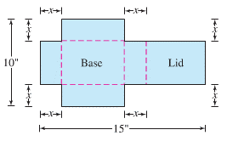

1. Write a formula  for the volume of the box
2. Find the domain of *V* for the problem situation and graph *V* over this domain
3. Use the graphical or analytically method to find the maximum volume and the value of *x* that gives it.
4. An open box of maximum volume is to be made from a square piece of material, 24 *inches* on a side, by cutting equal squares from the corners and turning up the sides.

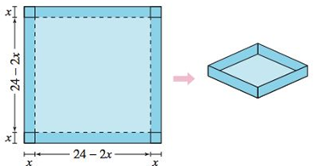

1. Write the volume *V* as a function of *x*.
2. Find the critical number of the function and find the maximum value.
3. Graph the function and verify the maximum volume from the graph.
4. A manufacturer wants to design an open box having square base and a surface area of 108 square inches. What dimensions will produce a box with maximum volume?
5. A rectangular solid (with a square base) has a surface area of 337.5 . Find the dimensions that will result in a solid with maximum volume.
6. A parcel delivery service will deliver a package only if the length plus girth (distance around) does not exceed 108 *inches*.
7. Find the dimensions of a rectangular box with square ends that satisfies the delivery service’s restriction and has maximum volume. What is the maximum volume?
8. Find the dimensions (radius and height) of a cylinder container that meets the delivery service’s requirement and has maximum volume. What is the maximum volume?

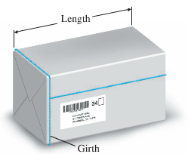

1. A rectangular package to be sent by a postal service can have a maximum combined length and girth (perimeter of a cross section) of 108 *inches*. Find the dimensions of the package of maximum volume that can be sent.

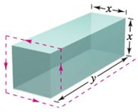

1. A page is to contain 30 *square* *inches* of print. The margins at the top and bottom of the page are 2 *inches* wide. The margins on the sides are 1 *inch* wide. What dimensions will minimize the amount of paper used?
2. A rectangular page is to contain 24 *squares* *inches* of print. The margins at the top and bottom of the page are , and the margins on the left and right are to be 1 *inch*. What should the dimensions of the page be so that the least amount of paper used?

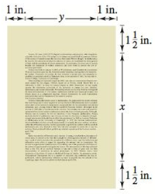

1. A rectangle has its base on the *x*-axis and its upper vertices on the parabola . What is the largest area the rectangle can have, and what are its dimensions?
2. Find the points of  that are closet to (0, 3)
3. Which points on the graph of  are closest to the point ?
4. A rectangle is bounded by the *x-* and *y-*axes and the graph of . What length and width should the rectangle have so that its area is a maximum?



1. A right triangle is formed in the first quadrant by the *x-* and *y-*axes and a line through the point .



1. Write the length *L* of the hypotenuse as a function of *x*.
2. Graph the function and approximate *x* graphically such that the length of the hypotenuse is a minimum.
3. Find the vertices of the triangle such that its area is a minimum.
4. Two factories are located at the coordinates  and , and their power is at . Find *y* such that the total length of power line from the power supply to the factories is a minimum.

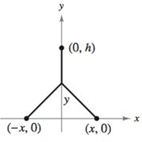

1. A right triangle whose hypotenuse is  long is revolved about one of its legs to generate a right circular cone. Find the radius, height, and volume of the cone of greatest volume that can be made this way.

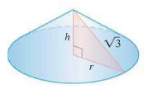

1. Find the volume of the largest right circular cone that can be inscribed in a sphere of radius 3.

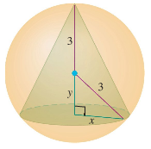

1. The slant height of the cone is 3 *m*. How large should the indicated angle be to maximize the cone’s volume?

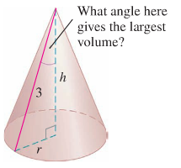

1. Find the area of the largest isosceles triangle that can be inscribed in a circle of radius 6.

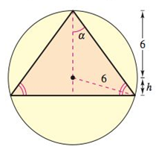

1. Solve the area as a function of *h*.
2. Solve the area as a function of *α*.
3. Identify the type of triangle of maximum area.
4. A rectangle is bounded by the  and the semicircle 



What length and width should the rectangle have so that its area is a maximum?

1. What are the dimensions of the lightest open-top right circular cylindrical can that will hold a volume of 1000 ?
2. Find the volume of the largest right circular cone that can be inscribed in a sphere of radius *r*.

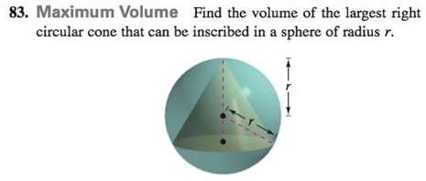

1. A window is in the form of a rectangle surmounted by a semicircle. The rectangle is of clear glass, whereas the semicircle is of tinted glass that transmits only half as much light per unit area as clear glass does. The total perimeter is fixed. Find the proportions of the window that will admit the most light. Neglect the thickness of the frame.

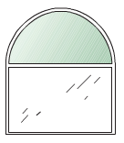

1. The cost per hour for fuel to run a train is  dollars, where *v* is the speed of the train in miles per hour. (Note that the cost goes up as the square of the speed.) Other costs, including labor are $300 per hour. How fast should the train travel on a 360-mile trip to minimize the total cost for the trip?
2. Jane is 2 mi offshore in a boat and wishes to reach a coastal village 6 mi down a straight shoreline from the point nearest the boat. She can row 2 mph and can walk 5 mph. Where should she land her boat to reach the village in the least amount of time?
3. The trough in the figure is to be made to the dimensions shown. Only the angle *θ* can be varied. What value of *θ* will maximize the trough’s volume?

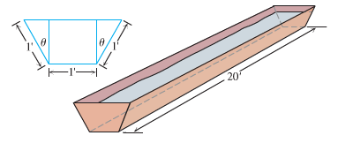

1. The height above the ground of an object moving vertically is given by 

with *s* in feet and *t* in seconds. Find

1. The object’s velocity when *t* = 0
2. Its maximum height and when it occurs
3. Its velocity when *s* = 0
4. Compare the answers to the following two construction problems.
5. A rectangular sheet of perimeter 36 *cm* and dimensions *x* *cm* and *y* *cm* is to be rolled into a cylinder as shown in part (*a*) of the figure. What values of *x* and *y* give the largest volume?
6. The same sheet is to be revolved about one of the sides of length *y* to sweep out the cylinder as shown in part (*b*) of the figure. What values of *x* and *y* give the largest volume?

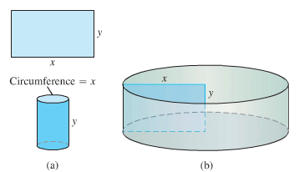

1. The 8-*feet* wall stands 27 *feet* from the building. Find the length of the shortest straight beam that will reach to the side of the building from the ground outside the wall.

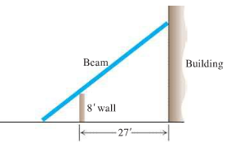

1. A small frictionless cart, attached to the wall by a spring, is pulled 10 cm from its rest position and released at time *t* = 0 to roll back and forth for 4 *sec*. Its position at time *t* is 
2. What is the cart’s maximum speed? When is the cart moving that fast? Where is it then? What is the magnitude of the acceleration then?
3. Where is the cart when the magnitude of the acceleration is greatest? What is the cart’s speed then?

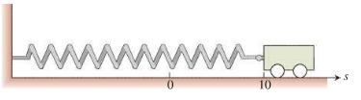

1. The owner of a retail lumber store wants to construct a fence an outdoor storage are adjacent to the store, using all of the store as part of one side of the area. Find the dimensions that will enclose the largest area if

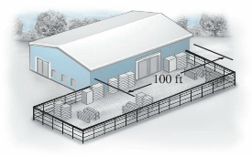

1. 240 *feet* fencing material are used.
2. 400 *feet* fencing material are used.
3. Some birds tend to avoid flights over large bodies of water during daylight hours. Suppose that an adult bird with this tendency is taken from its nesting area on the edge of a large lake to an island 5 miles offshore and is then release.

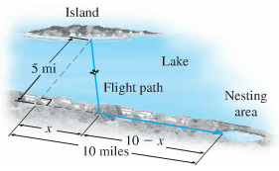

1. If it takes only 1.4 times as much energy to fly over water as land, how far up the shore (*x*, in miles) should the bird head to minimize the total energy expended in returning to the nesting area?
2. If it takes only 1.1 times as much energy to fly over water as land, how far up the shore should the bird head to minimize the total energy expended in returning to the nesting area?
3. A pharmacy has a uniform annual demand for 200 bottles of a certain antibiotic. It costs $10 to store one bottle for one year and $40 to place an order. How many times during the year should the pharmacy order the antibiotic in order to minimize the total storage and reorder costs?
4. A 300-room hotel in Las Vegas is filled to capacity every night at $80 a room. For each $1 increase in rent, 3 fewer rooms are rented. If each rented room costs $10 to service per day, how much should be the management charge for each room to maximize gross profit? What is the maximum gross profit?
5. A multimedia company anticipates that there will be a demand for 20,000 copies of a certain DVD during the next year. It costs the company $0.50 to store a DVD for one year. Each time it must make additional DVDs, it costs $200 to set up the equipment. How many DVDs should the company make during each production run to minimize its total storage and setup costs?
6. A university student center sells 1,600 cups of coffee per day at a price of $2.40.
7. A market survey shows that for every $0.05 reduction in price, 50 more cups of coffee will be sold. How much should be the student center charge for a cup of coffee in order to maximize revenue?
8. A different market survey shows that for every $0.10 reduction in the original $2.40 price, 60 more cups of coffee will be sold. Now how much should the student center charge for a cup of coffee in order to maximize revenue?
9. Suppose you are standing on the shore of a circular pond with radius 1 *mi* and you want to get to a point on the shore directly opposite your position (on the other end of a diameter). You plan to swim at 2 *mi/hr* from your current position to another point *P* on the shore and then walk at 3 *mi/hr* along the shore to the terminal point. How should you choose *P* to minimize the total time for the trip?

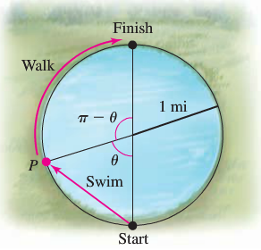

1. Four feet of wire is to be used to form a square and a circle. How much of the wire should be used for the square and how much should be used for the circle to enclose the maximum total area?

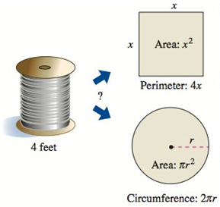

1. Two posts, one 12 *feet* high and the other 28 *feet* high, stand 30 *feet* apart. They are to be stayed by two wires, attached to a single stake, running from ground level on the top of each post. Where should the stake be placed to use the least amount of wire?

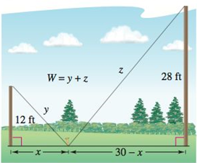

1. A farmer plans to fence a rectangular pasture adjacent to a river. The pasture must contain 245,000  in order to provide enough grass for the herd. No fencing is needed along the river. What dimensions will require the least amount of fencing?

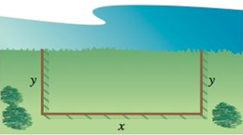

1. A Norman window is constructed by adjoining a semicircle to the top of an ordinary rectangular window. Find the dimensions of a Norman window of maximum area when the total perimeter is 16 *feet*.

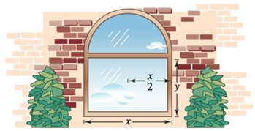

1. 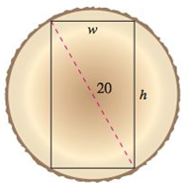A wooden beam has a rectangular cross section of height *h* and width *w*, the strength *S* of the beam is directly proportional to the width and the square of the height. What are the dimensions of the strongest beam that can be cut from a round log of diameter 20 *inches*?



1. A light source is located over the center of a circular table of diameter 4 *feet*. Find the height *h* of the light source such that the illumination *I* at the perimeter of the table is maximum when

|  |  |
| --- | --- |
| where *s* is the slant height  *α* is the angle at which the light strikes the table  *k* is a constant. |  |

1. When light waves traveling in a transparent medium strike the surface of a second transparent medium, they change direction. This change of direction is called refraction and is defined by ***Snell’s Law of Refraction***,



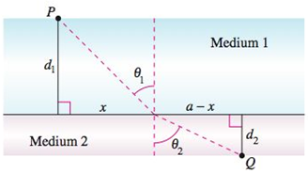

Where  and  are the magnitudes of the angles.

 and  are the velocities of light in the two media.

Show that the light waves traveling from *P* to *Q* follow the path of the minimum time.

1. You are in a boat 2 *miles* from the nearest point on the coast. You are to go to a point *Q* that is 3 *miles* down the coast and 1 *mile* inland. You can row at 3  and walk 4 . Toward what point on the coast should you row in order to reach *Q* in the least time?

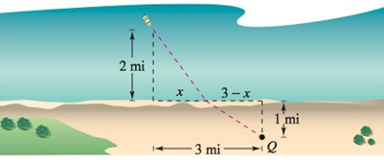

1. You are in a boat 2 *miles* from the nearest point on the coast. You are to go to a point *Q* that is 3 *miles* down the coast and 1 *mile* inland. You can row at 2  and walk 4 . Toward what point on the coast should you row in order to reach *Q* in the least time?

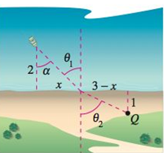

1. A sector with central angle *θ* is cut from a circle of radius 12 *inches*, and the edges of the sector are brought together to form a cone. Find the magnitude of *θ* such that the volume of the cone is a maximum.

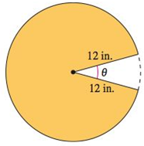

1. A rancher has 400 *feet* of fencing with which to enclose two adjacent rectangular corrals. What dimensions should be used so that the enclosed area will be a maximum?



1. The amount of illumination of a surface is proportional to the intensity of the light source, inversely proportional to the square of the distance from the light source, and proportional to , where *θ* is the angle at which the light strikes the surface. A rectangular room measures 10 *feet* by 24 *feet*, with a 10-*foot* ceiling. Determine the height at which the light should be placed to allow the corners of the floor to receive as much light as possible.

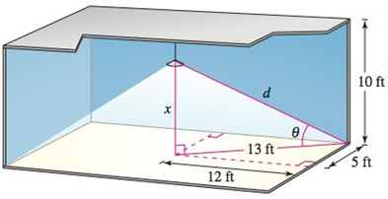

1. Consider a room in the shape of a cube, 4 *meters* on each side. A bug at point *P* wants to walk to point *Q* at the opposite corner. Determine the shortest path.

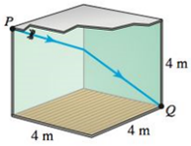

1. The line joining *P* an *Q* crosses the two parallel lines. The point *R* is *d* units from *P*. How far from *Q* should the point *S* be positioned so that the sum of the areas of the two shaded triangles is a minimum? So that the sum is a maximum?

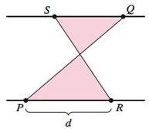

1. Equal squares are cut out of two adjacent corners of a square of sheet metal having sides of length 25 *cm*. the three resulting flaps are bent up, to form the sides of a dustpan. Find the maximum volume of a dustpan made in this way.



1. You must get from a point *P* on the straight shore of a lake to a stranded swimmer who is 50 *m* from a point *Q* on the shore that is 50 *m* from you. If you can swim at a speed of 2 *m/s* and run at a speed of 4 *m/s*, at what point along the shore, *x* meters from *Q*, should you stop running and start swimming if you want to reach the swimmer in the minimum time?

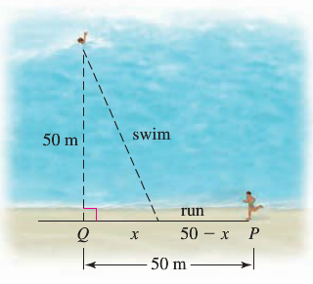

1. Find the function *T* that gives the travel time as a function of *x*, where 



1. Find the critical point of *T* on (0, 50) 
2. Evaluate *T* at the critical point and the endpoints (*x* = 0 and *x* = 50) to verify that the critical point corresponds to an absolute minimum. What is the minimum travel time? 
3. Graph the function *T* to check your work.
4. Consider the function  with . Explain geometrically why *f* has exactly one absolute extreme value on . Find the critical points to determine the value of *x* at which *f* has an extreme value. 
5. An 8-foot-tall fence runs parallel to the side of a house 3 *feet* away. What is the length of the shortest ladder that clears the fence and reaches the house? Assume that the vertical wall of the house and the horizontal ground have infinite extent. 

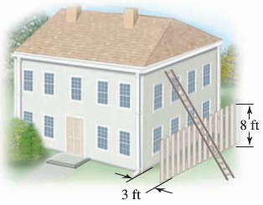

1. A man wishes to get from an initial point on the shore of a circular pond with radius 1 *mi* to a point on the shore directly opposite (on the other end of the diameter). He plans to swim from the initial point to another point on the shore and then walk along the shore to the terminal point.
2. If he swims at 2 *mi/hr* and walks at 4 *mi/hr*, what are the minimum and maximum times for the trip? 
3. If he swims at 2 *mi/hr* and walks at 1.5 *mi/hr*, what are the minimum and maximum times for the trip? 
4. If he swims at 2 *mi/hr*, what is the minimum walking speed for which it is quickest to walk the entire distance?
5. A boat on the ocean is 4 *mi* from the nearest point on a straight shoreline; that point is 6 *mi* from a restaurant on the shore. A woman plans to row the boat straight to a point on the shore and then walk along the shore to the restaurant.

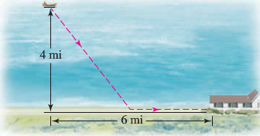

1. If she walks at 3 *mi/hr* and rows at 2 *mi/hr*, at which point on the shore should she land to minimize the total travel time? 
2. If she walks at 3 *mi/hr* what is the minimum speed at which she must row so that the quickest way to the restaurant is to row directly (with no walking)? 
3. A cone is constructed by cutting a sector of angle *θ* from a circular sheet of metal with radius 20 *cm*. the cut sheet is then folded up and wheeled. What angle *θ* maximizes the volume of the cone?

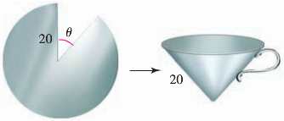 

Find the radius and height of the cone with maximum volume that can be formed in this way.

1. Several mathematical stories originated with the second wedding of the mathematician and astronomer Johannes Kepler. Here is one: while shopping for wine for his wedding, Kepler noticed that the price of a barrel of wine (here assumed to be a cylinder) was determined solely by the length *d* of a dipstick that was inserted diagonally through a hole in the top of the barrel to the edge of the base of the barrel.

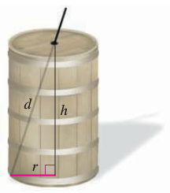

Kepler realized that this measurement does not determine the volume of the barrel and that for a fixed value of *d*, the volume varies the radius *r* and height *h* of the barrel. For a fixed value of *d*, what is the ratio *r/h* that maximizes the volume of the barrel? 

1. A load must be suspended 6 *m* below a high ceiling using cables attached to two supports that are 2 *m* apart.

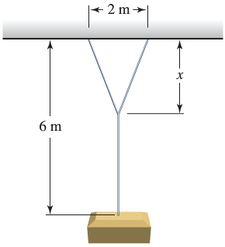 

How far below the ceiling (*x*) should the cables be joined to minimize the total length of cable used?

1. An island is 3.5 *mi* from the nearest point on a straight shoreline; that point is 8 *mi* from a power station. A utility company plans to lay electrical cable underwater from the island to the shore and then underground along the shore to the power station. Assume that is costs $2,400/*mi* to lay underwater cable and $1,200/*mi* to lay underground cable. At what point should the underwater cable meet the shore in order to minimize the cost of the project? 

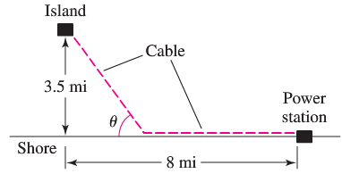

1. A crank of radius *r* rotates with an angular frequency *ω*. It is connected to a piston by a connecting rod of length *L*. the acceleration of the piston varies with the position of the crank according to the function



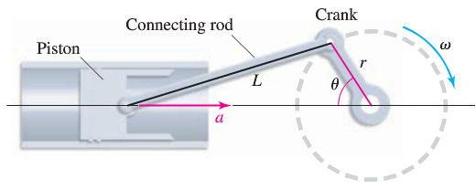

For fixed *ω* and *r*, find the values of *θ*, with , for which the acceleration of the piston is a maximum and minimum. 

1. A rain gutter is made from sheets of metal 9 *in* wide. The gutters have a 3-*in* base and two 3-*in* sides, folded up at an angle *θ*.

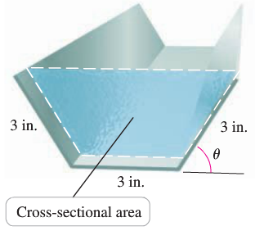

What angle *θ* maximizes the cross-sectional area of the gutter? 

1. Two poles of heights *m* and *n* are separated by a horizontal distance *d*. A rope is stretched from the top of one pole to the ground and then to the top of the other pole. Show that the configuration that requires the least amount of rope occurs when 

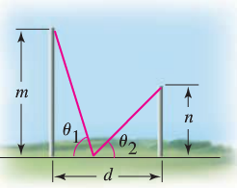

1. Fermat’s principle states that when light travels between two points in the same medium (at a constant speed), it travels on the path that minimizes the travel time. Show that when light from a source *A* reflects off of a surface and is received at point *B*, the angle of incidence equals the angle of reflection, or 

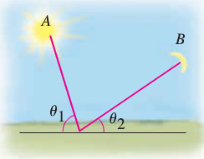

***Section* 3.4 – L’Hôpital’s Rule**

John Bernoulli discovered a rule using derivatives to calculate limits of fractions whose numerator and denominators both approach zero or ±∞. The rule is known today as ***L’Hôpital’s Rule***, after Guillaume de L’Hôpital.

**Indeterminate form 0/0**

***Theorem* – L’Hôpital’s Rule**

Suppose that , that *f* and *g* are differentiable on an open interval *I* containing *a*, and that  on *I* if *x* ≠ *a*. Then



Assuming the limit on the right side of this equation exists.

***Example***

* 
* 
* 



* 







***Example***

Use l’Hôpital Rule to find 

***Solution***









***Example***

Use l’Hôpital Rule to find 

***Solution***







***Example***

Use l’Hôpital Rule to find 

***Solution***



***Indeterminate* form ∞ / ∞, ∞ − 0, ∞ − ∞**

L’Hôpital Rule applies to the indeterminate form ∞/∞, 0/0. If



***Example***

Find the limits of these ∞ / ∞ forms:

1. 
2. 
3. 

***Solution***

1. 









1. 







1. 





***Example***

Find the limits of these ∞ ⋅ 0 forms:

1. 
2. 

***Solution***

1.  





1. 







***Example***

Find the limits of these ∞ − ∞ form: 

***Solution***













**Indeterminate Powers**

If , then



***Example***

Apply l’Hôpital Rule to show that 

***Solution***















***Example***

Find 

***Solution***









***Exercises Section* 3.4 – L’Hôpital’s Rule**

Apply l’Hôpital Rule to evaluate

|  |  |  |  |  |
| --- | --- | --- | --- | --- |
|  | | |  | |
|  |  | |

Find

|  |  |
| --- | --- |
|  |  |

***Section* 3.5 – Linear Approximation / Mean Value Theorem**

A line tangent to a graph of a function  at a point  is used to approximate the value of  at points near *x*.

**Linear Approximation**

***Definition***

Suppose  is differentiable on an interval *I* containing the point *a*. The linear approximation to  at *a* is the linear function



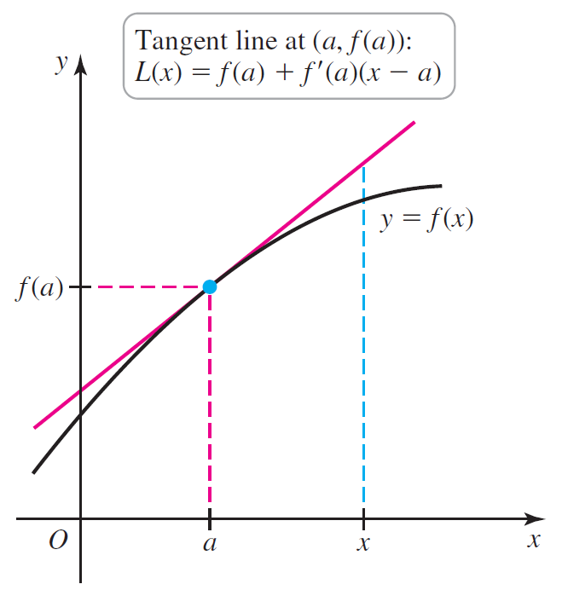

***Example***

Find the linear approximation to  at  and use it to approximate 

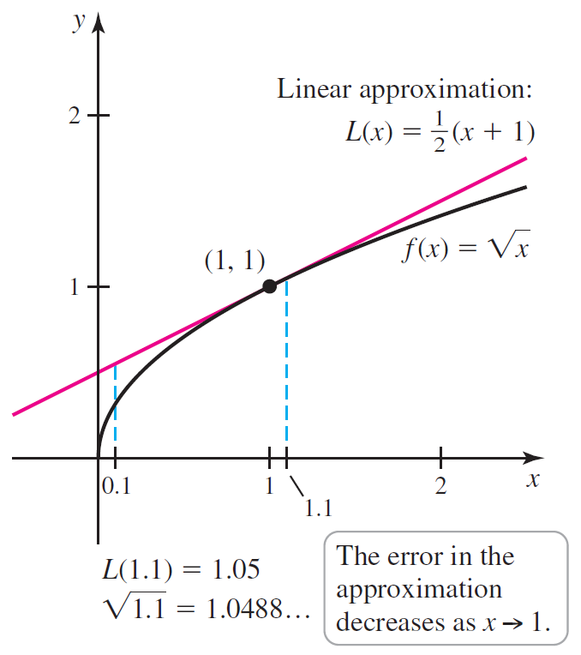***Solution***













The exact value 



**Relationship Between  and **

Suppose  is differentiable on an interval *I* containing the point *a*. The change in the value of  between two points *a* and  is approximately



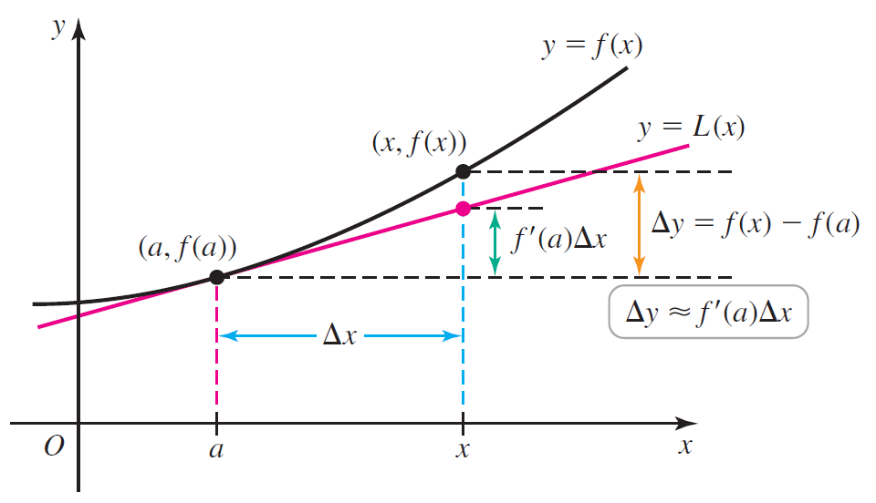

***Rolle’s Theorem***

Suppose that  is continuous at every point of the closed interval [*a, b*] and differentiable at every point of its interior (*a, b*). If , then there is at least on number *c* in (*a, b*) at which 

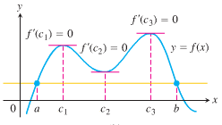

***Proof***

Being continuous,  assumes absolute maximum and minimum values on [*a, b*]. These can occur only

1. At interior points where  is zero,
2. At interior points where  does not exist,
3. At the endpoints of the function’s domain, in this case *a* and *b*.

By hypothesis, has a derivative at every interior point. That rules out possibility (2), leaving us with interior points where  and with the two endpoints *a* and *b*.

If either maximum or the minimum occurs at a point *c* between *a* and *b*. then .

If both the absolute maximum and the absolute minimum occur at the endpoints, then because  it must be the case that  is a constant function with  for every . Therefore  and the point *c* can be taken anywhere in the interior (*a, b*).

***Example***

Show that the equation  has exactly one real solution.

***Solution***



 and , the Intermediate Value Theorem the equation has one real solution in the open interval (−1, 0).

 (***always positive***). Rolle’s Theorem would guarantees the existence of a point  in between them where  was zero. Therefore,  has no more than one zero.

**The Mean Value *Theorem***

Suppose  is continuous on a closed interval [*a, b*] and differentiable on the interval’s interior . Then there is at least one point *c* in (*a, b*) at which



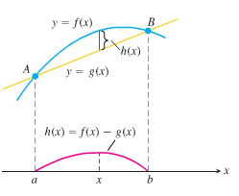

***Example***

The function  is continuous for  and differentiable for . Since  and , the Mean Value Theorem says that at some point *c* in the interval, the derivative  must have the value . In this case we can identify *c* by solving the equation 2*c* = 2 to get *c* = 1. However, it is not always easy to find *c* algebraically, even though we know it always exists.

If  at each point *x* of an open interval (*a, b*), then  for all , where *C* is a constant.

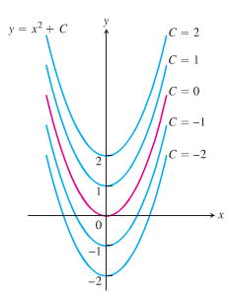

***Corollary***

If  at each point *x* of an open interval (*a, b*), then there exists a constant C such that  for all . That is,  is a constant function on (*a, b*).

***Section* 3.6 – Newton’s Method**

**Procedure for *Newton’s* *Method***

The goal of Newton’s method, also called the ***Newton-Raphson*** method, for estimating a solution of an equation  is to produce a sequence of approximations that approach the solution.

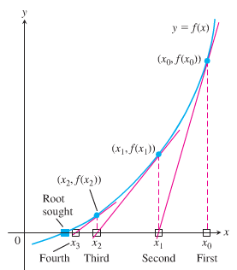

We begin with the first number of the sequence. Then the function is approximated by its tangent line, and one computes the *x*-intercept of this tangent line. At each step the method approximates a zero of *f* with a zero of one of its linearization.

Initial estimates, , the method than uses the tangent curve  to approximate the curve, calling the point  where the tangent meets the *x*-axis. The number usually a better approximation to the solution that is . The point  where the tangent to the curve at  crosses the *x*-axis is the next approximation in the sequence. We continue on using each approximation to generate the next, until we are close enough to the root to stop.

The point-slope equation for the tangent to the curve at  is



We can find where it crosses the *x*-axis by setting *y* = 0.





***Newton’s Method***

1. Guess a first approximation to a solution of the equation . A graph of  may help.
2. Use the first approximation to get a second, the second to get a third, and so on, using the formula



***Example***

Find the positive root of the equation 

***Solution***









***Example***

Find the *x*-coordinate of the point where the curve  crosses the horizontal line *y* = 1.

***Solution***

--









|  |  |  |  |  |
| --- | --- | --- | --- | --- |
| ***n*** |  |  |  |  |
| 0 | 1 | −1 | 2 | 1.5 |
| 1 | 1.5 | 0.875 | 5.75 | 1.347826087 |
| 2 | 1.347826087 | 0.100682173 | 4.449905482 | 1.325200399 |
| 3 | 1.325200399 | 0.002058362 | 4.268468292 | 1.324718174 |
| 4 | 1.324718174 | 0.000000924 | 4.264634722 | 1.324717957 |
| 5 | 1.324717957 | −1.8672 E−13 | 4.264632999 | 1.324717957 |

The result: 

***Exercises*** ***Section* 3.6 – Newton’s Method**

1. Use Newton’s method to estimate the on real solution of . Start with  and then find 
2. Use Newton’s method to estimate the on real solution of . Start with  for the left-hand zero and with  for the zero on the right. Then, in each case, find 
3. Use Newton’s method to estimate the on real solution of . Start with  for the left-hand zero and with  for the zero on the right. Then, in each case, find 
4. Use Newton’s method to estimate the on real solution of . Start with  and then find 