***Lecture Four* - Integration**

***Section* 4.1 – Antiderivatives**

***Antiderivatives***



**Definition of Antiderivatives**

A Function *F* is an ***antiderivative*** of a function *f* on an interval *I* if

 for all *x* in *I*.

***Theorem***

If *F* is an antiderivative of *f* on an interval *I*, then the most general antiderivative of *f* on *I* is



Where *C* is an arbitrary constant.

**Notation for Antiderivatives and indefinite integrals**

The notation 

where *C* is an arbitrary constant, means that *F* is an Antiderivative of *f*.

That is  for all *x* in the domain of *f*.

 Indefinite integral

Antiderivative

Integrand

Integral sign



Differential

***Basic Integration Rules***











***Example***

Find each indefinite integral.

1. 







1. 







***Example***

Evaluate 

***Solution***







***Example***

Evaluate 

***Solution***



***Example***

Evaluate 

***Solution***



***Example***

Evaluate 

***Solution***



***Definition***

The ***natural logarithm*** is the function given by



Zero width: 

***Definition***

The ***number e*** is that number in the domain of the natural logarithm satisfying



**Other Indefinite Integrals**











***Example***

Evaluate 

***Solution***



***Example***

Evaluate 

***Solution***



***Example***

Evaluate 

***Solution***

 

***Example***

Evaluate 

***Solution***









***Exercises*** ***Section* 4.1 – Antiderivatives**

Find each indefinite integral.

|  |  |  |
| --- | --- | --- |
|  |  |  |

1. Solve the initial value problem: 
2. Solve the initial value problem: 
3. Solve the initial value problem: 
4. Solve the initial value problem: 
5. Find the general solution of , and find the particular solution that satisfies the initial condition *F*(1) = 8.
6. Derive the position function if a ball is thrown upward with initial velocity of 32 *feet* per second from an initial height of 48 *feet*. When does the ball hit the ground? With what velocity does the ball hit the ground?
7. Suppose a publishing company has found that the marginal cost at a level of production of *x* thousand books is given by



And that the fixed cost (the cost before the first book can be produced) is a $25,000. Find the cost function .

***Section* 4.2 – Area under Curves**

The ***definite integral*** is the key tool in calculus for defining and calculating quantities important to mathematics and science, such as areas, volumes, lengths, and more…

***Area***

To find the area of the shaded region *R* that lies above the *x*-axis, below the graph of  and between the vertical lines *x* = 0 and *x* = 1.



|  |  |
| --- | --- |
|  |  |

|  |  |
| --- | --- |
|  |  |

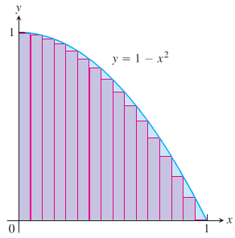 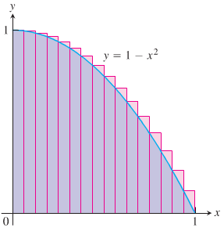

In each case of the computations, the interval [*a, b*] over which the function *f* is defined was subdivided into *n* equal subintervals (also called ***length***) , and f was evaluated at a point in each subinterval. The finite sums can be given by the form:



**Distance Traveled**

The distance formula is given by: 

***Example***

The velocity function of a projectile fired straight up into the air is . Use the summation technique to estimate how far the projectile rises during the first 3 *sec*. How close do the sums come to the exact value of 435.9 *m*?

**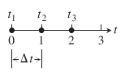*Solution***

1. 







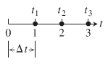 

1. 







1. 







1. 







The true value is 435.9 if you use more subintervals , the interval 436.13 & 435.67

The projectile rose about 436 m during the first 3 sec of flight.

**Average Value of a Nonnegative Continuous Function**

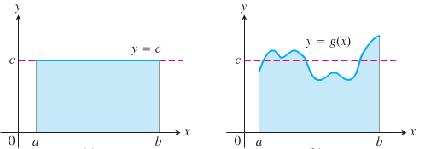

The average value of a collection of *n* numbers  is obtained by adding them together and dividing by *n*.

***Example***

Estimate the average value of the function  on the interval [0, π].

***Solution***

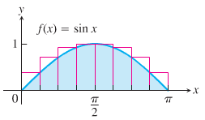

To get the upper sum approximation with 8 rectangles of equal width .





**Finite Sums and Sigma Notation**

***Sigma notation*** enables us to write a sum with many terms in the compact form



The Greek letter ∑ (capital ***sigma***, corresponding to our letter *S*)



***Example***

|  |  |  |
| --- | --- | --- |
| ***Sigma Notation*** | ***Written*** | ***Value of the Sum*** |
|  |  | 15 |
|  |  |  |
|  |  |  |
|  |  |  |

***Example***

We can write:



***Example***

Express the sum 1+ 3 +5 +7 + 9 in sigma notation.

***Solution***

Starting with *k* = 0: 

Starting with *k* = 1: 

***Theorem on Sums***

If  and  are infinite sequences, then for every positive integer ***n***,









***Proof***







***Example***









***Example***

Show that the sum of the first *n* integers is 

***Solution***

The sum of the first 4 integers is: 

To prove the formula in general:



Since it is twice the desired quantity, the sum of the first *n* integers is 



**Limits of Finite Sums**

***Example***

Find the limiting value of lower sum approximations to the area of the region *R* below the graph of  and above the interval [0, 1] on the *x*-axis using equal-width rectangles whose width approach zero and whose number approaches infinity.

***Solution***

The lower sum approximation using *n* rectangles of equal width: 

By subdividing the interval [0, 1] into *n* equal width subintervals:







We can write this in sigma notation:



















The lower sum approximation converge to 

The upper sum approximation also converge to 

***Review***

**Definition of Arithmetic Sequence**

A sequence  is an arithmetic sequence if there is a real number ***d*** such that for every positive integer ***k***,



The number  is called the ***common difference*** of the sequence.

***The nth Term of an Arithmetic Sequence***: 

***Example***

Express the sum in terms of summation notation: . (Answers are not unique)

***Solution***

Number of terms: *n* = 5

Difference in terms: *d* = 11 − 4 = 7







***Theorem***

**Formulas for** 

If  is an arithmetic sequence with common difference ***d***, then the *n*th partial sum  (that is, the sum of the first ***n*** terms) is given by either



***Definition* of *Geometric* Sequence**

A sequence  is a geometric sequence if  and if there is a real number  such that for every positive integer *k*.



The number  is called the ***common ratio*** of the sequence.

***The formula for the nth Term of a Geometric Sequence***: 

The common ratio for:  is 

***Example***

Express the sum in terms of summation notation (Answers are not unique.)



***Solution***





***Theorem*: Formula for** 

The nth partial sum  of a geometric sequence with first term  and common ratio  is



***Riemann Sums***

The theory of limits of finite approximations was made precise by the German mathematician ***Bernhard Riemann***.

We introduce the notion of a *Riemann sum*, which underlies the theory of the definite integral.

Let a closed interval [*a*, *b*] be partitioned by points 

To make the notation consistent, so that



The set:  is called a partition of [*a*, *b*].

The partition *P* divides [*a*, *b*] into *n* closed subintervals



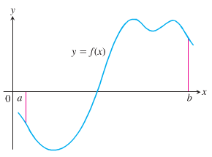



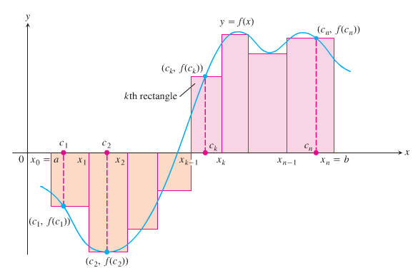

These products are:



The sum is called a ***Riemann sum*** *for f on the interval* [*a, b*], and  in the subintervals.

If we choose *n* subintervals all having equal width  to partition [*a, b*], then choose the point to be the right-hand endpoints of each subintervals when forming the Riemann sum. This choice leads to the Riemann sum formula



***Example***

The set is a partition of [0, 2]

***Solution***

There are five subintervals of *P*: [0, 0.2], [0.2, 0.6], [0.6, 1], [1, 1.5], and [1.5, 2]

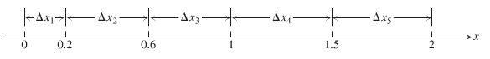

The lengths of the subintervals are:



The longest subinterval length is 0.5, so the norm of the partition is 

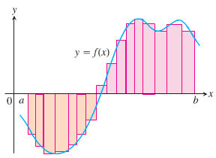 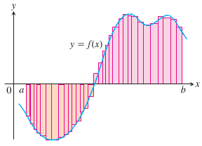

***Exercises*** ***Section* 4.2 – Area under Curves**

Use finite approximations to estimate the area under the graph of the function using

1. A lower sum with two rectangles of equal width
2. A lower sum with four rectangles of equal width
3. A upper sum with two rectangles of equal width
4. A upper sum with four rectangles of equal width
5. 
6. 
7. Use finite approximations to estimate the average value of *f* on the given interval by partitioning the interval into four subintervals of equal length and evaluating *f* at the subinterval midpoints.



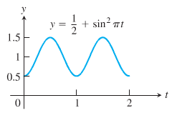

1. Use finite approximations to estimate the average value of *f* on the given interval by partitioning the interval into four subintervals of equal length and evaluating *f* at the subinterval midpoints.



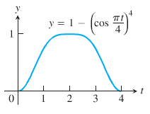

Write the sums without sigma notation. Then evaluate them:

|  |  |  |  |
| --- | --- | --- | --- |
|  |  |  |  |

1. Write the following expression 1 + 2 + 4 + 8 + 16 + 32 in sigma notation
2. Write the following expression 1 − 2 + 4 − 8 + 16 − 32 in sigma notation
3. Write the following expression  in sigma notation
4. Write the following expression  in sigma notation
5. Suppose that . Find the value of 

Evaluate the sums

|  |  |  |
| --- | --- | --- |
|  |  |  |

1. Graph the function  over the given interval [0, 2]. Partition the interval into four subintervals of equal length. Then add to your sketch the rectangles associated with the Riemann sum , given  is the
2. Left-hand endpoint
3. Right-hand endpoint
4. Midpoint of k*th* subinterval.

(Make a separate sketch for each set of rectangles.)

***Section* 4.3 – Definite Integral**

***Definition***

Let  be a function defined on a closed interval [*a, b*]. We say that a number *J* is the ***definite integral* of *f* over [*a, b*]** and that *J* is the limit of the Riemann sums  if the following condition is satisfied:

Given any number ε > 0 there is a corresponding number δ > 0 such that for every partition

 of [a, b] with  and any choice of  in , we have



***Leibniz*** introduced a notation for the definite integral that captures its construction as a limit of Riemann sums.



**Integral of *f* from *a* to *b*.**





***Theorem* – Integrability of Continuous Functions**

If a function *f* is continuous over the interval [*a, b*], or if *f* has at most finitely many jump discontinuities there, then the definite integral  exists and *f* in integrable over [*a, b*]

**Properties of Definite Integrals**

 

***Theorem***

When *f* and *g* are integrable over the interval [*a, b*], the definite integral satisfies the rules:

*Order of Integration*: 

*Zero Width Interval*: 

*Constant Multiple*: 

*Sum and Difference*: 

*Additivity*: 

*Max-Min* Inequality: If *f* has ***maximum*** value *max* *f* and ***minimum*** value *min* *f* on [*a, b*], then



Domination: 



|  |  |
| --- | --- |
|  |  |
| ***Zero Width Interval***: | ***Constant Multiple***: (*k* = 2) |
|  |  |
| ***Sum***: (*areas add*) | Additive for definite integrals: |
|  |  |
| Max-Min Inequality: | Domination |

***Example***

Suppose that . Find:

1. 
2. 

***Solution***

1. 
2. 





***Example***

Show that the value of  is less than or equal to 

***Solution***

: is the lower bound

: is the upper bound

The maximum value of  on [0, 1] is 

So, 

**Area Under the Graph of a Nonnegative Function**

***Definition***

If  is nonnegative and integrable over a closed interval [*a, b*], then the area under the curve  over [*a, b*] is the integral of *f* from *a* to *b*,



***Example***

Compute  and find the area *A* under *y* = *x* over the interval [0, *b*], *b* > 0.

***Solution***

To Compute the definite integral, we consider the partition *P* subdivides the interval [0, *b*] into *n* subintervals of equal width .

















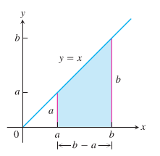 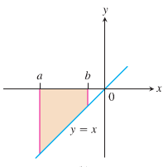 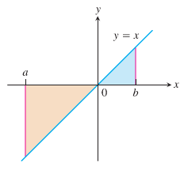













***Section* 4.4 – Fundamental Theorem of Calculus**

**Mean Value Theorem for Definite Integrals**

If *f* is continuous on [*a, b*], then some point *c* in [*a, b*],



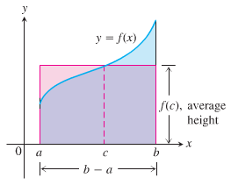

***Theorem* − The Fundamental Theorem of Calculus, P-1**

If *f* is continuous on [*a, b*], then  is continuous on [*a, b*], and differentiable on (*a, b*) and its derivative is :



***Theorem* − The Fundamental Theorem of Calculus, P-2**

If *f* is continuous at every point in [*a, b*], then *F* is any antiderivative of *f* on [*a, b*], then



***Example***

1. 





1. 





1. 







***Theorem* − The Net Change Theorem**

The net change in a function  over an interval  is the integral of tis rate of change:



***Example***

Consider the analysis of a heavy rock blown straight up from the ground by a dynamite blast. The velocity of the rock at any time *t* during its motion was given as 

1. Find the displacement of the rock during the time period 
2. Find the total distance traveled during this time period.

***Solution***

1. 









The height if the rock is 256 *ft* above the ground 8 *sec* after the explosion.

1. 

The velocity is positive over the time [0, 5] and negative over [5, 8]













***Example***

Shows the graph of  and its mirror image  are reflected across the *x*-axis. For each function, compute

1. The definite integral over the interval [−2, 2]
2. The area between the graph and the *x*-axis over [−2, 2]

***Solution***

1. 

















1. In both cases, the area between the curve and the *x*-axis over [−2, 2] is  units.

***Example***

Shows the graph of  between  and . Compute

1. The definite integral of  over [0, 2π]
2. The area between the graph and the *x*-axis over [0, 2π]

**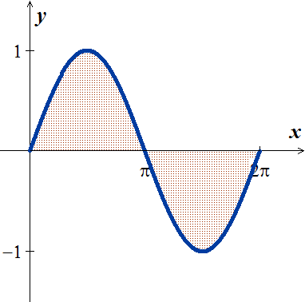*Solution***

1. 







1. The area between the graph and the axis is obtained by adding the absolute values













***Summary***

To find the area between the graph of  and the *x*-axis over the interval [*a, b*]:

1. Subdivide [*a, b*] at the zeros of *f*.
2. Integrate f over each subinterval.
3. Add the absolute values of the integrals.

***Example***

Find the area of the region between the *x*-axis and the graph of 

***Solution***

The zeros of: 



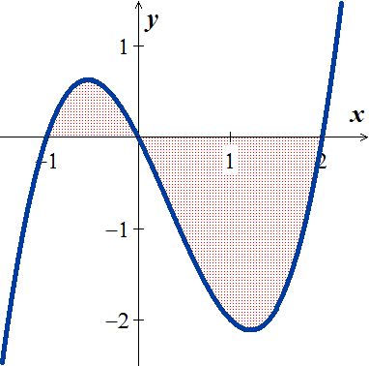

|  |  |
| --- | --- |
|  |  |









***Areas between Curves***

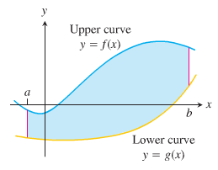 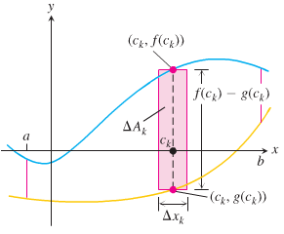

***Definition***

If  and  are continuous with  throughout [*a, b*], then the ***area of the region between the curves***  **from *a* to *b*** is:



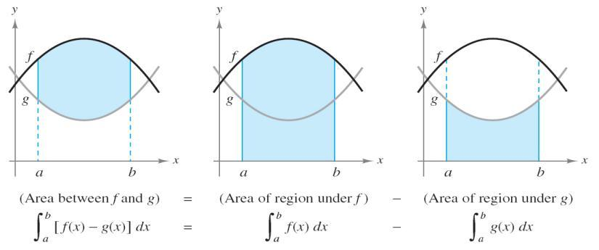

***Example***

Find the area of the region enclosed by the parabola  and the line .

***Solution***

The limits of integrations are found by letting:

 



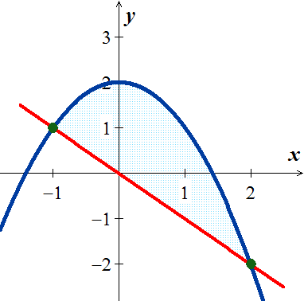 









***Example***

Find the area of the region in the first quadrant that is bounded above by  and below the *x*-axis and the line

***Solution***

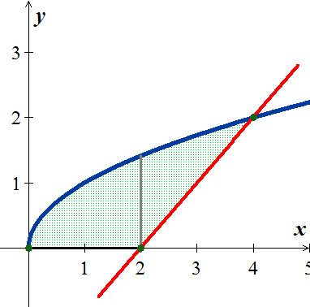













Total Area 











**Integration with Respect to *y***

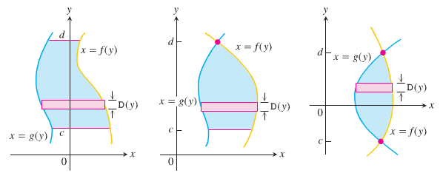

 **(*From right hand to left* hand)**

***Example***

Find the area of the region by integrating with respect to y, in the first quadrant that is bounded above by  and below the *x*-axis and the line.

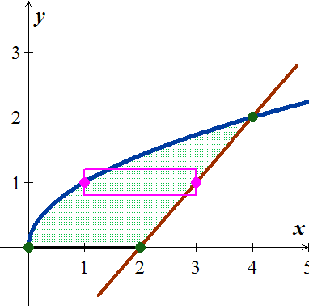***Solution***





















***Exercises*** ***Section* 4.4 – Fundamental Theorem of Calculus**

Evaluate the integrals

|  |  |  |
| --- | --- | --- |
|  |  |  |

Find the total area between the region between the given graph and the *x*-axis

|  |  |
| --- | --- |
|  |  |

1. Find the area of the region between the graph of  and the , for 
2. Find the area of the region between the graph of  and the , for 
3. Find the area of the region between the graph of  and the , for 
4. Find the area of the region between the graph of  and the , for 
5. Find the area of the region above the  bounded by 
6. Find the area of the region above the  bounded by 
7. Find the area of the region between the graph of  and the , for 
8. Find the area of the region between the graph of  and the , for 
9. Find the area of the region bounded by the graph of 
10. Find the area of the region bounded by the graph of 
11. Find the area of the region bounded by the graph of 
12. Find the area of the region bounded by the graph of 
13. Find the area of the region bounded by the graph of 
14. Find the area of the region bounded by the graph of 
15. Archimedes, inventor, military engineer, physicist, and the greatest mathematician of classical times in the Western world, discovered that the area under a parabolic arch is two-thirds the base times the height. Sketch the parabolic arch , assuming that *h* and *b* are positive. Then use calculus to find the area of the region enclosed between the arch and the *x*-axis
16. Suppose that a company’s marginal revenue from the manufacture and sale of eggbeaters is



Where *r* is measured in thousands of dollars and *x* in thousands of units. How much money should the company expect from a production run of *x* = 3 thousand eggbeaters? To find out, integrate the marginal revenue from *x* = 0 to *x* = 3.

1. The height *H* (*ft*) of a palm tree after growing for *t* years is given by



1. Find the tree’s height when *t* = 0, *t* = 4, and *t* = 8.
2. Find the tree’s average height for 

***Section* 4.5 – Working with Integrals**

**Definite Integrals of Symmetric Functions**

***Theorem***

Let *f* be continuous on the symmetric interval [−*a, a*]

* If  is even, then 
* If  is odd, then 

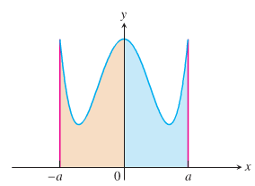 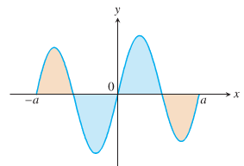

***Example***

Evaluate 

***Solution***

Since 









**Average Value of a Continuous Function Revisited**

The average value of a nonnegative continuous function *f* over an interval [*a, b*], leading us to define this average as the area under the graph of  divided by *b* − *a*.



***Definition***

If *f* is integrable on [*a, b*], then its *average value* on [*a, b*], also called its ***mean***, is



***Example***

Find the average value of 

***Solution***

 is a function of an upper semicircle with a radius 2 and centered at the origin.

The area between the semicircle and the x-axis from −2 to 2 can be computed using the geometry formula:

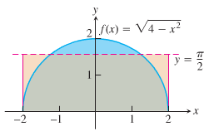 -









***Example***

We can model the voltage in the electrical wiring of a typical home with the sine function



Which express the voltage *V* in volts as a function of time *t* in seconds. The function runs through 60 cycles each second (its frequency is 60 Hz (*hertz*)). The positive constant  is the ***peak voltage***.

***Solution***

The average value of *V* over the half-cycle from 0 to  sec is



 











The average value of the voltage over a full cycle is zero.

To measure the voltage effectively, we can use an instrument the square root of the average value of the square of the voltage, namely:



“rms” : root mean square.



The rms voltage is: 

The “115 volts ac” means that the rms voltage is 115. The peak voltage is:



***Exercises Section* 4.5 – Working with Integrals**

1. If *f* is an odd function, why is 
2. If *f* is an even function, why is 
3. Is  an even or odd function? Is  an even or odd function?

Use symmetry to evaluate the following integrals

|  |  |
| --- | --- |
|  |  |

Find the average value of the following functions on the given interval.

|  |  |
| --- | --- |
|  |  |

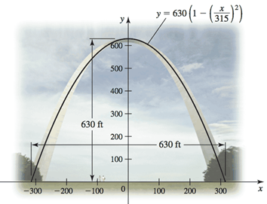

1. The Gateway Arch in St. Louis is 630 *ft* high and has a 630-*ft* base. Its shape can be modeled by the parabola



Find the average height of the arch above the ground.

1. The planets orbit the Sun in elliptical orbits with the Sun at one focus. The equation of an ellipse whose dimensions are 2 *a* in the *x-*direction and 2 *b* in the *y*-direction is



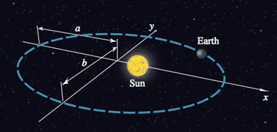

1. Let  denote the square of the distance from a planet to the center of the ellipse at (0, 0). Integrate over the interval  to show that the average value of  is 
2. Show that in the case of a circle (*a* = *b* = *R*), the average value in part (*a*) is .
3. Assuming 0 < *b* < *a*, the coordinates of the Sun are . Let  denote the square of the distance from the planet to the Sun. Integrate over the interval  to show that the average value of  is .

***Section* 4.6 – Substitution Rule**

***Substitution*: Running the Chain Rule Backwards**

The Chain rule formula is: 

We can see that  is an antiderivative of the function . Therefore, if we integrate both sides

 

***Example***

Find the integral 

***Solution***

|  |  |
| --- | --- |
| Let: |  |

***Example***

Find the integral 

***Solution***

|  |  |
| --- | --- |
| Let: |  |

***Theorem* – The Substitution Rule**

If  is differentiable function whose range is an interval *I*, and *f* is continuous on *I*, then



***Proof***

By the Chain Rule,  is an antiderivative of  whenever *F* is an antiderivative of *f*:





If we make the substitution , then











**Integral of** 

If *u* is a differentiable function that is never zero 

***Example***

Evaluate the integral 

***Solution***

 









***Example***

Evaluate the integral 

***Solution***

|  |  |
| --- | --- |
|  |  |

***Example***

Find the integral 

***Solution***

 

 

**The General Antiderivative of the Exponential Function**



***Example***

Evaluate the integral 

***Solution***















***Example***

Find the integral 

***Solution***

 



***Example***

Find the integral 

***Solution***





***Example***

Find the integral 

***Solution***

Let: 















***Example***

Find the integral 

***Solution***

|  |  |
| --- | --- |
| Let: | ***Or*** let: |

***Definition***

If *a* > 0 and *u* is a differentiable of *x*, then  is a differentiable function of *x* and



***Example***

* 
* 
* 









**Substitution Formula**

***Theorem***

If  is continuous on the interval [*a, b*] and *f* is continuous on the range of , then



***Proof***

Let *F* denote any antiderivative of *f*. Then









***Example***

Evaluate 

***Solution***

 





 



***Example***

Evaluate 

***Solution***

Let  











***Example***

Evaluate the integral 

***Solution***

 











***Integrals*** of 

***Example***

Find the integral 

***Solution***

 





***Example***

Find the integral 

***Solution***

 





***Integration Formulas***

 

 

 

***Exercises*** ***Section* 4.6 – Substitution Rule**

Evaluate the indefinite integrals by using the given substitutions to reduce the integrals to standard form

1. 
2. 
3. 
4. 
5. 

Evaluate the integrals

|  |  |  |
| --- | --- | --- |
|  |  |  |

|  |  |  |
| --- | --- | --- |
|  |  |  |

|  |  |
| --- | --- |
|  |  |

1. Evaluate the integral 
2. , followed by 
3. , followed by 
4. 

Evaluate the integrals

|  |  |
| --- | --- |
|  |  |

|  |  |
| --- | --- |
|  |  |

Solve the initial value problem

|  |  |
| --- | --- |
|  |  |

1. Verify the integration formula: 
2. Verify the integration formula: 
3. Find the area of the region bounded by the graphs of 
4. Find the area of the region bounded by the graph of 
5. Find the area of the region bounded by the graph of  and the  between  and .
6. Find the area of the region bounded by the graph of  and the  between  and .
7. A company is considering a new manufacturing process in one of its plants. The new process provides substantial initial savings, with the savings declining with time *t* (in years) according to the rate-of-savings function



where  is in thousands of dollars per year. At the same time, the cost of operating the new process increases with time *t* (in years), according to the rate-of-cost function (in thousands of dollars per year)



1. For how many years will the company realize savings?
2. What will be the net total savings during this period?
3. Find the producers’ surplus if the supply function for pork bellies is given by



Assume supply and demand are in equilibrium at 