***Exercise***

Sometimes the solution of a max-min problem depends on the proportions of the shapes involved. As a case in point, suppose that a right circular cylinder of radius *r* and height *h* is inscribed in a right circular cone of radius *R* and height *H*. Find the value of *r* (in terms of *R* and *H*) that maximizes the total surface area of the cylinder (including top and bottom). As you will see, the solution depends on whether  or 

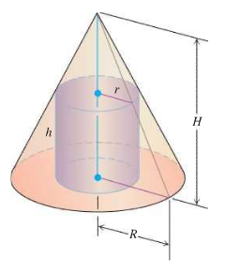

***Solution***

***Exercise***

A poorly chosen value of  can lead to the unexpected results. The graph of  indicates that there are three roots of : they are  and two roots near .

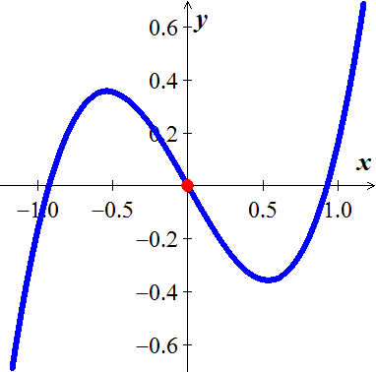

1. Verify by using Newton’s method to approximates the known root  by using an initial value of . Calculate the approximation  until two consecutive values agree to 6 decimal places. What happens and why?
2. What happens if you use an initial value of ?
3. What happens if you use an initial value of ?

***Solution***

***Exercise***

An ice cream cone with a height of one unit holds a sphere of ice cream. What is the radius of the ice cream sphere that maximizes the amount of the ice cream inside the cone?

You can see why this question results in an optimization problem: If the radius is small, much of the sphere is inside the cone, but the volume of the sphere is small. Alternatively, if the radius is large, the volume of the sphere is large, but only a small fraction of the sphere is inside the cone. Somewhere between these extremes, there should an optimal radius.

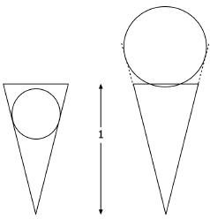 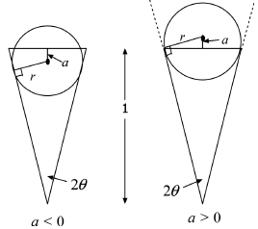

We assume that the cone has a base angle of 2*θ* and that the ice cream sphere is tangent to the sides of the cone. The solution requires the formula for the volume of a spherical cap. A cap of height *h* sliced from a sphere of radius *r* has volume of

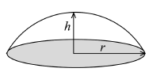



To optimize the problem from the given information is to find a function. In this case, the objective function is the volume of the ice cream sphere that is inside the cone. Two cases must be considered. Let *a* be the distance between the center of the sphere and the top edge of the cone, where *a* > 0 means the center is below the top of the cone and *a* < 0 means the center is below the top of the cone.

1. In the case that *a* > 0, show that . (The line from the center of the sphere to the point of tangency is perpendicular to the cone.)
2. In the case that *a* > 0, show that the volume of ice cream inside the cone is , where 
3. In the case that *a* < 0, show that , which is the same relationship as in the case that *a* > 0.
4. For *a* < 0, show that the volume of the ice cream inside the cone is , where . Thus the volume function is the same for both *a* > 0 and *a* < 0.
5. Argue that the maximum value of *r* that needs to be considered occurs when the bottom of the sphere is at the top of the cone (*a* > 0). In this case .
6. Argue that the minimum value of *r* that needs to be considered occurs when the top of the sphere is at the top of the cone (*a* < 0). In this case .

***Solution***

***Exercise***

Let 

1. Show that Newton’s method takes the form 
2. Let  and then find the exact values of 
3. Graph  and illustrate how  were found. Does Newton’s method lead to an approximate solution to  if ? Why or why not?

***Solution***

***Exercise***

A baseball is launched into the outfield on parabolic trajectory given by . Find the average height of the baseball over the horizontal extent of its flight.

***Solution***

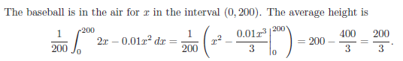

***Exercise***

Without evaluating the integrals, explain why the following statement is true for positive integers *n*.

 (***hint***: *graph/ relation*)

***Solution***

Since  are inverse functions of each other , therefore, they are symmetric about the line *y* = *x* in the square box [0, 1].

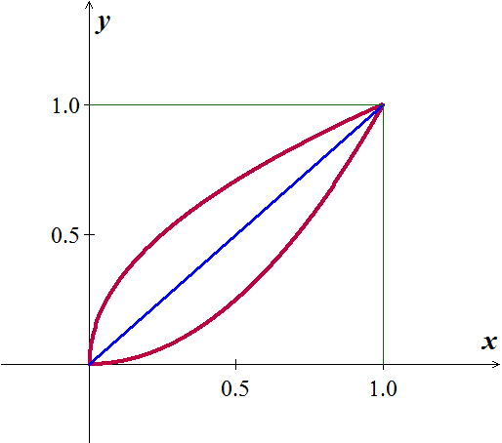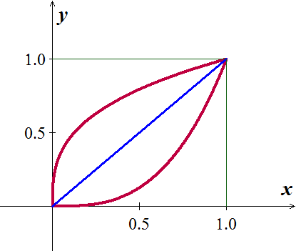

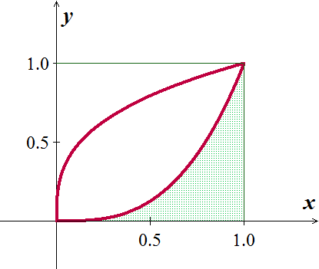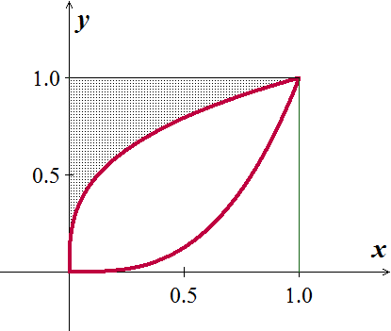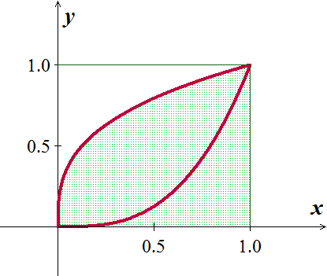

The two area, below  and above  are equals, so the total area of  add to the area of the square with a side equals to 1.

***Exercise***

Evaluate: 

***Solution***

Let 























***Exercise***

Skydivers ***A*** and ***B*** are in a helicopter hovering at 6400 *ft*. Skydiver ***A*** jumps and descends for 4 *sec* before opening her parachute. The helicopter then climbs to 7000 *ft.* and hovers there. Forty-five seconds after ***A*** leaves the aircraft, ***B*** jumps and descends for 13 *sec* before opening his parachute. Both skydivers descend at 16 *ft/sec* with parachutes open. Assume that the skydivers fall freely (no effective air resistance) before their parachutes open.

1. At what altitude does ***A***’s parachute open?
2. At what altitude does ***B***’s parachute open?
3. Which skydiver lands first?

***Solution***

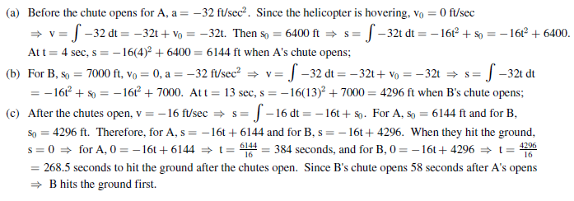

***Exercise***

Use the Substitution Rule to prove 

***Solution***

***Exercise***

Use the Substitution Rule to prove 

***Solution***