|  |  |
| --- | --- |
|  |  |
|  |  |
|  |  |
|  |  |

***Incr.***:  ***Decr.***: 

***LMIN***:  ***LMAX***: 



1. The elevation *h* (in feet above the ground) of a stone dropped from height of 1000 *ft* is modeled by the equation , where *t* is measured in seconds and air resistance is neglected. Approximate the change in elevation over the interval  (recall that )
2. The energy *E* (in joules) released by an earthquake of magnitude *M* is modeled by the equation . Approximate the change in energy released when the magnitude changes from 7.0 to 7.5 (recall that )
3. The population of a culture of cells grows according to the function , where  is measured in weeks.
4. What is the average rate of change in population over the interval ?
5. At what point of the interval  is the instantaneous rate of change equal to the average rate of change?
6. Bamboo belongs to the grass family and is one of the fastest-growing plants in the world.
7. A bamboo shoot was 500 *cm* tall at 10:00AM and 515 *cm* at 3:00 PM. Compute the average growth rate of the bamboo shoot in *cm/hr* over the period of time from 10:00 AM to 3:00 PM.
8. Based on the Mean Value Theorem, what can you conclude about the instantaneous growth rate of bamboo measured in millimeters per second between 10:00 AM to 3:00 PM?

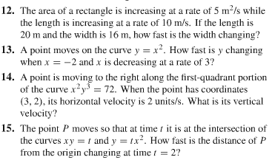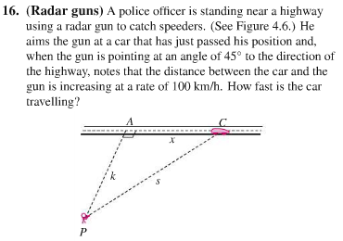

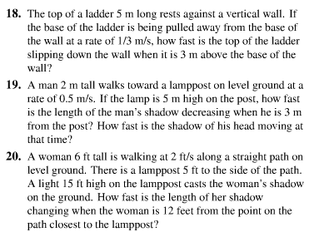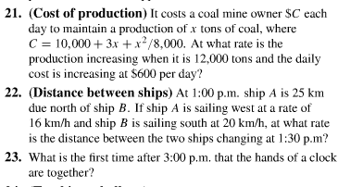

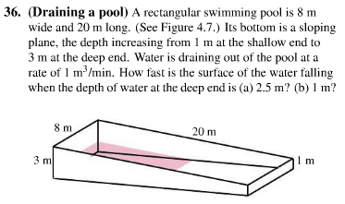

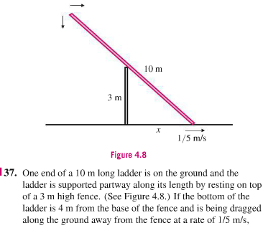



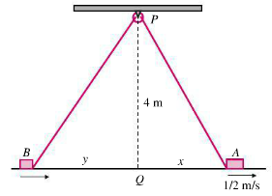



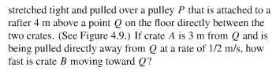

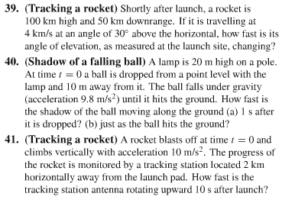

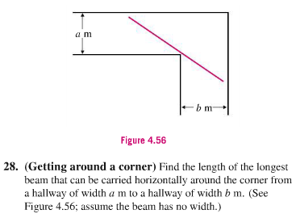

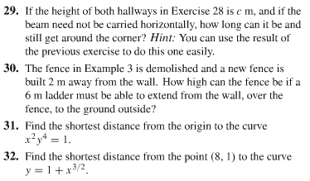

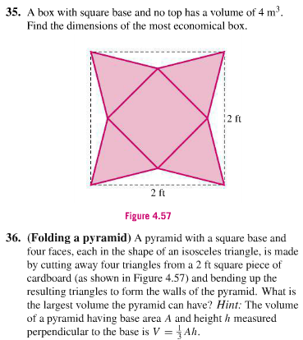

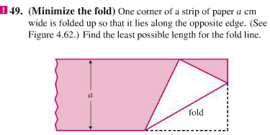

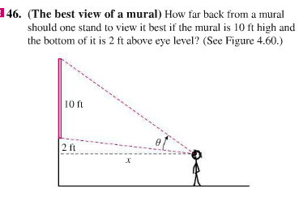

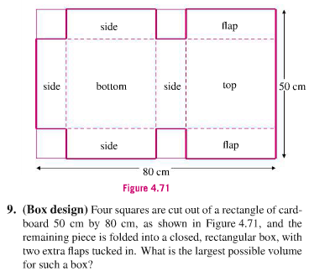

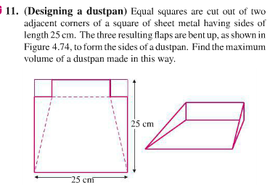

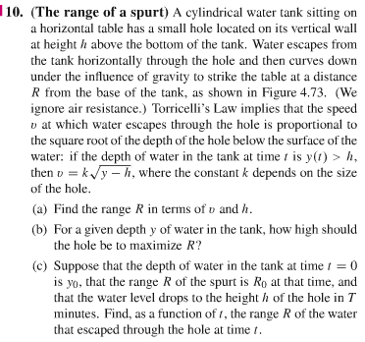

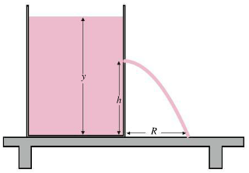

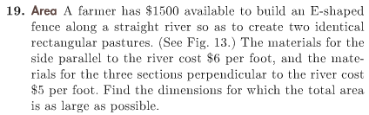

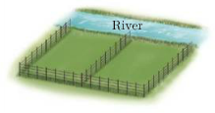

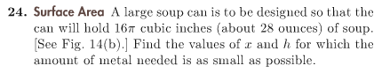

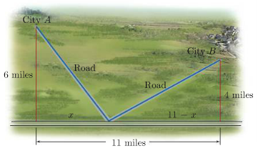

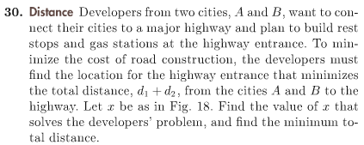

***Exercise***

The cross sections of an irrigation canal are isosceles trapezoids of which three sides are 8 *feet* long. Determine the angle of elevation *θ* of the sides such that the area of the cross sections is a maximum by completing the following.

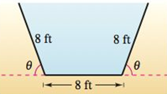

1. Analytically complete six rows of a table such as the one below

|  |  |  |  |
| --- | --- | --- | --- |
| ***Base* 1** | ***Base* 2** | ***Altitude*** | ***Area*** |
| 8 |  |  |  |
| 8 |  |  |  |

1. Write the cross-sectional area *A* as a function of *θ*.
2. Find the critical number of the function.
3. Find the angle that will yield the maximum cross-sectional area.
4. Estimate the maximum cross-sectional area.
5. Graph the function and verify the maximum cross-sectional area.

***Solution***

**Thomas**

