Water runs into a conical tank at the rate of . The tank stands point down and has a height of 20 *feet* and a base radius of 8 *feet*. How fast is the water level rising when the water is 6 *feet* deep?

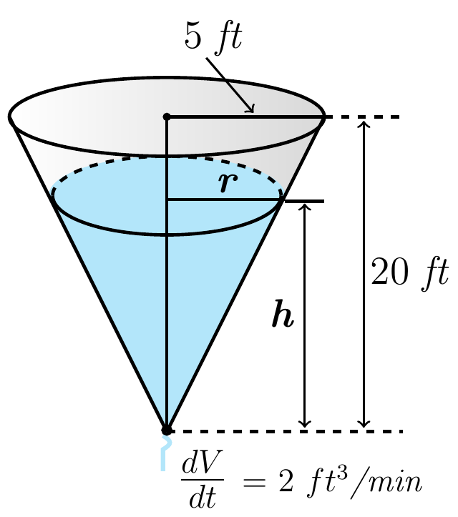 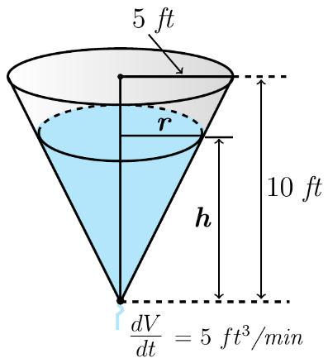 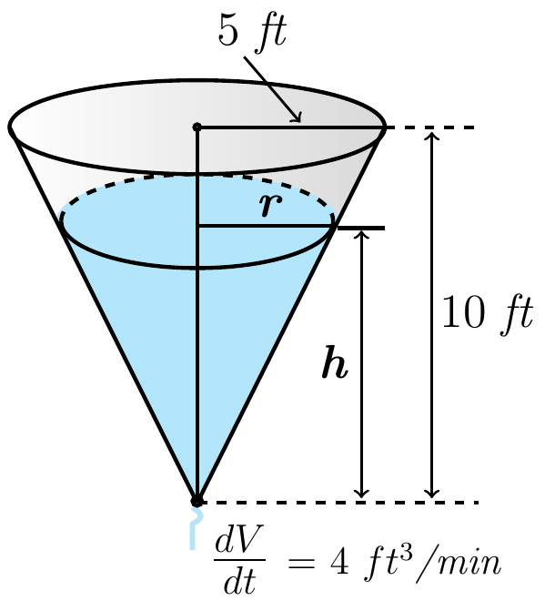

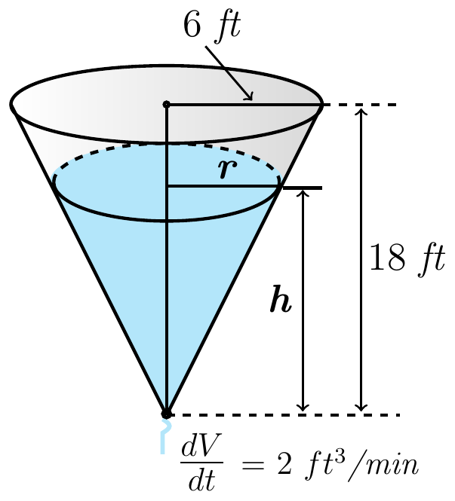 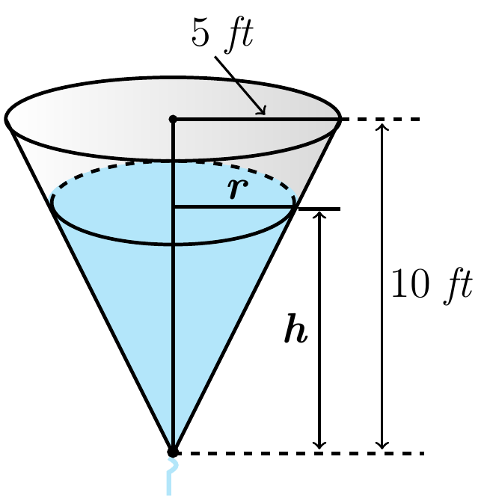

A hot air balloon rising straight up from a level filed is tracked by a range finder 500 *feet* from the liftoff point. At the moment the range finder’s elevation angle is , the angle is increasing at the rate of 0.14 *rad/min*. How fast is the balloon rising at that moment?

