***Lecture One –* Limits and Derivatives**

***Section* 1.1 – Idea of Limits**

***Position Function***

An object that is falling or vertically projected into the air has its height above the ground, *s*(t), in feet, given by



** is the original velocity (initial velocity) of the object, in *feet* per *second*

*t* is the time that the object is in motion, in *second*

** is the original height (initial height) of the object, in *feet*

The average rate is given by: 

***Example***

A rock breaks loose from the top of a tall cliff. What is its average speed

1. During the first 2 *sec* of fall?
2. During the 1-*sec* interval between second 1 and *second* 2?

***Solution***

Since the rock falls free (*down*) without any initial velocity or height. 

1. For the first 2 *sec*: 









1. From 1 *sec* to 2 *sec*: 





***Example***

Find the speed of a falling rock  over a time interval . Then find the average speed at 1 *sec* and 2 *sec*.

***Solution***











If 





The average speed has the limiting value 32 *ft/sec* as *h* approaches 0.

If 





The average speed has the limiting value 64 *ft/sec* as *h* approaches 0.

**Average Rates of Changes and Secant Lines**

The average rate of change of  with respect to *x* over the interval  is





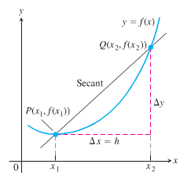

***Defining the Slope of a Curve***

The slope of a line is the rate at which it rises or falls.

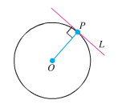

To define the tangency for general curves, we need an approach that makes the behavior of the secants through *P* and points *Q* as *Q* moves toward *P* along the curve:

1. Find the slope of the secant *PQ*.
2. Investigate the limiting value of the slope as *Q* approaches *P* along the curve.
3. If the limit exists, take it to be the slope of the curve at *P* and define the tangent to the curve at *P* to be the line through *P* with this slope.



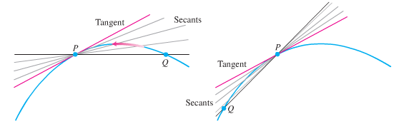

***Example***

Find the slope of the parabola  at the point . Write an equation for the tangent to the parabola at this point.

***Solution***

***Secant slope*** = 











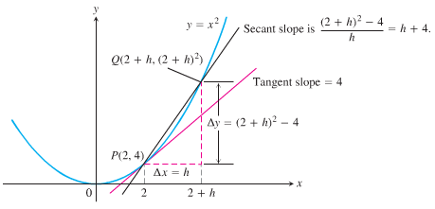

As *Q* approaches *P*, *h* approaches 0. Then the secant slope 







***Exercises Section* 1.1 – Idea of Limits**

1. Find the average rate of change of the function  over the interval 
2. Find the average rate of change of the function  over the interval 
3. Find the average rate of change of the function  over the interval 
4. Find the slope of  at the point  and an equation of the tangent line at this *P*.
5. Find the slope of  at the point  and an equation of the tangent line at this *P*.
6. Find the slope of  at the point  and an equation of the tangent line at this *P*.
7. Make a table of values for the function  at the points



1. Find the average rate of change of  over the intervals  for each  in the table
2. Extending the table if necessary, try to determine the rate of change of  at .
3. The accompanying graph shows the total amount of gasoline A in the gas tank of an automobile after being driven for *t* days.

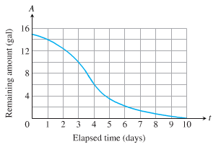

1. Estimate the average rate of gasoline consumption over the time intervals



1. Estimate the instantaneous rate of gasoline consumption over the time 