***Solution Section* 1.1 – Idea of Limits**

***Exercise***

Find the average rate of change of the function  over the interval 

***Solution***









***Exercise***

Find the average rate of change of the function  over the interval 

***Solution***









***Exercise***

Find the average rate of change of the function  over the interval 

***Solution***









***Exercise***

Find the slope of  at the point  and an equation of the tangent line at this *P*.

***Solution***

 









As *h* approaches 0. Then the secant slope 

 





***Exercise***

Find the slope of  at the point  and an equation of the tangent line at this *P*.

***Solution***









 As *h* approaches 0. Then the secant slope 

 





***Exercise***

Find the slope of  at the point  and an equation of the tangent line at this *P*.

***Solution***







 As *h* approaches 0. Then 

 





***Exercise***

Make a table of values for the function  at the points



1. Find the average rate of change of  over the intervals  for each  in the table
2. Extending the table if necessary, try to determine the rate of change of  at .

***Solution***

|  |  |  |  |  |  |  |
| --- | --- | --- | --- | --- | --- | --- |
| ***x*** | 1.2 | 1.1 | 1.01 | 1.001 | 1.0001 | 1 |
|  | −4.0 |  |  |  |  | −3 |











1. The rate of change of  at  is 

***Exercise***

The accompanying graph shows the total amount of gasoline *A* in the gas tank of an automobile after being driven for *t* days.

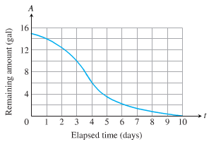

1. Estimate the average rate of gasoline consumption over the time intervals



1. Estimate the instantaneous rate of gasoline consumption over the time 

***Solution***

1. Average rate of gasoline consumption over the time intervals:

























1. At 

At 

At 