***Section* 1.2 – Definitions / Techniques of Limits**

**Definition of the Limit of a Function**

If  becomes arbitrary close to a single number *L* as *x* approaches  from either side, then



Which is read as “the limit of  as *x* approaches  is *L.*”

|  |  |
| --- | --- |
| ***Notation*** | ***Terminology*** |
|  | ***x*** approaches ***a*** from the left (through values ***less*** than *a*) |
|  | ***x*** approaches ***a*** from the right (through values ***greater*** than *a*) |

***Example***

How does the function  behave near ?

***Solution***





For :



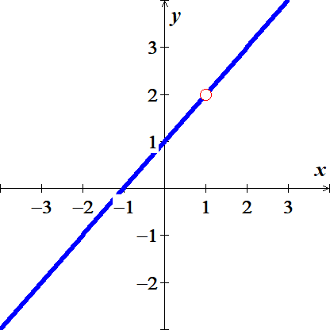 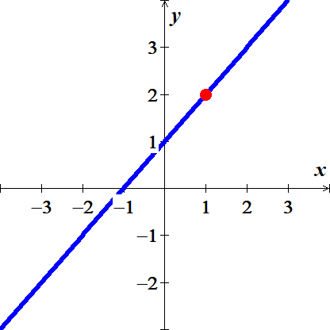

|  |  |  |  |  |  |  |
| --- | --- | --- | --- | --- | --- | --- |
| ***x*** | .9 | .99 | .999 | 1.001 | 1.01 | 1.1 |
|  | 1.9 | 1.99 | 1.999 | 2.001 | 2.01 | 2.1 |





 

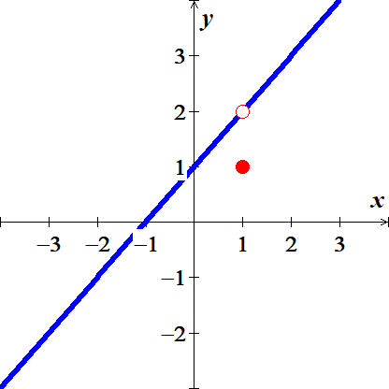

***Example***

Discuss the behavior of the following function as .



***Solution***

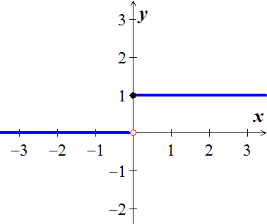

The unit step function  has no limit as , it jumps, because the values jump at *x* = 0.

To the left of zero  . For the positive values of *x* close to zero 

***One-Sided Limits***

To have a limit *L* as *x* approaches *c*, a function *f* must be defined on ***both sides*** of *c* and its values  must approach *L* as *x* approaches *c* from either side. Because of this, ordinary limits are called ***two-sided***.

If *f* fails to have two-sided limit at *c*, it may still have one-sided limit.

If the approach is from the *right*, the limit is a ***right-hand limit***. 

If the approach is from the *left*, the limit is a ***left-hand limit***. 

***Example***

The domain of  is ; its graph is the semicircle.

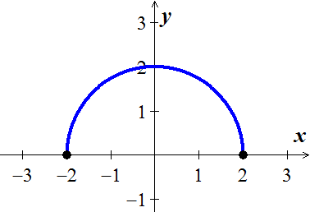

We have: 

The function doesn’t have a left-hand limit at  or a right-hand limit at .

It does not have ordinary two-sided limits at either −2 or 2.

***Theorem***

A function  has a limit as *x* approaches *c* if and only if it has left-hand and right-hand limits there and these one-sided limits are equal:



***Properties of Limits***

***Constant function*** : 

***Identity function*** : 

***Example***

Given the function graphed:

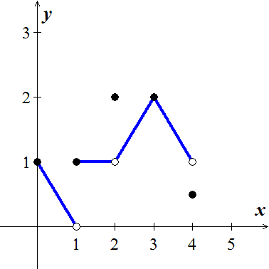

At *x* = 0: 

 don’t exist. The function is not defined to the left of *x* = 0

At *x* = 1:  

 doesn’t exist. The right-hand and left-hand limits are not equal.

At *x* = 2:  

 even though 

At *x* = 3: 

At *x* = 4:  even though 

 do not exist.

The function is not defined to the right of *x* = 4

***Definitions***

We say that  has right-hand limit *L* at  and 

If for every number *ε* > 0 there exists a corresponding number *δ* > 0 such that for all *x*



We say that  has left-hand limit *L* at  and 

If for every number *ε* > 0 there exists a corresponding number *δ* > 0 such that for all *x*



***Example***

Prove that 

***Solution***

Let *ε* > 0 be given. 



or 





If we choose , we have



According to the definition, this shows that 

***Example***

Discuss the behavior of the following function as .

 

***Solution***

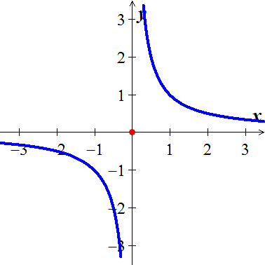

 has *no limit* as  because the values of  grow arbitrary large (negative and positive) value as  and do not stay close.

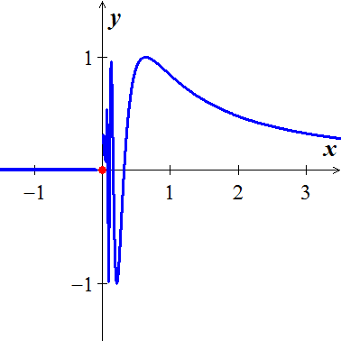

 has *no limit* as  because the function’s values oscillate between −1 and +1 in every open interval containing 0. The values do not stay close to any one number as .

***Limit Laws***

If 

*Constant Multiple Rule:* 

*Sum and Difference Rules:* 

*Product Rule*: 

*Quotient Rule:*  

*Power Rule:* 

*Root Rule:* 

***Example***

Find the following limits:

  

***Solution***

1.  ***Sum and Difference Rules***



1.  ***Quotient Rule***

 ***Sum and Difference Rules***



1.  ***Root Rule***

 ***Difference Rule***







***Theorem* – Limits of Polynomials**

If , then 

***Theorem* – Limits of Rational Functions**

If  and  are polynomials and , then 

***Example***

Find the limit: 

***Solution***







***Eliminating Zero Denominators Algebraically***

***Example***

Evaluate: 

***Solution***











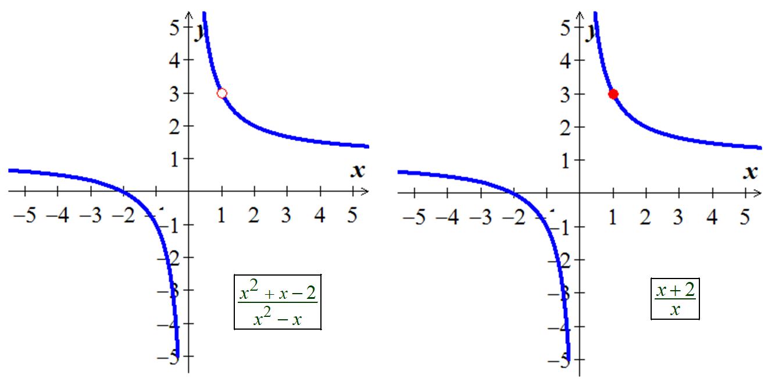

***Example***

Evaluate: 

***Solution***



 















***The Sandwich (Squeeze) Theorem***

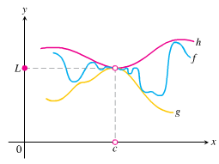

Suppose that  for all *x* in some open interval containing *c*, except possibly at *x* = *c* itself. Suppose also that



***Example***

Given that , find the , no matter how complicated *u* is.

***Solution***







The Sandwich theorem implies that 

***Theorem***

Suppose that  for all *x* in some open interval containing *c*, except possibly at *x* = *c* itself, and the limits of *f* and *g* both exist as *x* approaches *c*, then



***Example***

Show that  has no limit as *x* approaches zero from either side.

***Solution***

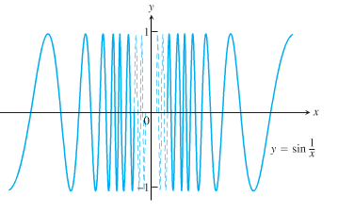

As *x* approaches zero, its reciprocal, , grows without bound and the values of  cycle repeatedly from −1 to 1.

There is no single number *L* that the function’s values stay increasingly close to as *x* approaches zero.

The function has neither a right-hand limit nor a left-hand limit at *x* = 0.

***Limit Involving ***

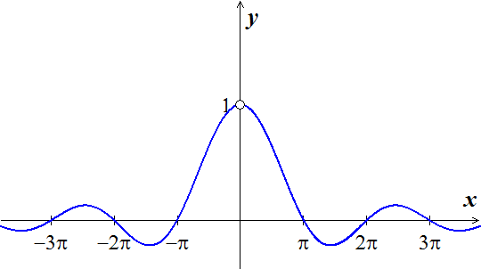

A central fact about  is that in radian measure it limit as *θ* → 0 is **1**.

***Theorem***



***Proof***

We need to show that the right-hand limit is 1, 

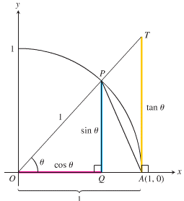

Notice that:













 ***Taking reciprocals reverses the inequalities***



Since , then



So 

***Example***

Show that 

***Solution***

Using the half-angle formula: 



 ***Let*** 









***Example***

Show that 

***Solution***

 ***Since we need* 2*x in the denominator***







***Example***

Show that 

***Solution***



 





***Exercises*** ***Section* 1.2 – Definitions / Techniques of Limits**

(**1 − 121**) Find the limit:

|  |  |  |
| --- | --- | --- |
|  |  |  |

|  |  |  |
| --- | --- | --- |
|  |  |  |

|  |  |  |
| --- | --- | --- |
|  |  |  |

1. For the function  graphed, find the following limits or explain why they do not exist.

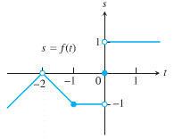



1. Suppose . Find

|  |  |
| --- | --- |
|  |  |

1. Explain why the limits do not exist for 

(**125 − 126**) Evaluate the limit using the form  for

|  |  |
| --- | --- |
|  |  |

1. If, find 
2. If, find 
3. If  and . At what points *c* do you automatically know ? What can you say about the value of the limits at these points?
4. Let 

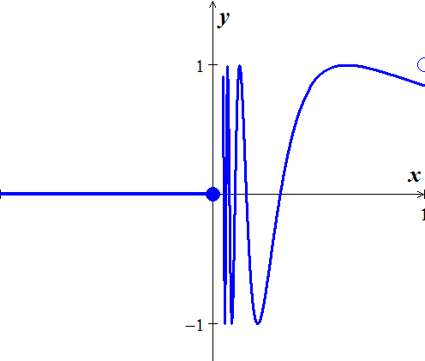

1. Does  exist? If so, what is it? If not, why not?
2. Does  exist? If so, what is it? If not, why not?
3. Does  exist? If so, what is it? If not, why not?
4. Let 

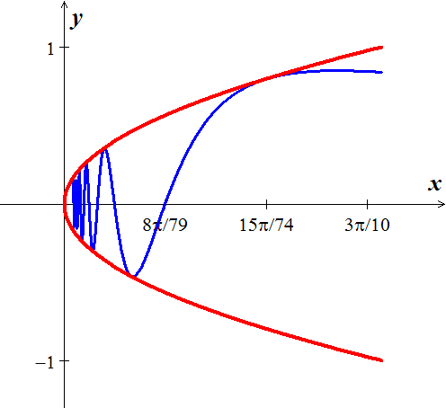

1. Does  exist? If so, what is it? If not, why not?
2. Does  exist? If so, what is it? If not, why not?
3. Does  exist? If so, what is it? If not, why not?
4. Let 



1. Does  exist? If so, what is it? If not, why not?
2. Does  exist? If so, what is it? If not, why not?
3. Does  exist? If so, what is it? If not, why not?
4. Which of the following statements about the function  graphed here are true, and which are false?

|  |  |
| --- | --- |
|  |  |