***Solution*** ***Section* 1.2 – Definitions / Techniques of Limits**

***Exercise***

Find the limit: 

***Solution***



***Exercise***

Find the limit: 

***Solution***



***Exercise***

Find the limit: 

***Solution***



***Exercise***

Find the limit: 

***Solution***



***Exercise***

Find the limit: 

***Solution***





***Exercise***

Find the limit: 

***Solution***







***Exercise***

Find the limit: 

***Solution***







***Exercise***

Find the limit: 

***Solution***





***Exercise***

Find the limit: 

***Solution***





***Exercise***

Find the limit: 

***Solution***







***Exercise***

Find the limit: 

***Solution***









***Exercise***

Find the limit: 

***Solution***





***Exercise***

Find the limit: 

***Solution***







***Exercise***

Find the limit:

***Solution***





 (***Doesn’t exist***)

***Exercise***

Find the limit:

***Solution***







***Doesn’t exist***

***Exercise***

Find: 

***Solution***





***Exercise***

Find: 

***Solution***









***Exercise***

Find the limit: 

***Solution***





***Exercise***

Find the limit: 

***Solution***





***Exercise***

Find the limit: 

***Solution***





***Exercise***

Find the limit: 

***Solution***









***Exercise***

Find the limit: 

***Solution***







= 22 +2(2) + 4



***Exercise***

Find the limit: 

***Solution***









***Exercise***

Find the limit: 

***Solution***















***Exercise***

Find the limit: 

***Solution***







***Exercise***

Find the limit: 

***Solution***







***Exercise***

Find the limit: 

***Solution***





***Exercise***

Find the limit: 

***Solution***





***Exercise***

Find the limit: 

***Solution***









***Exercise***

Find the limit: 

***Solution***











***Doesn’t exist***

***Exercise***

Find the limit: 

***Solution***







***Exercise***

Find the limit: 

***Solution***











***Exercise***

Find the limit: 

***Solution***











***Exercise***

Find the limit: 

***Solution***













***Exercise***

Find the limit: 

***Solution***











***Exercise***

Find the limit: 

***Solution***

















***Exercise***

Find the limit: 

***Solution***



















***Exercise***

Find the limit: 

***Solution***



























***Exercise***

Find the limit: 

***Solution***







***Exercise***

Find the limit: 

***Solution***





***Exercise***

Find the limit: 

***Solution***







***Exercise***

Find the limit: 

***Solution***





***Exercise***

Find the limit: 

***Solution***







***Exercise***

Find 

***Solution***







***Exercise***

Find 

***Solution***





***Exercise***

Find 

***Solution***







***Exercise***

Find 

***Solution***





















***Exercise***

Find 

***Solution***



Since 











***Exercise***

Find 

***Solution***



Since 









***Exercise***

Find 

***Solution***

Let: 





***Exercise***

Find 

***Solution***



 Let: 

 ***By definition:*** 



***Exercise***

Find 

***Solution***





 ***By definition:*** 



***Exercise***

Find 

***Solution***











***Exercise***

Find 

***Solution***











***Exercise***

Find 

***Solution***









***Exercise***

Find 

***Solution***

Let:  





***Exercise***

Find 

***Solution***















***Exercise***

Find 

***Solution***











***Exercise***

Find 

***Solution***





***Exercise***

Find 

***Solution***





***Exercise***

Find 

***Solution***









***Exercise***

Find 

***Solution***









***Exercise***

Find 

***Solution***















***Exercise***

Find 

***Solution***













***Exercise***

Find 

***Solution***









***Exercise***

Find 

***Solution***



 





***Exercise***

Find 

***Solution***

 







***Exercise***

Find 

***Solution***













***Exercise***

Find the limit: 

***Solution***











***Exercise***

Find the limit: 

***Solution***













***Exercise***

Find the limit: 

***Solution***











***Exercise***

Find the limit: 

***Solution***











***Exercise***

Find the limit: 

***Solution***













***Exercise***

Find the limit: 

***Solution***













***Exercise***

Find the limit: 

***Solution***







***Exercise***

Find the limit: 

***Solution***











***Exercise***

Find the limit: 

***Solution***















***Exercise***

Find the limit: 

***Solution***















***Exercise***

Find the limit: 

***Solution***











***Exercise***

Find the limit: 

***Solution***









***Exercise***

Find the limit: 

***Solution***













***Exercise***

Find the limit: 

***Solution***



 













***Exercise***

Find the limit: 

***Solution***









***Exercise***

Find the limit: 

***Solution***













***Exercise***

Find the limit: 

***Solution***















***Exercise***

Find the limit: 

***Solution***













***Exercise***

Find the limit: 

***Solution***











***Exercise***

Find the limit: 

***Solution***











***Exercise***

Find the limit: 

***Solution***









***Exercise***

Find the limit: 

***Solution***













***Exercise***

Find the limit: 

***Solution***









***Exercise***

Find the limit: 

***Solution***







***Exercise***

Find the limit: 

***Solution***





***Exercise***

Find the limit: 

***Solution***









***Exercise***

Find the limit: 

***Solution***









***Exercise***

Find 

***Solution***







***Exercise***

Find 

***Solution***









***Exercise***

Find 

***Solution***









***Exercise***

Find 

***Solution***







***Exercise***

Find 

***Solution***











***Exercise***

Find 

***Solution***





***Exercise***

Find 

***Solution***





***Exercise***

Find 

***Solution***





***Exercise***

Find 

***Solution***











***Exercise***

Find 

***Solution***











***Exercise***

Find 

***Solution***









***Exercise***

Find 

***Solution***









***Exercise***

Find 

***Solution***













***Exercise***

Find 

***Solution***





***Exercise***

Find 

***Solution***







***Exercise***

Find 

***Solution***





***Exercise***

Find 

***Solution***





***Exercise***

Find 

***Solution***







***Exercise***

Find 

***Solution***







***Exercise***

Find 

***Solution***



***Exercise***

Find 

***Solution***





***Exercise***

Find 

***Solution***





***Exercise***

Find 

***Solution***







***Exercise***

Find 

***Solution***





***Exercise***

Find 

***Solution***







***Exercise***

Find 

***Solution***







***Exercise***

Find 

***Solution***





***Exercise***

For the function  graphed, find the following limits or explain why they do not exist.



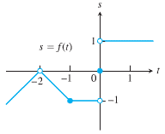***Solution***

1. 
2. 
3. 
4. 

***Exercise***

Suppose . Find

|  |  |
| --- | --- |
|  |  |
|  |  |

***Solution***

1. 





1. 





1. 





1. 





***Exercise***

Explain why the limits do not exist for 

***Solution***



|  |  |
| --- | --- |
|  | ***Doesn’t exist*** |

***Exercise***

Evaluate the limit using the form  for 

***Solution***











***Exercise***

Evaluate the limit using the form  for 

***Solution***















 



***Exercise***

If, find 

***Solution***





 ***Multiply both sides by* 2**

 ***Add* 5 *on both sides***



***Exercise***

If, find 

***Solution***

















***Exercise***

If  and . At what points *c* do you automatically know ? What can you say about the value of the limits at these points?

***Solution***

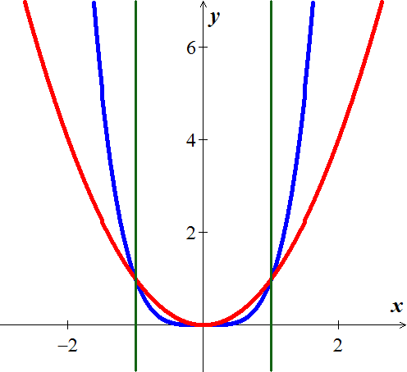





 

 









***Exercise***

Let 

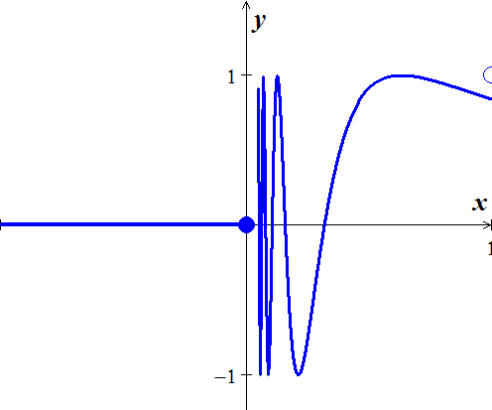

1. Does  exist? If so, what is it? If not, why not?
2. Does  exist? If so, what is it? If not, why not?
3. Does  exist? If so, what is it? If not, why not?

***Solution***

1.  doesn’t exist, since  doesn’t approach any single value as 
2. 
3.  doesn’t exist, since  doesn’t exist

***Exercise***

Let 

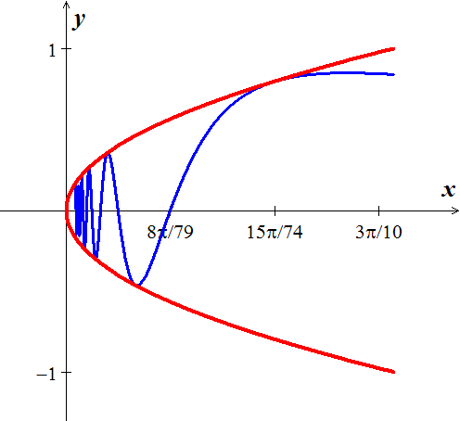

1. Does  exist? If so, what is it? If not, why not?
2. Does  exist? If so, what is it? If not, why not?
3. Does  exist? If so, what is it? If not, why not?

***Solution***

1.  exists, by the sandwich theorem 
2.  doesn’t exist, since  is not defined for 
3.  doesn’t exist, since  doesn’t exist.

***Exercise***

Which of the following statements about the function  graphed here are true, and which are false?

***Solution***

1. 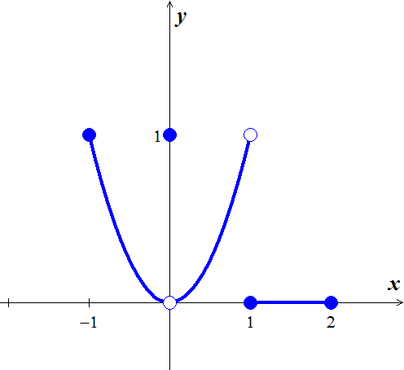 ***True***
2.  ***True***
3.  ***False***
4.  ***True***
5.  ***True***
6.  ***True***
7.  ***False***
8.  ***False***
9.  ***False***
10.  ***False***
11.  ***True***
12.  ***False***