***Section* 1.5 – Continuity**

***Definition* of *Continuity***

Let *c* be a number in the interval (*a*, *b*), and let *f* be a function whose domain contains the interval (*a*, *b*). The function *f*  is continuous at the point *c* if the following conditions are true.

1. is defined
2. 
3. 

If *f* is continuous at every point in the interval (*a*, *b*), then it is continuous on an open interval (*a*, *b*)

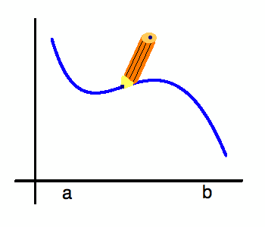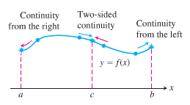

***Definition***

***Interior point***: A function  is **continuous at an interior point *c*** of its domain if



***Endpoint***: A function  is **continuous at a left point *a*** or is **continuous at a right point *b*** of its domain if



* If a function  is not continuous at a point *c*, we say that  is ***discontinuous*** at *c*. (is a ***point of discontinuity***)

***Example***

Find the points at which the functionis continuous and the points at which  is not continuous

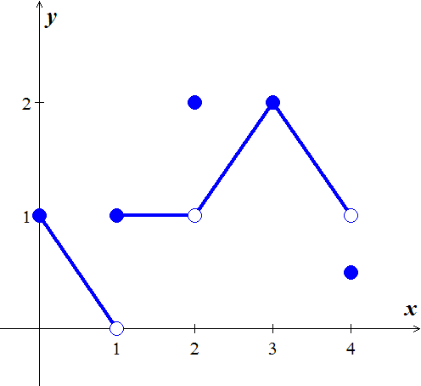

***Solution***

The function  is continuous at every point in its domain [0, 4] except at   and .

At these points, there are breaks in the graph.

   is continuous 

  *doesn’t exist*  is discontinuous 

   is discontinuous 

   is continuous 

   is discontinuous 

 These points are not in the domain of *f*.  is discontinuous

 

***Example***

At what points the function is continuous?

***Solution***

The function is continuous at every point of its domain [−2, 2].

Including, where  is right-continuous, and , where  is left-continuous.

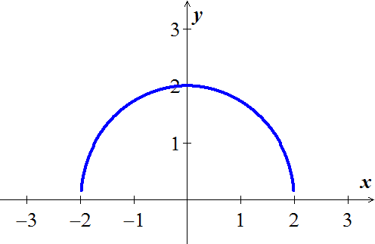

***Continuous Functions***

A function is ***continuous on an interval*** iff it is continuous at every point of the interval. A ***continuous function*** is one that is continuous at every point of its domain. A continuous function need not be continuous on every interval.

***Example***

Determine at which points do the function  is continuous and discontinuous

**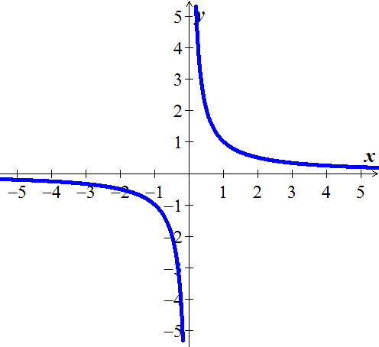*Solution***

The function  is a continuous function because

it is continuous at every point of its domain.

It has a point of discontinuity at , however, because it is not defined.

It is discontinuous on any interval containing 

***Theorem* – Properties of Continuous Functions**

If the functions  are continuous at , then the following combinations are continuous at .

*Sums and Differences* 

*Constant multiples* , for any number *k*.

*Products* 

*Quotients *

*Powers *

*Roots ,* provided it is defined on an open interval containing *c*, where *n* is a positive integer

***Proof***









This shows that  is continuous

***Composites***

All composites of continuous functions are continuous.

If  is continuous at  and  is continuous at , then  is continuous at 

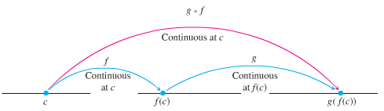

***Example***

Show that  is continuous everywhere on its domain

***Solution***

Let 

∴ The function *y* is continuous on 

***Example***

Show that  is continuous everywhere on its domain

***Solution***

Let 

∴ The function is the composite of a quotient continuous functions with the continuous absolute value function.

***Theorem***

If *g* is continuous at the point *b* and , then



***Proof***

Let *ε* > 0 be given. Since *g* is continuous at *b*, there exists a number  such that





If we let , we then have that 

Which implies from the first statement that  whenever . From the definition of the limit, this proves that 

***Example***

Find the 

***Solution***











***Example***

Show that  has a continuous extension to , and find that extension.

***Solution***



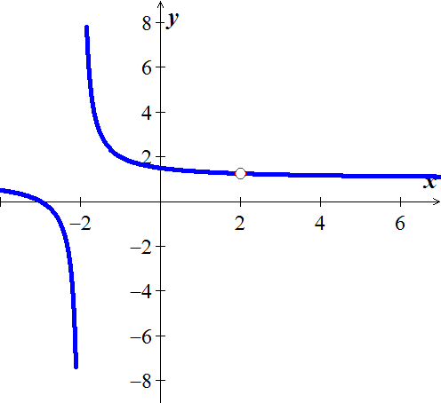 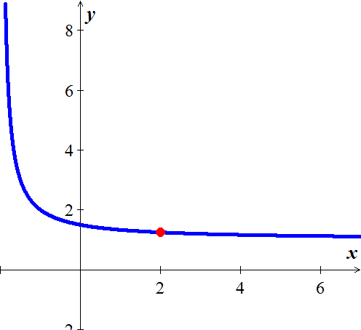

After simplification the function is continuous at 



The new function is the function *f* with its point of discontinuity at  removed.

***Theorem* − the Intermediate Value Theorem for Continuous Functions**

If *f* is a continuous function on a closed interval [*a*, *b*], and if  is any value between  and , then  for some ***c*** in [*a*, *b*].

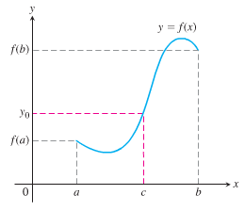

**A Consequence for Root Finding**

We call a solution of the equation  a ***root*** of the equation or zero of the function *f*. The Intermediate Value Theorem said that if ***f*** is continuous, then any interval on which *f* changes sign contains a zero of the function.

***Example***

Show that there is a root of the equation  between 1 and 2.

***Solution***





Since is continuous, the Intermediate Value Theorem says there is a zero of *f* between 1 and 2.

***Example***

Use the Intermediate Value Theorem to prove that the equation  has a solution.

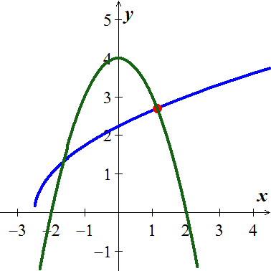

***Solution***

The function  is continuous on the interval  since it is the composite of the square root function with nonnegative linear function . Then the function  is the sum of the function  and . It follows that  is continuous on the interval .

By trial and error:





 is continuous on the interval .

Since the value  is between  and 7, by the Intermediate Value Theorem there is a number . That is, the number *c* solves the original equation.

***Exercises*** ***Section* 1.5 – Continuity**

1. Given the graphed function 
2. Does  exist?
3. Does  exist?
4. Does ?
5. Is  continuous at ?
6. Does  exist?
7. Does  exist?
8. Does ?
9. Is  continuous at ?

(**2 − 11**) At what point(s) is the given function continuous?

|  |  |  |
| --- | --- | --- |
|  |  |  |

1. Find , then is the function continuous at the point being approached?
2. Find , then is the function continuous at the point being approached?
3. Find , then is the function continuous at the point being approached?
4. Explain why the equation  has at least one solution.

(**16 − 19**) Show that the equation has three solutions in the given interval

|  |  |
| --- | --- |
|  |  |

1. Show that the equation has six solutions in the given interval 
2. If functions  and  are continuous for , could  possibly be discontinuous at a point of [0, 1]? Give reason for your answer.
3. Suppose that a function  is continuous on the closed interval [0, 1] and that  for every *x* in [0, 1]. Show that there must exist a number *c* in [0, 1] such that  (***c*** is called a ***fixed point*** of ).
4. Use the Intermediate Value Theorem to show that the equation  has a solution in the interval .
5. The amount of an antibiotic (in *mg*) in the blood *t* hours after an intravenous line is opened is given by



1. Use the Intermediate Value Theorem to show that the amount of drug is 30 *mg* at some time in the interval  and again at some time in the interval 
2. Estimate the times at which 
3. Is the amount of drug in the blood ever 50 *mg*?

(**25 − 27**) Determine whether the following functions are continuous at *a*.

|  |  |
| --- | --- |
|  |  |

(**28 − 31**) Find the intervals on which the following functions are continuous. Specify right- or left- continuity at the endpoints

|  |  |  |  |
| --- | --- | --- | --- |
|  |  |  |  |

1. Let 

Determine values of the constants *a* and *b* for which  is continuous at 