***Solution*** ***Section* 1.5 – Continuity**

***Exercise***

Given the graphed function 

1. Does  exist?
2. 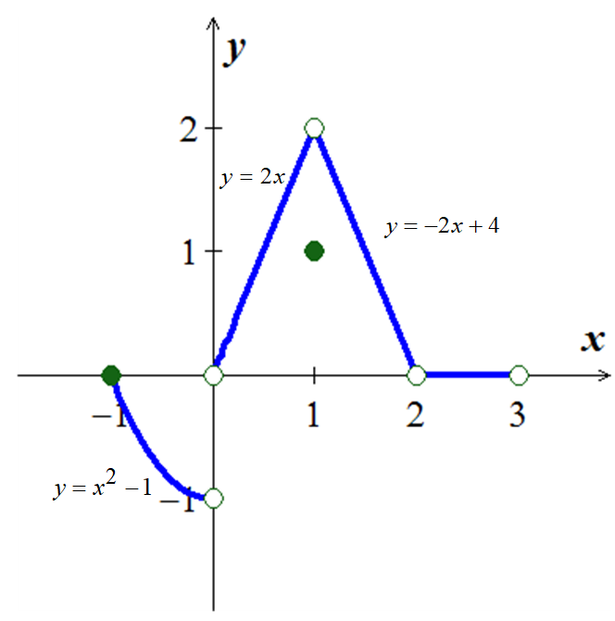Does  exist?
3. Does ?
4. Is  continuous at ?
5. Does  exist?
6. Does  exist?
7. Does ?
8. Is  continuous at ?

***Solution***

1. Yes 
2. Yes, 
3. Yes
4. Yes
5. Yes, 
6. Yes, 
7. No
8. No

***Exercise***

At what points is the function  continuous?

***Solution***

The function is continuous everywhere except when 

***Exercise***

At what points is the function  continuous?

***Solution***

The function is continuous everywhere except when 

***Exercise***

At what points is the function  continuous?

***Solution***

The function is continuous everywhere

***Exercise***

At what points is the function  continuous?

***Solution***

The function is continuous everywhere except when 

***Exercise***

At what points is the function  continuous?

***Solution***

The function is continuous everywhere except when 

***Exercise***

At what points is the function  continuous?

***Solution***

The function is continuous everywhere except when 

***Exercise***

At what points is the function  continuous?

***Solution***

The function is continuous everywhere

***Exercise***

At what points is the function  continuous?

***Solution***

The function is continuous on the interval , and discontinuous when 

***Exercise***

At what points is the function  continuous?

***Solution***

The function is continuous on the interval , and discontinuous when 

***Exercise***

At what points is the function  continuous?

***Solution***

The function is continuous everywhere 

***Exercise***

Find , then is the function continuous at the point being approached?

***Solution***







 The function is continuous at 

***Exercise***

Find , then is the function continuous at the point being approached?

***Solution***







 The function is continuous at 

***Exercise***

Find , then is the function continuous at the point being approached?

***Solution***











∴ The function is continuous at 

***Exercise***

Explain why the equation  has at least one solution.

***Solution***







for some *x* between  and 

According to the Intermediate Value Theorem, and the function  is continuous and has at least one solution.

***Exercise***

Show that the equation  has three solutions in the interval [−4, 4]

***Solution***











By the Intermediate Value Theorem,  for some *x* in each of the intervals , , and . Thus,  has three solutions in [−4, 4]. Since the polynomial of degree 3 can have at most 3 solutions, these are the solutions.

***Exercise***

Show that the equation has three solutions in the given interval 

***Solution***

|  |  |  |  |  |  |  |  |  |  |  |  |  |  |  |  |  |  |  |  |  |  |  |  |  |  |  |  |  |  |  |  |  |  |  |  |  |  |  |  |  |  |  |  |  |  |  |  |  |  |  |  |  |  |
| --- | --- | --- | --- | --- | --- | --- | --- | --- | --- | --- | --- | --- | --- | --- | --- | --- | --- | --- | --- | --- | --- | --- | --- | --- | --- | --- | --- | --- | --- | --- | --- | --- | --- | --- | --- | --- | --- | --- | --- | --- | --- | --- | --- | --- | --- | --- | --- | --- | --- | --- | --- | --- | --- |
| |  |  | | --- | --- | | ***x*** | ***y*** | | −19 | −1299 | | −18 | −742 | | −17 | −273 | | −16 | 114 | | −15 | 425 | | −14 | 666 | | −13 | 962 | | −12 | 1029 | | −10 | 1050 | | −9 | 1031 | | −8 | 978 | | −7 | 897 | | −6 | 794 | | −5 | 675 | | −4 | 546 | | −3 | 413 | | −2 | 282 | | −1 | 159 | | 0 | 50 | | 1 | −39 | | 2 | −102 | | 3 | −133 | | 4 | −126 | | 5 | −75 | | 6 | 26 | |  |

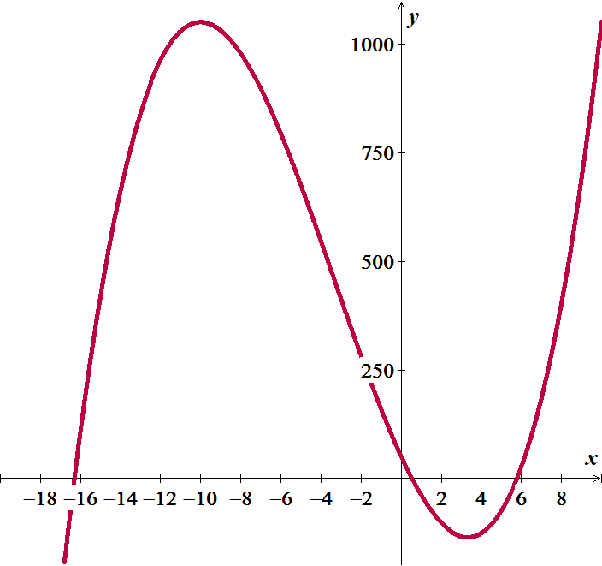

By the Intermediate Value Theorem,  for some *x* in each of the intervals , , and .

***Exercise***

Show that the equation has three solutions in the given interval 

***Solution***

|  |  |  |  |  |  |  |  |  |  |  |  |  |  |  |  |  |  |  |  |  |  |  |  |  |  |  |  |  |  |  |  |  |  |  |  |  |  |  |  |  |  |
| --- | --- | --- | --- | --- | --- | --- | --- | --- | --- | --- | --- | --- | --- | --- | --- | --- | --- | --- | --- | --- | --- | --- | --- | --- | --- | --- | --- | --- | --- | --- | --- | --- | --- | --- | --- | --- | --- | --- | --- | --- | --- |
| |  |  | | --- | --- | | ***x*** | ***y*** | | .05 | −1.6 | | .1 | −0.6 | | .15 | 0.08 | | .2 | .48 | | .25 | .656 | | .3 | .66 | | .35 | .543 | | .4 | .36 | | .45 | .161 | | .5 | 0 | | .55 | −.07 | | .6 | 0 | | .65 | .266 | | .7 | .78 | | .75 | 1.6 | | .8 | 2.76 | | .85 | 4.33 | | .9 | 6.36 | | .95 | 8.9 | |  |

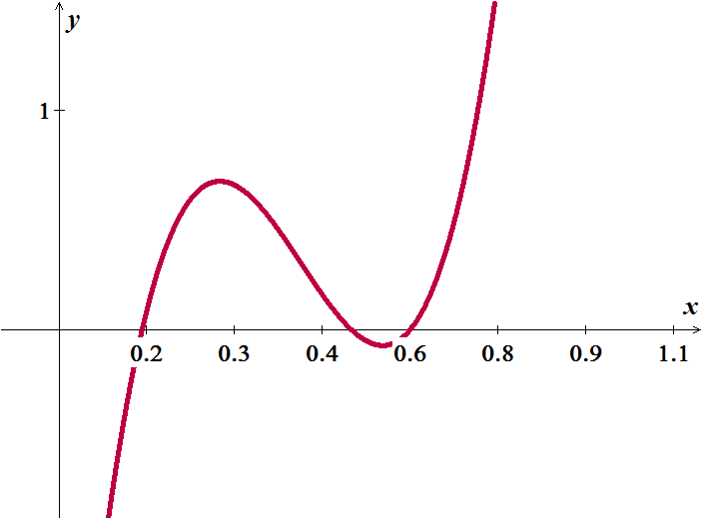

By the Intermediate Value Theorem,  for some *x* in each of the intervals , , and .

***Exercise***

Show that the equation has three solutions in the given interval 

***Solution***

|  |  |  |  |  |  |  |  |  |  |  |  |  |  |  |  |  |  |  |  |  |  |  |  |  |  |  |  |  |  |  |  |  |  |  |  |  |  |
| --- | --- | --- | --- | --- | --- | --- | --- | --- | --- | --- | --- | --- | --- | --- | --- | --- | --- | --- | --- | --- | --- | --- | --- | --- | --- | --- | --- | --- | --- | --- | --- | --- | --- | --- | --- | --- | --- |
| |  |  | | --- | --- | | ***x*** | ***y*** | | −2 | −3.0 | | −1.75 | −1.109 | | −1.5 | 0.125 | | −1.25 | 0.797 | | −1.0 | 1 | | −0.75 | 0.828 | | −0.5 | 0.375 | | −0.25 | −0.266 | | 0 | −1.0 | | 0.25 | −1.73 | | 0.5 | −2.375 | | 0.75 | −2.828 | | 1.0 | −3.0 | | 1.25 | −2.797 | | 1.5 | −2.12 | | 1.75 | −0.89 | | 2. | 1.0 | |  |

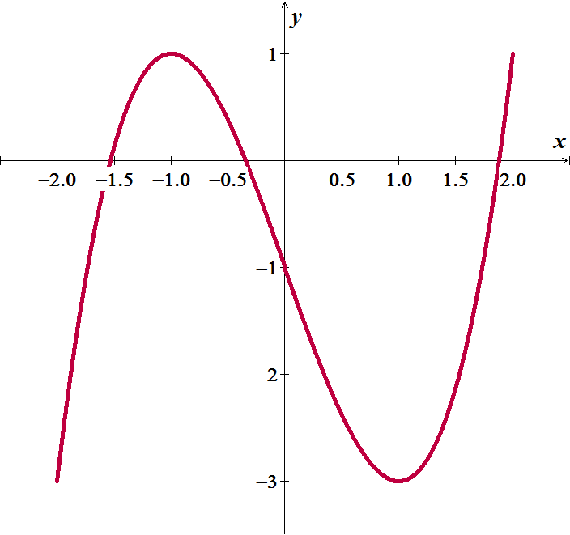

By the Intermediate Value Theorem,  for some *x* in each of the intervals , , and .

***Exercise***

Show that the equation has six solutions in the given interval 

***Solution***

|  |  |  |  |  |  |  |  |  |  |  |  |  |  |  |  |  |  |  |  |  |  |  |  |  |  |  |  |  |  |
| --- | --- | --- | --- | --- | --- | --- | --- | --- | --- | --- | --- | --- | --- | --- | --- | --- | --- | --- | --- | --- | --- | --- | --- | --- | --- | --- | --- | --- | --- |
| |  |  | | --- | --- | | ***x*** | ***y*** | | −3.0 | 170.0 | | −2.5 | −6.86 | | −2.0 | −25.0 | | −1.5 | −7.61 | | −1.0 | 2.0 | | −0.5 | 1.02 | | 0.0 | −1.0 | | 0.5 | 1.01 | | 1.0 | 2.0 | | 1.5 | −7.6 | | 2.0 | −25.0 | | 2.5 | −6.86 | | 3.0 | 170.0 | |  |

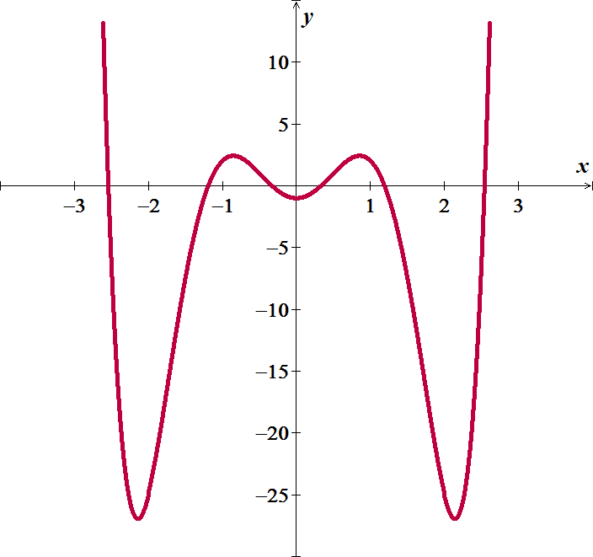

By the Intermediate Value Theorem,  for some *x* in each of the intervals , , , ,  and .

***Exercise***

If functions  and  are continuous for , could  possibly be discontinuous at a point of [0, 1]? Give reason for your answer.

***Solution***

Yes, if we can get a value of  is between [0, 1],  and .

Then  is discontinuous at 

***Exercise***

Suppose that a function  is continuous on the closed interval [0, 1] and that  for every *x* in [0, 1]. Show that there must exist a number *c* in [0, 1] such that  (***c*** is called a ***fixed point*** of ).

***Solution***

Let  ⇒ . In these cases, *c* = 0 or *c* =1.

Let  because .

Define  ⇒ *g* is continuous on [0, 1].



By the Intermediate Value Theorem there is a number *c* in [0, 1] such that



***Exercise***

Use the Intermediate Value Theorem to show that the equation  has a solution in the interval .

***Solution***





By Intermediate value theorem, the function has a solution in 

***Exercise***

The amount of an antibiotic (in *mg*) in the blood *t* hours after an intravenous line is opened is given by



1. Use the Intermediate Value Theorem to show that the amount of drug is 30 *mg* at some time in the interval  and again at some time in the interval 
2. Estimate the times at which 
3. Is the amount of drug in the blood ever 50 *mg*?

***Solution***

1. 





30 is an intermediate value between for both  and .

1. 

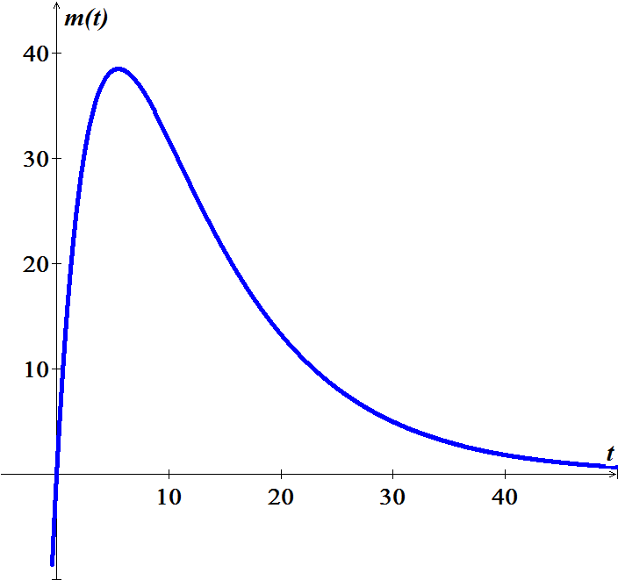



1. No, peak is 38.5 (using the graph)

***Exercise***

Determine whether the following functions are continuous at *a*. 

***Solution***



The function is continuous everywhere except @ 

***Exercise***

Determine whether the following functions are continuous at *a*. 

***Solution***

 **∴** *h* is discontinuous @ 3

***Exercise***

Determine whether the following functions are continuous at *a*.

***Solution***



**∴** *g* is discontinuous @ 4

***Exercise***

Find the intervals on which the following functions are continuous. Specify right- or left- continuity at the endpoints 

***Solution***



The function is continuous at −5 to the left and right of 

***Exercise***

Find the intervals on which the following functions are continuous. Specify right- or left- continuity at the endpoints 

***Solution***

The function is continuous at and to the right of 

***Exercise***

Find the intervals on which the following functions are continuous. Specify right- or left- continuity at the endpoints 

***Solution***

The function is continuous everywhere except at 

The function is continuous to the left of −5, then to the right of −5 to the left of 0, then to the right of 0 thru the left of 5 then to the tight of 5.

***Exercise***

Find the intervals on which the following functions are continuous. Specify right- or left- continuity at the endpoints 

***Solution***

The function is continuous everywhere.

***Exercise***

Let 

Determine values of the constants *a* and *b* for which  is continuous at 

***Solution***













