***Section* 1.6 – Precise Definition of a Limit**

***Example***

Consider the function  near . Intuitively it appears that *y* is close to 7 when *x* is close to 4, so . However, how close to  does *x* have to be so that  differs from 7 by, say less than 2 units?

**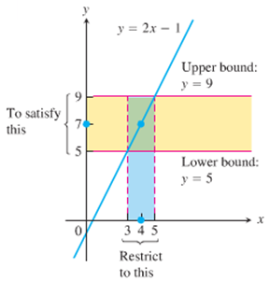*Solution***

We need to find the values of *x* for .



















Keeping *x* within 1 unit of  will keep *y* within 2 units of 

***Definition***

Let  be defined on an open interval about , except possibly at  itself. We say that **the limit of  as *x* approaches is the number *L***, and write



If, for every number , there exists a corresponding number  such that for all *x*,



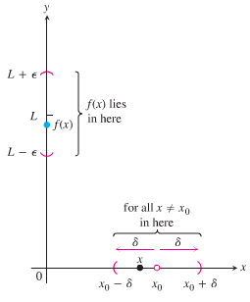

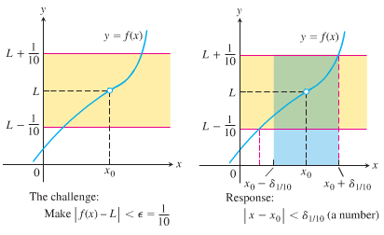

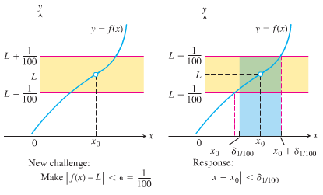

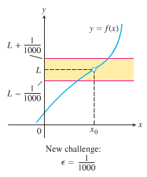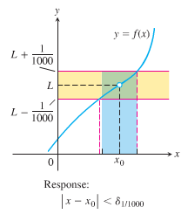

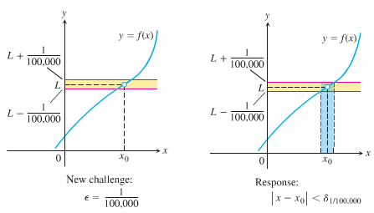

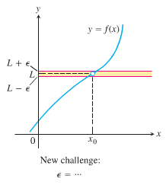

***Example***

Show that 

***Solution***

Let .

For any given , there exists a  so that  and *x* is within distance *δ* of , that is

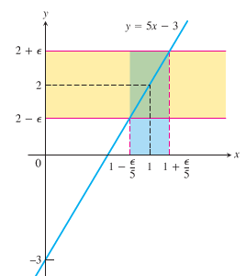 









Thus, we can take: 

If 









Which proves that 

***Example***

Prove the results presented graphically 

***Solution***

Let *ε*  > 0 be given, we must find *δ* > 0 such that for all *x*



This implication will hold if *δ* = *ε* or any smaller number.

***Example***

For the limit , find a *δ* > 0 that works for *ε* = 1. That is, find a *δ* > 0 such that for all *x*:

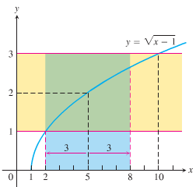

***Solution***







 ***Square all sides***







The inequality holds for all *x* in the open interval.

So it holds for all  in the interval as well.

Finding *δ* value.



Centered at  inside the interval



 (***to be centered***)



**How to Find *Algebraically* a *δ* for a Given *f*, *L*,  , and *ε*  > 0**

The process of finding a *δ* > 0 such that for all *x*:



Can be accomplished in two steps

1. Solve the inequality  to find an open interval  containing  on which the inequality holds for all .
2. Find a value of *δ* > 0 that places the open interval  centered at  inside the interval . The inequality  will hold for all  in this *δ* −interval.

***Example***

Prove that if



***Solution***

We need to show that given *ε* > 0 there exists a *δ* > 0 such that for all *x*:



1. *Solve the inequality  to find an open interval containing  on which the inequality holds for all .*

For , , and the inequality to solve is :

**

 ***Add 4 to all sides***

 ***Square root***

 ***Assume ε* < 4**



The inequality  holds for all  in the open interval 

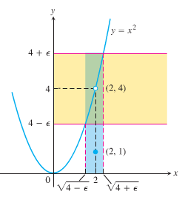

1. *Find a value of δ > 0 that places the open interval  inside the interval*.

Take δ to be the distance from  to the nearer endpoint of .

.











***Example***

Given that , prove that 

***Solution***

We need to show that given *ε* > 0 there exists a *δ* > 0 such that for all *x*:





 ***Triangle Inequality*** 



Since , there exists a number  such that for all *x*:



Similarly, since , there exists a number  such that for all *x*:



Let , the smaller of . If  then , so  and , so  . Therefore



This show that 

***Exercises*** ***Section* 1.6 – Precise Definition of Limits**

Sketch the interval (*a, b*) on the *x*-axis with the point inside. Then find a value of δ > 0 such that for all *x*, for

|  |  |
| --- | --- |
|  |  |

1. Use the graph to find a *δ* > 0 such that for all *x* 

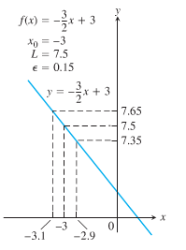

(**4 − 11**) Find an open interval about  on which the inequality holds. Then give a value for *δ* > 0 such that for all *x* satisfying  the inequality  holds.

1. 
2. 
3. 
4. 
5. 
6. 
7. 
8. 

(**12 − 17**) Give a formal proof that

|  |  |
| --- | --- |
|  |  |

1. Prove that 

