***Solution*** ***Section* 1.6 – Precise Definition of Limits**

***Exercise***

Sketch the interval (*a, b*) on the *x*-axis with the point inside. Then find a value of δ > 0 such that for all *x*, for 

***Solution***









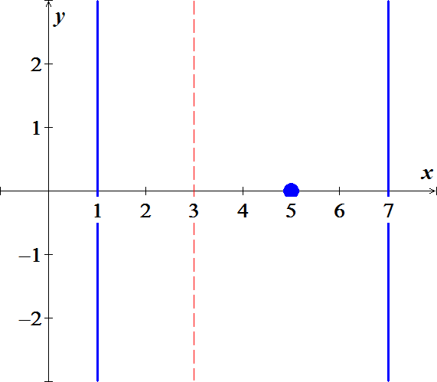

***Exercise***

Sketch the interval (*a, b*) on the *x*-axis with the point inside. Then find a value of δ > 0 such that for all *x*,  for 

***Solution***

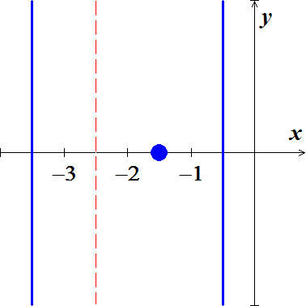









***Exercise***

Use the graph to find a *δ* > 0 such that for all *x* 

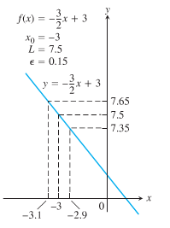***Solution***

***Given***: 















***Exercise***

Find an open interval about  on which the inequality holds. Then give a value for *δ* > 0 such that for all *x* satisfying  the inequality holds.



***Solution***



























***Exercise***

Find an open interval about  on which the inequality holds. Then give a value for *δ* > 0 such that for all *x* satisfying  the inequality holds.



***Solution***































***Exercise***

Find an open interval about  on which the inequality holds. Then give a value for *δ* > 0 such that for all *x* satisfying  the inequality holds.



***Solution***



























***Exercise***

Find an open interval about  on which the inequality holds. Then give a value for *δ* > 0 such that for all *x* satisfying  the inequality holds.



***Solution***





















***Exercise***

Find an open interval about  on which the inequality holds. Then give a value for *δ* > 0 such that for all *x* satisfying  the inequality holds.



***Solution***





















***Exercise***

Find an open interval about  on which the inequality holds. Then give a value for *δ* > 0 such that for all *x* satisfying  the inequality holds.



***Solution***



























***Exercise***

Find an open interval about  on which the inequality holds. Then give a value for *δ* > 0 such that for all *x* satisfying  the inequality holds.



***Solution***





















***Exercise***

Find an open interval about  on which the inequality holds. Then give a value for *δ* > 0 such that for all *x* satisfying  the inequality holds.



***Solution***

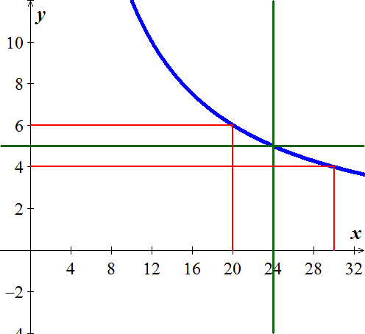























***Exercise***

Prove that 

***Solution***





 ***divide by*** (−).

















***Exercise***

Prove that 

***Solution***























***Exercise***

Prove that 

***Solution***





















***Exercise***

Prove that 

***Solution***

For  





For  









***Exercise***

Prove that 

***Solution***

















***Exercise***

Prove that 

***Solution***

Let  and let 

Suppose that 





 ***√***

***Exercise***

Prove that 

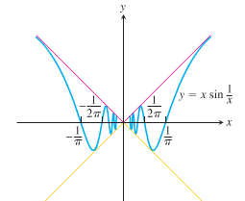

***Solution***



Then by the sandwich theorem, 