***Solution*** ***Section* 2.10 – Related Rates**

***Exercise***

If  and , then what is 

***Solution***











***Exercise***

If  and , then what is 

***Solution***











***Exercise***

A cube’s surface area increases at the rate of 72 . At what rate is the cube’s volume changing when the edge length is *x* = 3 *in*?

***Solution***

Cube’s surface: 

















***Exercise***

The radius *r* and height *h* of a right circular cone are related to the cone’s volume *V* by the equation .

1. How is  related to  if ***r***is constant?
2. How is  related to  if ***h***is constant?
3. How is  related to  and  if neither ***r***nor ***h***is constant?

***Solution***

1. 
2. 
3. 

***Exercise***

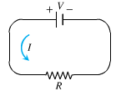The voltage ***V***(volts), current ***I*** (amperes), and resistance ***R*** (ohms) of an electric circuit like the one shown here are related by the equation . Suppose that *V* is increasing at the rate of 1 volt/sec while *I* is decreasing at the rate of . Let *t* denote time in seconds.

1. What is the value of ?
2. What is the value of ?
3. What equation relates  to  and ?
4. Find the rate at which *R* is changing when *V* = 12 volts and *I* = 2 amp. Is *R* increasing or decreasing?

***Solution***

1. 
2. 
3. 

 



1. 



***R*** is increasing

***Exercise***

Let *x* and *y* be differentiable functions of *t* and let  be the distance between the points (*x*, 0) and (0, *y*) in the *xy*−plane.

1. How is  related to  if *y* is constant?
2. How is  related to  and  if neither *x* nor *y* is constant?
3. How is  related to  if *s* is constant?

***Solution***



1. 



1. 





1. 









***Exercise***

A 13-*foot* ladder is leaning against a house when its base starts to slide away. By the time the base is 12 *feet* from the house, the base is moving at the rate of 5 *ft/sec*.

1. How fast is the top of the ladder sliding down the wall then?
2. At what rate is the area of the triangle formed by the ladder, wall, and the ground changing then?
3. At what rate is the angle *θ* between the ladder and the ground changing then?

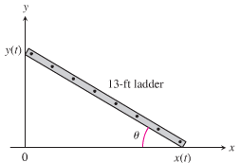***Solution***

***Given***: 



1. 











The ladder is sliding down the wall

1. Area of the triangle formed by the ladder and the walls is: 







1. 





 





***Exercise***

A 13-*feet* ladder is leaning against a vertical wall when he begins pulling the foot of the ladder away from the wall at a rate of 0.5 *ft/s*. How fast is the top of the ladder sliding down the wall when the foot of the ladder is 5 *feet* from the wall?

***Solution***



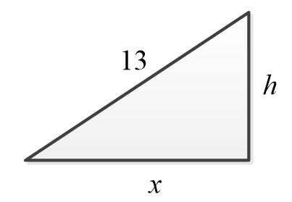













So, the top of the ladder slides down the wall at 

***Exercise***

A 12-*feet* ladder is leaning against a vertical wall when he begins pulling the foot of the ladder away from the wall at a rate of 0.2 *ft/s*. What is the configuration of the ladder at the instant that the vertical speed of the top of the ladder equals the horizontal speed of the foot of the ladder?

***Solution***







The vertical speed of the top of the ladder equals the horizontal speed of the foot of the ladder.









Since *x = h*, the triangle is forming a  with





***Exercise***

A swimming pool is 50 *m* long and 20 *m* wide. Its length decreases linearly along the length from 3 *m* to 1 *m*. It is initially empty and is filed at a rate of 1 .

1. How fast is the water level rising 250 min after the filling begins?
2. How long will it take to fill the pool?



***Solution***

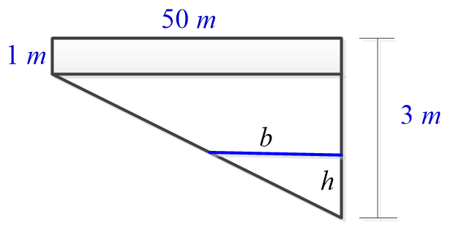



The area of the side:

















1. 





So 











1. 



Since 

Then it will take 2,000 *minutes*.

***Exercise***

An inverted conical water tank with a height of 12 *feet* and a radius of 6 *feet* is drained through a hole in the vertex at a rate of 2 . What is the rate of change of the water depth when the water depth is 3 *feet*?

***Solution***

***Given***: 

The water forms a cone with volume:



From the triangles:





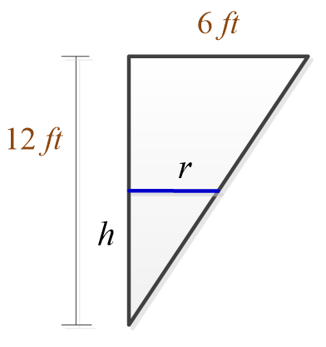 







So, the depth of the water is decreasing at a rate of 

***Exercise***

Water runs into a conical tank at the rate of . The tank stands point down and has a height of 20 *feet* and a base radius of 8 *feet*. How fast is the water level rising when the water is 6 *feet* deep?

***Solution***

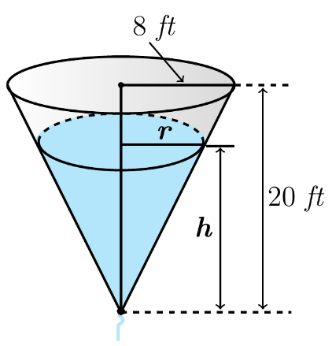***Given***: 

The water forms a cone with volume:



From the triangles:

















The water level is rising at about 0.33157 ***ft/min***.

***Exercise***

Water runs into a conical tank at the rate of . The tank stands point down and has a height of 10 *feet* and a base radius of 4 *feet*. How fast is the water level rising when the water is 6 *feet* deep?

***Solution***

***Given***: 

The water forms a cone with volume:



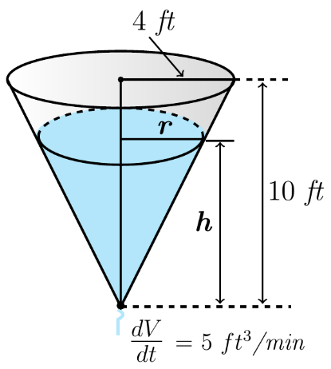From the triangles:

















The water level is rising at about 0.2763 ***ft/min***.

***Exercise***

Water runs into a conical tank at the rate of . The tank stands point down and has a height of 20 *feet* and a base radius of 5 *feet*. How fast is the water level rising when the water is 4 *feet* deep?

***Solution***

***Given***: 

The water forms a cone with volume:



From the triangles:



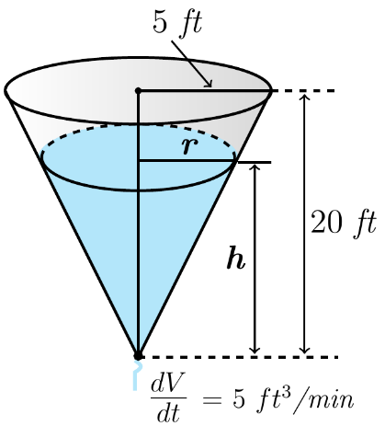













The water level is rising at about 1.59155 ***ft/min***.

***Exercise***

Water runs into a conical tank at the rate of . The tank stands point down and has a height of 20 *feet* and a base radius of 5 *feet*. How fast is the water level rising when the water is 5 *feet* deep?

***Solution***

***Given***: 

The water forms a cone with volume:

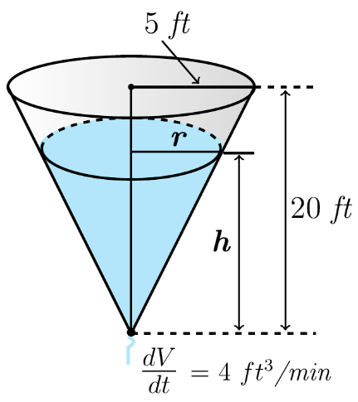

From the triangles:

















The water level is rising at about 0.814873 ***ft/min***.

***Exercise***

Water runs into a conical tank at the rate of . The tank stands point down and has a height of 10 *feet* and a base radius of 5 *feet*. How fast is the water level rising when the water is 4 *feet* deep?

***Solution***

***Given***: 

The water forms a cone with volume:

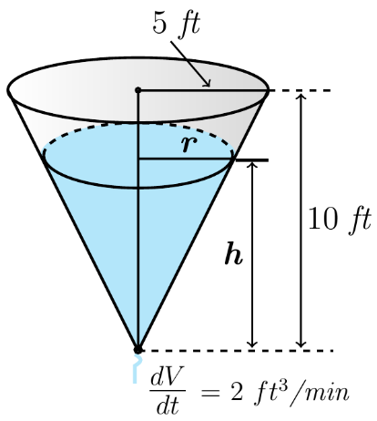

From the triangles:

















The water level is rising at about 0.159155 ***ft/min***.

***Exercise***

Water runs into a conical tank at the rate of . The tank stands point down and has a height of 18 *feet* and a base radius of 6 *feet*. How fast is the water level rising when the water is 6 *feet* deep?

***Solution***

***Given***: 

The water forms a cone with volume:



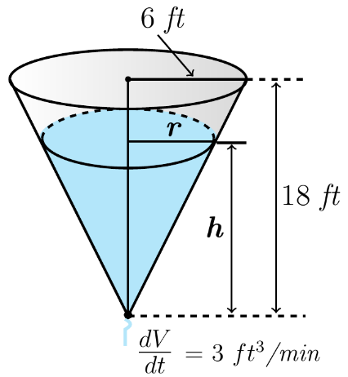From the triangles:

















The water level is rising at about 0.23873 ***ft/min***.

***Exercise***

Water runs into a conical tank at the rate of . The tank stands point down and has a height of 18 *feet* and a base radius of 6 *feet*. How fast is the water level rising when the water is 12 *feet* deep?

***Solution***

***Given***: 

The water forms a cone with volume:



From the triangles:



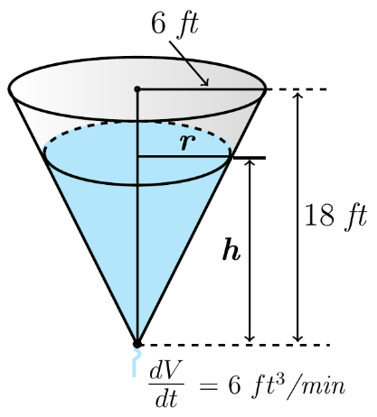













The water level is rising at about 0.119366 ***ft/min***.

***Exercise***

A hemispherical tank with a radius of 10 *m* is filled from an inflow pipe at a rate of . (Hint: The volume of a cap of thickness *h* sliced from a sphere of radius *r* is ).

1. How fast is the water level rising when the water level is 5 *m* from the bottom of the tank?
2. What is the rate of change of the surface area of the water when the water is 5 *m* deep?

***Solution***

***Given***: 

1. 





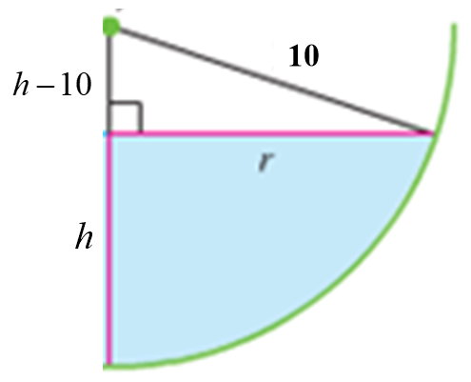When 





1. 

From the right triangle:























***Exercise***

A fisherman hooks a trout and reels in his line at 4 *in/sec*. Assume the trip of the fishing rod is 12 *feet* above the water directly above the fisherman and the fish is pulled horizontally directly towards the fisherman. Find the horizontal speed of the fish when it is 20 *feet* from the fisherman.



***Solution***

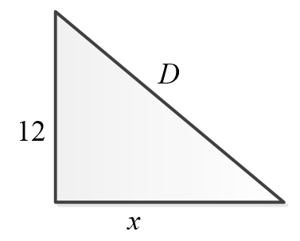Let *x* be the distance between the fisherman’s feet & fish.

Let *D* be the distance between the fisherman’s head & the fish.

***Given***: 











The fish is moving toward the fisherman at about 4.66 *inches* per *second*.

***Exercise***

Water is flowing at the rate of 6 from a reservoir shaped like a hemispherical bowl of radius 13 ***m***. Answer the following questions, given that the volume of water in a hemispherical bowl of radius *R* is  when the water is *y* meters deep.

1. At what rate the water level changing when the water is 8 ***m*** deep?
2. What is the radius *r* of the water’s surface when the water is *y* ***m*** deep?
3. At what rate is the radius *r* changing when the water is 8 ***m*** deep?

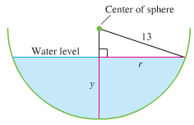***Solution***

***Given***: 

1. 



 ***Factor*** 



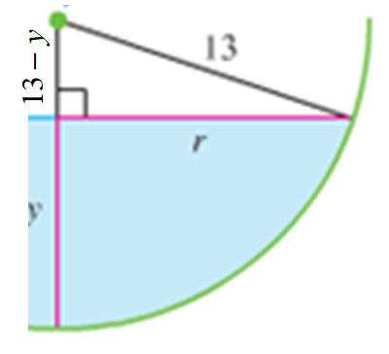



1. The hemispherical is on the circle:











1. 











***Exercise***

A spherical balloon is inflated with helium at the rate of . How fast is the balloon’s radius increasing at the instant the radius is 5 *feet*? How fast the surface area increasing?

***Solution***

***Given***: 

If 

















The rate of the surface area is increasing.

***Exercise***

A hot air balloon rising straight up from a level filed is tracked by a range finder 500 *feet* from the liftoff point. At the moment, the range finder’s elevation angle is , the angle is increasing at the rate of 0.14 *rad/min*. How fast is the balloon rising at that moment?

***Solution***

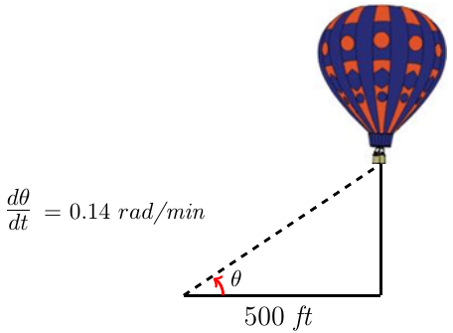***Given***: 













The balloon is rising at the rate of 280 *ft/min*.

***Exercise***

A hot air balloon rising straight up from a level filed is tracked by a range finder 1,000 *feet* from the liftoff point. At the moment, the range finder’s elevation angle is , the angle is increasing at the rate of  . How fast is the balloon rising at that moment?

***Solution***

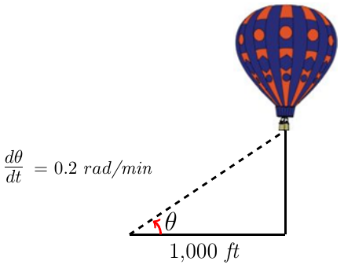***Given***: 













The balloon is rising at the rate of 800 *ft/min*.

***Exercise***

A hot air balloon rising straight up from a level filed is tracked by a range finder 1,000 *feet* from the liftoff point. At the moment, the range finder’s elevation angle is , the angle is increasing at the rate of  . How fast is the balloon rising at that moment?

***Solution***

***Given***: 













The balloon is rising at the rate of 400 *ft/min*.

***Exercise***

A balloon rising vertically above a level, straight road at a constant rate of 1 *ft/sec*. Just when the balloon is 65 *feet* above the ground, a bicycle moving at a constant rate of 17 *ft/sec* passes under it. How fast is the distance  between the bicycle and the balloon increasing 3 *sec* later?

***Solution***

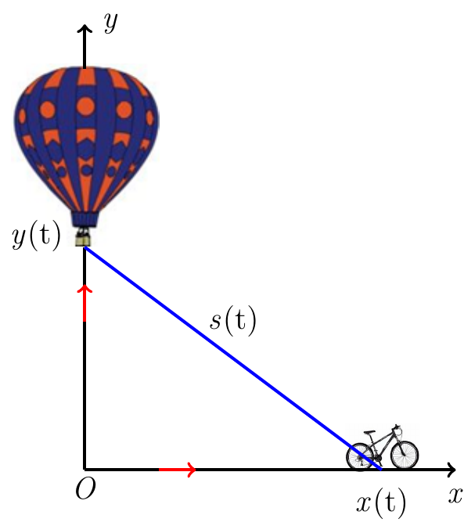***Given***: 

Bicycle increasing 3 *sec*:





















***Exercise***

An observer stands 300 *feet* from the launch site of a hot-air balloon. The balloon is launched vertically and maintains a constant upward velocity of 20 *ft/sec*. what is the rate of change of the angle of elevation of the balloon when it is 400 *feet* from the ground? The angle of elevation is the angle *θ*  between the observer’s line of sight to the balloon and the ground.

***Solution***

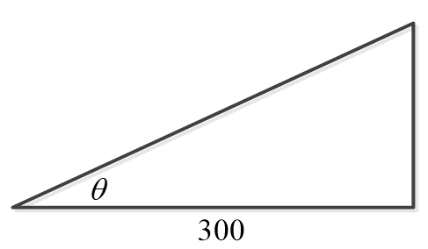***Given***: 











***Exercise***

A dinghy is pulled toward a dock by a rope from the bow through a ring on the dock 6 *ft* above the bow. The rope is hauled in at rate of 2 *ft/sec*.

1. How fast is the boat approaching the dock when 10 *ft* of rope are out?
2. At what rate is the angle *θ* changing at this instant?

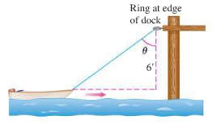***Solution***

***Given***: 

1. 











1. 



 





***Exercise***

The figure shows a boat 1 *km* offshore, sweeping the shore with a searchlight. The light turns at a constant rate .

1. How fast is the light moving along the shore when it reaches point *A*?
2. How many revolutions per minute is 0.6 *rad/sec*?

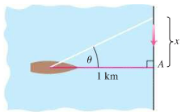***Solution***

***Given***: 





1. At 





∴ The speed of the light is 0.6 *km/sec* when it reaches point *A*.

1. 

***Exercise***

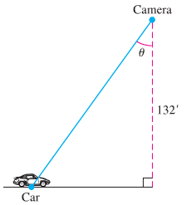You are videotaping a race from a stand 132 *feet* from the track, following a car that is moving at 180 *mi/h* (264 *ft/sec*). How fast will your camera angle *θ*  be changing when the car is right in front of you? A half second later?

***Solution***









***x***



At half second later the car has traveled 132 *feet* right to the perpendicular

 , and  (since *x* increases)





***Exercise***

The coordinates of a particle in the metric *xy*−plane are differentiable functions of time *t* with  and . How fast is the particle’s distance from the origin changing as it passes through the point (5, 12)?

***Solution***

***Given***: 













***Exercise***

Coffee is draining from a conical filter into a cylindrical coffeepot at the rate of 10 .

1. How fast is the level in the pot rising when the coffee in the cone is 5 *in*. deep?
2. How fast is the level in the cone falling then?

***Solution***



1. Let *h* be the height of the coffee in the pot.

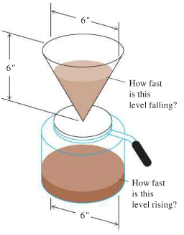Volume of the coffee:













1. Radius of the filter: 

Volume of the filter:















***Exercise***

A particle moves along the parabola  *in* the first quadrant in such a way that its *x*-coordinate (measure in meters) increases at a steady 10 *m/sec*. How fast is the angle of inclination *θ* of the line joining the particle to the origin changing when *x* = 3 *m*?

***Solution***

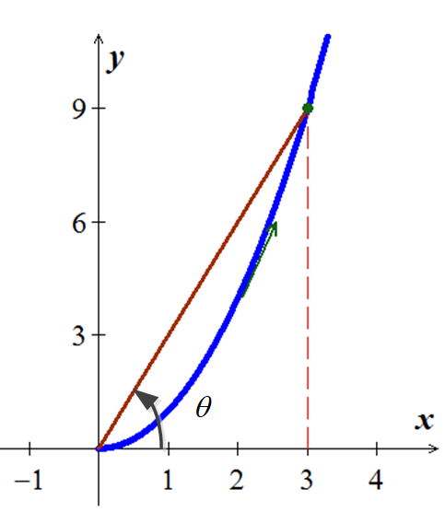***Given***: 













***Exercise***

To find the height of a lamppost, you stand a 6 *feet* pole 20 *feet* from the lamp and measure the length *a* of its shadow, finding it to be 15 *feet*, give or take an inch. Calculate the height of the lamppost using the value of *a* = 15 and estimate the possible error in the result.

***Solution***

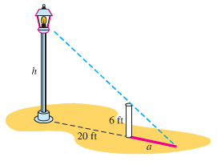





















 

***Exercise***

A light shines from the top of a pole 50 *feet* high. A ball is dropped from the same height from a point 30 *feet* away from the light. How fast is the shadow of the ball moving along the ground  *sec* later? (Assume the ball falls a distance  *ft* in *t* *sec*.)

***Solution***





Triangles *XOY* and *XQP* are similar:































***Exercise***

A spherical iron ball 8 *in*. in diameter is coated with a layer of ice of uniform thickness. If the ice melts at the rate of 10 , how fast is the thickness of the ice decreasing when it is 2 *in*. thick? How fast is the outer surface area of ice decreasing?

***Solution***

***Given***: 





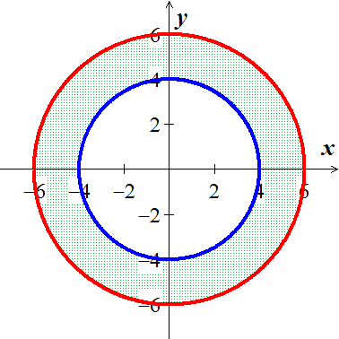













The outer surface of the ice is decreasing at 

***Exercise***

On a morning of a day when the sun will pass directly overhead, the shadow of an 80−*feet* building on level ground is 60 *feet* long. At the moment in question, the angle *θ* the sun makes with the ground is increasing at the rate of 0.27 °/ *min*. At what rate is the shadow decreasing?

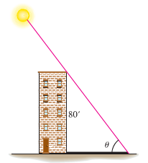***Solution***

***Given***: 













 





***Exercise***

A baseball diamond is a square 90 *feet* on a side. A player runs from first base to second at a rate of 16 *ft/sec*.

1. At what rate is the player’s distance from third base changing when the player is 30 *feet* from first base?
2. At what rates are angles  changing at that time?
3. The player slides into second base at the rate of 15 *ft/sec*. At what rates are angles  changing as the player touches base?

***Solution***

***Given***: 

***x***: Distance between player and 2*nd* base

***s***: Distance between player and 3*rd* base

1. 

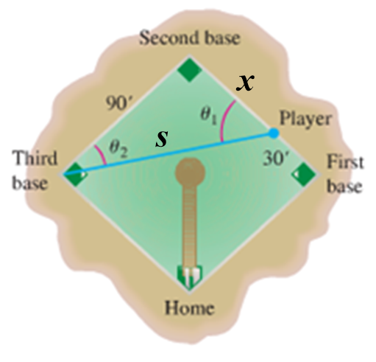

















1. 



 













 







1.  







Player slides into second base 













Player slides into second base 





***Exercise***

Runners stand at first and second base in a baseball game. At the moment, a ball is hit the runner at first base runs to second base at 18 *ft/s*; simultaneously the runner on second runs to third base at 20 *ft/s*. How fast is the distance between the runners changing 1 *sec* after the ball is hit?

(*Hint*: The distance between consecutive bases I 90 *feet* and the bases lie at the corners of a square.)



***Solution***

***Given***: 

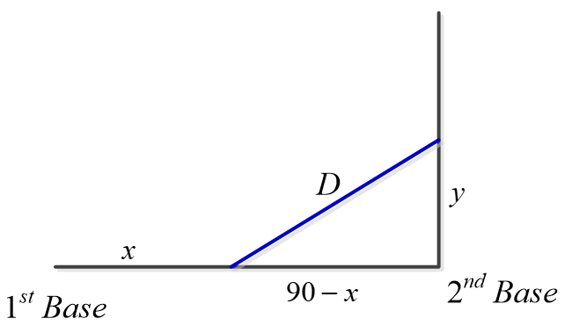After 1 *sec*, 

















So, the distance between the runners is decreasing at a rate about 11.99 *feet* per *second*.

***Exercise***

The variables *x* and *y* are both differentiable functions of *t* and are related by the equation . Find  when , given  when .

***Solution***









***Exercise***

A pebble is dropped into a calm pond, causing ripples in the form of concentric circles. The radius *r* of the outer ripple is increasing at a constant rate of 1 *foot* per *second*.

When the radius is 4 *feet*, at what rate is the total area ***A*** of the disturbed water changing?

***Solution***

***Given***: 

***Find***: 









***Exercise***

Air is being pumped into a spherical balloon at a rate of 4.5 .

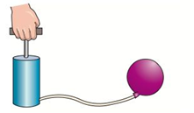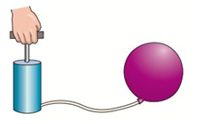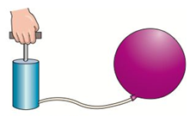

Find the rate of change of the radius when the radius is 2 *feet*.

***Solution***

***Given***:  ***Find***: 











***Exercise***

An Airplane is flying on a flight path that will take it directly over a radar tracking station. The distance *s* is decreasing at a rate of 400 *mph* when . what is the speed of the plane?

***Solution***

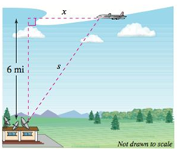***Given***: 

***Find***: 











***Exercise***

Find the rate of change in the angle of elevation of the camera at 10 *seconds* after lift-off.

***Solution***

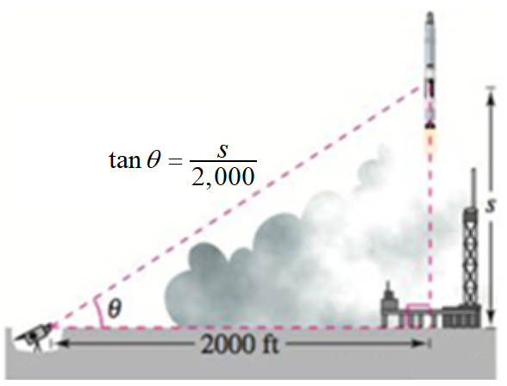***Given***: 

***Find***: 





 









***Exercise***

In the engine, a 7−*inch* connecting rod is fastened to a crank of radius 3 *inches*, the crankshaft rotates counterclockwise at a constant rate of 200 *revolutions per minute*.

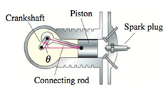Find the velocity of the piston when .

***Solution***

***Given***: 

***Find***: 

 





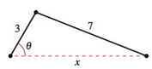





.





***Exercise***

A swimming pool is 12 *meters* long, 6 *meters* wide, 1 *meter* deep at the shallow end, and 3 *meters* deep at the deep end. Water is being pumped into the pool at , and there is 1 *meter* of water at the deep end.

1. 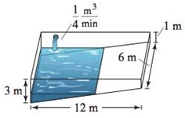What percent of the pool is filled?
2. At what rate is the water level rising?

***Solution***

***Given***: 

1. Total Volume:





Volume of 1 *m* of water:





% pool filled 



1. Since there is 1 *m* of water in the pool, then 





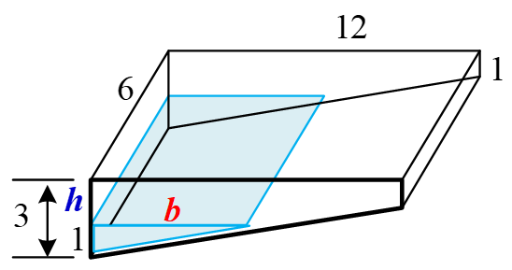













***Exercise***

A trough is 12 *feet* long and 3 *feet* across the top. Its ends are isosceles triangles with altitudes of 3 *feet*.

1. Water is being pumped into the trough at . How fast is the water level rising when the depth *h* is 1 *foot*?
2. 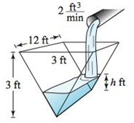The water is rising at a rate of  when . Determine the rate at which water is being pumped into the trough.

***Solution***

***Given***: 

1. 





 





1. ***Given***: , 





***Exercise***

A ladder 25 *feet* long is leaning against the wall of a house. The base of the ladder is pulled away from the wall at a rate of 2 *feet* per *second*.

1. How fast is the top of the ladder moving down the wall when its base is 7 *feet*, 15 *feet*, and 24 *feet* from the wall?
2. Consider the triangle formed by the side of the house, the ladder, and the ground. Find the rate at which the area of the triangle is changing when the base of the ladder is 7 *feet* from the wall.
3. 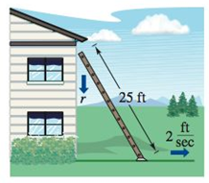Find the rate at which the angle between the ladder and the wall of the house is changing when the base of the ladder is 7 *feet* from the wall.

***Solution***

***Given***: 







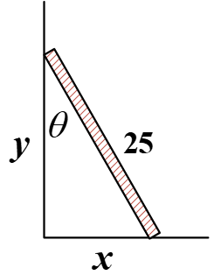 

1. 































1. 



We have: 





1. 





We have: 









***Exercise***

A construction worker pulls a five-*meter* plank up the side of a building under construction by means of a rope tied to one end of the plank. Assume the opposite end of the plank follows a path perpendicular to the wall of the building and the worker pulls the rope at a rate of . How fast is the end of the plank sliding along the ground when it is 2.5 *meters* from the wall of the building?

***Solution***

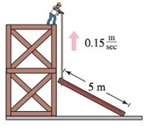

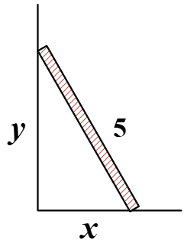



***Given***: 







***Exercise***

A winch at the top of a 12-*meter* building pulls a pipe of the same length to a vertical position. The winch pulls in rope at a rate of . Find the rate of vertical change and the rate of horizontal change at the end of the pipe when 

***Solution***

When 

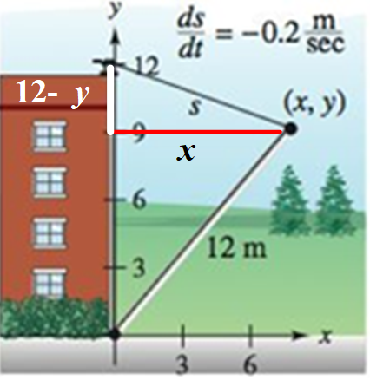

























 











***Exercise***

A boat is pulled into a dock by means of a winch 12 *feet* above the deck of the boat.

1. The winch pulls in rope at a rate of 4 *feet* per *second*. Determine the speed of the boat when there is 13 *feet* of rope out. What happens to the speed of the boat as it gets closer to the dock?
2. Suppose the boat is moving at a constant rate of 4 *feet* per *second*. Determine the speed at which the winch pulls in rope when there is a total of 13 *feet* of rope out. What happens to the speed at which the winch pulls in rope as the boat gets closer to the dock?

***Solution***

Let *L* be the length of the rope.

1. 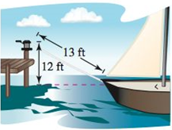





***Given***: 

When 









1. 













***Exercise***

An air traffic controller spots two planes at the same altitude converging on a point as they fly at right angles to each other. One plane is 225 *miles* from the point moving at 450 . The other plane is 300 *miles* from the point moving at 600 .

1. At what rate is the distance between the planes decreasing?
2. How much time does the air traffic controller have to get one of the planes on a different flight path?

***Solution***

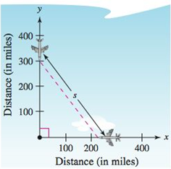***Given***: 

1. 















1. 

***Exercise***

An airplane is flying at an altitude of 5 *miles* and passes directly over a radar antenna. When the plane is 10 *miles* away , the radar detects that the distance *s* is changing at a rate of 240 . What is the speed of the plane?

***Solution***

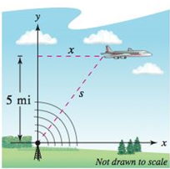***Given***: 

1. 













***Exercise***

A man 6 *feet* tall walks at a rate of 5 *feet* per *second* away from a light that is 15 *feet* above the ground.

1. When he is 10 *feet* from the base of the light, at what rate is the tip of his shadow moving?
2. When he is 10 *feet* from the base of the light, at what rate is the length of his shadow changing?

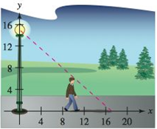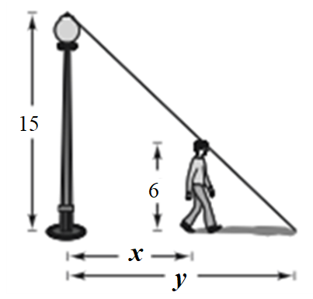***Solution***

1. 













1. 





***Exercise***

A man 6 *feet* tall walks at a rate of 5 *feet* per *second* *toward* a light that is 20 *feet* above the ground.

1. When he is 10 *feet* from the base of the light, at what rate is the tip of his shadow moving?
2. When he is 10 *feet* from the base of the light, at what rate is the length of his shadow changing?

***Solution***

1. 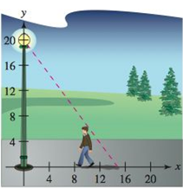



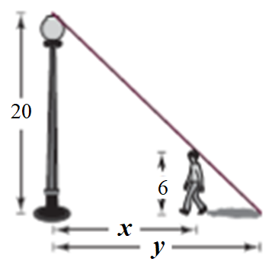









1. 





***Exercise***

A man 6 *feet* tall walks at a rate of 5  toward a streetlight that is 30 *feet* high. The man’s 3-*foot*-tall child follows at the same speed, but 10 *feet* behind the man. At times, the shadow behind the child is caused by the man, and at other times, by the child.

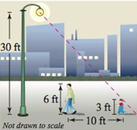

1. Suppose the man is 90 *feet* from the streetlight. Show that the man’s shadow extends beyond the child’s shadow.
2. Suppose the man is 60 *feet* from the streetlight. Show that the child’s shadow extends beyond the man’s shadow.
3. Determine the distance *d* from the man to the streetlight at which the tips of the two shadows are exactly the same distance from the streetlight.
4. Determine how fast the tip of the man’s shadow is moving as a function of *x*, the distance between the man and the streetlight. Discuss the continuity of this shadow speed function.

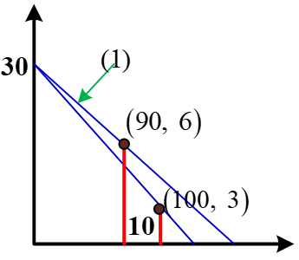***Solution***

1. Line (1):  



When 





The shadow determined by the man extends beyond the shadow by the child.

1. 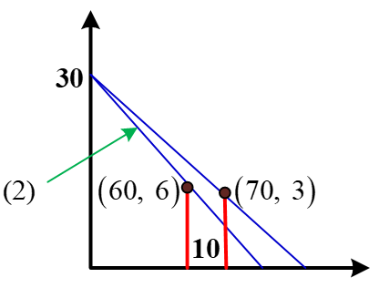Line (2): 





When 





The shadow determined by the child extends beyond the shadow by the man.

1. The points: , , and 











1. ***Given***: 

The shadow is determined by the man











The shadow is determined by the child













 is not continuous at .

***Exercise***

A ball is dropped from a height of 20 *m*, 12 *m* away from the top of a 20-*meter* lamppost. The ball’s shadow, caused by the light at the top of the lamppost, is moving along the level ground. How fast is the shadow moving 1 *second* after the ball is released?

***Solution***

 



At 

