***Solution*** ***Section* 2.1 – Introducing the Derivative**

***Exercise***

Use the definition of the derivative to determine the slope of the curve . Find an equation of the line tangent to the curve  at *P*; then graph the curve and the tangent line.



***Solution***















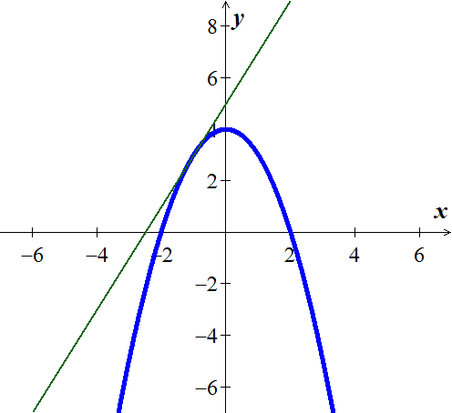

At (−1, 3) 





***Exercise***

Use the definition of the derivative to determine the slope of the curve . Find an equation of the line tangent to the curve  at *P*; then graph the curve and the tangent line.



***Solution***









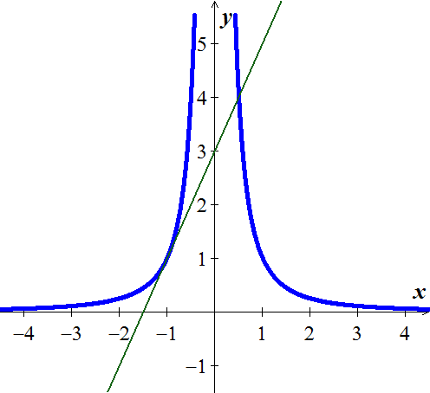 



. 





At (−1, 3) 





***Exercise***

Use the definition of the derivative to determine the slope of the curve . Find an equation of the line tangent to the curve  at *P*; then graph the curve and the tangent line.



***Solution***

















At (1, 2)  





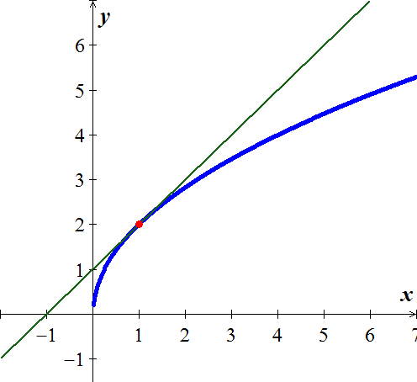

***Exercise***

Use the definition of the derivative to determine the slope of the curve . Find an equation of the line tangent to the curve  at *P*; then graph the curve and the tangent line.

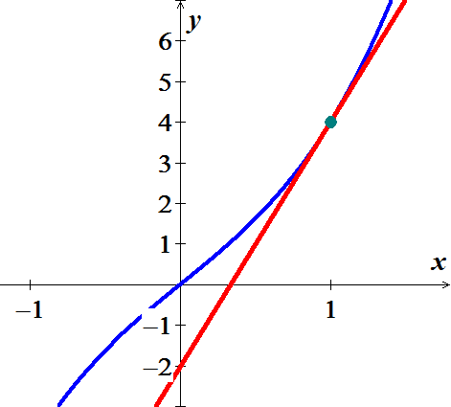

***Solution***











At 

 





***Exercise***

Use the definition of the derivative to determine the slope of the curve . Find an equation of the line tangent to the curve  at *P*; then graph the curve and the tangent line.



***Solution***













At 

 



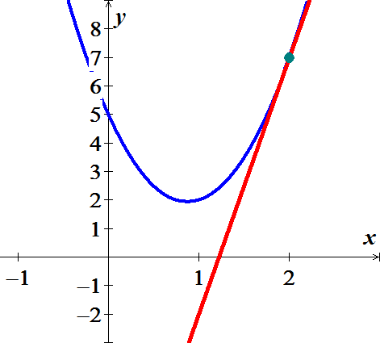

***Exercise***

Use the definition of the derivative to determine the slope of the curve . Find an equation of the line tangent to the curve  at *P*; then graph the curve and the tangent line.



***Solution***

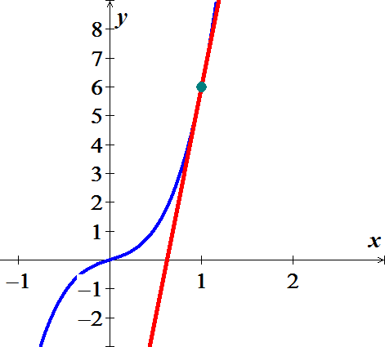











 



***Exercise***

Use the definition of the derivative to determine the slope of the curve . Find an equation of the line tangent to the curve  at *P*; then graph the curve and the tangent line.



***Solution***





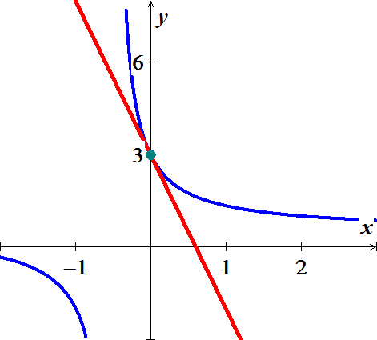 







 

***Exercise***

Use the definition of the derivative to determine the slope of the curve . Find an equation of the line tangent to the curve  at *P*; then graph the curve and the tangent line.



***Solution***



















 

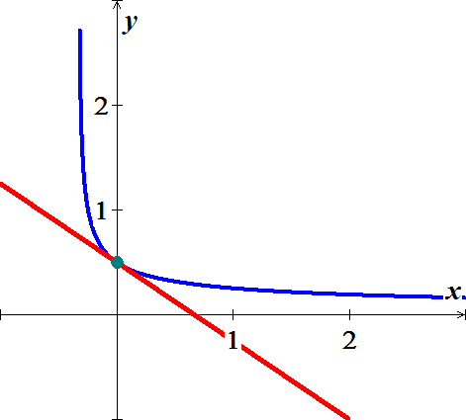

***Exercise***

Find the slope of the curve  at the point 

***Solution***















***Exercise***

Find the slope of the curve  at the point 

***Solution***















***Exercise***

Find the slope of the curve  at the point 

***Solution***















***Exercise***

Find equations of all lines having slope −1 that are tangent to the curve 

***Solution***





 ***Cross multiplication***



















At  





***Exercise***

What is the rate of change of the area of a circle  with respect to the radius when the radius is ?

***Solution***















***Exercise***

Find the slope of the tangent to the curve  at the point where 

***Solution***





















***Exercise***

Fin the values of the derivatives of the function . Then find the values of 

***Solution***





















***Exercise***

Fin the values of the derivatives of the function . Then find the values of 

***Solution***



























***Exercise***

Find the derivative of 

***Solution***















***Exercise***

Find the derivative of *y* with the respect to *t* for the function 

***Solution***















***Exercise***

Find the derivative of 

***Solution***













***Exercise***

Differentiate the function  and find the slope of the tangent line at the given value of the independent variable.

***Solution***

















***Exercise***

Find the equation of the tangent line to  that is parallel to 2*x* + *y* = 0

***Solution***

2*x* + *y* = 0 ⇒ *y* = −2*x* ⇒ slope = −2



















The line equation is given by 





***Exercise***

Use the definition of limits to find the derivative: 

***Solution***

















***Exercise***

Use the definition of limits to find the derivative: 

***Solution***













***Exercise***

Suppose the height *s* of an object (in *m*) above the ground after *t* seconds is approximated by the function 

1. Make a table showing the average velocities of the object from time  to , for  .
2. Use the table in part (*a*) to estimate the instantaneous velocity of the object at .
3. Use limits to verify your estimate in part (*b*).

***Solution***

1. 







|  |  |
| --- | --- |
| *h* |  |
| 0.01 | 15.151 |
| 0.001 | 15.1951 |
| 0.0001 | 15.1995 |
| 0.00001 | 15.2 |
| 0.000001 | 15.2 |

1. 



1. 



***Exercise***

Suppose the following graph represents the number of bacteria in a culture *t* hours after the start of an experiment.

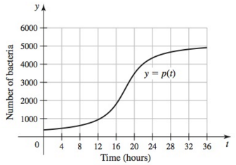

1. At approximately what time is the instantaneous growth rate the greatest, for ? Estimate the growth rate at this time.
2. At approximately what time is the instantaneous growth rate the least, for ? Estimate the growth rate at this time.
3. What is the average growth rate over the interval ?

***Solution***

1. 

Point the rate 





1. It is smallest at 





1. Growth rate 



