***Solution*** ***Section* 2.5 – Derivative as Rates of Change**

***Exercise***

The position  of a body moving on a coordinate line, with *s* in meters and *t* in seconds.

1. Find the body’s displacement and average velocity for the given time interval.
2. Find the body’s speed and acceleration at the endpoints of the interval.
3. When, if ever, during the interval does the body change direction?

***Solution***

1. Displacement: 





Average velocity = 





1. 







1. 





*v* is negative in the interval 

*v* is positive in the interval 

The body changes direction at 

***Exercise***

The position  of a body moving on a coordinate line, with *s* in meters and *t* in seconds.

1. Find the body’s displacement and average velocity for the given time interval.
2. Find the body’s speed and acceleration at the endpoints of the interval.
3. When, if ever, during the interval does the body change direction?

***Solution***

1. Displacement: 







Average velocity = 

1. 











1. 



*v* is never equal to zero ⇒ The body never changes direction.

***Exercise***

At time *t*, the position of a body moving along the *s*-axis is  ***m***.

1. Find the body’s acceleration each time the velocity is zero.
2. Find the body’s speed each time the acceleration is zero.
3. Find the total distance traveled by the body from *t* = 0 to *t* = 2.

***Solution***

1. 







The body is motionless but being accelerated left when *t* = 1, and motionless but being accelerated right when *t* = 3.

1. 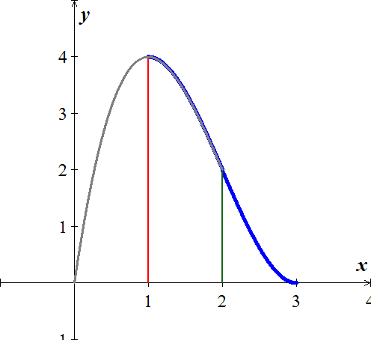







1. The body moves forward on 







The body moves backward on 







Total distance 

***Exercise***

A rock thrown vertically upward from the surface of the moon at a velocity of 24 *m/sec* (about 86 *km/h*) reaches a height of  *m* in *t* *sec*.

1. Find the rock’s velocity and acceleration at time *t*. (The acceleration in this case is the acceleration of gravity on the moon.)
2. How long does it take the rock to reach its highest point?
3. How high does the rock go?
4. How long does it take the rock to reach half its maximum height?
5. How long is the rock aloft?

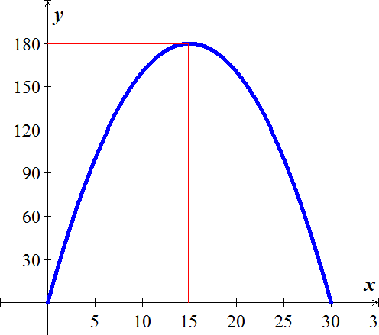***Solution***

1. 



1. 





1. 



1. Since the maximum high is 180 *m*, then half is 90 *m*:













It took 4.39 *sec* going up and 25.6 *sec* going down.

1. The rock took 30 *sec* to reach its highest point.

***Exercise***

Had Galileo dropped a cannonball from the Tower of Pisa, 179 *ft* above the ground, the ball’s height above the ground *t* *sec* into the fall would have been .

1. What would have been the ball’s velocity, speed, and acceleration at time *t*?
2. About how long would it have taken the ball to hit the ground?
3. What would have been the ball’s velocity at the moment of impact?

***Solution***

1. 





1. 









1. When *t* = 3.3 *sec*

⇒ 





***Exercise***

A toy rocket fired straight up into the air has height  after *t* seconds.

1. What is the rocket’s initial velocity (when )?
2. What is the acceleration when ?
3. At what time will the rocket hit the ground?
4. At what velocity will the rocket be traveling just as it smashes into the ground?

***Solution***

1. 



1. 



1. 

The rocket hit the ground at 





***Exercise***

A helicopter is rising straight up in the air. Its distance from the ground *t* seconds after takeoff is 

1. How long will it take for the helicopter to rise 20 *feet* ?
2. Find the velocity and the acceleration of the helicopter when it is 20 *feet* above the ground.

***Solution***

1. 





It will take 10 *sec*. for the helicopter to rise 20 *feet.*

1. 







***Exercise***

The position of a particle moving on a line is given by , where *t* is measured in *seconds* and *s* in *feet*.

1. What is the velocity after 3 *seconds* and after 6 *seconds*?
2. When the particle moving in the positive direction?
3. Find the total distance traveled by the particle during the first 7 *seconds*.

***Solution***

1. 









1. 



The particle is moving in the positive direction at 3.5 *sec*

1. 



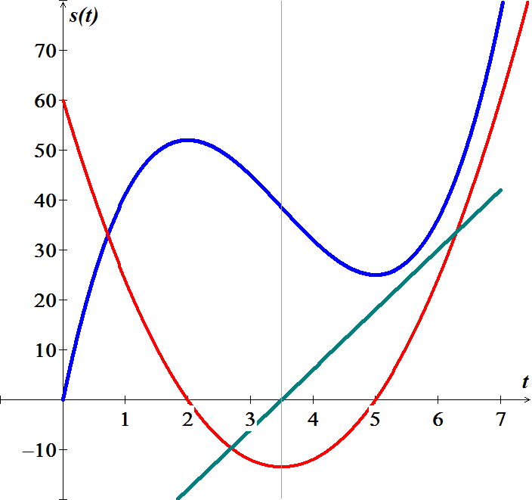

***Exercise***

A small probe is launched vertically from the ground. After it reaches its high point, a parachute deploys, and the probe descends to Earth. The height of the probe the ground is



1. Graph the height function and describe the motion of the probe.
2. Find the velocity of the probe.
3. Graph the velocity function and determine the approximate time at which the velocity is a maximum.

***Solution***

1. 

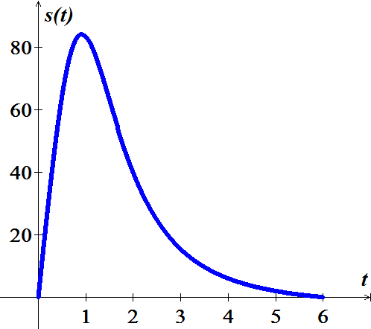 









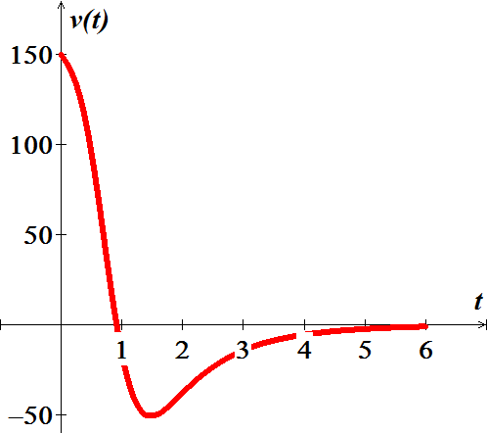

The maximum height is 84.107 at 

1. 
2. 



The maximum velocity is 150

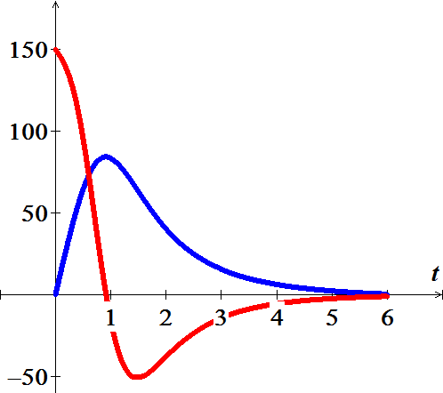

***Exercise***

Suppose the cost of producing *x* lawn mowers is 

1. Determine the average and marginal costs for  lawn mowers.
2. Interpret the meaning of your results in part (*a*)

***Solution***

1. Average Cost 







Marginal Cost 





1. The average cost of producing 3,000 lawmowers is $341.67 per mower.

The cost of producing the 3,001st lawmower is about $280.00

***Exercise***

Suppose a company produces fly rods. Assume  represents the cost of making *x* fly rods.

1. Determine the average and marginal costs for  fly rods.
2. Interpret the meaning of your results in part (*a*)

***Solution***

1. Average Cost 







Marginal Cost 





1. The average cost of producing 400 fly rods is $66.00 per fly rod.

The cost of producing the 401st flying rod is about $52.00

***Exercise***

Suppose  is the population of a city *t* years after 1950.

1. Determine the average rate of growth of the city from 1950 to 2000.
2. What was the rate of growth of the city in 1990?

***Solution***

From 1950 to 2000 

1. Average growth rate 





1. 



