***Solution*** ***Section* 3.1 – Maxima and Minima**

***Exercise***

Find the absolute maximum and minimum values of the function. Then graph the function. Identify the points on the graph where the absolute extrema occur, and include their coordinates.

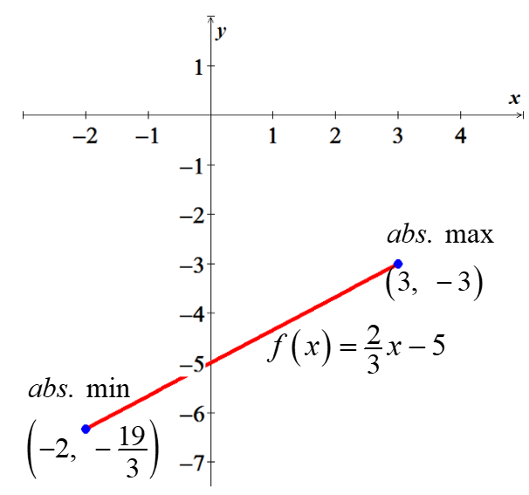

***Solution***



∴ No ***C***ritical ***P***oints (***CP***) or (***CN***).





***Absolute Maximum***: 

***Absolute Minimum***: 

***Exercise***

Find the absolute maximum and minimum values of the function. Then graph the function. Identify the points on the graph where the absolute extrema occur, and include their coordinates.

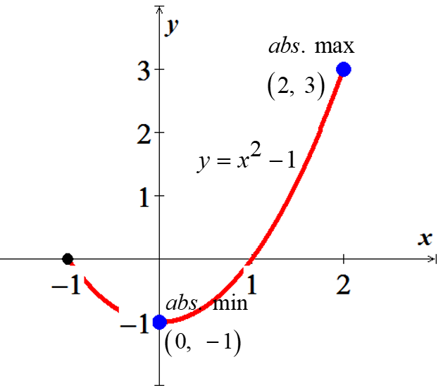

***Solution***

 (***CN***)







***Abs. Maximum***: 

***Abs. Minimum***: 

***Exercise***

Find the absolute maximum and minimum values of the function. Then graph the function. Identify the points on the graph where the absolute extrema occur, and include their coordinates.



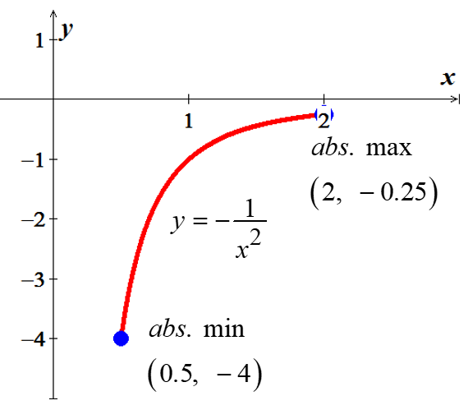***Solution***

  Which it is not in the domain

No critical point.





***Abs. Max***: 

***Abs. Min***: 

***Exercise***

Find the absolute maximum and minimum values of the function. Then graph the function. Identify the points on the graph where the absolute extrema occur, and include their coordinates.



***Solution***

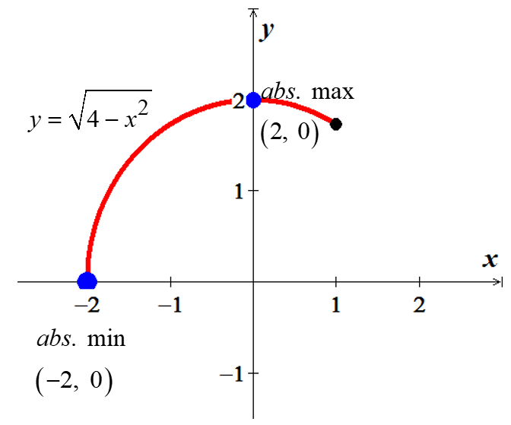



 

Critical points: 







***Abs. Max***:  ***Abs. Min***: 

***Exercise***

Find the absolute maximum and minimum values of the function. Then graph the function. Identify the points on the graph where the absolute extrema occur, and include their coordinates.



***Solution***

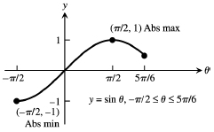 (***CN***)







***Abs. Min***: 

***Abs. Max***: 

***Exercise***

Find the absolute maximum and minimum values of the function. Then graph the function. Identify the points on the graph where the absolute extrema occur, and include their coordinates.



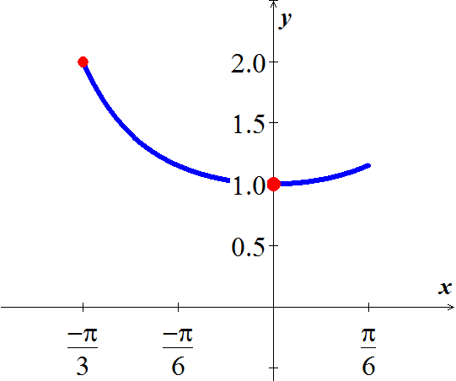***Solution***

 (***CN***)







***Abs. Max***: 

***Abs. Min***: 

***Exercise***

Find the absolute maximum and minimum values of 

***Solution***

 (***CN***)







***Abs. Max***: 

***Abs. Min***: 

***Exercise***

Find the absolute maximum and minimum values of 

***Solution***

 (***CN***)







***Abs. Max***: 

***Abs. Min***: 

***Exercise***

Find the absolute maximum and minimum values of 

***Solution***

|  |  |
| --- | --- |
|  | (since it is ***periodic***) |











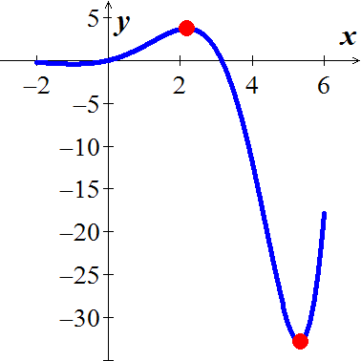

***Abs. Max***: 

***Abs. Min***: 

***Exercise***

Find the absolute maximum and minimum values of 

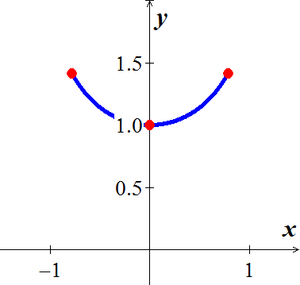***Solution***

 (***CN***)







***Abs. Max***: 

***Abs. Min***: 

***Exercise***

Find the absolute maximum and minimum values of 

***Solution***

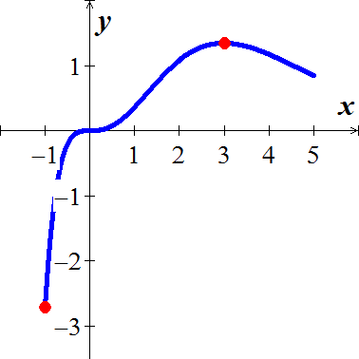













***Abs. Max***: 

***Abs. Min***: 

***Exercise***

Find the absolute maximum and minimum values of 

***Solution***

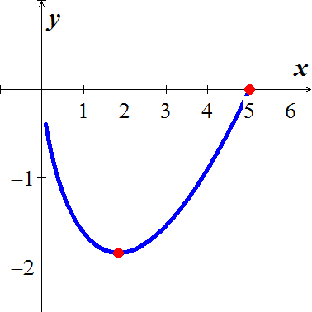











***Abs. Max***: 

***Abs. Min***: 

***Exercise***

Find the absolute extrema of 

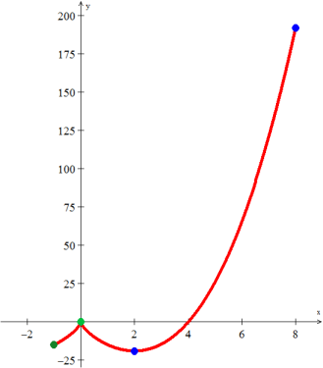***Solution***











The derivative is undefined at

|  |  |
| --- | --- |
| *x* |  |
| −1 | −15 |
| 0 | 0 |
| 2 | −19.05 |
| 8 | 192 |

***Abs. max: *** ***Abs. Min*** 

***Exercise***

Find the minimum and maximum values of 

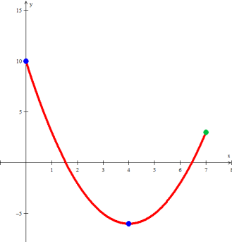***Solution***





→*y* = 16 - 32 + 10 = -6



***Abs. Maximum*** (0, 10)

***Abs. Minimum*** (4, −6)

***Exercise***

Find the absolute extrema of the function on the closed interval 

***Solution***







***Abs. Max***:  ***abs Min***: 

***Exercise***

Find the absolute extrema of the function on the closed interval 

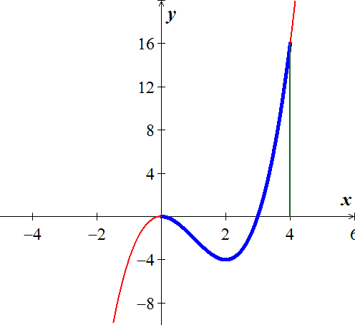***Solution***











***Abs. Max***:  ***LMIN***: 

***Exercise***

Find the absolute extrema of the function on the closed interval 

***Solution***

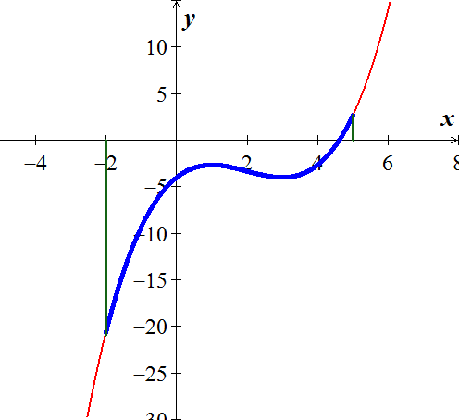









***Abs. max***:  ***abs. min***: 

***Exercise***

Find the absolute extrema of the function on the closed interval 

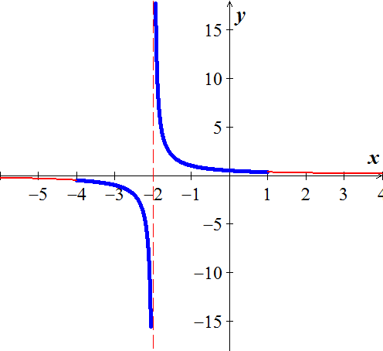***Solution***





There is ***no*** Relative Extrema.

***Exercise***

Find the absolute extrema of the function on the closed interval 

***Solution***

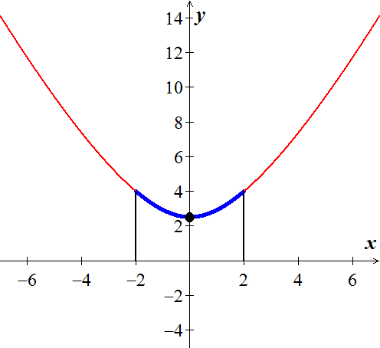













***RMAX***:  ***RMIN***: 

***Exercise***

Find the absolute maximum and minimum values of each function (if they exist).



***Solution***



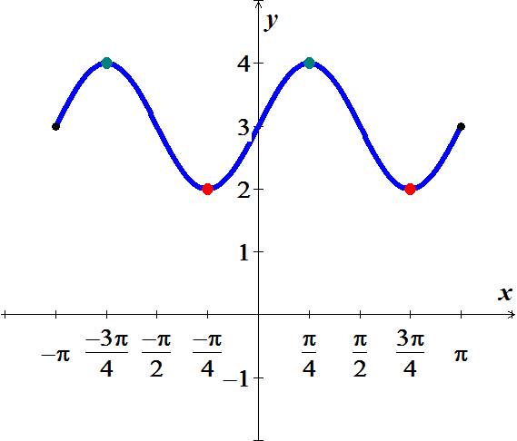

|  |  |
| --- | --- |
|  |  |
|  | 3 |
|  | 4 |
|  | 2 |
|  | 4 |
|  | 2 |
|  | 3 |

***Abs. Min***:  ***Abs. Max***: 

***Exercise***

Find the absolute maximum and minimum values of each function (if they exist).



***Solution***





There is no ***absolute*** ***Max.*** or ***Min***. since 

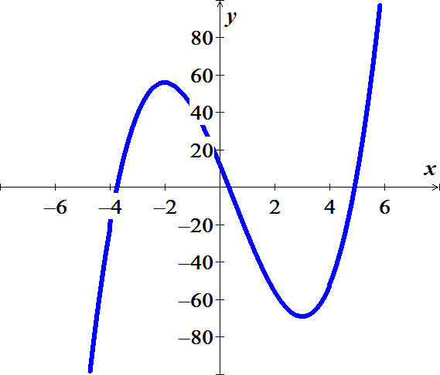

***Exercise***

Find the absolute maximum and minimum values of each function (if they exist).



***Solution***









|  |  |
| --- | --- |
|  |  |
|  | 0 |
|  |  |
|  |  |

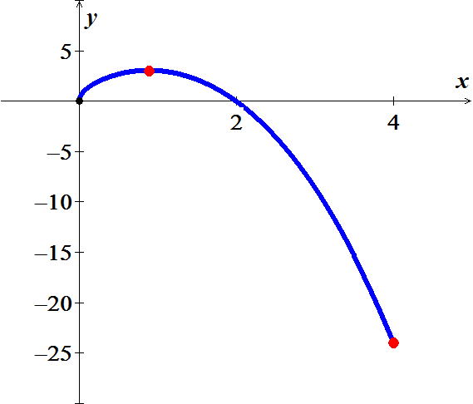

***Abs. Min***:  ***Abs. Max***: 

***Exercise***

Find the absolute maximum and minimum values of each function (if they exist).



***Solution***







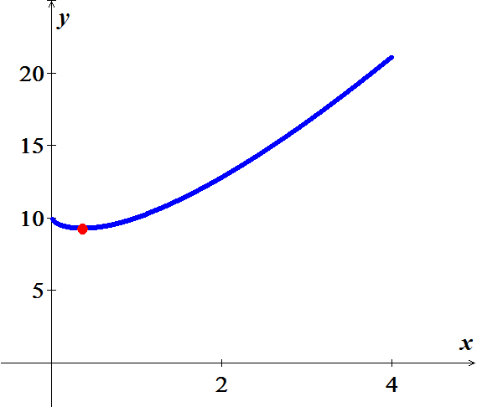

***Abs. Min***: 

***Exercise***

Find the absolute maximum and minimum values of each function (if they exist).

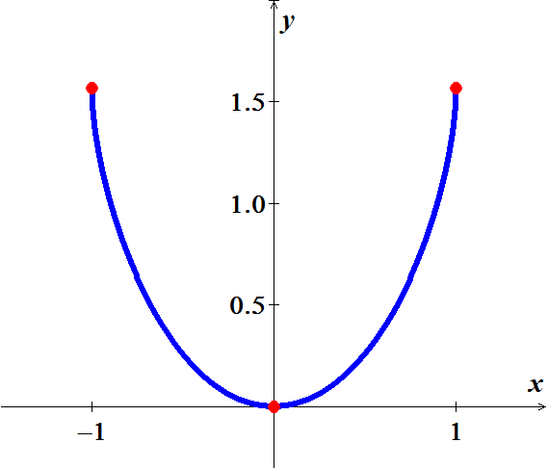

***Solution***





|  |  |
| --- | --- |
|  |  |
|  |  |
|  |  |
|  |  |

***Abs. Min***:  ***Abs. Max***: 

***Exercise***

Determine all critical points of 

***Solution***

 (***CN***)



***Critical point***: 

***Exercise***

Determine all critical points of 

***Solution***

 





The ***critical numbers*** are: *x* = 1, 2, 3

  

***Critical points***: (1, 0), (2, 1) and (3, 0)

***Exercise***

Determine all critical points of 

***Solution***

 

*x* = 2 is not in the domain

The critical numbers are: *x* = 0, 4

 

***Critical points***: 

***Exercise***

Determine all critical points of 

***Solution***





The critical numbers are: *x* = 0, 4

 

***Critical points***: 

***Exercise***

Find the extreme values (absolute and local) of the function and where they occur 

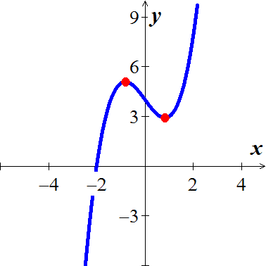***Solution***







***LMAX***:  ***LMIN***: 

***Exercise***

Find the extreme values (absolute and local) of the function and where they occur 

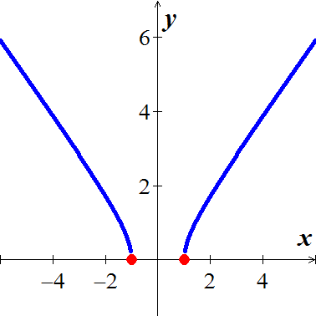***Solution***

***Domain***: 





***LMIN***: 

***Exercise***

Find the extreme values (absolute and local) of the function and where they occur 

***Solution***

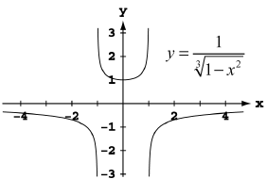***VA***: 





 (***CN***)

***LMIN***  

***Exercise***

Find the extreme values (absolute and local) of the function and where they occur 

***Solution***

 

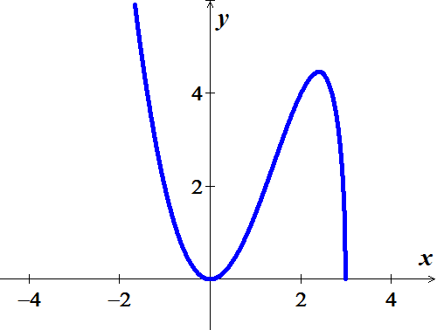 

 

  (***CN***)







***LMAX***:  ***LMIN***: 

***Exercise***

Find the extreme values (absolute and local) of the function and where they occur 

***Solution***

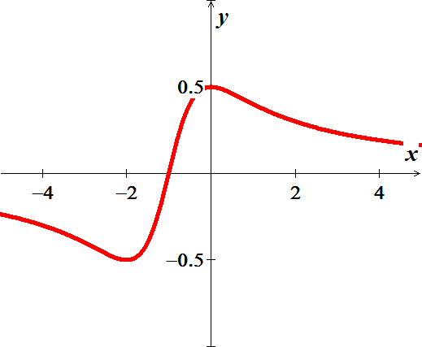 





 (***CN***)





***LMAX***:  ***LMIN***: 

***Exercise***

Find the extreme values (absolute and local) of the function and where they occur 

***Solution***

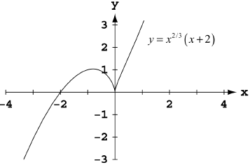 





  (***CN***)





***LMAX***:  ***LMIN***: 

***Exercise***

Find the extreme values (absolute and local) of the function and where they occur 

***Solution***

 

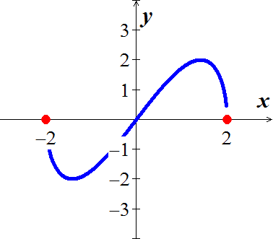 



 **(*CN*)**







***LMAX***:  ***LMIN***: 

***Exercise***

Find the extreme values (absolute and local) of the function and where they occur 

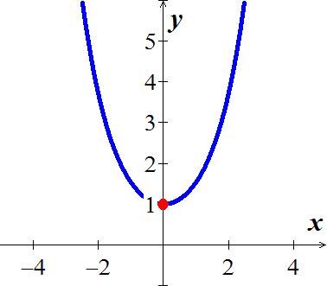***Solution***







***LMIN***: 

***Exercise***

Find the extreme values (absolute and local) of the function and where they occur



***Solution***

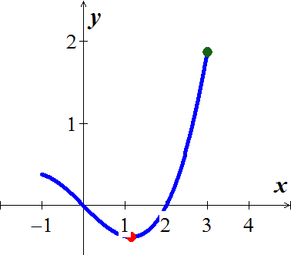











***LMIN***:  ***abs. Max***: 

***Exercise***

Find the extreme values (absolute and local) of the function and where they occur 

***Solution***



 (***CN***)

Since the critical number are not within the domain; inside the log has to be positive.

No abs or local extreme

***Exercise***

Find the extreme values (absolute and local) of the function and where they occur



***Solution***



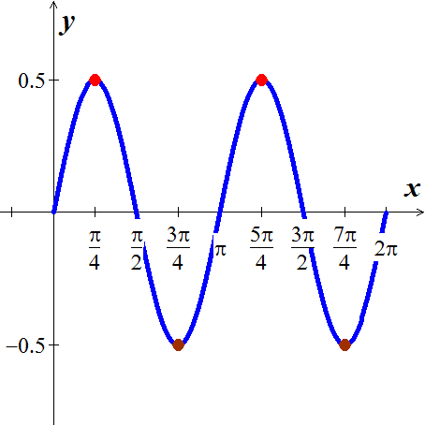 (***CN***)













***LMIN***:  ***LMAX***: 

***Exercise***

Find the extreme values (absolute and local) of the function and where they occur 

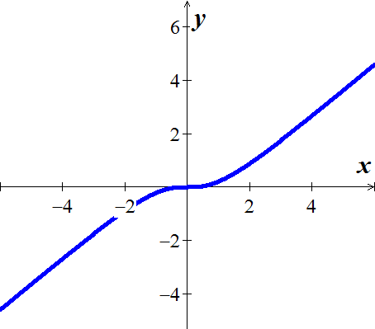***Solution***



 (***CN***)

***No extreme values***

***Exercise***

Let 

1. Does exist?
2. Show the only local extreme value of  occurs at *x* = 2.
3. Does the result in part (*b*) contradict the Extreme Value Theorem?

***Solution***

1.  is undefined at *x* = 2
2.  and 
3. No,  domain is all real numbers and doesn’t need to have a global maximum. Any restriction of *f* to a closed interval of the form [*a, b*] would have a maximum and minimum value on the interval.

***Exercise***

When a telephone wire is hung between two poles, the wire forms a U-shape curve called a Catenary. For instance, the function   models the shape of the telephone wire strung between two poles that are 60 *ft*. apart (*x* & *y* are measured in *ft*.). Show that the lowest point on the wire is midway between two poles. How much does the wire sag between the two poles?

***Solution***





Critical number(s)











⇒ *x* = 0









***Exercise***

You are sitting in a classroom next to the wall looking at the blackboard at the front of the room. The blackboard is 12 *feet* long and starts 3 *feet* from the wall you are sitting next to.

1. Show that your viewing angle is If you are *x* *feet* from the front wall
2. Find *x* so that α is as large as possible

***Solution***

1. 



α = Angle of the large triangle − Wall triangle angle



1. 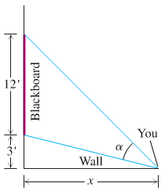



















Local maximum of 41.8103° when *x* ≈ 6.7082 *ft*.