***Solution*** ***Section* 3.2 – Graphing Functions**

***Exercise***

Find the open intervals on which the function  is increasing or decreasing

***Solution***

|  |  |  |
| --- | --- | --- |
| −∞ −3 1 ∞ | | |
|  |  |  |
| ***Increasing*** | ***Decreasing*** | ***Increasing*** |







***Increasing***: 

***Decreasing***: 

***Exercise***

Find the critical numbers and decide on which the function  is increasing or decreasing

***Solution***

|  |  |
| --- | --- |
| **−∞ 1 ∞** | |
| *Decreasing* | *Increasing* |











***Decreasing***: 

***Increasing***: 

***Exercise***

Find the critical numbers and the open intervals on which the function is increasing or decreasing.



***Solution***

 





|  |  |
| --- | --- |
| **−1  ∞** | |
| *Decreasing* | *Increasing* |



 but the domain is 

***Decreasing*** 

***Increasing*** 

***Exercise***

Find the critical numbers and the open intervals on which the function is increasing or decreasing.



***Solution***

  

|  |  |  |
| --- | --- | --- |
| −∞ −**2** **2** ∞ | | |
| − | + | − |
| ***Decreasing*** | ***Increasing*** | ***Decreasing*** |



***Decreasing: ***

***Increasing: ***

***Exercise***

Find the critical numbers and the open intervals on which the function is increasing or decreasing.



***Solution***

 



|  |  |  |
| --- | --- | --- |
| −∞ −1 1 ∞ | | |
| − | + | − |
| ***Decreasing*** | ***Increasing*** | ***Decreasing*** |

***Decreasing: ***

***Increasing: ***

***Exercise***

Find the critical numbers and the open intervals on which the function is increasing or decreasing.



***Solution***

|  |  |  |
| --- | --- | --- |
| −∞ −**2** **2** ∞ | | |
| **+** | **−** | **+** |
| ***Increasing*** | ***Decreasing*** | ***Increasing*** |







***Decreasing: ***

***Increasing: ***

***Exercise***

Find the open intervals on which the function  is increasing or decreasing

***Solution***





|  |  |
| --- | --- |
| **−∞ 0 ∞** | |
| ***<* 0**  ***Decreasing*** | ***>* 0**  ***Increasing*** |





***Decreasing***: 

***Increasing***: 

***Exercise***

Find the open intervals on which the function is increasing and decreasing. Then, identify the function’s local and absolute extreme values, if any, saying where they occur.



***Solution***





|  |  |
| --- | --- |
| **−∞  ∞** | |
| ***Increasing*** | ***Decreasing*** |

***Decreasing***: 

***Increasing***: 





***LMAX***: 

***Exercise***

Find the open intervals on which the function is increasing and decreasing. Then, identify the function’s local and absolute extreme values, if any, saying where they occur.



***Solution***



|  |  |  |
| --- | --- | --- |
| −∞   ∞ | | |
| **+** | **−** | **+** |
| ***Increasing*** | ***Decreasing*** | ***Increasing*** |





***Decreasing***: 

***Increasing***: 

***LMAX***:  ***LMIN***: 

***Exercise***

Find the open intervals on which the function is increasing and decreasing. 

Then, identify the function’s local and absolute extreme values, if any, saying where they occur.

***Solution***







|  |  |  |
| --- | --- | --- |
| −∞   ∞ | | |
| **−** | **+** | **−** |
| ***Decreasing*** | ***Increasing*** | ***Decreasing*** |



***Decreasing***: 

***Increasing***: 

***LMAX***: 

***LMIN***: 

***Exercise***

Find the open intervals on which the function is increasing and decreasing .

Then, identify the function’s local and absolute extreme values, if any, saying where they occur.

***Solution***

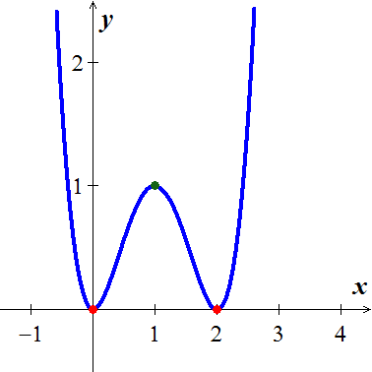





|  |  |  |  |
| --- | --- | --- | --- |
| −∞ 0 1 2 ∞ | | | |
| **−** | **+** | **−** | **+** |
| ***Decreasing*** | ***Increasing*** | ***Decreasing*** | ***Increasing*** |

***Decreasing***: 

***Increasing***: 

***LMAX***: 

***LMIN***: 

***Abs. minimum:*** 

***Exercise***

Find the open intervals on which the function is increasing and decreasing. 

Then, identify the function’s local and absolute extreme values, if any, saying where they occur.

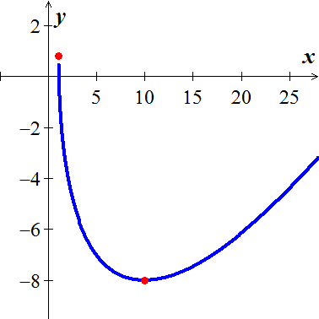***Solution***

***Domain***: *x* > 1















|  |  |
| --- | --- |
| 1 **∞** | |
| **−**  ***Decreasing*** | **+**  ***Increasing*** |

***Decreasing***:  ***Increasing***: 

***Local minimum***:  ***Local maximum***: 

***Absolute minimum:***  ***Absolute maximum:*** 

***Exercise***

Find the open intervals on which the function is increasing and decreasing. 

Then, identify the function’s local and absolute extreme values, if any, saying where they occur.

***Solution***

 



|  |  |
| --- | --- |
| −∞0 **∞** | |
| ***Increasing*** | ***Increasing*** |







***Increasing***: 

***No local extrema, no absolute extrema***

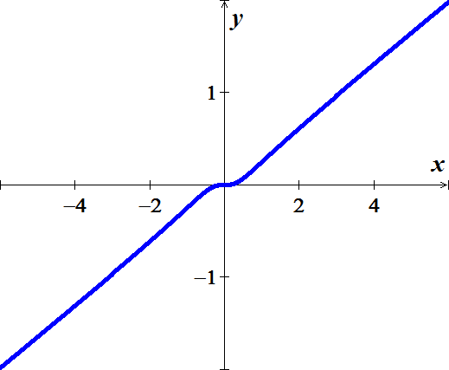

***Exercise***

Find the open intervals on which the function is increasing and decreasing. Then, identify the function’s local and absolute extreme values, if any, saying where they occur.



***Solution***







|  |  |  |
| --- | --- | --- |
| −∞   ∞ | | |
|  |  |  |
| ***Decreasing*** | ***Increasing*** | ***Increasing*** |







***Decreasing***: 

***Increasing***: 

***Local minimum***: 

***Local maximum***: ***None***

***Absolute minimum:*** 

***Absolute maximum:*** ***None***

***Exercise***

Find all relative Extrema as well as where the function is increasing and decreasing

***Solution***











|  |  |  |
| --- | --- | --- |
| **−∞ −1 1 ∞** | | |
| *> 0*  *Increasing* | *< 0*  *Decreasing* | *> 0*  *Increasing* |

***RMAX***: 

***RMIN***: 

***Increasing****: *

***Decreasing****:* 

***Exercise***

Find all relative Extrema of and Find the open intervals on which is increasing or decreasing

***Solution***



 



 *Multiply both sides by*







|  |  |  |
| --- | --- | --- |
| −∞  1 ∞ | | |
| **+** | **−** | **+** |
| ***Increasing*** | ***Decreasing*** | ***Increasing*** |

 (0, 0) and (1, 2)

***RMIN***: 

***RMAX***: 

***Increasing***: 

***Decreasing****:* 

***Exercise***

Find all relative Extrema as well as where the function is increasing and decreasing



|  |  |  |
| --- | --- | --- |
| −**∞ 0 3 ∞** | | |
| < 0  Decreasing | < 0  Decreasing | > 0  Increasing |

***Solution***









***RMIN***: 

***Decreasing***:  ***Increasing***: 

***Exercise***

Find all relative Extrema as well as where the function is increasing and decreasing 

***Solution***









 (0, 0) and (1, 1)

|  |  |  |
| --- | --- | --- |
| −∞  1 ∞ | | |
| **+** | **−** | **+** |
| ***Increasing*** | ***Decreasing*** | ***Increasing*** |

***RMAX***: 

***RMIN***: 

***Decreasing***: 

***Increasing****: *

***Exercise***

Find all relative Extrema as well as where the function is increasing and decreasing 

***Solution***



The critical values are , but the domain of the function is [−2, 2].

We can't go outside of that interval to test.

|  |  |
| --- | --- |
| **−2  2** | |
| **+** | **−** |
| ***Increasing*** | ***Decreasing*** |

The function has a RMAX of . Some texts also consider  as RMIN

***Exercise***

Find all relative Extrema as well as where the function is increasing and decreasing 

***Solution***

 







Critical points are and , but the domain is .

|  |  |
| --- | --- |
| **−**1  ∞ | |
| **−** | **+** |
| ***Decreasing*** | ***Increasing*** |

***Decreasing*** 

***Increasing*** 

***Exercise***

Find all relative Extrema as well as where the function is increasing and decreasing 

***Solution***

|  |  |  |
| --- | --- | --- |
| −∞ −1 1 ∞ | | |
| **−** | **+** | **−** |
| ***Decreasing*** | ***Increasing*** | ***Decreasing*** |

 





Critical numbers are 

***DECR: *** ***INCR: ***

***RMAX***:  ***RMIN***: 

***Exercise***

Find all relative Extrema as well as where the function is increasing and decreasing

***Solution***







|  |  |  |  |
| --- | --- | --- | --- |
| −∞ −2 0 2 ∞ | | | |
|  |  |  |  |
| ***decreasing*** | ***increasing*** | ***decreasing*** | ***increasing*** |







***DECR: *** ***INCR: ***

***RMAX***:  ***RMIN***: 

***Exercise***

Find the local extrema of the function on the given interval, and say where they occur



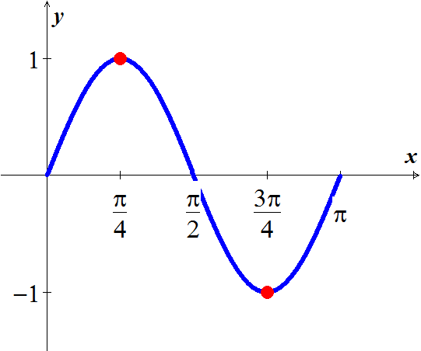***Solution***









|  |  |  |
| --- | --- | --- |
| 0 | | |
|  |  |  |
| ***Increasing*** | ***Decreasing*** | ***Increasing*** |

***DECR: *** ***INCR:***



***LMAX***:  ***LMIN***: 

***Exercise***

Find the local extrema of the function on the given interval, and say where they occur



***Solution***









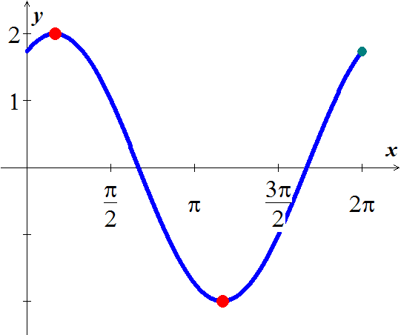

|  |  |  |
| --- | --- | --- |
| 0 | | |
|  |  |  |
| ***Increasing*** | ***Decreasing*** | ***Increasing*** |

***Increasing: ***

***Decreasing:*** 

***LMIN:*** 

***LMAX:***  

***Exercise***

Find the local extrema of the function on the given interval, and say where they occur



***Solution***







|  |  |
| --- | --- |
| 0 | |
|  |  |



***INCR:  DECR: ***

***LMIN:***  ***LMAX: ***

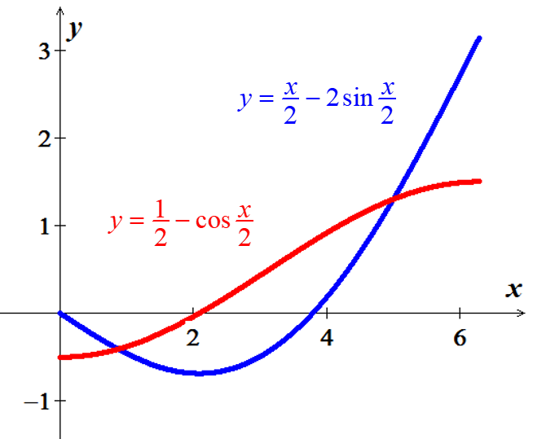

***Exercise***

Find the local extrema of the function on the given interval, and say where they occur



***Solution***

|  |  |
| --- | --- |
|  | |
|  |  |







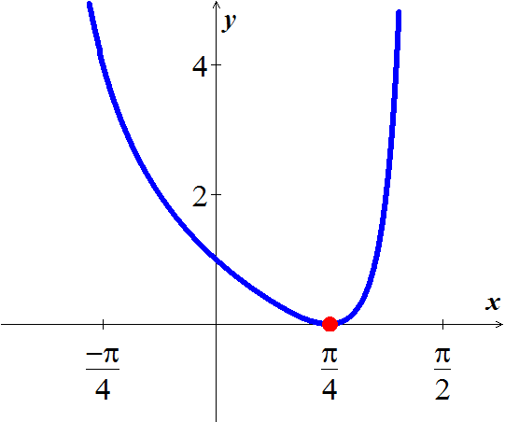

***INCR: ***

***DECR: ***

***LMIN:*** 

***LMAX: ***

***Exercise***

Determine the intervals on which the graph of the function is concave upward or concave downward.



***Solution***

 





 

|  |  |
| --- | --- |
| −∞  ∞ | |
| >0  ***Upward*** | < 0  ***Downward*** |







*f* is ***concave upward*** on 

*f* is ***concave downward*** on 

***Exercise***

Determine the intervals on which the graph of the function is concave upward or concave downward.



***Solution***

|  |  |
| --- | --- |
| −∞  ∞ | |
| >0  ***Upward*** | < 0  ***Downward*** |









***Concave up*** :  C***oncave down***: 

***Exercise***

Find the points of inflection. 

***Solution***









***Exercise***

Does  have any inflection points? If so, identify them.

***Solution***











***Exercise***

Find the second derivative of  and discuss the concavity of the graph

***Solution***





 for all *x > 0*

*f* is concave up for all *x >* 0.

***Exercise***

Determine the intervals on which the graph of the function is concave upward or concave downward.



***Solution***

 

|  |  |  |
| --- | --- | --- |
| −∞   ∞ | | |
| > 0  ***upward*** | < 0  ***downward*** | > 0  ***upward*** |

 









***Concave up*** on

***Concave down*** on 

***Exercise***

Find the extrema using the second derivative test

***Solution***

 ***CN*** is *x* = 0 

 



is a ***local maximum*** *(LMAX)*

***Exercise***

Discuss the concavity of the graph of *f* and find its points of inflection. 

***Solution***







***Points***: (0, 1)  Test fails

(3, −26) ⇒  ***local Minimum*** *(LMIN)*

***Exercise***

Find all relative extrema of 

***Solution***



|  |  |  |
| --- | --- | --- |
| −**∞ 0 1 ∞** | | |
| > 0  ***upward*** | < 0  ***downward*** | > 0  ***upward*** |





For *x* = 0 

For *x* = 0 

***Concave up*** on  ***concave down*** on 

***Points of inflection***: (0, 1), (1, 0)

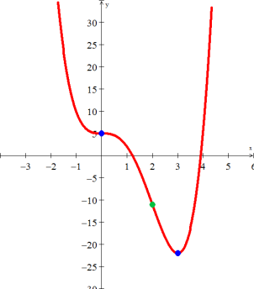***Exercise***

Sketch the graph 

***Solution***













|  |  |  |  |  |
| --- | --- | --- | --- | --- |
|  |  |  |  |  |
| (−∞, 0) |  | − | + | Decreasing, Concave up |
| *x* = 0 | 5 | 0 | 0 | RMAX |
| (0, 2) |  | − | − | Decreasing, Concave down |
| *x* = 2 | −11 | − | 0 | Point of Inflection |
| (2, 3) |  | − | + | Decreasing, Concave up |
| *x* = 3 | −22 | 0 | + | RMIN |
| (3, ∞) |  | + | + | Increasing, Concave up |

***Exercise***

Given 

***Solution***

**VA**:  **HA**: 

 



 





 

|  |  |  |  |  |
| --- | --- | --- | --- | --- |
|  |  |  |  |  |
| (−∞, −1) |  | + | **−** | Increasing, Concave up |
| *x* = −1 | *Undef.* | *Undef.* | *Undef.* | Vertical Asymptote |
| (−1, 0) |  | + | − | Increasing, Concave down |
| *x* = 0 | −1 | 0 | − | RMAX |
| (0, 1) |  | − | − | Decreasing, Concave down |
| *x* = 1 | *Undef.* | *Undef.* | *Undef.* | Vertical Asymptote |
| (1, ∞) |  | − | + | Decreasing, Concave up |

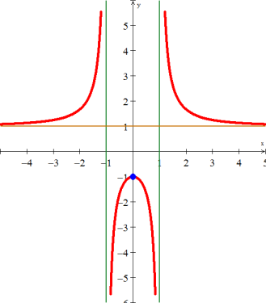

***Exercise***

Given 

***Solution***

















|  |  |  |  |  |
| --- | --- | --- | --- | --- |
| *x* |  |  |  |  |
| (0, 1) |  | − | + | Decreasing, Concave up |
| *x* = 1 | − 4 | 0 | *+* | RMIN |
| (1, ∞) |  | + | + | Increasing, Concave up |

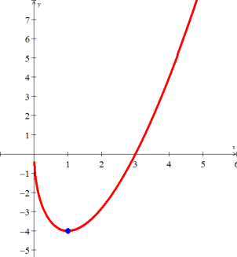

***Exercise***

Sketch the graph 

***Solution***











|  |  |  |  |  |
| --- | --- | --- | --- | --- |
| ***x*** |  |  |  |  |
| (−∞, −1) |  | + | + | Increasing, Concave Up |
| *x* = −1 | 5 | 0 | + | Concave Up |
| (−1, 0) |  | − | + | Decreasing, Concave Up |
| *x* = 0 | 3 | − | 0 | Decreasing, Pt. of Inflection |
| (0, 1) |  | − | − | Decreasing, Concave Down |
| *x* = 1 | 1 | 0 | − | Concave Down |
| (1, ∞) |  | + | − | Increasing, Concave Down |

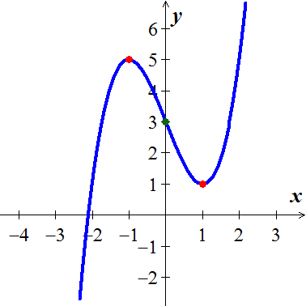

***Decreasing:  Increasing: ***

***Concave Down:  Concave Up: ***

***Local Minimum***:  ***Local Maximum***: 

***Points of inflection***: 

***Exercise***

Sketch the graph 

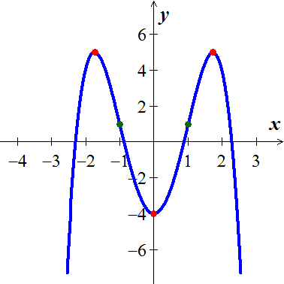***Solution***





 





 (***Points of Inflection***) 

|  |  |  |  |  |
| --- | --- | --- | --- | --- |
| ***x*** |  |  |  |  |
|  |  | + | − | Increasing, Concave Down |
|  | 5 | 0 | − | Concave Down |
|  |  | − | − | Decreasing, Concave Down |
| *x* = −1 | 1 | − | 0 | Decreasing, Pt. of Inflection |
| (−1, 0) |  | − | + | Decreasing, Concave Up |
| *x* = 0 | −4 | 0 | + | Concave Up |
| (0, 1) |  | + | + | Increasing, Concave Up |
| *x* = 1 | 1 | + | 0 | Increasing, Pt. of Inflection |
|  |  | + | − | Increasing, Concave Down |
|  | 5 | 0 | − | Concave Down |
|  |  | − | − | Decreasing, Concave Down |

***Decreasing:  Increasing: ***

***Concave Down:  Concave Up: ***

***Local Minimum***:  ***Local Maximum***: 

***Points of inflection***: 

***Exercise***

Sketch the graph 

***Solution***

 





 

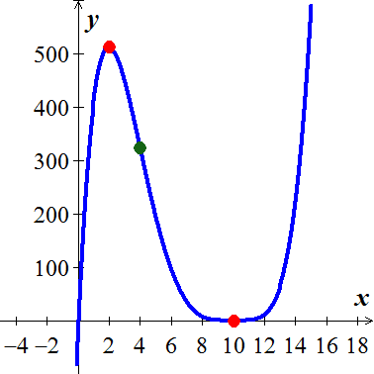













 

|  |  |  |  |  |
| --- | --- | --- | --- | --- |
| ***x*** |  |  |  |  |
|  |  | + | − | Increasing, Concave Down |
|  | 512 | 0 | − | Concave Down |
|  |  | − | − | Decreasing, Concave Down |
| *x* = 4 | 324 | − | 0 | Decreasing, Pt. of Inflection |
| (1, 10) |  | − | + | Decreasing, Concave Up |
| *x* = 10 | 0 | 0 | 0 | Pt. of Inflection |
|  |  | + | + | Increasing, Concave Up |

***Exercise***

Sketch the graph 

***Solution***









|  |  |  |  |  |
| --- | --- | --- | --- | --- |
| ***x*** |  |  |  |  |
|  | 0 | + | 0 |  |
|  |  | + | − | Increasing, Concave Down |
| *x* = π | π | 0 | 0 | Pt. of Inflection |
|  |  | + | + | Increasing, Concave Up |
| *x* = 2π | 2π | + | 0 |  |

***Decreasing: Increasing: ***

***Concave Down:  Concave Up: ***

***Local and Absolute Minimum***: 

***Local and Absolute Maximum***: 

***Points of inflection***: 

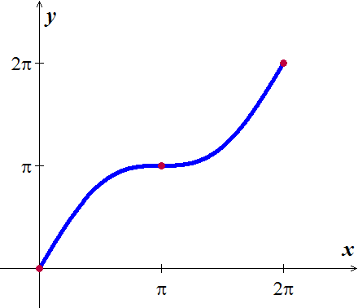

***Exercise***

Sketch the graph 

***Solution***







 







 (***Points of Inflection***)

|  |  |  |  |  |
| --- | --- | --- | --- | --- |
| ***x*** |  |  |  |  |
|  | 1 |  |  | ***Absolute Min.*** |
|  |  | + | − | Increasing, Concave Down |
|  | 2 | 0 | − | ***LMAX***, Concave Down |
|  |  | − | − | Decreasing, Concave Down |
|  | 0 | − | 0 | Decreasing, ***Pt. of Inflection*** |
|  |  | − | + | Decreasing, Concave Up |
|  | −2 | 0 | + | ***LMIN***, Concave Up |
|  |  | + | + | Increasing, Concave Up |
|  | 0 | + | 0 | ***Pt. of Inflection*** |
|  |  | + | − | Increasing, Concave Down |
|  | 1 |  |  | ***Absolute Max.*** |

***Exercise***

Sketch the graph 

***Solution***

 



 



|  |  |
| --- | --- |
| −∞0 **∞** | |
| ***Concave Up*** | ***Concave Down*** |

***Concave Down:  Concave Up: ***

***No Local or Absolute Extrema Points of inflection***: 

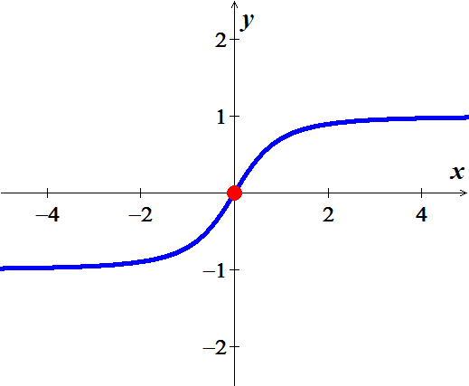

***Exercise***

Sketch the graph 

***Solution***

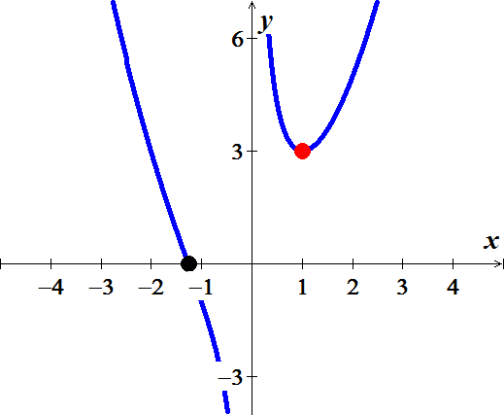*Vertical Asymptote*: 



 

 











|  |  |  |  |  |
| --- | --- | --- | --- | --- |
| ***x*** |  |  |  |  |
|  |  | − | + | Decreasing, Concave Up |
|  | 0 | − | 0 | Decreasing, ***Pt. of Inflection*** |
|  |  | − | − | Decreasing, Concave Down |
| *x* = 0 |  |  |  | ***V*.*A*.** |
| (0, 1) |  | − | + | Decreasing, Concave Up |
| *x* = 1 | 3 | 0 | + | ***LMIN*** |
|  |  | + | + | Increasing, Concave Up |

***Exercise***

Sketch the graph 

***Solution***

*Vertical Asymptote*: 









 





|  |  |  |  |  |
| --- | --- | --- | --- | --- |
| ***x*** |  |  |  |  |
|  |  | + | - | Increasing, Concave Up |
|  | 2 | 0 |  | ***LMAX*** |
|  |  | − | − | Decreasing, Concave Down |
| *x* = 2 |  |  |  | ***V*.*A*.** |
| (2, 3) |  | − | + | Decreasing, Concave Up |
| *x* = 3 | 6 | 0 | + | ***LMIN*** |
|  |  | + | + | Increasing, Concave Up |

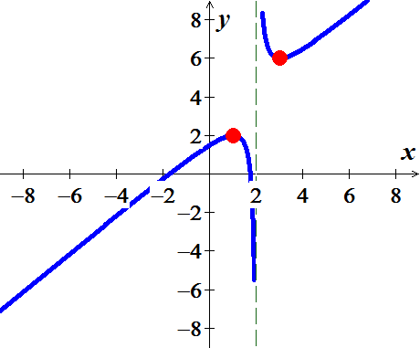

***Exercise***

Sketch the graph 

***Solution***

*Horizontal Asymptote*: 

 

 







|  |  |  |  |  |
| --- | --- | --- | --- | --- |
| ***x*** |  |  |  |  |
|  |  | + | + | Increasing, Concave Up |
|  | 2 | + | 0 | Increasing, ***Pt. of Inflection*** |
|  |  | + | − | Increasing, Concave Down |
| *x* = 0 |  | 0 | 0 | ***Abs. maximum, HA*** |
|  |  | − | − | Decreasing, Concave Down |
|  | 6 | − | 0 | Decreasing, ***Pt. of Inflection*** |
|  |  | − | + | Decreasing, Concave Up |



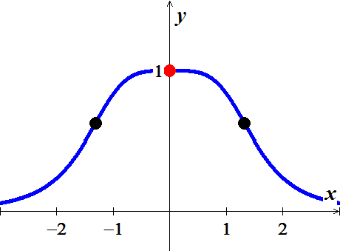





***Exercise***

Sketch the graph 

***Solution***

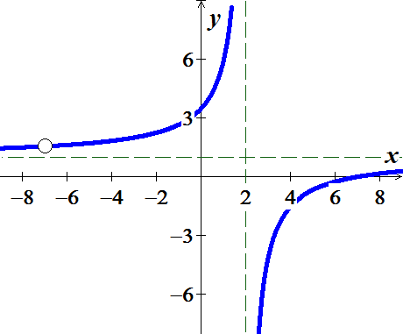

 

 



***Hole***: *x* = −7

***Oblique Asymptote***: *y* = 1

***Vertical Asymptote***: *x* = 2





***Exercise***

Sketch the graph 

***Solution***



***Vertical Asymptote***: *x* = 0

***Oblique Asymptote*: **

 

 





|  |  |  |  |
| --- | --- | --- | --- |
| −∞  0 1 ∞ | | | |
|  |  |  |  |
| ***Decreasing*** | ***Increasing*** | ***Decreasing*** | ***Increasing*** |

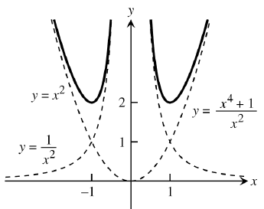

***Exercise***

Sketch the graph 

***Solution***



***Vertical Asymptote: ***

***Horizontal Asymptote*: **









|  |  |  |  |
| --- | --- | --- | --- |
| −∞  0  ∞ | | | |
|  |  |  |  |
| ***Decreasing*** | ***Decreasing*** | ***Increasing*** | ***Increasing*** |

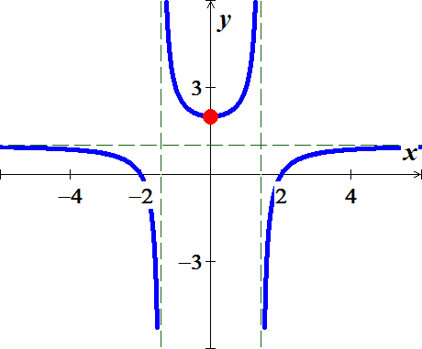

***Exercise***

Sketch the graph 

***Solution***

|  |  |
| --- | --- |
| ***Vertical Asymptote:***  ***Oblique Asymptote*:** |  |

|  |  |
| --- | --- |
|  |  |
|  |  |
|  |  |









|  |  |  |  |
| --- | --- | --- | --- |
| −∞  1 2 ∞ | | | |
|  |  |  |  |
| ***Decreasing*** | ***Increasing*** | ***Increasing*** | ***Decreasing*** |

***Incr.***:  ***Decr.***: 

***LMIN***:  ***LMAX***: 

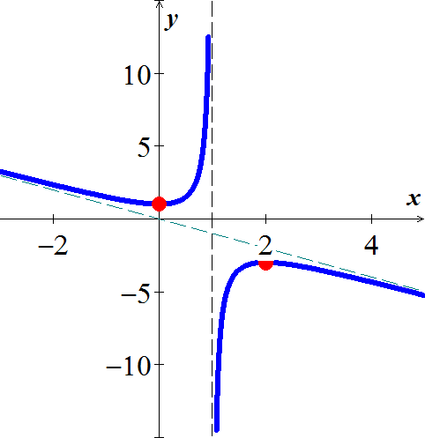

***Exercise***

Sketch the graph 

***Solution***









***Vertical Asymptote: ***

***Hole: ***

***Oblique Asymptote*: **

 





|  |  |  |  |
| --- | --- | --- | --- |
| −∞ −5 −2 1 ∞ | | | |
|  |  |  |  |
| ***Increasing*** | ***Decreasing*** | ***Decreasing*** | ***Increasing*** |

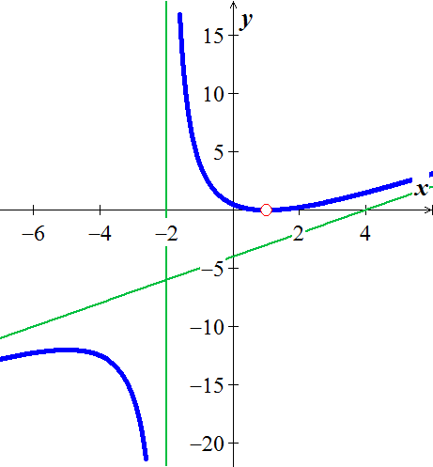

***Exercise***

Sketch the graph 

***Solution***

***VA:*** *N/A* ***HA*: **









|  |  |
| --- | --- |
|  |  |
|  |  |
|  |  |

|  |  |  |
| --- | --- | --- |
| −∞ −2 2 ∞ | | |
| **−** | **+** | **−** |
| ***Decreasing*** | ***Increasing*** | ***Decreasing*** |

***Incr.***:  ***Decr.***: 

***LMIN***:  ***LMAX***: 

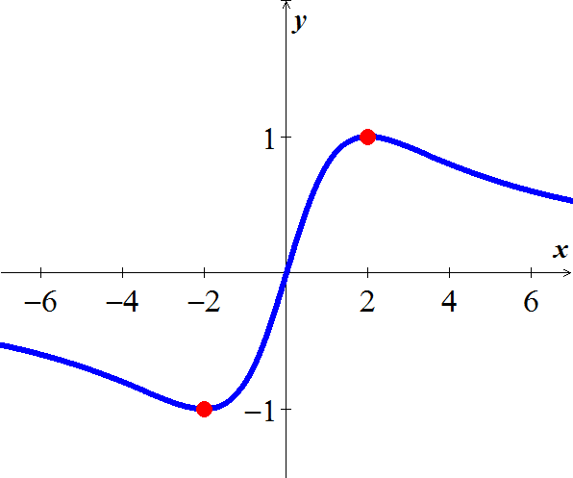

***Exercise***

Sketch the graph of 

***Solution***

  ***Oblique*** Asymptote



  (***CN***)



***No point of inflection*** and when 

|  |  |  |  |
| --- | --- | --- | --- |
| −∞  **0** 2 ∞ | | | |
| ***Increasing*** | ***Decreasing*** | | ***Increasing*** |
| ***Concave down*** | | ***Concave up*** | |

|  |  |
| --- | --- |
| ***RMIN***:  ***RMAX***: | ***Decreasing***:  ***Increasing***: |

***Concave down***: 

***Concave up***: 

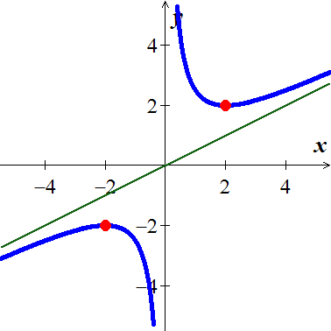

***Exercise***

Sketch the graph of 

***Solution***





 

|  |  |  |
| --- | --- | --- |
| −∞ −2 1 ∞ | | |
| **−** | **+** | **+** |
| ***Decr.*** | ***Incr.*** | ***Incr.*** |



|  |  |
| --- | --- |
|  |  |
|  |  |
|  |  |

|  |  |  |
| --- | --- | --- |
| −∞ −1 1 ∞ | | |
| **+** | **−** | **+** |
| ***Up*** | ***Down*** | ***Up*** |



|  |  |
| --- | --- |
|  |  |
|  |  |

Points of inflection: 

***Incr.***:  ***Decr.***: 

***LMIN***:  ***LMAX***: 

***Concave down***:  ***Concave up***: 

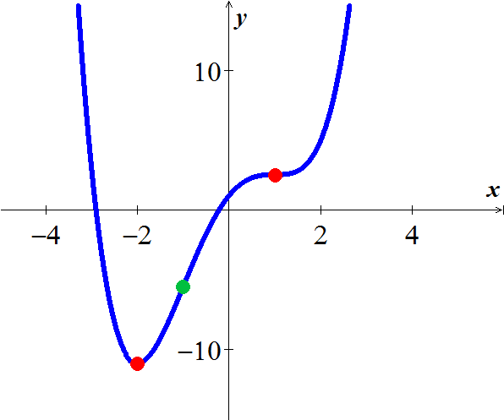

***Exercise***

Sketch the graph of 

***Solution***

 

|  |  |  |
| --- | --- | --- |
| −∞   ∞ | | |
| **−** | **+** | **−** |
| ***Decr.*** | ***Incr.*** | ***Decr.*** |



|  |  |
| --- | --- |
|  |  |
|  |  |
|  |  |

|  |  |
| --- | --- |
|  |  |
|  |  |
|  |  |
|  |  |



|  |  |  |  |
| --- | --- | --- | --- |
| −∞  0 3 ∞ | | | |
| **−** | **+** | **−** | **+** |
| ***Down*** | ***Up*** | ***Down*** | ***Up*** |







Points of inflection: 

***Incr.***:  ***Decr.***: 

***LMIN***:  ***LMAX***: 

***Concave down***:  ***Concave up***: 

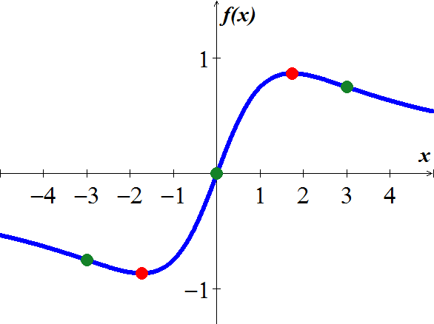

***Exercise***

Sketch the graph of 

***Solution***







|  |  |
| --- | --- |
|  |  |
|  |  |
|  |  |
|  |  |

|  |  |
| --- | --- |
|  |  |
|  |  |
|  |  |





|  |  |  |
| --- | --- | --- |
| 0   2 | | |
| **+** | **−** | **+** |
| ***Up.*** | ***Down.*** | ***Up .*** |

Points of inflection: 

***Incr.***:  ***Decr.***: 

***Abs. MIN***:  ***Abs. MAX***: 

***Concave down***:  ***Concave up***: 

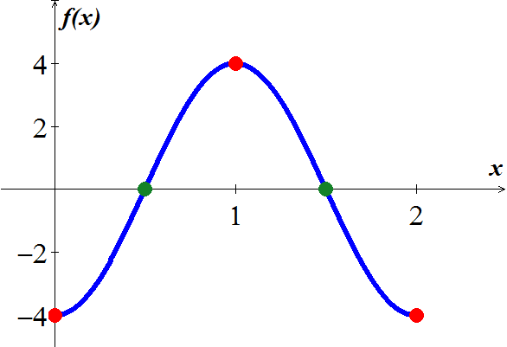

***Exercise***

Sketch the graph of 

***Solution***



 

|  |  |  |  |  |
| --- | --- | --- | --- | --- |
| −∞  −2  2 ∞ | | | | |
| **+** | **−** | **−** | **+** | **+** |
| ***Incr*** | ***Decr*** | ***Decr*** | ***Incr*** | ***Incr*** |



|  |  |
| --- | --- |
|  |  |
|  |  |
|  |  |







|  |  |  |  |
| --- | --- | --- | --- |
| −2 2 | | | |
| **+** | **−** | **+** | **−** |
| ***Up*** | ***Down*** | Up | ***Down*** |



Points of inflection: 

***Incr.***: 

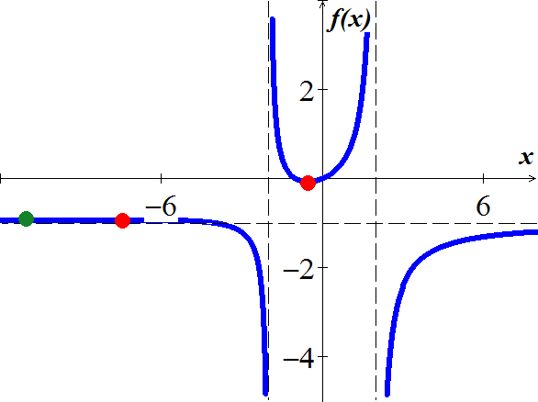***Decr.***: 

***LMIN***: 

***LMAX***: 

***Concave down***: 

***Concave up***: 

***Exercise***

Sketch the graph of 

***Solution***

***Domain***: 





|  |  |
| --- | --- |
| 0 | |
| + | − |
| ***Incr.*** | ***Decr.*** |







|  |  |
| --- | --- |
| 0 | |
| − | + |
| ***Down*** | ***Up*** |





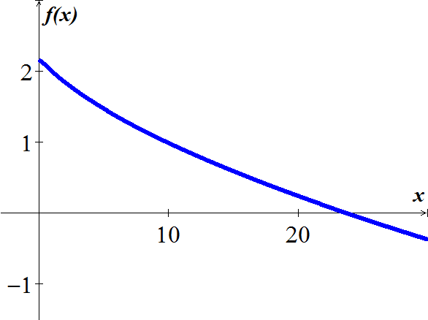









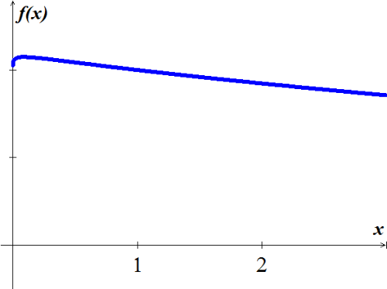

 ***Point of inflection***.

***Incr.***:  ***Decr.***: 

***Abs. MIN***: *none* ***Abs. MAX***: 

***Concave down***:  ***Concave up***: 

***Exercise***

Sketch the graph of 

***Solution***





Using software: 

|  |  |
| --- | --- |
|  |  |
|  |  |
|  |  |
|  |  |
| 0 |  |
|  |  |
|  |  |
|  |  |

|  |  |  |  |  |  |
| --- | --- | --- | --- | --- | --- |
| −2   0   2 | | | | | |
| **+** | **−** | **+** | **−** | **+** | **−** |
| ***Incr*** | ***Decr*** | ***Incr*** | ***Decr*** | ***Incr*** | ***Decr*** |







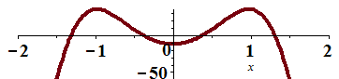

Using graph and software to find the roots:

Point of inflection: 

|  |  |  |  |  |
| --- | --- | --- | --- | --- |
| −2     2 | | | | |
| **−** | **+** | **−** | **+** | **−** |
| ***Down*** | ***Up*** | ***Down*** | ***Up*** | ***down*** |

***Incr.***: 

***Decr.***: 

***Abs. MIN***:  ***Abs. MAX***:  L***MAX***: 

***Concave down***: 

***Concave up***: 

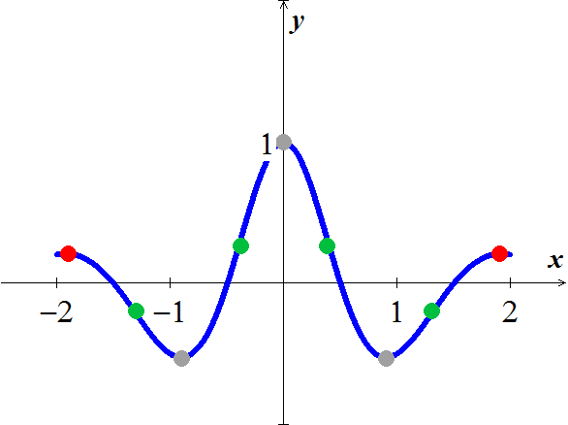

|  |  |
| --- | --- |
|  |  |
|  |  |
|  |  |
|  |  |
| 0 |  |

***Exercise***

Sketch the graph of 

***Solution***













|  |  |  |  |  |
| --- | --- | --- | --- | --- |
|  | | | | |
| **−** | **+** | **+** | **−** | **+** |
| ***Decr.*** | ***Incr.*** | ***Incr.*** | ***Decr.*** | ***Incr.*** |





 







Point of inflection: 

|  |  |  |  |
| --- | --- | --- | --- |
|  | | | |
| **−** | **+** | **−** | **−** |
| ***Down*** | ***Up.*** | ***Down*** | ***Down*** |



***Incr.***: 

***Decr.***: 

***Abs. MIN***: 

***LMAX***: 

***Concave down***: 

***Concave up***: 

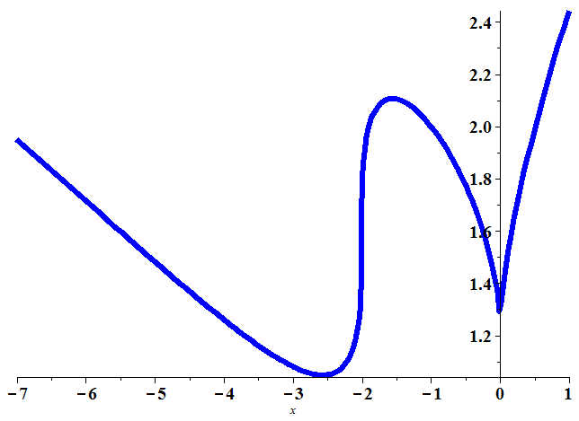

***Exercise***

Sketch the graph of 

***Solution***









|  |  |  |
| --- | --- | --- |
|  | | |
| **−** | **+** | **−** |
| ***Decr.*** | ***Incr.*** | ***Decr.*** |

|  |  |
| --- | --- |
|  |  |
|  |  |
|  |  |





|  |  |  |
| --- | --- | --- |
|  | | |
| **+** | **−** | **+** |
| ***Up*** | ***Down*** | ***Up*** |



|  |  |
| --- | --- |
|  |  |
|  |  |
|  |  |

***Incr.***:  ***Decr.***: 

***Abs. MIN***:  ***LMAX***: 

***Concave down***:  ***Concave up***: 

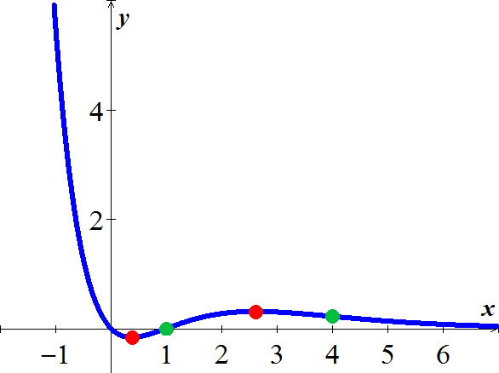

***Exercise***

The revenue *R* generated from sales of a certain product is related to the amount *x* spent on advertising by



Where *x* and *R* are in thousands of dollars. Is there a point of diminishing returns for this function?

***Solution***







*x* = 200 (or $200,000) is a ***diminishing point***

An increased investment beyond this point is usually considered a poor use of capital

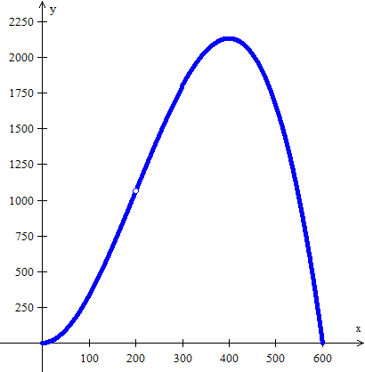

***Exercise***

Find the point of diminishing returns (*x*, *y*) for the function



where represents revenue in thousands of dollars and *x* represents the amount spent on advertising in tens of thousands of dollars.

***Solution***













The point of diminishing returns is 

***Exercise***

A county realty group estimates that the number of housing starts per year over the next three years will be

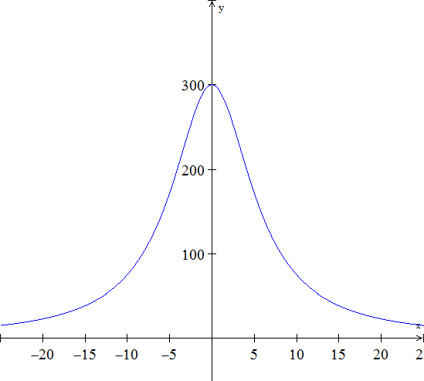

Where *r* is the mortgage rate (in percent).

1. Where is  increasing?
2. Where is  decreasing?

***Solution***







***a***)  is ***increasing*** on the interval 

***b***)  is ***decreasing*** on the interval 

***Exercise***

Suppose the total cost  to manufacture a quantity *x* of insecticide (in hundreds of liters) is given by . Where is  decreasing?

***Solution***

|  |  |  |
| --- | --- | --- |
| **0 8 10** | | |
|  |  |  |
| ***Increasing*** | ***Decreasing*** | ***Increasing*** |





 is ***decreasing*** (8, 10)

***Exercise***

The cost of a computer system increases with increased processor speeds. The cost *C* of a system as a function of processor speed is estimated as , where *x* is the processor speed in MHz. Determine the intervals where the cost function is decreasing.

***Solution***

|  |  |
| --- | --- |
|  | |
|  |  |
| ***Decreasing*** | ***Increasing*** |





The cost function is decreasing 

***Exercise***

The percent of concentration of a drug in the bloodstream *t* hours after the drug is administered is given by . On what time interval is the concentration of the drug increasing?

***Solution***

  

|  |  |
| --- | --- |
|  | |
|  |  |
| ***Increasing*** | ***Decreasing*** |







The concentration of the drug is increasing over 

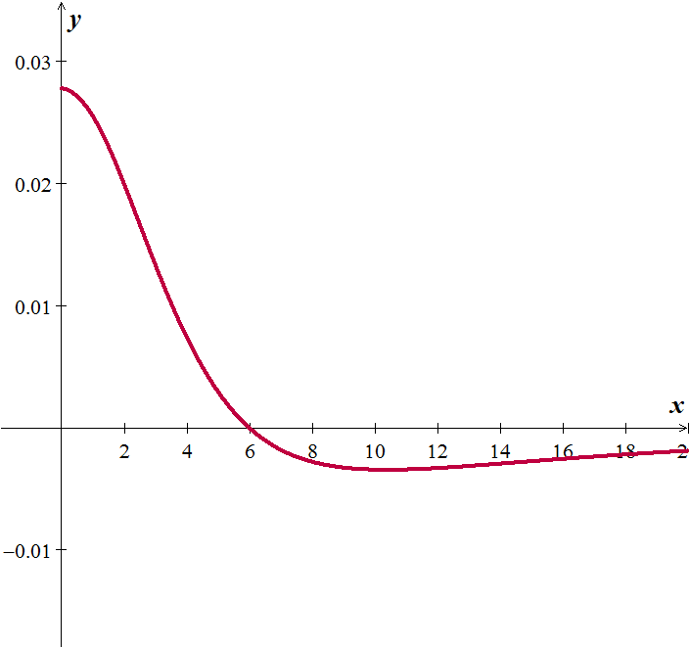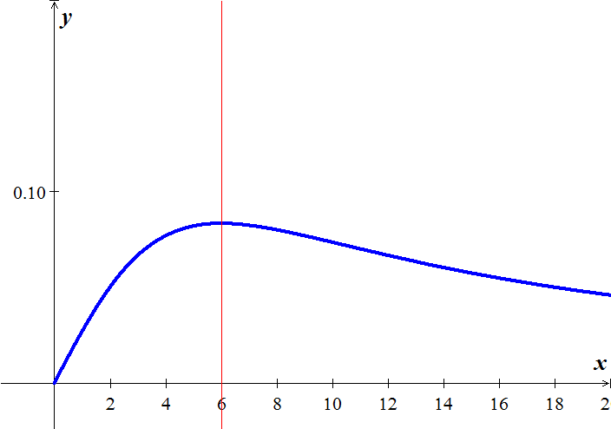

***Exercise***

Coughing forces the trachea to contract, this in turn affects the velocity of the air through the trachea. The velocity of the air during coughing can be modeled by:  where *k* is a constant, R is the normal radius of the trachea (also a constant) and *r* is the radius of the trachea during coughing. What radius *r* will produce the maximum air velocity?

***Solution***







A trachea radius of zero minimizes air velocity (duh!). And a radius of 2/3 its normal size maximizes air flow.

***Exercise***

 is an approximation to the total profit (in thousands of dollars) from the sale of *x* hundred thousand tires. Find the number of hundred thousands of tires that must be sold to maximize profit.

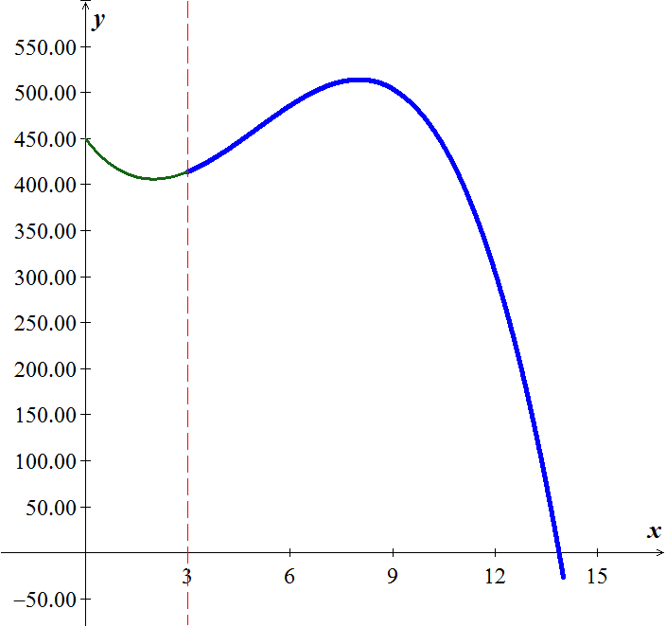***Solution***











The number of tires that must be sold to maximize profit is 800,000 tires

***Exercise***

 is an approximation to the number of salmon swimming upstream to spawn, where *x* represents the water temperature in degrees Celsius. Find the temperature that produces the maximum number of salmon.

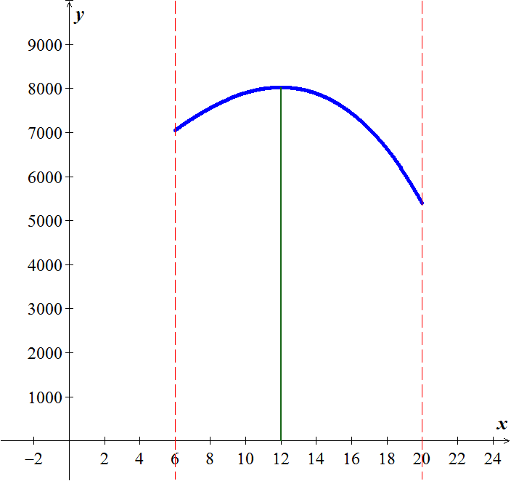***Solution***













12° is the temperature that produces the maximum number of salmon