***Solution*** ***Section* 3.6 – Newton’s Method**

***Exercise***

Use Newton’s method to estimate the on real solution of .

Start with  and then find 

***Solution***





 















***Exercise***

Use Newton’s method to estimate the on real solution of . Start with  for the left-hand zero and with  for the zero on the right. Then, in each case, find 

***Solution***





 





























***Exercise***

Use Newton’s method to estimate the on real solution of . Start with  for the left-hand zero and with  for the zero on the right. Then, in each case, find 

***Solution***





 





























***Exercise***

Use Newton’s method to estimate the on real solution of . Start with  and then find 

***Solution***





 

















***Exercise***

Use the Newton’s method to approximate the roots to ten digits of 

***Solution***

By inspection:  (***root***)

 



We apply Newton’s method to 



|  |  |  |  |  |
| --- | --- | --- | --- | --- |
| ***n*** |  |  |  |  |
| 0 | 0.0000000000 | −1 | −1 | −1 |
| 1 | −1 | 3.000000 | −7.000000 | −0.5714285714 |
| 2 | −0.5714285714 | 0.5510204082 | −4.4285714286 | −0.4470046083 |
| 3 | −0.4470046083 | 0.0464439678 | −3.6820276497 | −0.4343909149 |
| 4 | −0.4343909149 | 0.0004773158 | −3.6063454894 | −0.4342585605 |
| 5 | −0.4342585605 | 0.0000000525 | −3.6055513629 | −0.4342585459 |
| 6 | −0.4342585459 | 0.0000000000 | −3.6055512755 | −0.4342585459 |



|  |  |  |  |  |
| --- | --- | --- | --- | --- |
| ***n*** |  |  |  |  |
| 0 | 1 | 1 | 5 | 0.8 |
| 1 | 0.8000000000 | 0.1200000000 | 3.8000000000 | 0.7684210526 |
| 2 | 0.7684210526 | 0.0029916898 | 3.6105263158 | 0.7675924505 |
| 3 | 0.7675924505 | 0.0000020597 | 3.6055547030 | 0.7675918792 |
| 4 | 0.7675918792 | −0.0000000000 | 3.6055512755 | 0.7675918792 |



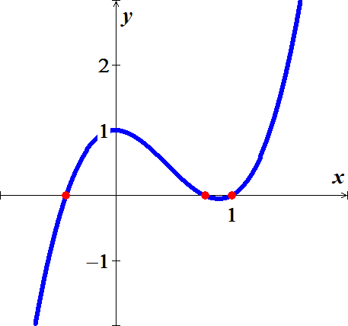

***Exercise***

Use the Newton’s method to approximate the roots to ten digits of 

***Solution***



|  |  |  |  |  |
| --- | --- | --- | --- | --- |
| ***n*** |  |  |  |  |
| 0 | −1.0000000000 | 2.1248149813 | −14.0423533155 | −0.8486852642 |
| 1 | −0.8486852642 | 0.3155271886 | −10.0631909420 | −0.8173306780 |
| 2 | −0.8173306780 | 0.0109389885 | −9.3722247034 | −0.8161635070 |
| 3 | −0.8161635070 | 0.0000145618 | −9.3472814463 | −0.8161619491 |
| 4 | −0.8161619491 | 0.0000000000 | −9.3472481901 | −0.8161619491 |



|  |  |  |  |  |
| --- | --- | --- | --- | --- |
| ***n*** |  |  |  |  |
| 0 | 1.0000000000 | −0.4281010598 | 5.1658930904 | 1.0828706774 |
| 1 | 1.0828706774 | 0.0209547377 | 5.6769600505 | 1.0791794875 |
| 2 | 1.0791794875 | 0.0000433190 | 5.6534997356 | 1.0791718252 |
| 3 | 1.0791718252 | 0.0000000002 | 5.6534511061 | 1.0791718251 |



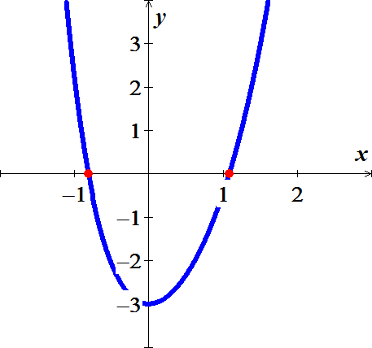

***Exercise***

Use the Newton’s method to approximate the roots to ten digits of 

***Solution***



|  |  |  |  |  |
| --- | --- | --- | --- | --- |
| ***n*** |  |  |  |  |
| 0 | 0.0000000000 | 2.0000000000 | −4.0000000000 | 0.5000000000 |
| 1 | 0.5000000000 | −0.6875000000 | −7.8750000000 | 0.4126984127 |
| 2 | 0.4126984127 | −0.0485945125 | −6.7756706818 | 0.4055265009 |
| 3 | 0.4055265009 | −0.0003088207 | −6.6896876153 | 0.4054803372 |
| 4 | 0.4054803372 | −0.0000000128 | −6.6891368363 | 0.4054803353 |



|  |  |  |  |  |
| --- | --- | --- | --- | --- |
| ***n*** |  |  |  |  |
| 0 | −2.0000000000 | −6.0000000000 | 84.0000000000 | −1.9285714286 |
| 1 | −1.9285714286 | −0.6062020289 | 67.3894731362 | −1.9195759282 |
| 2 | −1.9195759282 | −0.0087501134 | 65.4495366742 | −1.9194422357 |
| 3 | −1.9194422357 | −0.0000019108 | 65.4209537375 | −1.9194422065 |
| 4 | −1.9194422065 | 0.0000000000 | 65.4209474938 | −1.9194422065 |



|  |  |  |  |  |
| --- | --- | --- | --- | --- |
| ***n*** |  |  |  |  |
| 0 | 2.0000000000 | 10.0000000000 | 84.0000000000 | 1.8809523810 |
| 1 | 1.8809523810 | 1.6364873659 | 57.4894829058 | 1.8524865245 |
| 2 | 1.8524865245 | 0.0789319071 | 51.9953690888 | 1.8509684681 |
| 3 | 1.8509684681 | 0.0002159404 | 51.7110173775 | 1.8509642921 |
| 4 | 1.8509642921 | 0.0000000016 | 51.7102363689 | 1.8509642921 |



