***Solution Section* 4.6 – Substitution Rule**

***Exercise***

Evaluate the indefinite integrals by using the given substitutions to reduce the integrals to standard form



***Solution***

Let 







***Exercise***

Evaluate the indefinite integrals by using the given substitutions to reduce the integrals to standard form



***Solution***

Let 









***Exercise***

Evaluate the indefinite integrals by using the given substitutions to reduce the integrals to standard form



***Solution***

Let 







***Exercise***

Evaluate the indefinite integrals by using the given substitutions to reduce the integrals to standard form



***Solution***

Let 









***Exercise***

Evaluate the indefinite integrals by using the given substitutions to reduce the integrals to standard form



***Solution***

Let 







Let 









***Exercise***

Evaluate the integrals 

***Solution***

Let 







***Exercise***

Evaluate the integrals 

***Solution***

Let 







***Exercise***

Evaluate the integrals 

***Solution***

Let 









***Exercise***

Evaluate the integrals 

***Solution***

Let 







***Exercise***

Evaluate the integrals 

***Solution***

Let 







***Exercise***

Evaluate the integrals 

***Solution***

|  |  |
| --- | --- |
| Let |  |

***Exercise***

Evaluate the integrals 

***Solution***

Let 











***Exercise***

Evaluate the integrals 

***Solution***

Let 









***Exercise***

Evaluate the integrals 

***Solution***

Let 









***Exercise***

Evaluate the integrals 

***Solution***





***Exercise***

Evaluate the integrals 

***Solution***

|  |  |
| --- | --- |
| Let |  |

***Exercise***

Evaluate the integrals 

***Solution***

|  |  |
| --- | --- |
|  |  |

***Exercise***

Evaluate the integrals 

***Solution***

Let 









***Exercise***

Evaluate the integrals 

***Solution***

|  |  |
| --- | --- |
|  |  |

***Exercise***

Evaluate the integrals 

***Solution***

Let 









***Exercise***

Evaluate the integrals 

***Solution***

Let 













***Exercise***

Evaluate the integrals 

***Solution***

|  |  |
| --- | --- |
|  |  |

***Exercise***

Evaluate the integrals 

***Solution***

Let 











***Exercise***

Evaluate the integrals 

***Solution***

Let 













***Exercise***

Evaluate the integrals. 

***Solution***





***Exercise***

Evaluate the integrals 

***Solution***





***Exercise***

Evaluate the integrals 

***Solution***

 





***Exercise***

Evaluate the integrals 

***Solution***

 

 ***Substitute for x and dx***











***Exercise***

Find the integral

***Solution***





***Exercise***

Find the integral

***Solution***







***Exercise***

Find the integral

***Solution***





***Exercise***

Find the integral

***Solution***









***Exercise***

Find the integral

***Solution***





***Exercise***

Find the integral

***Solution***







***Exercise***

Find the integral

***Solution***

|  |  |
| --- | --- |
|  |  |

***Exercise***

Find the integral

***Solution***













***Exercise***

Find the integral

***Solution***

 



***Exercise***

Find the integral

***Solution***

 



***Exercise***

Find the integral

***Solution***







***Exercise***

Find the integral

***Solution***







***Exercise***

Find the integral

***Solution***







***Exercise***

Evaluate the integral 

***Solution***

 

















***Exercise***

Evaluate the integral 

***Solution***



 





***Exercise***

Evaluate 

***Solution***

Let 









***Exercise***

Evaluate 

***Solution***

 







***Exercise***

Evaluate 

***Solution***

 







***Exercise***

Evaluate 

***Solution***

 ***Using Completing the Square***











***Exercise***

Evaluate 

***Solution***













 





***Exercise***

Find the integral

***Solution***





***Exercise***

Find the integral

***Solution***







***Exercise***

Find the integral

***Solution***





***Exercise***

Find the integral

***Solution***





***Exercise***

Find the indefinite integral.

***Solution***



|  |  |
| --- | --- |
|  |  |

***Exercise***

Evaluate the integral 

***Solution***

 







***Exercise***

Evaluate the integral 

***Solution***

Let 





 





***Exercise***

Evaluate the integral 

***Solution***



***Exercise***

Find the indefinite integral.

***Solution***





***Exercise***

Evaluate the integral 

***Solution***











***Exercise***

Evaluate the integral 

***Solution***





***Exercise***

Evaluate the integral 

***Solution***

|  |  |
| --- | --- |
|  |  |

***Exercise***

Find the integral

***Solution***





***Exercise***

Evaluate the integral 

***Solution***









***Exercise***

Find the integral

***Solution***

|  |  |
| --- | --- |
|  |  |

***Exercise***

Find the integral

***Solution***









***Exercise***

Find the integral

***Solution***

|  |  |
| --- | --- |
|  |  |

***Exercise***

Find the integral

***Solution***

 









***Exercise***

Find the integral

***Solution***





***Exercise***

Evaluate the integral 

***Solution***

|  |  |
| --- | --- |
|  |  |

***Exercise***

Find the integral

***Solution***













***Exercise***

Evaluate the integral 

***Solution***

Let 









***Exercise***

Find the integral

***Solution***

|  |  |
| --- | --- |
|  |  |

***Exercise***

Evaluate the integral 

***Solution***

Let 









***Exercise***

Evaluate the integral 

***Solution***



 





***Exercise***

Evaluate 

***Solution***

Let 



 





***Exercise***

Evaluate 

***Solution***



 





***Exercise***

Evaluate 

***Solution***



 





***Exercise***

Evaluate 

***Solution***

  





***Exercise***

Evaluate 

***Solution***





 

 





***Exercise***

Evaluate 

***Solution***





 

 



***Exercise***

Evaluate 

***Solution***





 



 









/***Exercise***

Evaluate 

***Solution***



 



***Exercise***

Evaluate 

***Solution***





 





***Exercise***

Evaluate 

***Solution***

 



***Exercise***

Evaluate 

***Solution***

 



***Exercise***

Evaluate 

***Solution***

 



***Exercise***

Evaluate 

***Solution***









***Exercise***

Evaluate the integral 

***Solution***

 



***Exercise***

Evaluate the integral 

***Solution***

 



***Exercise***

Evaluate the integral 

***Solution***

 



***Exercise***

Evaluate the integral 

***Solution***

 



***Exercise***

Evaluate the integral 

***Solution***

 



***Exercise***

Evaluate the integral 

***Solution***

 



***Exercise***

Evaluate the integral 

***Solution***

 



***Exercise***

Evaluate the integral 

***Solution***

 



***Exercise***

Evaluate the integral 

***Solution***

 



***Exercise***

Evaluate the integral 

***Solution***

 



***Exercise***

Evaluate the integral 

***Solution***

 



***Exercise***

Evaluate the integral 

***Solution***

 



***Exercise***

Evaluate the integral 

***Solution***

  



***Exercise***

Evaluate the integral 

***Solution***

 



***Exercise***

Evaluate the integral 

***Solution***

 



***Exercise***

Evaluate the integral 

***Solution***





***Exercise***

Evaluate the integral 

***Solution***

  



***Exercise***

Evaluate the integral 

***Solution***

  



***Exercise***

Evaluate the integral 

***Solution***

 



***Exercise***

Evaluate the integral 

***Solution***

 



***Exercise***

Evaluate the integral 

***Solution***













***Exercise***

Evaluate the integral 

***Solution***















***Exercise***

Evaluate the integral 

***Solution***













***Exercise***

Evaluate the integral 

***Solution***

 



***Exercise***

Evaluate the integral 

***Solution***













***Exercise***

Evaluate the integral 

***Solution***















***Exercise***

Evaluate the integral 

***Solution***

 



***Exercise***

Evaluate the integral 

***Solution***

 

 



***Exercise***

Evaluate the integral 

***Solution***

 



 



***Or***

 







***Exercise***

Evaluate the integral 

***Solution***

 



***Exercise***

Evaluate the integral 

***Solution***





***Exercise***

Evaluate the integral 

***Solution***

 



***Exercise***

Evaluate the integral 

***Solution***

 







***Exercise***

Evaluate the integral 

***Solution***

 



***Exercise***

Evaluate the integral 

***Solution***

 





***Exercise***

Evaluate the integral 

***Solution***

 



***Exercise***

Evaluate the integral 

***Solution***

 





***Exercise***

Evaluate the integral 

***Solution***

 



***Exercise***

Evaluate the integral 

***Solution***













***Exercise***

Evaluate the integral 

***Solution***

 



***Exercise***

Evaluate the integral 

***Solution***

 



***Exercise***

Evaluate the integral 

***Solution***

 



***Exercise***

Evaluate the integral 

***Solution***

 



***Exercise***

Evaluate the integral 

***Solution***

 



***Exercise***

Evaluate the integral 

***Solution***

 



***Exercise***

Evaluate the integral 

***Solution***

 



***Exercise***

Evaluate the integral 

***Solution***

 



***Exercise***

Evaluate the integral 

***Solution***

 



***Exercise***

Evaluate the integral 

***Solution***

 





***Exercise***

Evaluate the integral 

***Solution***

 





***Exercise***

Evaluate the integral 

***Solution***









***Exercise***

Evaluate the integrals 

1. , followed by 
2. , followed by 
3. 

***Solution***

1. Let 























1. Let 

















1. Let 













***Exercise***

Evaluate: 

***Solution***

 









***Exercise***

Evaluate the integral 

***Solution***



 is a semi-circle with center (0, 0) and radius = 2. Since *x* from 0 to 2

⇒ Area = (Area of this circle)





***Exercise***

Evaluate the integral 

***Solution***

 









***Exercise***

Evaluate the integral 

***Solution***

 









***Exercise***

Evaluate the integral 

***Solution***

 







***Exercise***

Evaluate the integral 

***Solution***

 







***Exercise***

Evaluate the integral 

***Solution***

 







***Exercise***

Evaluate the integral 

***Solution***

 







***Exercise***

Evaluate the integral 

***Solution***

 







***Exercise***

Evaluate the integral 

***Solution***

|  |  |
| --- | --- |
| Let | ***OR*** |

***Exercise***

Evaluate the integral 

***Solution***













***Or***









***Exercise***

Evaluate the integral 

***Solution***









***Exercise***

Evaluate the integral 

***Solution***











***Or***















***Exercise***

Evaluate the integral 

***Solution***

Let 







***Exercise***

Evaluate the integral 

***Solution***

 







***Exercise***

Evaluate the integral 

***Solution***









***Exercise***

Evaluate the integral 

***Solution***

 







***Exercise***

Evaluate the integral 

***Solution***

Let 











***Exercise***

Evaluate the integral 

***Solution***















***Exercise***

Evaluate the integral 

***Solution***

 









***Exercise***

Evaluate 

***Solution***

 







***Exercise***

Evaluate the integral 

***Solution***















***Exercise***

Evaluate the integral 

***Solution***









***Exercise***

Evaluate the integral 

***Solution***













***Exercise***

Evaluate the integral 

***Solution***

















***Exercise***

Evaluate the integral 

***Solution***













***Exercise***

Evaluate the integral 

***Solution***









***Exercise***

Evaluate the integral 

***Solution***

Let 











***Exercise***

Evaluate the integral 

***Solution***

Let 













***Exercise***

Evaluate the integral 

***Solution***













***Exercise***

Evaluate the integral 

***Solution***









***Exercise***

Evaluate the integral 

***Solution***



 









***Exercise***

Evaluate the integral 

***Solution***



 











***Exercise***

Evaluate the integral 

***Solution***







***Exercise***

Evaluate the integral 

***Solution***









***Exercise***

Evaluate the integral 

***Solution***







 

***Exercise***

Evaluate 

***Solution***

Let: 



 









***Exercise***

Evaluate 

***Solution***





 









***Exercise***

Evaluate 

***Solution***





 







***Exercise***

Evaluate 

***Solution***









 

 









***Exercise***

Evaluate 

***Solution***















***Exercise***

Evaluate the definite integral 

***Solution***

 







***Exercise***

Evaluate the definite integral 

***Solution***

 





***Exercise***

Evaluate the definite integral 

***Solution***

 







***Exercise***

Evaluate the definite integral 

***Solution***

















***Exercise***

Evaluate the definite integral 

***Solution***

 

 





***Exercise***

Evaluate the definite integral 

***Solution***

 









***Exercise***

Evaluate the definite integral 

***Solution***

 











***Exercise***

Evaluate the definite integral 

***Solution***

 





***Exercise***

Evaluate the definite integral 

***Solution***









***Exercise***

Evaluate the definite integral 

***Solution***

 





***Exercise***

Evaluate the definite integral 

***Solution***









***Exercise***

Evaluate the definite integral 

***Solution***

 





***Exercise***

Evaluate the definite integral 

***Solution***







***Exercise***

Evaluate the definite integral 

***Solution***

 

 







***Exercise***

Evaluate the definite integral 

***Solution***











***Exercise***

Evaluate the definite integral 

***Solution***









***Exercise***

Evaluate the definite integral 

***Solution***

 







***Exercise***

Evaluate the definite integral 

***Solution***

 







***Exercise***

Evaluate the definite integral 

***Solution***













***Exercise***

Evaluate the definite integral 

***Solution***

 













***Exercise***

Evaluate the definite integral 

***Solution***

 







***Exercise***

Evaluate the definite integral 

***Solution***









***Exercise***

Evaluate the definite integral 

***Solution***

 









***Exercise***

Evaluate the definite integral 

***Solution***



 









***Exercise***

Evaluate the definite integral 

***Solution***

 







***Exercise***

Evaluate the definite integral 

***Solution***

 







***Exercise***

Evaluate the definite integral 

***Solution***















***Exercise***

Evaluate the definite integral 

***Solution***

 







***Exercise***

Evaluate the definite integral 

***Solution***















***Exercise***

Evaluate the definite integral 

***Solution***



 









***Exercise***

Evaluate the definite integral 

***Solution***















***Exercise***

Evaluate the definite integral 

***Solution***

Let  



















***Exercise***

Evaluate the definite integral 

***Solution***

Let 





















***Or***

Let 

















***Exercise***

Evaluate the definite integral 

***Solution***





















***Exercise***

Evaluate the definite integral 

***Solution***

 





















***Exercise***

Evaluate the definite integral 

***Solution***











***Exercise***

Evaluate the definite integral 

***Solution***

 









***Exercise***

Evaluate the definite integral 

***Solution***

 







***Exercise***

Evaluate the definite integral 

***Solution***

 







***Exercise***

Evaluate the definite integral 

***Solution***

 







***Exercise***

Evaluate the definite integral 

***Solution***

 







***Exercise***

Evaluate the definite integral 

***Solution***

 







***Exercise***

Evaluate the definite integral 

***Solution***

 









***Exercise***

Evaluate the definite integral 

***Solution***













***Exercise***

Evaluate the definite integral 

***Solution***

 







***Exercise***

Evaluate the definite integral 

***Solution***















***Exercise***

Solve the initial value problem 

***Solution***



Let 















***Exercise***

Solve the initial value problem 

***Solution***



Let 

















***Exercise***

Verify the integration formula: 

***Solution***

If 











 **√** Which verifies the formula

***Exercise***

Verify the integration formula: 

***Solution***

If 













 **√** Which verifies the formula

***Exercise***

Find the area of the region bounded by the graphs of 

***Solution***

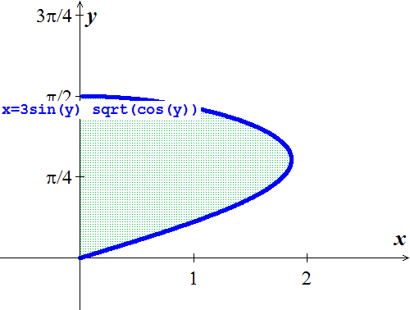 









***Exercise***

Find the area of the region bounded by the graph of 

***Solution***



 







***Exercise***

Find the area of the region bounded by the graph of  and the  between  and .

***Solution***

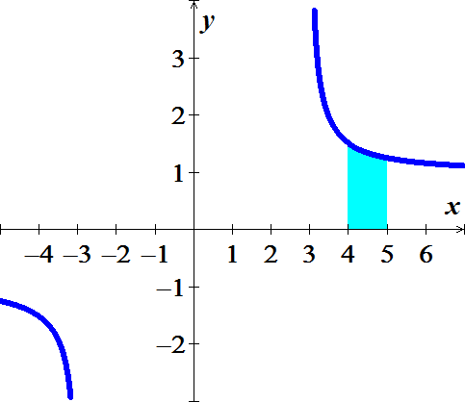

 





***Exercise***

Find the area of the region bounded by the graph of  and the  between  and .

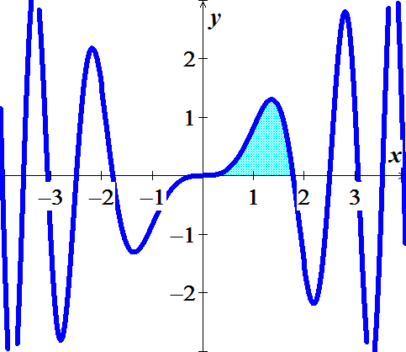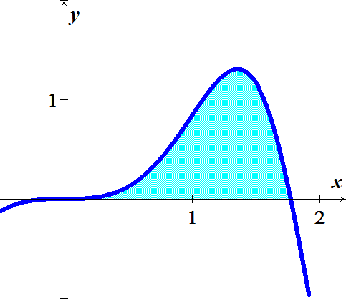***Solution***











***Exercise***

Find the area of the region bounded by the graph of  and the  between  and .

***Solution***









***Exercise***

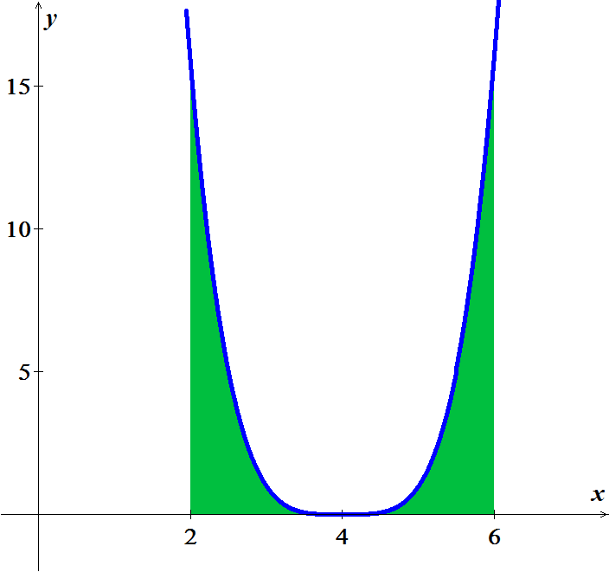Find the area of the region bounded by the graph of  and the  between  and .

***Solution***









***Exercise***

Perhaps the simplest change of variables is the shift or translation given by , where *c* is a real number.

1. Prove that shifting a function does not change the net area under the curve, in the sense that



1. Draw a picture to illustrate this change of variables in the case that , , , and 

***Solution***

1. Let 





1. Given: 







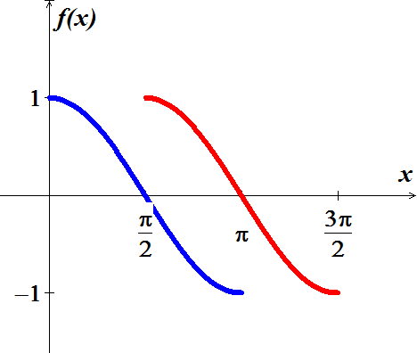

***Exercise***

Another change of variables that can be interpreted geometrically is the scaling , where *c* is a real number. Prove and interpret the fact that



Draw a picture to illustrate this change of variables in the case that , , , and 

***Solution***

Let 





Given: 





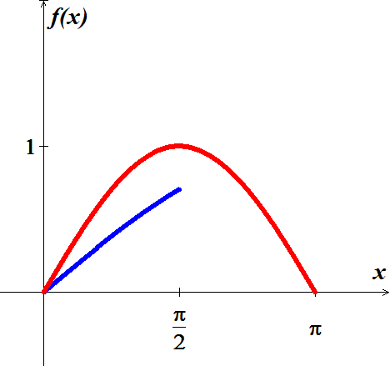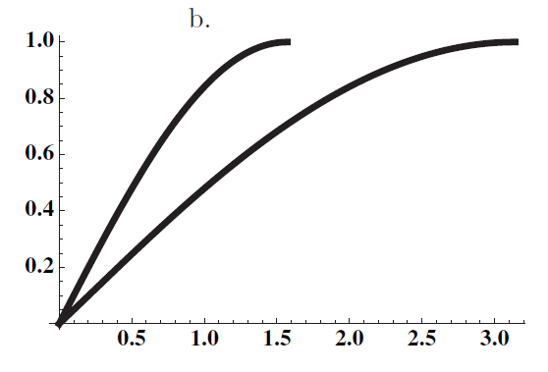

***Exercise***

The function  satisfies the equation . Find  and check your answer by substitution.

***Solution***









 *√*

***Exercise***

Assume  is continuous on , , and . Evaluate .

***Solution***









***Exercise***

The area of the shaded region under the curve  in

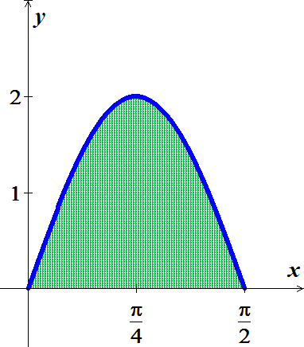 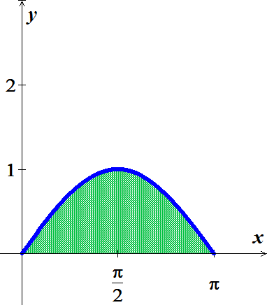

1. Equals the area on the shaded region under the curve 
2. Explain why this is true without computation areas.

***Solution***

1.  







1. Let  area of 

 area of 

Area of  is 

 ***√***

***Exercise***

The area of the shaded region under the curve  on the interval 

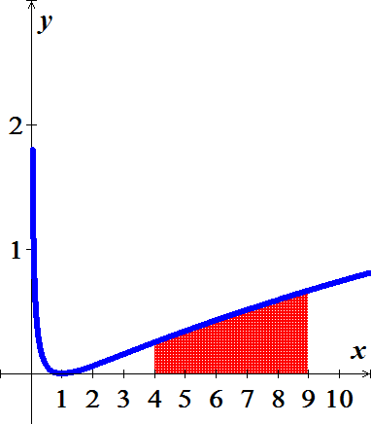 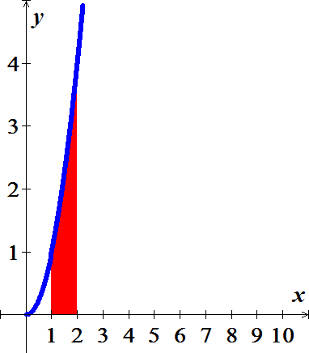

1. Equals the area on the shaded region under the curve  on the interval 
2. Explain why this is true without computation areas.

***Solution***

1. Let 









 ***√***















1.  ***√***

***Exercise***

The family of parabolas , where , has the property that for , the *x-*intercept is  and the *y-*intercept is . Let  be the area of the region in the first quadrant bounded by the parabola and the . Find  and determine whether it is increasing, decreasing, or constant function of *a*.

***Solution***

***Given***:   & 









 is a constant function.

***Exercise***

Consider the right triangle with vertices , , and , where  and . Show that the average vertical distance from points on the  to the hypotenuse is , for all .

***Solution***

 



Average vertical distance is:











***Exercise***

Consider the integral 

1. Find *I* using the identity 
2. Find *I* using the identity 
3. Confirm that the results in part (*a*) and (*b*) are consistent and compare the work involved in each method.

***Solution***

1. 







 







1.  





 

 

 From part (***a***)



1. The results from part *a* & *b* are consistent.

***Exercise***

Let , for .

1. Evaluate 
2. Evaluate 
3. Evaluate 
4. Use geometry to evaluate 
5. Find the value of *s* such that 

***Solution***

1. 
2. 





1. 
2.  is the area inside a circle in the first quadrant of radius 2





1.   is an even function



















 

 







***Exercise***

Evaluate the limits 

***Solution***









***Exercise***

Evaluate the limits 

***Solution***







***Exercise***

Prove that for nonzero constants *a* and *b*, 

***Solution***

 



 ***√***

***Exercise***

Let  be a real number and consider the family of functions  on the interval .

1. Graph , for *a* = 1, 2, 3.
2. Let  be the area of the region bounded by the graph of  and the on the interval . Graph  for . Is  an increasing function, a decreasing function, or neither?

***Solution***

|  |  |
| --- | --- |
|  |  |
|  |  |

1. 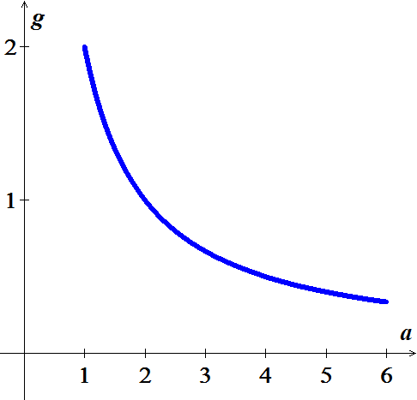









The function is decreasing as  is increasing.

***Exercise***

Explain why if a function *u* satisfies the equation , then it also satisfies the equation . Is it true that is *u* satisfies the second equation, then it satisfies the first equation?

***Solution***





 ***√***

***Exercise***

Let 

1. Find the interval on which  is increasing and the intervals on which  is decreasing.
2. Find the intervals on which  is concave up and the intervals on which  is concave down.
3. For what values of *x* does  have local minima? Local maxima?
4. Where are the inflection points of ?

***Solution***

1. 

|  |  |  |
| --- | --- | --- |
| 0 **1 2** | | |
| + | − | + |



Where  is multiplicity of 15

 is multiplicity of 9

Therefore, the sign will change.

 is increasing on 

 is decreasing on 

1. 

|  |  |  |  |
| --- | --- | --- | --- |
| 0 **1**   **2** | | | |
| − | − | + | + |







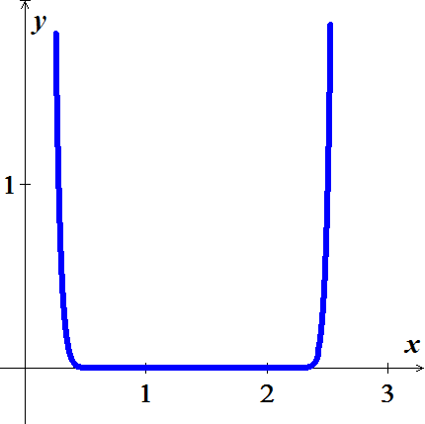Concave up: 

Concave down: 

1. LMIN: 

LMAX: 

1. 

***Exercise***

A company is considering a new manufacturing process in one of its plants. The new process provides substantial initial savings, with the savings declining with time *t* (in years) according to the rate-of-savings function



where  is in thousands of dollars per year. At the same time, the cost of operating the new process increases with time *t* (in years), according to the rate-of-cost function (in thousands of dollars per year)



1. For how many years will the company realize savings?
2. What will be the net total savings during this period?

***Solution***

1. For how many years will the company realize savings?



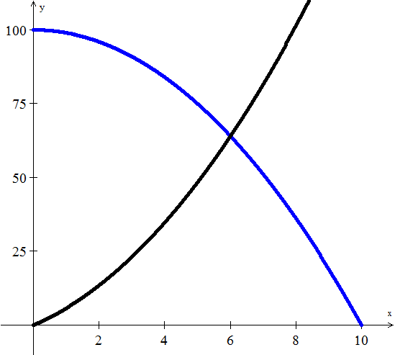







The company should use this type for 6 years.

***b***) What will be the net total savings during this period?

Total savings 









The company will save a total of $372,000. Over the 6-*year* period

***Exercise***

Find the producers’ surplus if the supply function for pork bellies is given by



Assume supply and demand are in equilibrium at 

***Solution***

The equilibrium price:





Producer’s surplus 











The producers’ surplus is $12,931.66

***Exercise***

An object moves along a line with a velocity in  given by . Its initial position is .

1. Graph the velocity function.
2. The position of the object is given by , for . Find the position function, for .
3. What is the period of the motion − that is, starting at any point, how long does it take the object to return to that position?

***Solution***

1. 

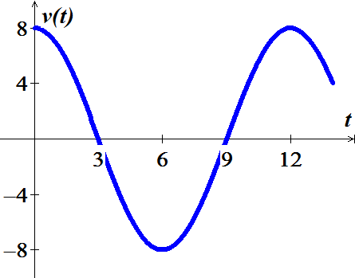

|  |  |
| --- | --- |
|  |  |
| 0 | 8 |
| 3 | 0 |
| 6 | −8 |
| 9 | 0 |
| 12 | 8 |

1. 







1. Period: 

***Exercise***

The population of a culture of bacteria has a growth rate given by  bacteria per hour, for , where  is a real number. It is shown that the increase in the population over time interval  is given by . (note that the growth rate decreases in time, reflecting competition for space and food.)

1. Using the population model with , what is the increase in the population over the time interval ?
2. Using the population model with , what is the increase in the population over the time interval ?
3. Let  be the increase in the population over a fixed time interval . For fixed *T*, does  increase or decrease with the parameter *r*? Explain.
4. A lab technician measures an increase in the population of 350 bacteria over the 10-*hr* period . Estimate the value of *r* that best fits this data point.
5. Use the population model in part (*b*) to find the increase in population over time interval , for any . If the culture is allowed to grow indefinitely , does the bacteria population increase without bound? Or does it approach a finite limit?

***Solution***

1.  & 









1.  & 









1.  decreases as *r* increases.

Because 

1. 











1. 







∴ The bacteria approach a finite limit of 100.

***Exercise***

Consider the function  and the area function .

1. Graph  on the interval [0, 6].
2. Compute and graph *A* on the interval [0, 6].
3. Show that the local extrema of *A* occur at the zeros of .
4. Give a geometric and analytical explanation for the observation in part (c).
5. Find the approximate zeros of *A*, other than 0, and call them  and .
6. Find *b* such that the area bounded by the graph of  and the *x*-axis on the interval  equals the area bounded by the graph of  and the *x*-axis on the interval .
7. 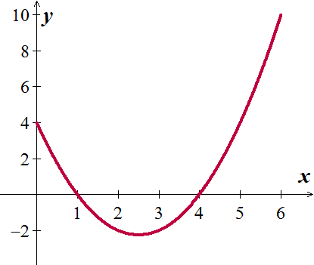If  is an integrable function and , is it always true that the local extrema of *A* occur at the zeros of ? Explain

***Solution***

1. 





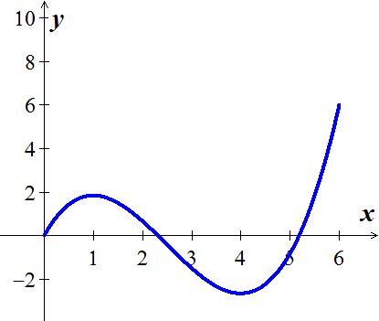

1. 



The zeros of *f* are at 1 and 4, and *A* has a local maximum at *x* = 1 and local minimum at *x* = 4.

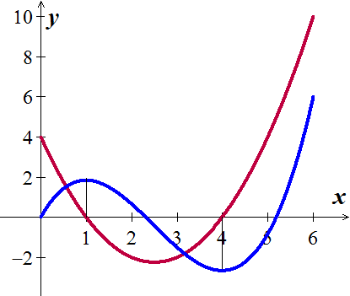

1. Since *f* is above the axis from 0 to 1, the net area *A* is increasing and switches to decreasing to the right of 1. When *x* is between 1 and 4, the function *f* is below *x*-axis (negative sign), the Area *A* is decreasing.

By the fundamental Theorem: , the zeros of *f* are critical points of *A*.

1. 



1. 



















Since 



 (and 2 complex numbers)

1. No, if the function is a piecewise function.



Then  has a maximum at *x* = 1 even though *f* is never zero.

This is a case where an extreme point occurs at a singular point rather than a stationary point.