***Section* 4.2 – Area under Curves**

The ***definite integral*** is the key tool in calculus for defining and calculating quantities important to mathematics and science, such as areas, volumes, lengths, and more…

***Area***

To find the area of the shaded region *R* that lies above the *x*-axis, below the graph of  and between the vertical lines *x* = 0 and *x* = 1.



|  |  |
| --- | --- |
|  |  |

|  |  |
| --- | --- |
|  |  |

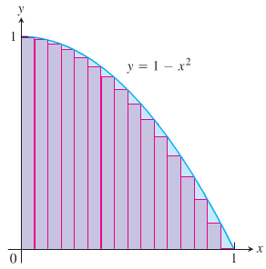 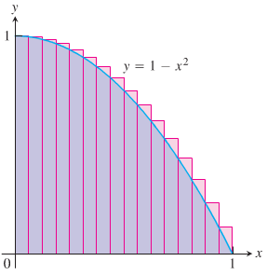

In each case of the computations, the interval [*a, b*] over which the function *f* is defined was subdivided into *n* equal subintervals (also called ***length***) , and f was evaluated at a point in each subinterval. The finite sums can be given by the form:



**Distance Traveled**

The distance formula is given by: 

***Example***

The velocity function of a projectile fired straight up into the air is . Use the summation technique to estimate how far the projectile rises during the first 3 *sec*. How close do the sums come to the exact value of 435.9 *m*?

**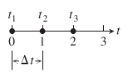*Solution***

1. 







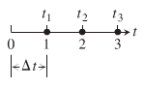 

1. 







1. 







1. 







The true value is 435.9 if you use more subintervals , the interval 436.13 & 435.67

The projectile rose about 436 m during the first 3 sec of flight.

**Average Value of a Nonnegative Continuous Function**

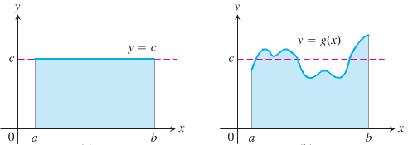

The average value of a collection of *n* numbers  is obtained by adding them together and dividing by *n*.

***Example***

Estimate the average value of the function  on the interval [0, π].

***Solution***

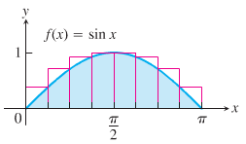

To get the upper sum approximation with 8 rectangles of equal width .





**Finite Sums and Sigma Notation**

***Sigma notation*** enables us to write a sum with many terms in the compact form



The Greek letter ∑ (capital ***sigma***, corresponding to our letter *S*)



***Example***

|  |  |  |
| --- | --- | --- |
| ***Sigma Notation*** | ***Written*** | ***Value of the Sum*** |
|  |  | 15 |
|  |  |  |
|  |  |  |
|  |  |  |

***Example***

We can write:



***Example***

Express the sum 1+ 3 +5 +7 + 9 in sigma notation.

***Solution***

Starting with *k* = 0: 

Starting with *k* = 1: 

***Theorem on Sums***

If  and  are infinite sequences, then for every positive integer ***n***,









***Proof***







***Example***









***Example***

Show that the sum of the first *n* integers is 

***Solution***

The sum of the first 4 integers is: 

To prove the formula in general:



Since it is twice the desired quantity, the sum of the first *n* integers is 



**Limits of Finite Sums**

***Example***

Find the limiting value of lower sum approximations to the area of the region *R* below the graph of  and above the interval [0, 1] on the *x*-axis using equal-width rectangles whose width approach zero and whose number approaches infinity.

***Solution***

The lower sum approximation using *n* rectangles of equal width: 

By subdividing the interval [0, 1] into *n* equal width subintervals:







We can write this in sigma notation:



















The lower sum approximation converge to 

The upper sum approximation also converge to 

***Review***

**Definition of Arithmetic Sequence**

A sequence  is an arithmetic sequence if there is a real number ***d*** such that for every positive integer ***k***,



The number  is called the ***common difference*** of the sequence.

***The nth Term of an Arithmetic Sequence***: 

***Example***

Express the sum in terms of summation notation: . (Answers are not unique)

***Solution***

Number of terms: *n* = 5

Difference in terms: *d* = 11 − 4 = 7







***Theorem***

**Formulas for** 

If  is an arithmetic sequence with common difference ***d***, then the *n*th partial sum  (that is, the sum of the first ***n*** terms) is given by either



***Definition* of *Geometric* Sequence**

A sequence  is a geometric sequence if  and if there is a real number  such that for every positive integer *k*.



The number  is called the ***common ratio*** of the sequence.

***The formula for the nth Term of a Geometric Sequence***: 

The common ratio for:  is 

***Example***

Express the sum in terms of summation notation (Answers are not unique.)



***Solution***





***Theorem*: Formula for** 

The nth partial sum  of a geometric sequence with first term  and common ratio  is



***Riemann Sums***

The theory of limits of finite approximations was made precise by the German mathematician ***Bernhard Riemann***.

We introduce the notion of a *Riemann sum*, which underlies the theory of the definite integral.

Let a closed interval [*a*, *b*] be partitioned by points 

To make the notation consistent, so that



The set:  is called a partition of [*a*, *b*].

The partition *P* divides [*a*, *b*] into *n* closed subintervals



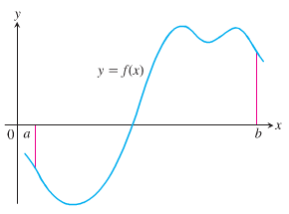



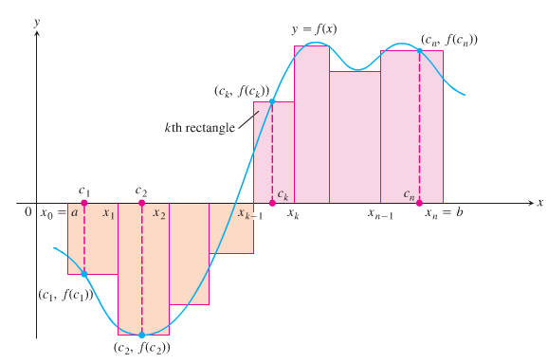

These products are:



The sum is called a ***Riemann sum*** *for f on the interval* [*a, b*], and  in the subintervals.

If we choose *n* subintervals all having equal width  to partition [*a, b*], then choose the point to be the right-hand endpoints of each subintervals when forming the Riemann sum. This choice leads to the Riemann sum formula



***Example***

The set is a partition of [0, 2]

***Solution***

There are five subintervals of *P*: [0, 0.2], [0.2, 0.6], [0.6, 1], [1, 1.5], and [1.5, 2]

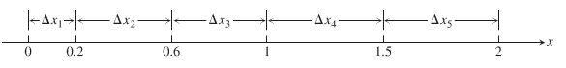

The lengths of the subintervals are:



The longest subinterval length is 0.5, so the norm of the partition is 

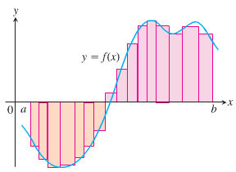 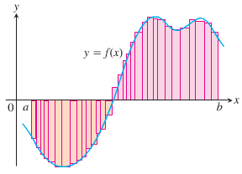

***Exercises*** ***Section* 4.2 – Area under Curves**

Use finite approximations to estimate the area under the graph of the function using

1. A lower sum with two rectangles of equal width
2. A lower sum with four rectangles of equal width
3. A upper sum with two rectangles of equal width
4. A upper sum with four rectangles of equal width
5. 
6. 
7. Use finite approximations to estimate the average value of *f* on the given interval by partitioning the interval into four subintervals of equal length and evaluating *f* at the subinterval midpoints.



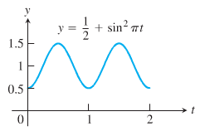

1. Use finite approximations to estimate the average value of *f* on the given interval by partitioning the interval into four subintervals of equal length and evaluating *f* at the subinterval midpoints.



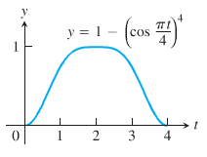

Write the sums without sigma notation. Then evaluate them:

|  |  |  |  |
| --- | --- | --- | --- |
|  |  |  |  |

1. Write the following expression 1 + 2 + 4 + 8 + 16 + 32 in sigma notation
2. Write the following expression 1 − 2 + 4 − 8 + 16 − 32 in sigma notation
3. Write the following expression  in sigma notation
4. Write the following expression  in sigma notation
5. Suppose that . Find the value of 

Evaluate the sums

|  |  |  |
| --- | --- | --- |
|  |  |  |

1. Graph the function  over the given interval [0, 2]. Partition the interval into four subintervals of equal length. Then add to your sketch the rectangles associated with the Riemann sum , given  is the
2. Left-hand endpoint
3. Right-hand endpoint
4. Midpoint of k*th* subinterval.

(Make a separate sketch for each set of rectangles.)