***Solution*** ***Section* 4.2 – Area under Curves**

***Exercise***

Use finite approximations to estimate the area under the graph of the function using



1. A lower sum with two rectangles of equal width
2. A lower sum with four rectangles of equal width
3. A upper sum with two rectangles of equal width
4. A upper sum with four rectangles of equal width

***Solution***

1. 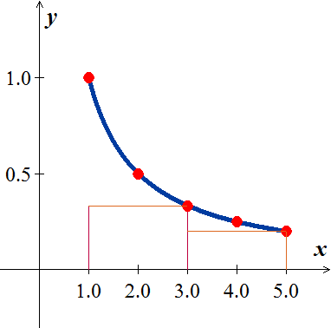Using 2 lower rectangles: 







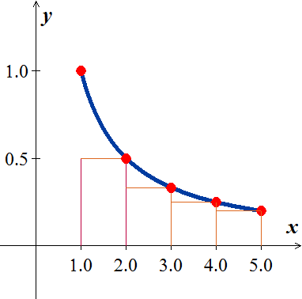 

1. Using 4 lower rectangles: 





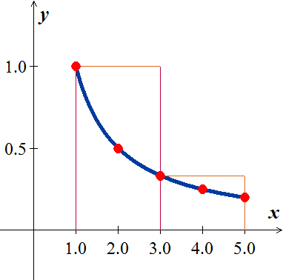 

1. Using 2 upper rectangles: 







1. 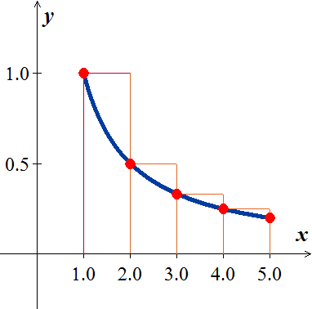Using 4 lower rectangles: 







***Exercise***

Use finite approximations to estimate the area under the graph of the function using



1. A lower sum with two rectangles of equal width
2. A lower sum with four rectangles of equal width
3. A upper sum with two rectangles of equal width
4. A upper sum with four rectangles of equal width

***Solution***

1. Using 2 lower rectangles:

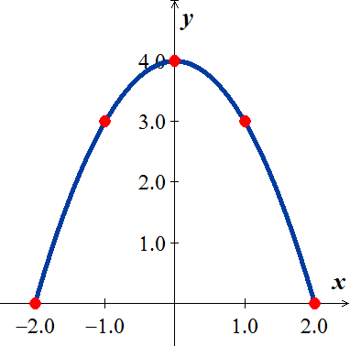 









1. Using 4 lower rectangles:









1. Using 2 upper rectangles:



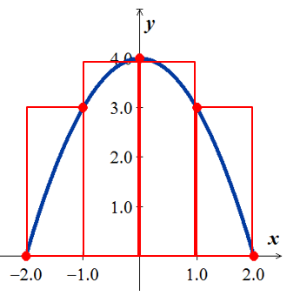





1. Using 4 lower rectangles:









***Exercise***

Use finite approximations to estimate the average value of *f* on the given interval by partitioning the interval into four subintervals of equal length and evaluating *f* at the subinterval midpoints.



***Solution***

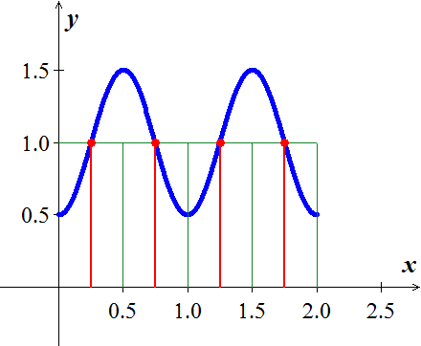















Average value 





***Exercise***

Use finite approximations to estimate the average value of *f* on the given interval by partitioning the interval into four subintervals of equal length and evaluating *f* at the subinterval midpoints.



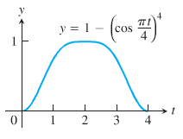***Solution***

















Average value 





***Exercise***

Write the sums without sigma notation. Then evaluate: 

***Solution***





***Exercise***

Write the sums without sigma notation. Then evaluate: 

***Solution***





***Exercise***

Write the sums without sigma notation. Then evaluate: 

***Solution***







***Exercise***

Write the sums without sigma notation. Then evaluate: 

***Solution***







***Exercise***

Write the following expression 1 + 2 + 4 + 8 + 16 + 32 in sigma notation

***Solution***





***Exercise***

Write the following expression 1 − 2 + 4 − 8 + 16 − 32 in sigma notation

***Solution***





***Exercise***

Write the following expression  in sigma notation

***Solution***



***Exercise***

Write the following expression  in sigma notation

***Solution***



***Exercise***

Suppose that . Find the value of 

***Solution***







***Exercise***

Evaluate the sums 

***Solution***







***Exercise***

Evaluate the sums 

***Solution***







***Exercise***

Evaluate the sums 

***Solution***







***Exercise***

Evaluate the sums 

***Solution***









***Exercise***

Evaluate the sums 

***Solution***











***Exercise***

Evaluate the sums 

***Solution***





***Exercise***

Evaluate the sums 

***Solution***

Let 



















***Exercise***

Evaluate the sums 

***Solution***





***Exercise***

Graph the function  over the given interval [0, 2]. Partition the interval into four subintervals of equal length. Then add to your sketch the rectangles associated with the Riemann sum , given  is the

1. Left-hand endpoint
2. Right-hand endpoint
3. Midpoint of k*th* subinterval.

***Solution***

