***Section* 4.4 – Fundamental Theorem of Calculus**

**Mean Value Theorem for Definite Integrals**

If *f* is continuous on [*a, b*], then some point *c* in [*a, b*],



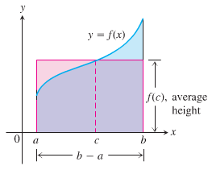

***Theorem* − The Fundamental Theorem of Calculus, P-1**

If *f* is continuous on [*a, b*], then  is continuous on [*a, b*], and differentiable on (*a, b*) and its derivative is :



***Theorem* − The Fundamental Theorem of Calculus, P-2**

If *f* is continuous at every point in [*a, b*], then *F* is any antiderivative of *f* on [*a, b*], then



***Example***

1. 





1. 





1. 







***Theorem* − The Net Change Theorem**

The net change in a function  over an interval  is the integral of tis rate of change:



***Example***

Consider the analysis of a heavy rock blown straight up from the ground by a dynamite blast. The velocity of the rock at any time *t* during its motion was given as 

1. Find the displacement of the rock during the time period 
2. Find the total distance traveled during this time period.

***Solution***

1. 









The height if the rock is 256 *ft* above the ground 8 *sec* after the explosion.

1. 

The velocity is positive over the time [0, 5] and negative over [5, 8]













***Example***

Shows the graph of  and its mirror image  are reflected across the *x*-axis. For each function, compute

1. The definite integral over the interval [−2, 2]
2. The area between the graph and the *x*-axis over [−2, 2]

***Solution***

1. 

















1. In both cases, the area between the curve and the *x*-axis over [−2, 2] is  units.

***Example***

Shows the graph of  between  and . Compute

1. The definite integral of  over [0, 2π]
2. The area between the graph and the *x*-axis over [0, 2π]

**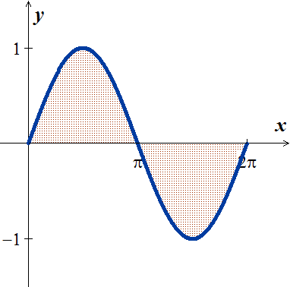*Solution***

1. 







1. The area between the graph and the axis is obtained by adding the absolute values













***Summary***

To find the area between the graph of  and the *x*-axis over the interval [*a, b*]:

1. Subdivide [*a, b*] at the zeros of *f*.
2. Integrate f over each subinterval.
3. Add the absolute values of the integrals.

***Example***

Find the area of the region between the *x*-axis and the graph of 

***Solution***

The zeros of: 



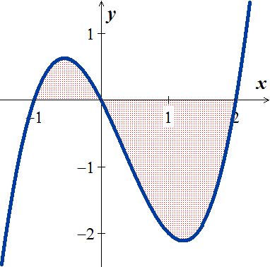

|  |  |
| --- | --- |
|  |  |









***Areas between Curves***

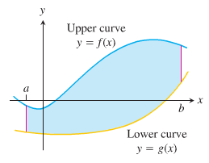 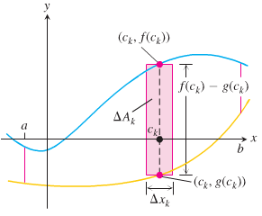

***Definition***

If  and  are continuous with  throughout [*a, b*], then the ***area of the region between the curves***  **from *a* to *b*** is:



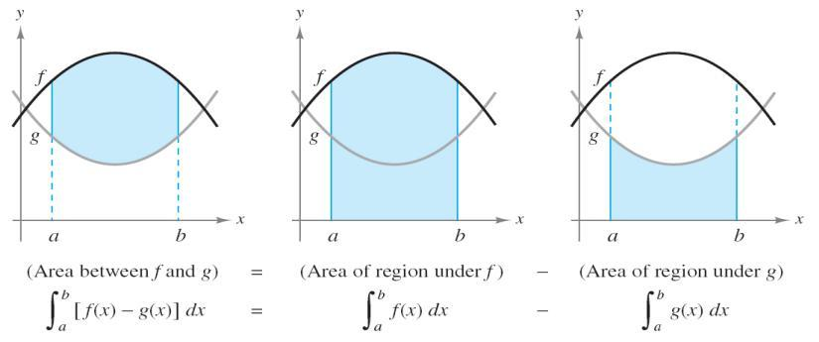

***Example***

Find the area of the region enclosed by the parabola  and the line .

***Solution***

The limits of integrations are found by letting:

 



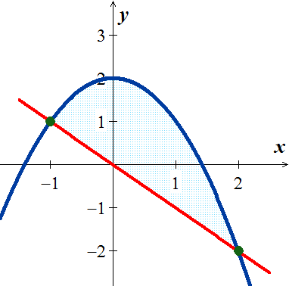 









***Example***

Find the area of the region in the first quadrant that is bounded above by  and below the *x*-axis and the line

***Solution***

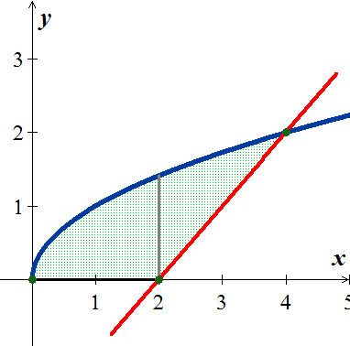













Total Area 











**Integration with Respect to *y***

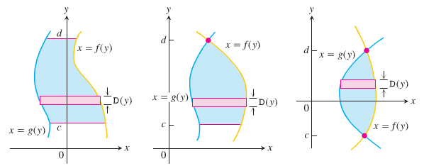

 **(*From right hand to left* hand)**

***Example***

Find the area of the region by integrating with respect to y, in the first quadrant that is bounded above by  and below the *x*-axis and the line.

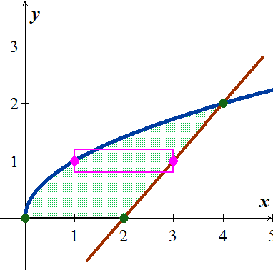***Solution***





















***Exercises*** ***Section* 4.4 – Fundamental Theorem of Calculus**

Evaluate the integrals

|  |  |  |
| --- | --- | --- |
|  |  |  |

Find the total area between the region between the given graph and the *x*-axis

|  |  |
| --- | --- |
|  |  |

1. Find the area of the region between the graph of  and the , for 
2. Find the area of the region between the graph of  and the , for 
3. Find the area of the region between the graph of  and the , for 
4. Find the area of the region between the graph of  and the , for 
5. Find the area of the region above the  bounded by 
6. Find the area of the region above the  bounded by 
7. Find the area of the region between the graph of  and the , for 
8. Find the area of the region between the graph of  and the , for 
9. Find the area of the region bounded by the graph of 
10. Find the area of the region bounded by the graph of 
11. Find the area of the region bounded by the graph of 
12. Find the area of the region bounded by the graph of 
13. Find the area of the region bounded by the graph of 
14. Find the area of the region bounded by the graph of 
15. Find the area of the region bounded by the graphs of  and 
16. Find the area of the region bounded by the graphs of  & 

Compute the area of the region bounded by the graph of  and the on the given interval.

|  |  |
| --- | --- |
|  |  |

1. Archimedes, inventor, military engineer, physicist, and the greatest mathematician of classical times in the Western world, discovered that the area under a parabolic arch is two-thirds the base times the height. Sketch the parabolic arch , assuming that *h* and *b* are positive. Then use calculus to find the area of the region enclosed between the arch and the *x*-axis
2. Suppose that a company’s marginal revenue from the manufacture and sale of eggbeaters is



Where *r* is measured in thousands of dollars and *x* in thousands of units. How much money should the company expect from a production run of *x* = 3 thousand eggbeaters? To find out, integrate the marginal revenue from *x* = 0 to *x* = 3.

1. The height *H* (*ft*) of a palm tree after growing for *t* years is given by



1. Find the tree’s height when *t* = 0, *t* = 4, and *t* = 8.
2. Find the tree’s average height for 