***Solution*** ***Section* 4.4 – Fundamental Theorem of Calculus**

***Exercise***

Evaluate the integral 

***Solution***







***Exercise***

Evaluate the integral 

***Solution***









***Exercise***

Evaluate the integral 

***Solution***







***Exercise***

Evaluate the integral 

***Solution***







***Exercise***

Evaluate the integral 

***Solution***







***Exercise***

Evaluate the integral 

***Solution***









***Exercise***

Evaluate the integral 

***Solution***









***Exercise***

Evaluate the integral 

***Solution***













***Exercise***

Evaluate the integral 

***Solution***











***Exercise***

Evaluate the integral 

***Solution***













***Exercise***

Evaluate the integral 

***Solution***











***Exercise***

Evaluate the integral 

***Solution***















***Exercise***

Evaluate the integral 

***Solution***









***Exercise***

Evaluate the integral 

***Solution***









***Exercise***

Evaluate the integral 

***Solution***







***Exercise***

Evaluate the integral 

***Solution***



 



***Exercise***

Evaluate the integral 

***Solution***









***Exercise***

Evaluate the integral 

***Solution***







***Exercise***

Evaluate the integral 

***Solution***









***Exercise***

Evaluate the integral 

***Solution***







***Exercise***

Evaluate the integral 

***Solution***







***Exercise***

Evaluate the integral 

***Solution***









***Exercise***

Evaluate the integral 

***Solution***









***Exercise***

Evaluate the integral 

***Solution***









***Exercise***

Evaluate the integral 

***Solution***







***Exercise***

Evaluate the integral 

***Solution***









 

***Exercise***

Evaluate the integral 

***Solution***









***Exercise***

Evaluate the integral 

***Solution***











***Exercise***

Evaluate the integral 

***Solution***









***Exercise***

Evaluate the integral 

***Solution***









***Exercise***

Find the total area between the region and the *x*-axis 

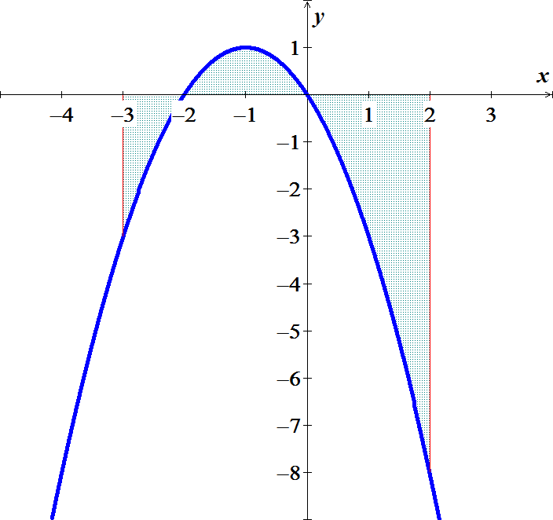***Solution***

















***Exercise***

Find the total area between the region and the *x*-axis 

***Solution***













***Exercise***

Find the total area between the region and the *x*-axis 

***Solution***

















***Exercise***

Find the total area between the region and the *x*-axis 

***Solution***













***Exercise***

Find the area of the region between the graph of  and the , for 

***Solution***

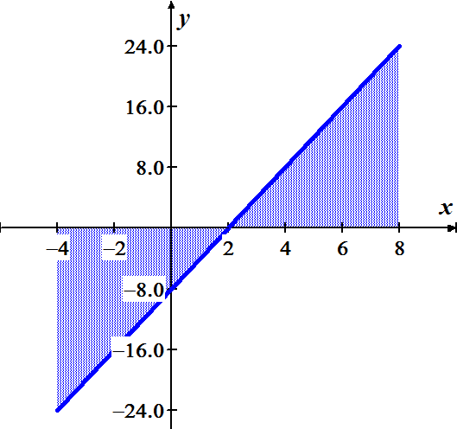













***Exercise***

Find the area of the region between the graph of  and the , for 

***Solution***

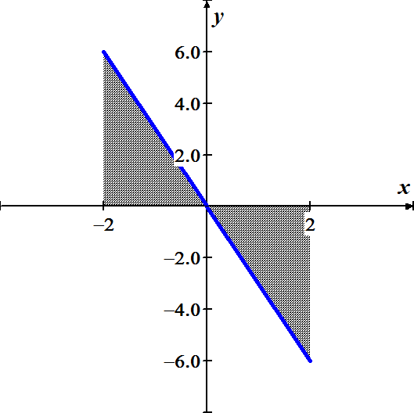













***Exercise***

Find the area of the region between the graph of  and the , for 

***Solution***

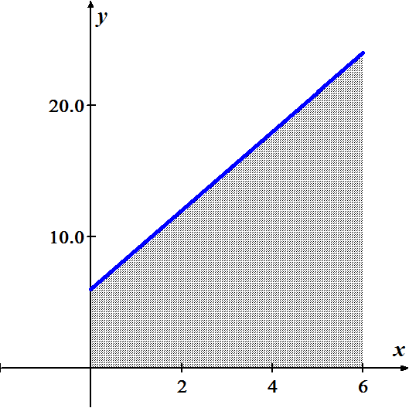











***Exercise***

Find the area of the region between the graph of  and the , for 

***Solution***

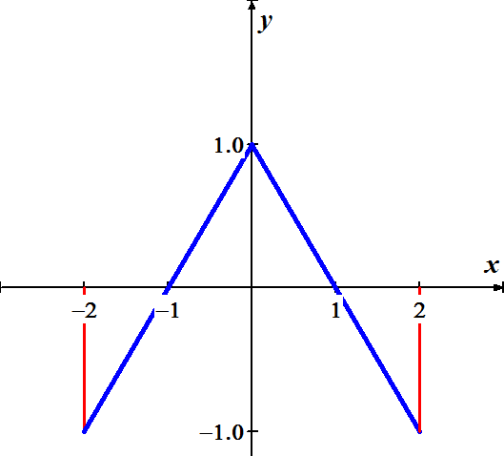











***Exercise***

Find the area of the region above the  bounded by 

***Solution***

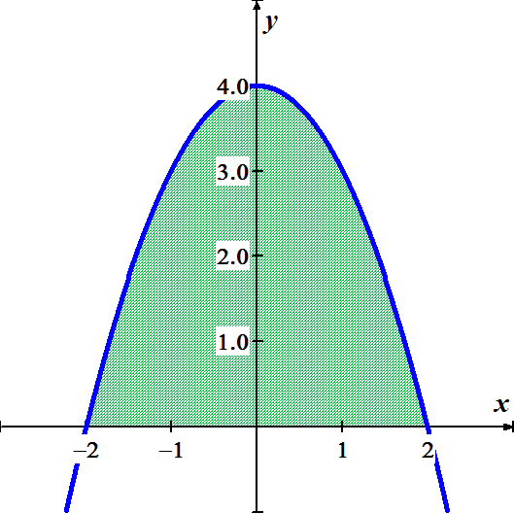













***Exercise***

Find the area of the region above the  bounded by 

***Solution***

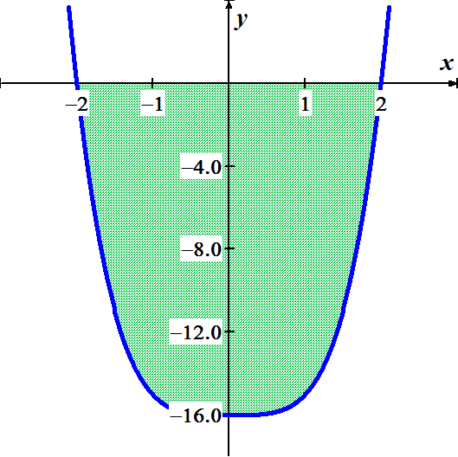











***Exercise***

Find the area of the region between the graph of  and the , for 

***Solution***

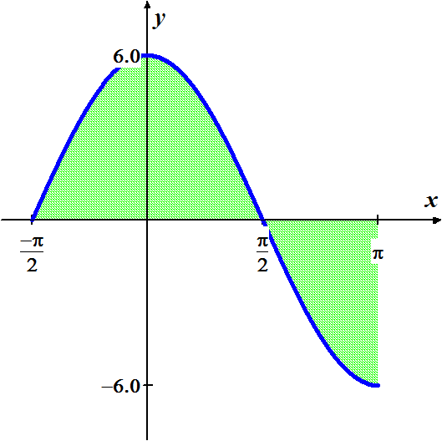













***Exercise***

Find the area of the region between the graph of  and the , for 

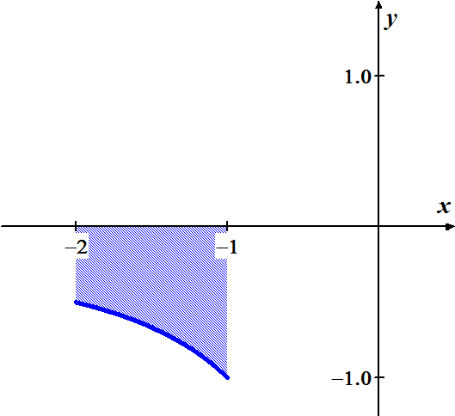***Solution***











***Exercise***

Find the area of the region bounded by the graph of



***Solution***





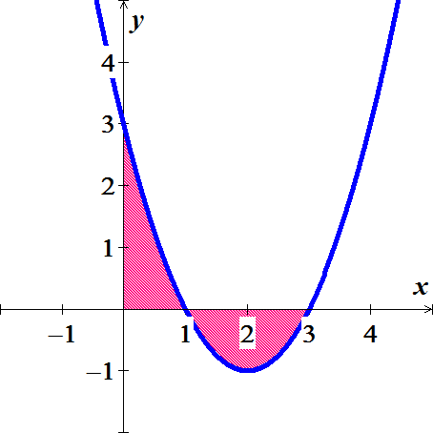







***Exercise***

Find the area of the region bounded by the graph of 

***Solution***

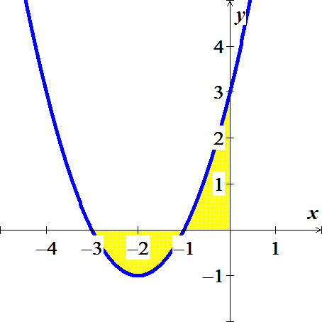











***Exercise***

Find the area of the region bounded by the graph of 

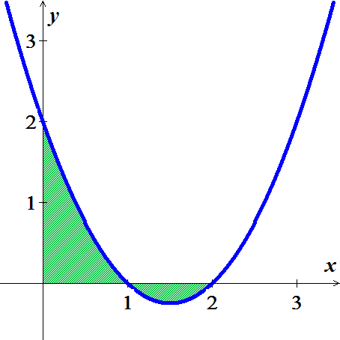***Solution***















***Exercise***

Find the area of the region bounded by the graph of 

***Solution***

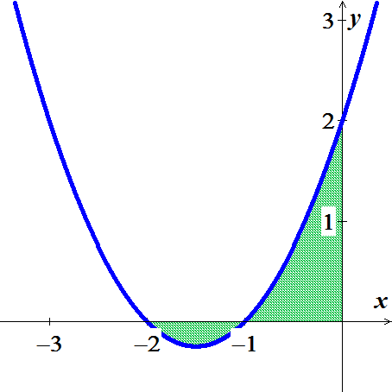











***Exercise***

Find the area of the region bounded by the graph of 

***Solution***

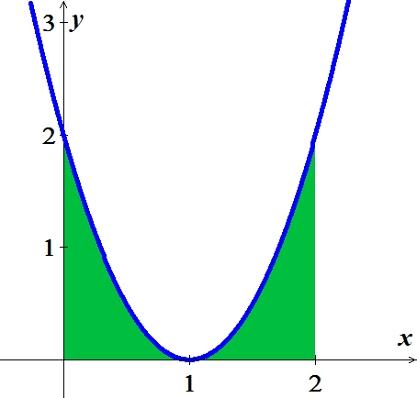











***Exercise***

Find the area of the region bounded by the graph of 

***Solution***

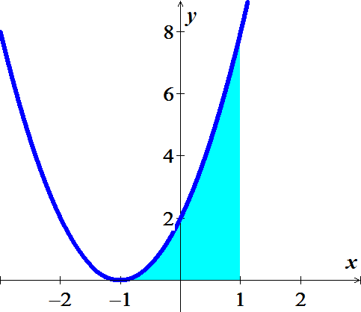











***Exercise***

Find the area of the region bounded by the graphs of  and 

***Solution***



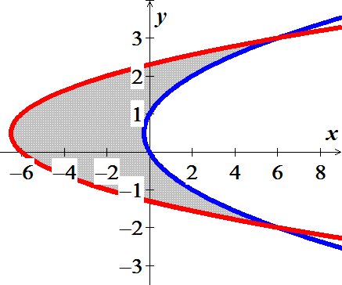















***Exercise***

Find the area of the region bounded by the graphs of  &  on 

***Solution***

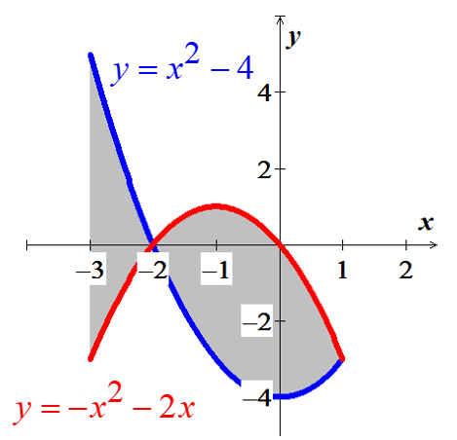

















***Exercise***

Compute the area of the region bounded by the graph of  and the on the given interval.



***Solution***

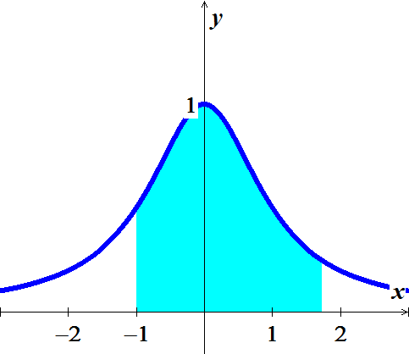 









***Exercise***

Compute the area of the region bounded by the graph of  and the on the given interval.



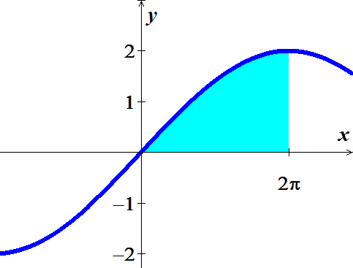***Solution***









***Exercise***

Archimedes, inventor, military engineer, physicist, and the greatest mathematician of classical times in the Western world, discovered that the area under a parabolic arch is two-thirds the base times the height. Sketch the parabolic arch , assuming that *h* and *b* are positive. Then use calculus to find the area of the region enclosed between the arch and the *x*-axis

***Solution***













***Exercise***

Suppose that a company’s marginal revenue from the manufacture and sale of eggbeaters is



Where *r* is measured in thousands of dollars and *x* in thousands of units. How much money should the company expect from a production run of *x* = 3 thousand eggbeaters? To find out, integrate the marginal revenue from *x* = 0 to *x* = 3.

***Solution***

 











***Exercise***

The height *H* (*feet*) of a palm tree after growing for *t* years is given by



1. Find the tree’s height when *t* = 0, *t* = 4, and *t* = 8.
2. Find the tree’s average height for 

***Solution***

1. 





1. Average height  











