***Section* 4.5 – Working with Integrals**

**Definite Integrals of Symmetric Functions**

***Theorem***

Let *f* be continuous on the symmetric interval [−*a, a*]

* If  is even, then 
* If  is odd, then 

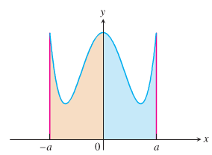 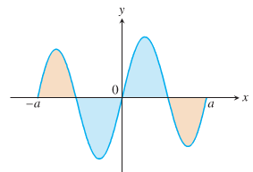

***Example***

Evaluate 

***Solution***

Since 









**Average Value of a Continuous Function Revisited**

The average value of a nonnegative continuous function *f* over an interval [*a, b*], leading us to define this average as the area under the graph of  divided by *b* − *a*.



***Definition***

If *f* is integrable on [*a, b*], then its *average value* on [*a, b*], also called its ***mean***, is



***Example***

Find the average value of 

***Solution***

 is a function of an upper semicircle with a radius 2 and centered at the origin.

The area between the semicircle and the x-axis from −2 to 2 can be computed using the geometry formula:

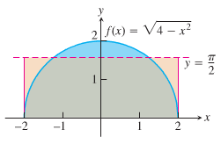 -









***Example***

We can model the voltage in the electrical wiring of a typical home with the sine function



Which express the voltage *V* in volts as a function of time *t* in seconds. The function runs through 60 cycles each second (its frequency is 60 Hz (*hertz*)). The positive constant  is the ***peak voltage***.

***Solution***

The average value of *V* over the half-cycle from 0 to  sec is



 











The average value of the voltage over a full cycle is zero.

To measure the voltage effectively, we can use an instrument the square root of the average value of the square of the voltage, namely:



“rms” : root mean square.



The rms voltage is: 

The “115 volts ac” means that the rms voltage is 115. The peak voltage is:



***Exercises Section* 4.5 – Working with Integrals**

1. If *f* is an odd function, why is 
2. If *f* is an even function, why is 
3. Is  an even or odd function? Is  an even or odd function?

Use symmetry to evaluate the following integrals

|  |  |
| --- | --- |
|  |  |

Find the average value of the following functions on the given interval.

|  |  |
| --- | --- |
|  |  |

Suppose that  and . Furthermore, suppose that  is an even function and  is an odd function. Evaluate the integrals

|  |  |  |
| --- | --- | --- |
|  |  |  |

Zuppose that  is an even function with . Evaluate the integral

|  |  |
| --- | --- |
|  |  |

Suppose that  is a nonzero real number and is an odd integrable function with . Evaluate the integral

|  |  |
| --- | --- |
|  |  |

1. The Gateway Arch in St. Louis is 630 *ft* high and has a 630-*ft* base. Its shape can be modeled by the parabola

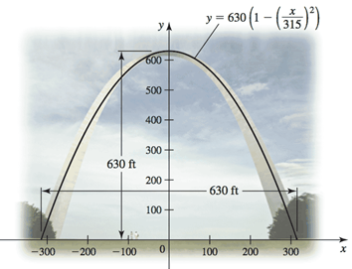



Find the average height of the arch above the ground.

1. The planets orbit the Sun in elliptical orbits with the Sun at one focus. The equation of an ellipse whose dimensions are 2 *a* in the *x-*direction and 2 *b* in the *y*-direction is

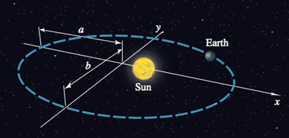

 W

1. Let  denote the square of the distance from a planet to the center of the ellipse at (0, 0). Integrate over the interval  to show that the average value of  is 
2. Show that in the case of a circle (*a* = *b* = *R*), the average value in part (*a*) is .
3. Assuming 0 < *b* < *a*, the coordinates of the Sun are . Let  denote the square of the distance from the planet to the Sun. Integrate over the interval  to show that the average value of  is .
4. A particle moves along a line with a velocity given by  starting with an initial position . Find the displacement of the particle between  and , which is given by . Find the distance traveled by the particle during this interval, which is .
5. A baseball is launched into the outfield on a parabolic trajectory given by . Find the average height of the baseball over the horizontal extent of its flight.
6. Find the average value of  shown in the figure on the interval  and then find the point(s) *c* in  guaranteed to exist by the Mean Value Theorem for Integrals

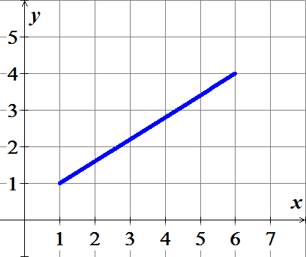

1. Find the average value of  shown in the figure on the interval  and then find the point(s) *c* in  guaranteed to exist by the Mean Value Theorem for Integrals

