***Solution Section* 4.5 – Working with Integrals**

***Exercise***

If *f* is an odd function, why is 

***Solution***

If  is an odd function then it is symmetric about the origin, which the region between −*a* and *a*, there is as much area above the axis and under *f* as there is below the axis and above *f*.

Therefore, the net area must be 0.

***Exercise***

If *f* is an even function, why is 

***Solution***

If *f* is an even function then it is symmetric about the *y-*axis, which the region that between −*a* and 0 has the same net area as the region between 0 and *a*.

So 



***Exercise***

Is  an even or odd function? Is  an even or odd function?

***Solution***









Therefore;  is an *even* function.









Therefore;  is also an even function.

***Exercise***

Use symmetry to evaluate the following integrals 

***Solution***

Because  is an *odd* function, then



***Exercise***

Use symmetry to evaluate the following integrals 

***Solution***

Because  is an *odd* function, then



***Exercise***

Use symmetry to evaluate the following integrals 

***Solution***

Because  is an even function, then









***Exercise***

Use symmetry to evaluate the following integrals 

***Solution***

***Odd*** ***Even***











***Exercise***

Use symmetry to evaluate the following integrals 

***Solution***

***Even*** ***Odd***









***Exercise***

Find the average value of the following functions on the given interval. 

***Solution***

Average value 





***Exercise***

Find the average value of the following functions on the given interval. 

***Solution***

Average value 







***Exercise***

Find the average value of the following functions on the given interval. 

***Solution***

Average value 







***Exercise***

Find the average value of the following functions on the given interval. 

***Solution***

Average value 









***Exercise***

Suppose that  and . Furthermore, suppose that  is an even function and  is an odd function. Evaluate the integral



***Solution***

 is an even function.







***Exercise***

Suppose that  and . Furthermore, suppose that  is an even function and  is an odd function. Evaluate the integral



***Solution***

 is an odd function









***Exercise***

Suppose that  and . Furthermore, suppose that  is an even function and  is an odd function. Evaluate the integral



***Solution***

 







***Exercise***

Suppose that  and . Furthermore, suppose that  is an even function and  is an odd function. Evaluate the integral



***Solution***

 is an even function, that implies  is an odd function.



***Exercise***

Suppose that  and . Furthermore, suppose that  is an even function and  is an odd function. Evaluate the integral



***Solution***

 is an even function and  is an odd function.







***Exercise***

Suppose that  is an even function with . Evaluate the integral 

***Solution***

 is an even function, that implies  is an odd function.



***Exercise***

Suppose that  is an even function with . Evaluate the integral 

***Solution***







  is an *even* function







***Exercise***

Suppose that  is a nonzero real number and is an odd integrable function with . Evaluate the integral 

***Solution***



 



***Exercise***

Suppose that  is a nonzero real number and is an odd integrable function with . Evaluate the integral 

***Solution***

 is an odd function



***Exercise***

The Gateway Arch in St. Louis is 630 *feet* high and has a 630-*ft* base. Its shape can be modeled by the parabola



Find the average height of the arch above the ground.

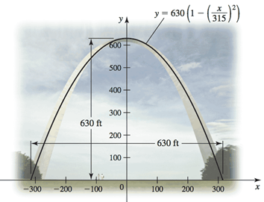***Solution***

*Average* *height* 







***Exercise***

The planets orbit the Sun in elliptical orbits with the Sun at one focus. The equation of an ellipse whose dimensions are 2 *a* in the *x-*direction and 2 *b* in the *y*-direction is



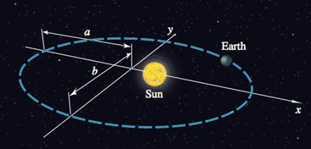

1. Let  denote the square of the distance from a planet to the center of the ellipse at (0, 0). Integrate over the interval  to show that the average value of  is 
2. Show that in the case of a circle (*a* = *b* = *R*), the average value in part (*a*) is .
3. Assuming 0 < *b* < a, the coordinates of the Sun are . Let  denote the square of the distance from the planet to the Sun. Integrate over the interval  to show that the average value of  is .

***Solution***

1. 









The average value of  









1. If 

The average value of 



1. 





The average value of 











***Exercise***

A particle moves along a line with a velocity given by  starting with an initial position . Find the displacement of the particle between  and , which is given by . Find the distance traveled by the particle during this interval, which is .

***Solution***



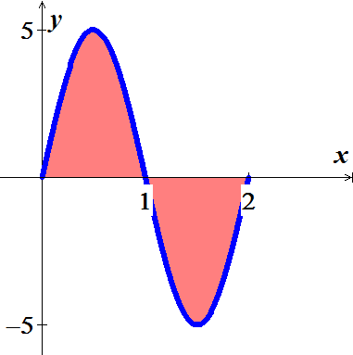 

















***Exercise***

A baseball is launched into the outfield on a parabolic trajectory given by . Find the average height of the baseball over the horizontal extent of its flight.

***Solution***





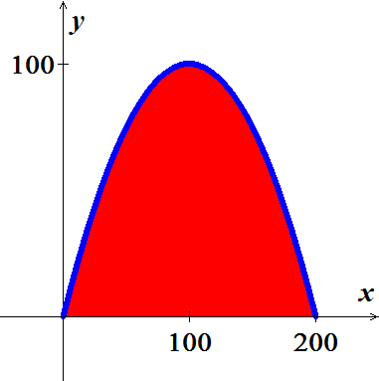 







***Exercise***

Find the average value of  shown in the figure on the interval  and then find the point(s) *c* in  guaranteed to exist by the Mean Value Theorem for Integrals

 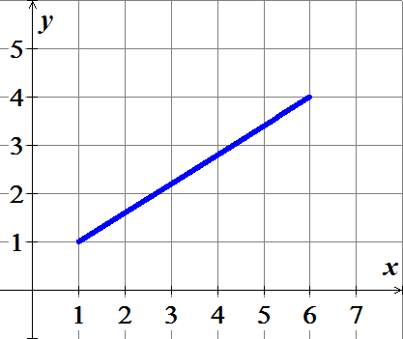

***Solution***

Since it is a straight line, then the average value is 2.5

The average value occurs at the midpoint of the interval which is 

***Exercise***

Find the average value of  shown in the figure on the interval  and then find the point(s) *c* in  guaranteed to exist by the Mean Value Theorem for Integrals

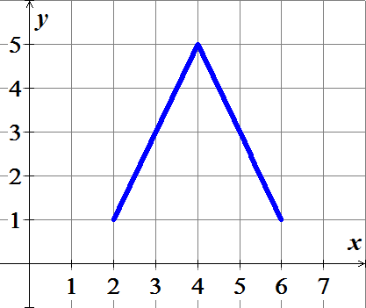

***Solution***

Over interval ; it is a straight line, then the average value is 3

Over interval ; it is a straight line, then the average value is 3 .

Therefore; the overage is 3 over 