***Section* 4.6 – Substitution Rule**

***Substitution*: Running the Chain Rule Backwards**

The Chain rule formula is:



We can see that  is an antiderivative of the function . Therefore, if we integrate both sides





***Example***

Find the integral 

***Solution***

|  |  |
| --- | --- |
| Let: |  |

***Example***

Find the integral 

***Solution***

|  |  |
| --- | --- |
| Let: |  |

***Theorem* – The Substitution Rule**

If  is differentiable function whose range is an interval *I*, and *f* is continuous on *I*, then



***Proof***

By the Chain Rule,  is an antiderivative of  whenever *F* is an antiderivative of *f*:





If we make the substitution , then











**Integral of** 

If *u* is a differentiable function that is never zero 

***Example***

Evaluate the integral 

***Solution***

 









***Example***

Evaluate the integral 

***Solution***

|  |  |
| --- | --- |
|  |  |

***Example***

Find the integral 

***Solution***

 

 

**The General Antiderivative of the Exponential Function**



***Example***

Evaluate the integral 

***Solution***















***Example***

Find the integral 

***Solution***

 



***Example***

Find the integral 

***Solution***





***Example***

Find the integral 

***Solution***

Let: 





















***Example***

Find the integral 

***Solution***

|  |  |
| --- | --- |
| Let: | ***Or*** let: |

***Definition***

If *a* > 0 and *u* is a differentiable of *x*, then  is a differentiable function of *x* and



***Example***

* 
* 



* 









**Substitution Formula**

***Theorem***

If  is continuous on the interval [*a, b*] and *f* is continuous on the range of , then



***Proof***

Let *F* denote any antiderivative of *f*. Then









***Example***

Evaluate 

***Solution***

 





 



***Example***

Evaluate 

***Solution***

Let 













***Example***

Evaluate the integral 

***Solution***

 











***Integrals*** of 

***Example***

Find the integral 

***Solution***

 





***Example***

Find the integral 

***Solution***

 





***Integration Formulas***

 

 

 

***Exercises*** ***Section* 4.6 – Substitution Rule**

Evaluate the indefinite integrals by using the given substitutions to reduce the integrals to standard form

1. 
2. 
3. 
4. 
5. 

Evaluate the integrals

|  |  |  |
| --- | --- | --- |
|  |  |  |

|  |  |  |
| --- | --- | --- |
|  |  |  |

|  |  |
| --- | --- |
|  |  |

|  |  |
| --- | --- |
|  |  |

|  |  |
| --- | --- |
|  |  |

1. Evaluate the integral 
2. , followed by 
3. , followed by 
4. 

Evaluate the integrals

|  |  |  |  |  |
| --- | --- | --- | --- | --- |
|  |  | | | |
|  | | | |  | |
|  | | |  | | |
|  | |  | | | | |

Solve the initial value problem

|  |  |
| --- | --- |
|  |  |

1. Verify the integration formula: 
2. Verify the integration formula: 
3. Find the area of the region bounded by the graphs of 
4. Find the area of the region bounded by the graph of 
5. Find the area of the region bounded by the graph of  and the  between  and .
6. Find the area of the region bounded by the graph of  and the  between  and .
7. Find the area of the region bounded by the graph of  and the  between  and .
8. Find the area of the region bounded by the graph of  and the  between  and .
9. Perhaps the simplest change of variables is the shift or translation given by , where *c* is a real number.
10. Prove that shifting a function does not change the net area under the curve, in the sense that



1. Draw a picture to illustrate this change of variables in the case that , , , and 
2. Another change of variables that can be interpreted geometrically is the scaling , where *c* is a real number. Prove and interpret the fact that



Draw a picture to illustrate this change of variables in the case that , , , and 

1. The function  satisfies the equation . Find  and check your answer by substitution.
2. Assume  is continuous on , , and . Evaluate .
3. The area of the shaded region under the curve  in

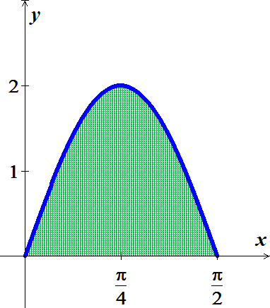 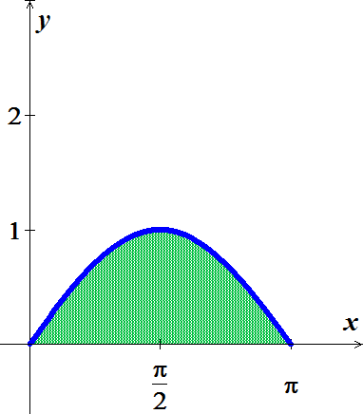

1. Equals the area on the shaded region under the curve 
2. Explain why this is true without computation areas.
3. The area of the shaded region under the curve  on the interval 

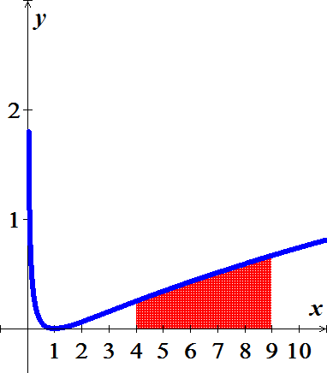 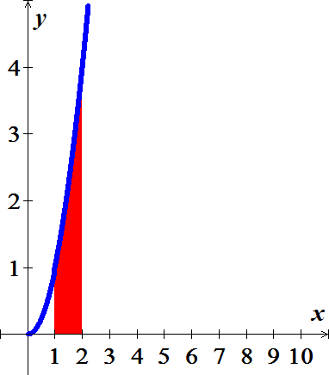

1. Equals the area on the shaded region under the curve  on the interval 
2. Explain why this is true without computation areas.
3. The family of parabolas , where , has the property that for , the *x-*intercept is  and the *y-*intercept is . Let  be the area of the region in the first quadrant bounded by the parabola and the . Find  and determine whether it is increasing, decreasing, or constant function of *a*.
4. Consider the right triangle with vertices , , and , where  and . Show that the average vertical distance from points on the  to the hypotenuse is , for all .
5. Consider the integral 
6. Find *I* using the identity 
7. Find *I* using the identity 
8. Confirm that the results in part (*a*) and (*b*) are consistent and compare the work involved in each method.
9. Let , for .
10. Evaluate 
11. Evaluate 
12. Evaluate 
13. Use geometry to evaluate 
14. Find the value of *s* such that 

Evaluate the limits

|  |  |
| --- | --- |
|  |  |

1. Prove that for nonzero constants *a* and *b*, 
2. Let  be a real number and consider the family of functions  on the interval .
3. Graph , for *a* = 1, 2, 3.
4. Let  be the area of the region bounded by the graph of  and the on the interval . Graph  for . Is  an increasing function, a decreasing function, or neither?
5. Explain why if a function *u* satisfies the equation , then it also satisfies the equation . Is it true that is *u* satisfies the second equation, then it satisfies the first equation?
6. Let 
7. Find the interval on which  is increasing and the intervals on which  is decreasing.
8. Find the intervals on which  is concave up and the intervals on which  is concave down.
9. For what values of *x* does  have local minima? Local maxima?
10. Where are the inflection points of ?
11. A company is considering a new manufacturing process in one of its plants. The new process provides substantial initial savings, with the savings declining with time *t* (in years) according to the rate-of-savings function



where  is in thousands of dollars per year. At the same time, the cost of operating the new process increases with time *t* (in years), according to the rate-of-cost function (in thousands of dollars per year)



1. For how many years will the company realize savings?
2. What will be the net total savings during this period?
3. Find the producers’ surplus if the supply function for pork bellies is given by



Assume supply and demand are in equilibrium at 

1. An object moves along a line with a velocity in  given by . Its initial position is .
2. Graph the velocity function.
3. The position of the object is given by , for . Find the position function, for .
4. What is the period of the motion − that is, starting at any point, how long does it take the object to return to that position?
5. The population of a culture of bacteria has a growth rate given by  bacteria per hour, for , where  is a real number. It is shown that the increase in the population over time interval  is given by . (note that the growth rate decreases in time, reflecting competition for space and food.)
6. Using the population model with , what is the increase in the population over the time interval ?
7. Using the population model with , what is the increase in the population over the time interval ?
8. Let  be the increase in the population over a fixed time interval . For fixed *T*, does  increase or decrease with the parameter *r*? Explain.
9. A lab technician measures an increase in the population of 350 bacteria over the 10-hr period . Estimate the value of *r* that best fits this data point.
10. Use the population model in part (*b*) to find the increase in population over time interval , for any . If the culture is allowed to grow indefinitely , does the bacteria population increase without bound? Or does it approach a finite limit?
11. Consider the function  and the area function .
12. Graph  on the interval [0, 6].
13. Compute and graph *A* on the interval [0, 6].
14. Show that the local extrema of *A* occur at the zeros of .
15. Give a geometric and analytical explanation for the observation in part (c).
16. Find the approximate zeros of *A*, other than 0, and call them  and .
17. Find *b* such that the area bounded by the graph of  and the *x*-axis on the interval  equals the area bounded by the graph of  and the *x*-axis on the interval .
18. If  is an integrable function and , is it always true that the local extrema of *A* occur at the zeros of ? Explain