***Solution*** ***Section* 4.4 – Fundamental Theorem of Calculus**

***Exercise***

Evaluate the integral 

***Solution***







***Exercise***

Evaluate the integral 

***Solution***









***Exercise***

Evaluate the integral 

***Solution***







***Exercise***

Evaluate the integral 

***Solution***







***Exercise***

Evaluate the integral 

***Solution***







***Exercise***

Evaluate the integral 

***Solution***









***Exercise***

Evaluate the integral 

***Solution***









***Exercise***

Evaluate the integral 

***Solution***













***Exercise***

Evaluate the integral 

***Solution***











***Exercise***

Evaluate the integral 

***Solution***













***Exercise***

Evaluate the integral 

***Solution***











***Exercise***

Evaluate the integral 

***Solution***















***Exercise***

Evaluate the integral 

***Solution***









***Exercise***

Evaluate the integral 

***Solution***









***Exercise***

Evaluate the integral 

***Solution***







***Exercise***

Evaluate the integral 

***Solution***



 



***Exercise***

Evaluate the integral 

***Solution***









***Exercise***

Evaluate the integral 

***Solution***







***Exercise***

Evaluate the integral 

***Solution***









***Exercise***

Evaluate the integral 

***Solution***







***Exercise***

Evaluate the integral 

***Solution***







***Exercise***

Evaluate the integral 

***Solution***









***Exercise***

Evaluate the integral 

***Solution***











***Exercise***

Evaluate the integral 

***Solution***









***Exercise***

Evaluate the integral 

***Solution***







***Exercise***

Evaluate the integral 

***Solution***









 

***Exercise***

Evaluate the integral 

***Solution***









***Exercise***

Evaluate the integral 

***Solution***











***Exercise***

Evaluate the integral 

***Solution***









***Exercise***

Evaluate the integral 

***Solution***









***Exercise***

Find the total area between the region and the *x*-axis 

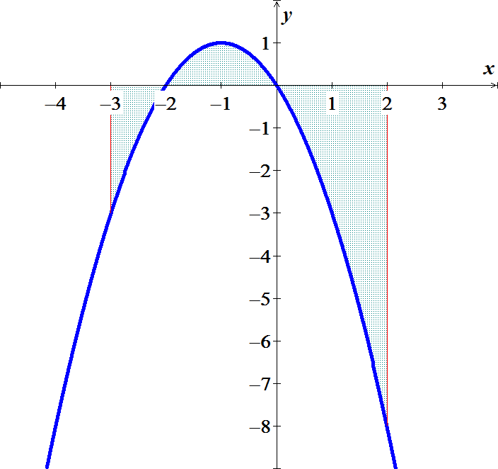***Solution***













***Exercise***

Find the total area between the region and the *x*-axis 

***Solution***











***Exercise***

Find the total area between the region and the *x*-axis 

***Solution***













***Exercise***

Find the total area between the region and the *x*-axis 

***Solution***













***Exercise***

Find the area of the region between the graph of  and the , for 

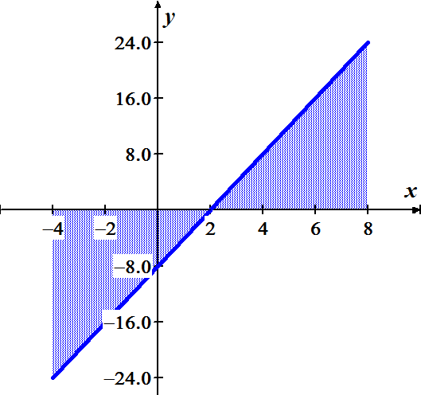***Solution***













***Exercise***

Find the area of the region between the graph of  and the , for 

***Solution***

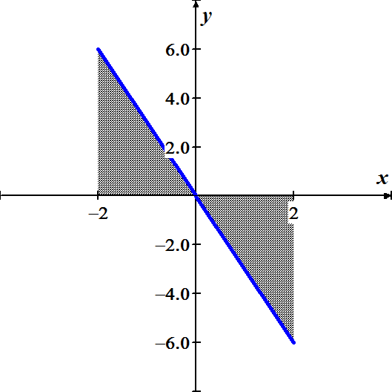











***Exercise***

Find the area of the region between the graph of  and the , for 

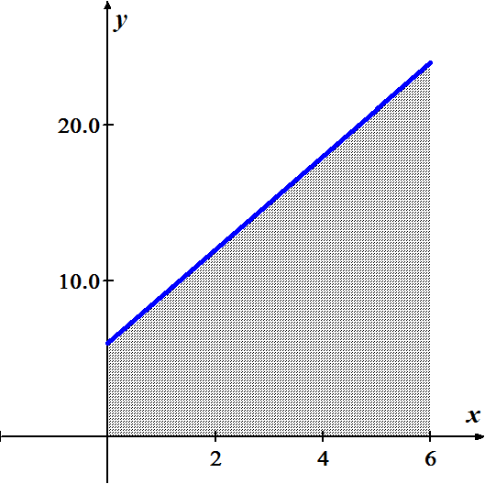***Solution***











***Exercise***

Find the area of the region between the graph of  and the , for 

***Solution***



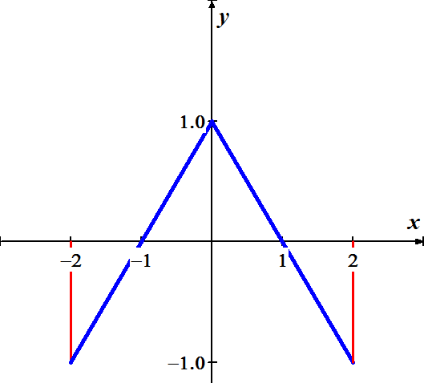







***Exercise***

Find the area of the region above the  bounded by 

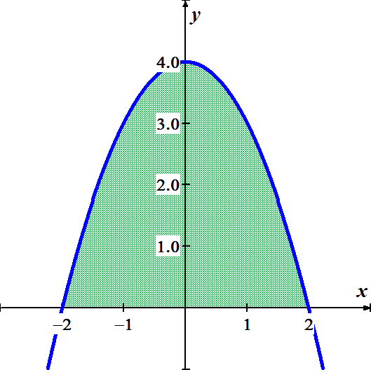***Solution***













***Exercise***

Find the area of the region above the  bounded by 

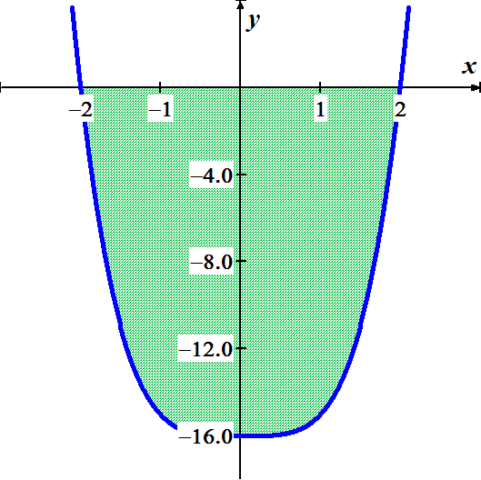***Solution***











***Exercise***

Find the area of the region between the graph of  and the , for 

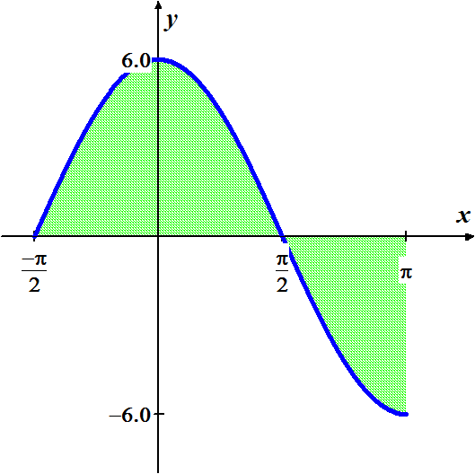***Solution***













***Exercise***

Find the area of the region between the graph of  and the , for 

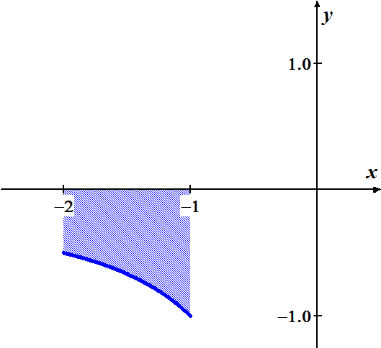***Solution***











***Exercise***

Find the area of the region bounded by the graph of

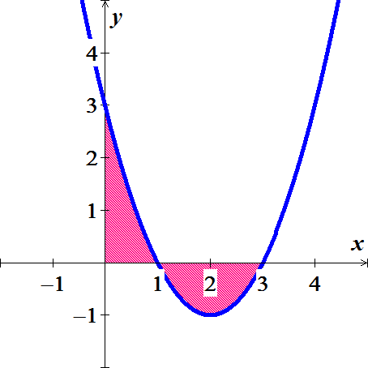 

***Solution***











***Exercise***

Find the area of the region bounded by the graph of 

***Solution***

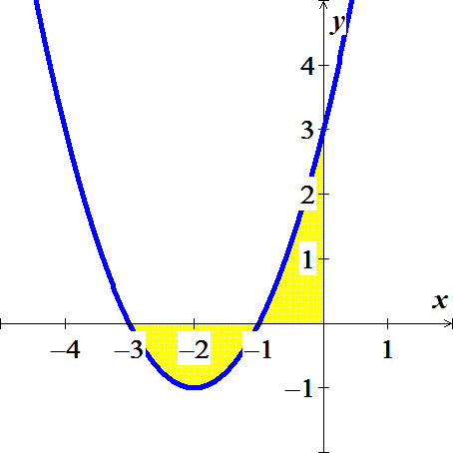









***Exercise***

Find the area of the region bounded by the graph of 

***Solution***

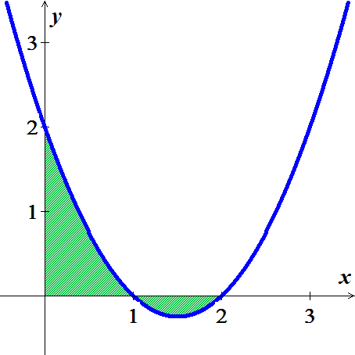











***Exercise***

Find the area of the region bounded by the graph of 

***Solution***

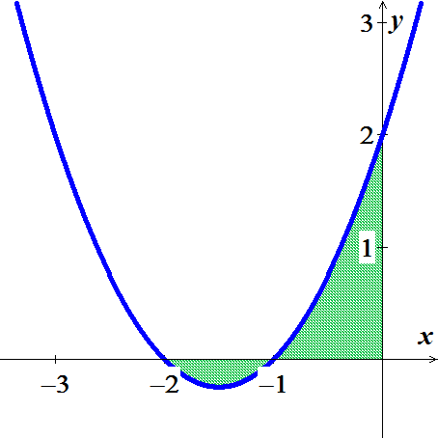









***Exercise***

Find the area of the region bounded by the graph of 

***Solution***



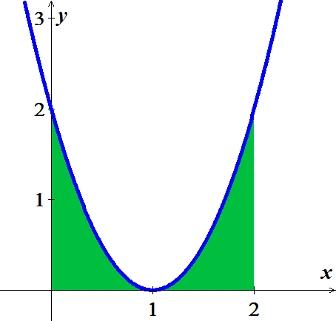







***Exercise***

Find the area of the region bounded by the graph of 

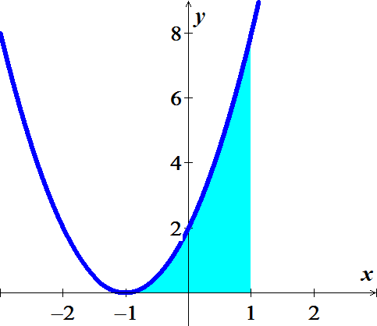***Solution***











***Exercise***

Find the area of the region bounded by the graphs of  and 

***Solution***



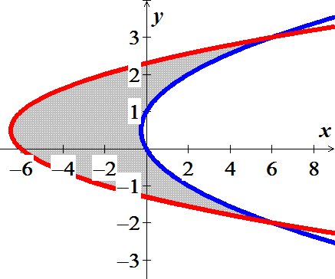













***Exercise***

Find the area of the region bounded by the graphs of  &  on 

***Solution***

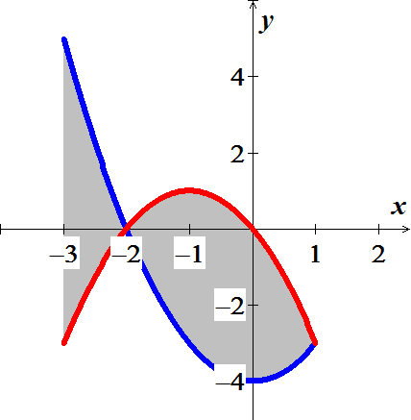





 









***Exercise***

Compute the area of the region bounded by the graph of  and the on the given interval.



***Solution***

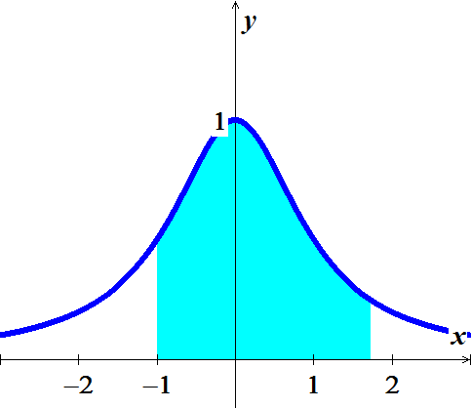 









***Exercise***

Compute the area of the region bounded by the graph of  and the on the given interval.



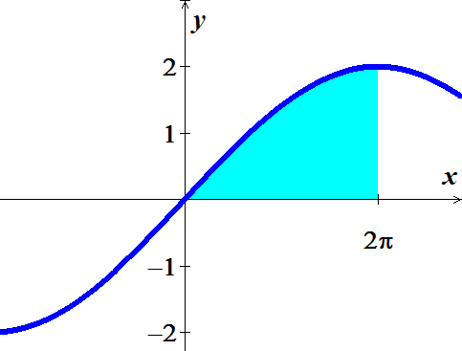***Solution***









***Exercise***

Archimedes, inventor, military engineer, physicist, and the greatest mathematician of classical times in the Western world, discovered that the area under a parabolic arch is two-thirds the base times the height. Sketch the parabolic arch , assuming that *h* and *b* are positive. Then use calculus to find the area of the region enclosed between the arch and the *x*-axis

***Solution***













***Exercise***

Suppose that a company’s marginal revenue from the manufacture and sale of eggbeaters is



Where *r* is measured in thousands of dollars and *x* in thousands of units. How much money should the company expect from a production run of *x* = 3 thousand eggbeaters? To find out, integrate the marginal revenue from *x* = 0 to *x* = 3.

***Solution***

 









***Exercise***

The height *H* (*feet*) of a palm tree after growing for *t* years is given by



1. Find the tree’s height when *t* = 0, *t* = 4, and *t* = 8.
2. Find the tree’s average height for 

***Solution***

1. 





1. Average height  









***Exercises Section* 4.5 – Working with Integrals**

***Exercise***

If *f* is an odd function, why is 

***Solution***

If *f* is an odd function then it is symmetric about the origin, which the region between −*a* and *a*, there is as much area above the axis and under *f* as there is below the axis and above *f*.

Therefore, the net area must be 0.

***Exercise***

If *f* is an even function, why is 

***Solution***

If *f* is an even function then it is symmetric about the *y-*axis, which the region that between −*a* and 0 has the same net area as the region between 0 and *a*.

So 

***Exercise***

Is  an even or odd function? Is  an even or odd function?

***Solution***

; therefore  is an even function.

 is also an even function.

***Exercise***

Use symmetry to evaluate the following integrals 

***Solution***

Because  is an odd function, then 

***Exercise***

Use symmetry to evaluate the following integrals 

***Solution***

Because  is an odd function, then 

***Exercise***

Use symmetry to evaluate the following integrals 

***Solution***

Because  is an even function, then









***Exercise***

Use symmetry to evaluate the following integrals 

***Solution***

***Odd*** ***Even***











***Exercise***

Use symmetry to evaluate the following integrals 

***Solution***

***Even*** ***Odd***









***Exercise***

Find the average value of the following functions on the given interval. 

***Solution***

Average value 

***Exercise***

Find the average value of the following functions on the given interval. 

***Solution***

Average value 







***Exercise***

Find the average value of the following functions on the given interval. 

***Solution***

Average value 







***Exercise***

Find the average value of the following functions on the given interval. 

***Solution***

Average value 









***Exercise***

Suppose that  and . Furthermore, suppose that  is an even function and  is an odd function. Evaluate the integral



***Solution***

 is an even function.







***Exercise***

Suppose that  and . Furthermore, suppose that  is an even function and  is an odd function. Evaluate the integral



***Solution***

 is an odd function









***Exercise***

Suppose that  and . Furthermore, suppose that  is an even function and  is an odd function. Evaluate the integral



***Solution***

 







***Exercise***

Suppose that  and . Furthermore, suppose that  is an even function and  is an odd function. Evaluate the integral



***Solution***

 is an even function, that implies  is an odd function.



***Exercise***

Suppose that  and . Furthermore, suppose that  is an even function and  is an odd function. Evaluate the integral



***Solution***

 is an even function and  is an odd function.







***Exercise***

Suppose that  is an even function with . Evaluate the integral 

***Solution***

 is an even function, that implies  is an odd function.



***Exercise***

Suppose that  is an even function with . Evaluate the integral 

***Solution***







  is an even function







***Exercise***

Suppose that  is a nonzero real number and is an odd integrable function with . Evaluate the integral 

***Solution***



 



***Exercise***

Suppose that  is a nonzero real number and is an odd integrable function with . Evaluate the integral 

***Solution***

 is an odd function



***Exercise***

The Gateway Arch in St. Louis is 630 *feet* high and has a 630-*ft* base. Its shape can be modeled by the parabola

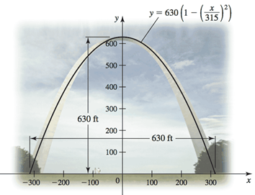

Find the average height of the arch above the ground.

***Solution***

Average height 







***Exercise***

The planets orbit the Sun in elliptical orbits with the Sun at one focus. The equation of an ellipse whose dimensions are 2 *a* in the *x-*direction and 2 *b* in the *y*-direction is



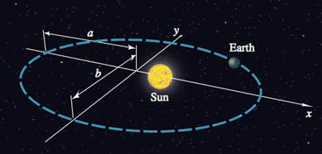

1. Let  denote the square of the distance from a planet to the center of the ellipse at (0, 0). Integrate over the interval  to show that the average value of  is 
2. Show that in the case of a circle (*a* = *b* = *R*), the average value in part (*a*) is .
3. Assuming 0 < *b* < a, the coordinates of the Sun are . Let  denote the square of the distance from the planet to the Sun. Integrate over the interval  to show that the average value of  is .

***Solution***

1. 





The average value of  









1. If 

The average value of 

1. 





The average value of 











***Exercise***

A particle moves along a line with a velocity given by  starting with an initial position . Find the displacement of the particle between  and , which is given by . Find the distance traveled by the particle during this interval, which is .

***Solution***



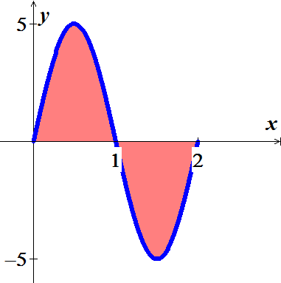 

















***Exercise***

A baseball is launched into the outfield on a parabolic trajectory given by . Find the average height of the baseball over the horizontal extent of its flight.

***Solution***



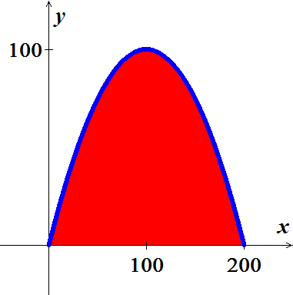









***Exercise***

Find the average value of  shown in the figure on the interval  and then find the point(s) *c* in  guaranteed to exist by the Mean Value Theorem for Integrals

 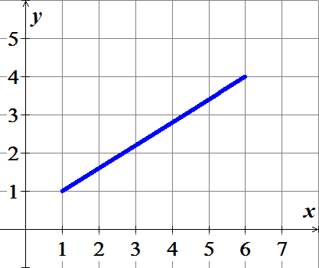

***Solution***

Since it is a straight line, then the average value is 2.5

The average value occurs at the midpoint of the interval which is 

***Exercise***

Find the average value of  shown in the figure on the interval  and then find the point(s) *c* in  guaranteed to exist by the Mean Value Theorem for Integrals

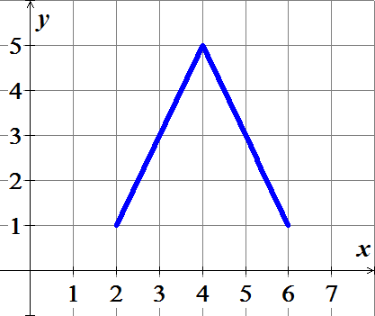

***Solution***

Over interval ; it is a straight line, then the average value is 3

Over interval ; it is a straight line, then the average value is 3 .

Therefore; the overage is 3 over 