***Solution Section* 1.1 – Idea of Limits**

***Exercise***

Find the average rate of change of the function  over the interval 

***Solution***









***Exercise***

Find the average rate of change of the function  over the interval 

***Solution***









***Exercise***

Find the average rate of change of the function  over the interval 

***Solution***









***Exercise***

Find the slope of  at the point  and an equation of the tangent line at this *P*.

***Solution***

 









As *h* approaches 0. Then the secant slope 

 





***Exercise***

Find the slope of  at the point  and an equation of the tangent line at this *P*.

***Solution***









 As *h* approaches 0. Then the secant slope 

 





***Exercise***

Find the slope of  at the point  and an equation of the tangent line at this *P*.

***Solution***







 As *h* approaches 0. Then 

 





***Exercise***

Make a table of values for the function  at the points



1. Find the average rate of change of  over the intervals  for each  in the table
2. Extending the table if necessary, try to determine the rate of change of  at .

***Solution***

|  |  |  |  |  |  |  |
| --- | --- | --- | --- | --- | --- | --- |
| ***x*** | 1.2 | 1.1 | 1.01 | 1.001 | 1.0001 | 1 |
|  | −4.0 |  |  |  |  | −3 |











1. The rate of change of  at  is 

***Exercise***

The accompanying graph shows the total amount of gasoline *A* in the gas tank of an automobile after being driven for *t* days.

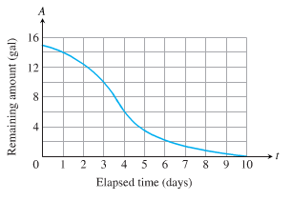

1. Estimate the average rate of gasoline consumption over the time intervals



1. Estimate the instantaneous rate of gasoline consumption over the time 

***Solution***

1. Average rate of gasoline consumption over the time intervals:







1. At 

At 

At 

***Solution*** ***Section* 1.2 – Definitions / Techniques of Limits**

***Exercise***

Find the limit: 

***Solution***



***Exercise***

Find the limit: 

***Solution***



***Exercise***

Find the limit: 

***Solution***



***Exercise***

Find the limit: 

***Solution***



***Exercise***

Find the limit: 

***Solution***



***Exercise***

Find the limit: 

***Solution***



***Exercise***

Find the limit: 

***Solution***



***Exercise***

Find the limit: 

***Solution***



***Exercise***

Find the limit: 

***Solution***



***Exercise***

Find the limit: 

***Solution***









***Exercise***

Find the limit: 

***Solution***



***Exercise***

Find the limit: 

***Solution***







***Exercise***

Find the limit:

***Solution***





 (***Doesn’t exist***)

***Exercise***

Find the limit:

***Solution***



 

***Doesn’t exist***

***Exercise***

Find: 

***Solution***



***Exercise***

Find: 

***Solution***









***Exercise***

Find the limit: 

***Solution***



***Exercise***

Find the limit: 

***Solution***



***Exercise***

Find the limit: 

***Solution***





***Exercise***

Find the limit: 

***Solution***









***Exercise***

Find the limit: 

***Solution***







= 22 +2(2) + 4



***Exercise***

Find the limit: 

***Solution***





= 3 + 4



***Exercise***

Find the limit: 

***Solution***















***Exercise***

Find the limit: 

***Solution***







***Exercise***

Find the limit: 

***Solution***







***Exercise***

Find the limit: 

***Solution***

 (***Doesn’t exist***)

***Exercise***

Find the limit: 

***Solution***



***Exercise***

Find the limit: 

***Solution***











***Exercise***

Find the limit: 

***Solution***







***Doesn’t exist***

***Exercise***

Find the limit: 

***Solution***







***Exercise***

Find the limit: 

***Solution***











***Exercise***

Find the limit: 

***Solution***











***Exercise***

Find the limit: 

***Solution***















***Exercise***

Find the limit: 

***Solution***











***Exercise***

Find the limit: 

***Solution***















***Exercise***

Find the limit: 

***Solution***













 



***Exercise***

Find the limit: 

***Solution***























***Exercise***

Find the limit: 

***Solution***







***Exercise***

Find the limit: 

***Solution***



***Exercise***

Find the limit: 

***Solution***







***Exercise***

Find the limit: 

***Solution***





***Exercise***

Find the limit: 

***Solution***







***Exercise***

Find 

***Solution***







***Exercise***

Find 

***Solution***





***Exercise***

Find 

***Solution***







***Exercise***

Find 

***Solution***





















***Exercise***

Find 

***Solution***



Since  









***Exercise***

Find 

***Solution***



Since  







***Exercise***

Find 

***Solution***

Let: 



***Exercise***

Find 

***Solution***



 Let: 

 ***By definition: ***



***Exercise***

Find 

***Solution***





 ***By definition: ***



***Exercise***

Find 

***Solution***











***Exercise***

Find 

***Solution***





 



***Exercise***

Find 

***Solution***



 



***Exercise***

Find 

***Solution***

Let:  



***Exercise***

Find 

***Solution***















***Exercise***

Find 

***Solution***











***Exercise***

Find 

***Solution***



***Exercise***

Find 

***Solution***



***Exercise***

Find 

***Solution***









***Exercise***

Find 

***Solution***









***Exercise***

Find 

***Solution***















***Exercise***

Find 

***Solution***













***Exercise***

Find 

***Solution***









***Exercise***

Find 

***Solution***



 





***Exercise***

Find 

***Solution***

 







***Exercise***

Find 

***Solution***













***Exercise***

For the function  graphed, find the following limits or explain why they do not exist.



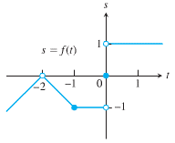***Solution***

1. 
2. 
3. 
4. 

***Exercise***

Suppose . Find

|  |  |  |  |
| --- | --- | --- | --- |
|  |  |  |  |

***Solution***

1. 
2. 
3. 





1. 





***Exercise***

Explain why the limits do not exist for 

***Solution***



|  |  |
| --- | --- |
|  | ***Doesn’t exist*** |

***Exercise***

Evaluate the limit using the form  for 

***Solution***











***Exercise***

Evaluate the limit using the form  for 

***Solution***















 



***Exercise***

If, find 

***Solution***





 ***Multiply both sides by* 2**

 ***Add* 5 *on both sides***



***Exercise***

If, find 

***Solution***















***Exercise***

If  and . At what points *c* do you automatically know ? What can you say about the value of the limits at these points?

***Solution***

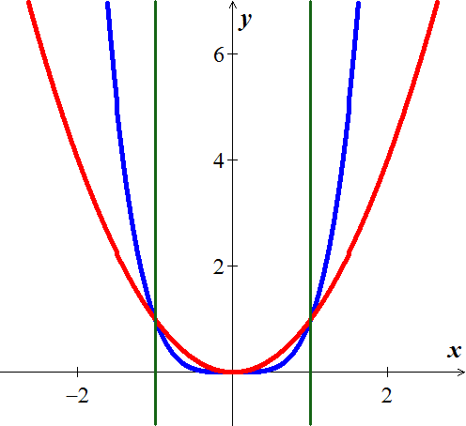





 

 





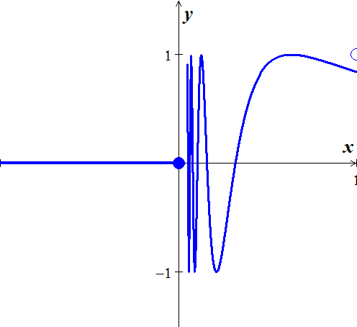***Exercise***

Let 

1. Does  exist? If so, what is it? If not, why not?
2. Does  exist? If so, what is it? If not, why not?
3. Does  exist? If so, what is it? If not, why not?

***Solution***

1.  doesn’t exist, since  doesn’t approach any single value as 
2. 
3.  doesn’t exist, since  doesn’t exist

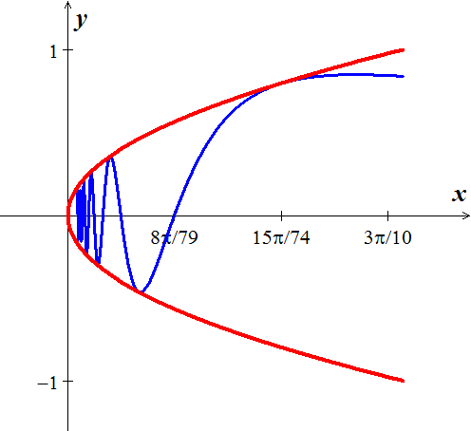***Exercise***

Let 

1. Does  exist? If so, what is it? If not, why not?
2. Does  exist? If so, what is it? If not, why not?
3. Does  exist? If so, what is it? If not, why not?

***Solution***

1.  exists, by the sandwich theorem 
2.  doesn’t exist, since  is not defined for 
3.  doesn’t exist, since  doesn’t exist.

***Exercise***

Which of the following statements about the function  graphed here are true, and which are false?

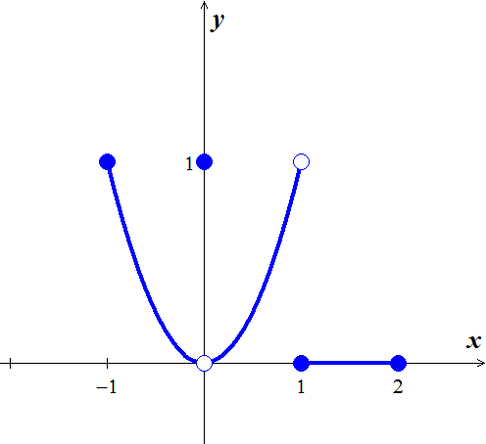***Solution***

1.  ***True***
2.  ***True***
3.  ***False***
4.  ***True***
5.  ***True***
6.  ***True***
7.  ***False***
8.  ***False***
9.  ***False***
10.  ***False***
11.  ***True***
12.  ***False***

***Solution*** ***Section* 1.3 – Infinite Limits**

***Exercise***

Find 

***Solution***



***Exercise***

Find 

***Solution***



***Exercise***

Find 

***Solution***



***Exercise***

Find 

***Solution***



***Exercise***

Find 

***Solution***



***Exercise***

Find 

***Solution***



***Exercise***

Find 

***Solution***



***Exercise***

Find 

***Solution***



***Exercise***

Find 

***Solution***



***Exercise***

Find 

***Solution***

 As  

***Exercise***

Find 

***Solution***

 As  

***Exercise***

Find 

***Solution***

 As  

***Exercise***

Find 

***Solution***



***Exercise***

Find 

***Solution***



***Exercise***

Find 

***Solution***



***Exercise***

Find 

***Solution***



***Exercise***

Find 

***Solution***



***Exercise***

Find 

***Solution***



***Exercise***

Find 

***Solution***



***Exercise***

Find 

***Solution***



***Exercise***

Find 

***Solution***



***Exercise***

Find 

***Solution***







***Exercise***

Find 

***Solution***







***Exercise***

Find 

***Solution***







***Exercise***

Find 

***Solution***



***Exercise***

Find 

***Solution***



***Exercise***

Let 

1. For what values of *a*, if any, does  equal a finite number?
2. For what values of *a*, if any, does ?
3. For what values of *a*, if any, does ?

***Solution***



1. If , then 

If , then 

1.  for any number other than 3 or 4.

As , then  is always positive.



1.  for any number other than 3 or 4.

As , then  is always positive, and 

***Exercise***

Analyze  and 

***Solution***





***Solution*** ***Section* 1.4 – Limits at Infinity**

***Exercise***

Find the limit as  and as  of 

***Solution***





***Exercise***

Find the limit as  and as  of 

***Solution***





***Exercise***

Find the limit as  and as  of 

***Solution***





***Exercise***

Find the limit as  and as  of 

***Solution***





***Exercise***

Find the limit as  and as  of 

***Solution***





***Exercise***

Find the limit as  and as  of 

***Solution***





***Exercise***

Find the limit as  and as  of 

***Solution***





***Exercise***

Find 

***Solution***



 *By the Sandwich Theorem*

***Exercise***

Find 

***Solution***







***Exercise***

Find 

***Solution***







***Exercise***

Find 

***Solution***







***Exercise***

Find 

***Solution***







***Exercise***

Find 

***Solution***







***Exercise***

Find 

***Solution***











***Exercise***

Find 

***Solution***















***Exercise***

Find 

***Solution***

















***Exercise***

Find 

***Solution***



***Exercise***

Find 

***Solution***



***Exercise***

Find 

***Solution***



***Exercise***

Find 

***Solution***



***Exercise***

Find 

***Solution***



***Exercise***

Graph the rational function . Include the equations of the asymptotes.

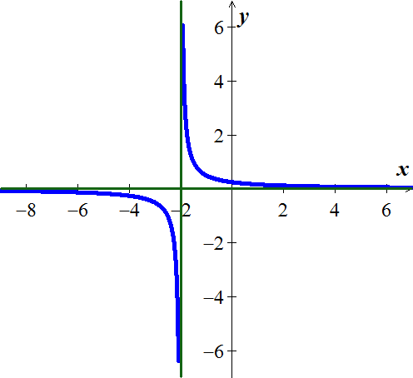***Solution***

***VA***: 

***HA***: 

***Exercise***

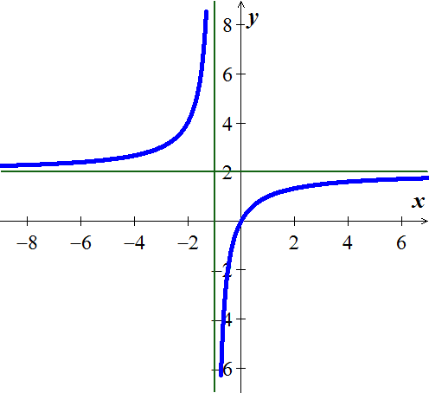Graph the rational function . Include the equations of the asymptotes.

***Solution***

***VA***: 

***HA***: 

***Exercise***

Graph the rational function . Include the equations of the asymptotes.

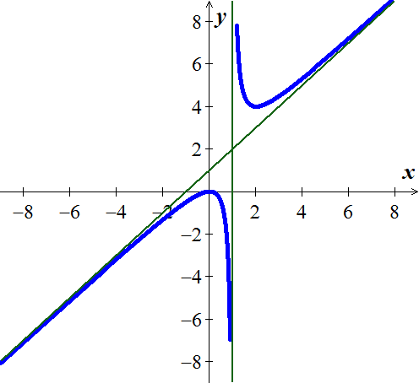***Solution***





***VA***: 

***Oblique Asymptote***: 

***Exercise***

Graph the rational function . Include the equations of the asymptotes.

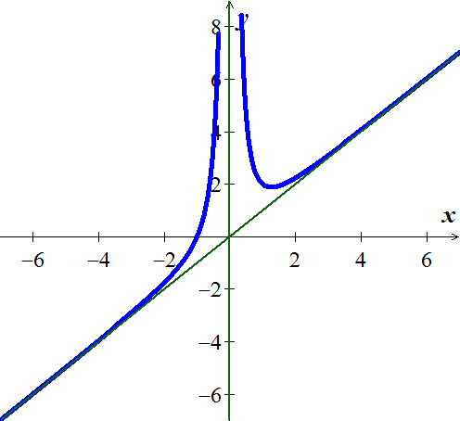***Solution***





***VA***: 

***Oblique Asymptote***: 

***Exercise***

Let 

1. Analyze ,, , and 
2. Does the graph of *f* have any vertical asymptotes? Explain?

***Solution***

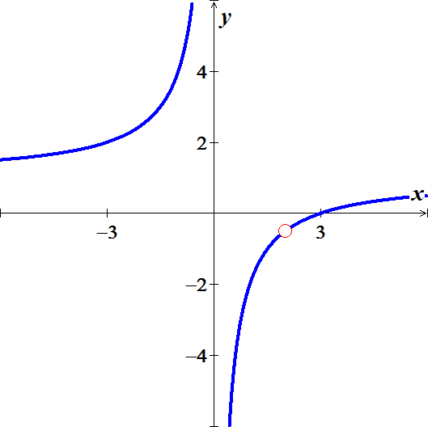

1. 







1.  

 

***Exercise***

Find the vertical, horizontal, hole, and oblique asymptotes (if any) of 

***Solution***



***Exercise***

Find the vertical, horizontal, hole, and oblique asymptotes (if any) of 

***Solution***



***Exercise***

Find the vertical, horizontal, hole, and oblique asymptotes (if any) of 

***Solution***



***Exercise***

Find the vertical, horizontal, hole, and oblique asymptotes (if any) of 

***Solution***



***Exercise***

Find the vertical, horizontal, hole, and oblique asymptotes (if any) of 

***Solution***



***Exercise***

Find the vertical, horizontal, hole, and oblique asymptotes (if any) of 

***Solution***

 



***Exercise***

Find the vertical, horizontal, hole, and oblique asymptotes (if any) of 

***Solution***



***Exercise***

Find the vertical, horizontal, hole, and oblique asymptotes (if any) of 

***Solution***

 



***Exercise***

Find the vertical, horizontal, hole, and oblique asymptotes (if any) of 

***Solution***



***Exercise***

Find the vertical, horizontal, hole, and oblique asymptotes (if any) of 

***Solution***



***Exercise***

Find the vertical, horizontal, hole, and oblique asymptotes (if any) of 

***Solution***



***Exercise***

Find the vertical, horizontal, hole, and oblique asymptotes (if any) of 

***Solution***



***Exercise***

Find the vertical, horizontal, hole, and oblique asymptotes (if any) of 

***Solution***



***Exercise***

Find the vertical, horizontal, hole, and oblique asymptotes (if any) of 

***Solution***



***Exercise***

Find the vertical, horizontal, hole, and oblique asymptotes (if any) of 

***Solution***



***Exercise***

Find the vertical, horizontal, hole, and oblique asymptotes (if any) of 

***Solution***



***Exercise***

Find the vertical, horizontal, hole, and oblique asymptotes (if any) of 

***Solution***





***Exercise***

Find the vertical, horizontal, hole, and oblique asymptotes (if any) of 

***Solution***



***Exercise***

Find the vertical, horizontal, hole, and oblique asymptotes (if any) of 

***Solution***





***Exercise***

Find the vertical, horizontal, hole, and oblique asymptotes (if any) of 

***Solution***







***Solution*** ***Section* 1.5 – Continuity**

***Exercise***

Given the graphed function 

1. Does  exist?
2. Does  exist?
3. Does ?
4. Is  continuous at ?
5. Does  exist?
6. Does  exist?
7. Does ?
8. Is  continuous at ?

***Solution***

|  |  |  |
| --- | --- | --- |
| 1. Yes 2. Yes, 3. Yes | 1. Yes 2. Yes, 3. Yes, | 1. No 2. No |

***Exercise***

At what points is the function  continuous?

***Solution***

The function is continuous everywhere except when 

***Exercise***

At what points is the function  continuous?

***Solution***

The function is continuous everywhere except when 

***Exercise***

At what points is the function  continuous?

***Solution***

The function is continuous everywhere

***Exercise***

At what points is the function  continuous?

***Solution***

The function is continuous everywhere except when 

***Exercise***

At what points is the function  continuous?

***Solution***

The function is continuous everywhere except when 

***Exercise***

At what points is the function  continuous?

***Solution***

The function is continuous everywhere except when 

***Exercise***

At what points is the function  continuous?

***Solution***

The function is continuous everywhere

***Exercise***

At what points is the function  continuous?

***Solution***

The function is continuous on the interval , and discontinuous when 

***Exercise***

At what points is the function  continuous?

***Solution***

The function is continuous on the interval , and discontinuous when 

***Exercise***

At what points is the function  continuous?

***Solution***

The function is continuous everywhere 

***Exercise***

Find , then is the function continuous at the point being approached?

***Solution***







 The function is continuous at 

***Exercise***

Find , then is the function continuous at the point being approached?

***Solution***







 The function is continuous at 

***Exercise***

Find , then is the function continuous at the point being approached?

***Solution***









 The function is continuous at 

***Exercise***

Explain why the equation  has at least one solution.

***Solution***



 for some *x* between  and 

According to the Intermediate Value Theorem, and the function  is continuous and has at least one solution.

***Exercise***

Show that the equation  has three solutions in the interval [−4, 4]

***Solution***











By the Intermediate Value Theorem,  for some *x* in each of the intervals , , and . Thus,  has three solutions in [−4, 4]. Since the polynomial of degree 3 can have at most 3 solutions, these are the solutions.

***Exercise***

Show that the equation has three solutions in the given interval 

***Solution***

|  |  |  |  |  |  |  |  |  |  |  |  |  |  |  |  |  |  |  |  |  |  |  |  |  |  |  |  |  |  |  |  |  |  |  |  |  |  |  |  |  |  |  |  |  |  |  |  |  |  |  |  |  |  |
| --- | --- | --- | --- | --- | --- | --- | --- | --- | --- | --- | --- | --- | --- | --- | --- | --- | --- | --- | --- | --- | --- | --- | --- | --- | --- | --- | --- | --- | --- | --- | --- | --- | --- | --- | --- | --- | --- | --- | --- | --- | --- | --- | --- | --- | --- | --- | --- | --- | --- | --- | --- | --- | --- |
| |  |  | | --- | --- | | ***x*** | ***y*** | | −19 | −1299 | | −18 | −742 | | −17 | −273 | | −16 | 114 | | −15 | 425 | | −14 | 666 | | −13 | 962 | | −12 | 1029 | | −10 | 1050 | | −9 | 1031 | | −8 | 978 | | −7 | 897 | | −6 | 794 | | −5 | 675 | | −4 | 546 | | −3 | 413 | | −2 | 282 | | −1 | 159 | | 0 | 50 | | 1 | −39 | | 2 | −102 | | 3 | −133 | | 4 | −126 | | 5 | −75 | | 6 | 26 | | By the Intermediate Value Theorem,  for some *x* in each of the intervals , , and . |

***Exercise***

Show that the equation has three solutions in the given interval 

***Solution***

|  |  |  |  |  |  |  |  |  |  |  |  |  |  |  |  |  |  |  |  |  |  |  |  |  |  |  |  |  |  |  |  |  |  |  |  |  |  |  |  |  |  |
| --- | --- | --- | --- | --- | --- | --- | --- | --- | --- | --- | --- | --- | --- | --- | --- | --- | --- | --- | --- | --- | --- | --- | --- | --- | --- | --- | --- | --- | --- | --- | --- | --- | --- | --- | --- | --- | --- | --- | --- | --- | --- |
| |  |  | | --- | --- | | ***x*** | ***y*** | | .05 | −1.6 | | .1 | −0.6 | | .15 | 0.08 | | .2 | .48 | | .25 | .656 | | .3 | .66 | | .35 | .543 | | .4 | .36 | | .45 | .161 | | .5 | 0 | | .55 | −.07 | | .6 | 0 | | .65 | .266 | | .7 | .78 | | .75 | 1.6 | | .8 | 2.76 | | .85 | 4.33 | | .9 | 6.36 | | .95 | 8.9 | | By the Intermediate Value Theorem,  for some *x* in each of the intervals , , and . |

***Exercise***

Show that the equation has three solutions in the given interval 

***Solution***

|  |  |  |  |  |  |  |  |  |  |  |  |  |  |  |  |  |  |  |  |  |  |  |  |  |  |  |  |  |  |  |  |  |  |  |  |  |  |
| --- | --- | --- | --- | --- | --- | --- | --- | --- | --- | --- | --- | --- | --- | --- | --- | --- | --- | --- | --- | --- | --- | --- | --- | --- | --- | --- | --- | --- | --- | --- | --- | --- | --- | --- | --- | --- | --- |
| |  |  | | --- | --- | | ***x*** | ***y*** | | −2 | −3.0 | | −1.75 | −1.109 | | −1.5 | 0.125 | | −1.25 | 0.797 | | −1.0 | 1 | | −0.75 | 0.828 | | −0.5 | 0.375 | | −0.25 | −0.266 | | 0 | −1.0 | | 0.25 | −1.73 | | 0.5 | −2.375 | | 0.75 | −2.828 | | 1.0 | −3.0 | | 1.25 | −2.797 | | 1.5 | −2.12 | | 1.75 | −0.89 | | 2. | 1.0 | | By the Intermediate Value Theorem,  for some *x* in each of the intervals , , and . |

***Exercise***

Show that the equation has six solutions in the given interval 

***Solution***

|  |  |  |  |  |  |  |  |  |  |  |  |  |  |  |  |  |  |  |  |  |  |  |  |  |  |  |  |  |  |
| --- | --- | --- | --- | --- | --- | --- | --- | --- | --- | --- | --- | --- | --- | --- | --- | --- | --- | --- | --- | --- | --- | --- | --- | --- | --- | --- | --- | --- | --- |
| |  |  | | --- | --- | | ***x*** | ***y*** | | −3.0 | 170.0 | | −2.5 | −6.86 | | −2.0 | −25.0 | | −1.5 | −7.61 | | −1.0 | 2.0 | | −0.5 | 1.02 | | 0.0 | −1.0 | | 0.5 | 1.01 | | 1.0 | 2.0 | | 1.5 | −7.6 | | 2.0 | −25.0 | | 2.5 | −6.86 | | 3.0 | 170.0 | | By the Intermediate Value Theorem,  for some *x* in each of the intervals , , , ,  and . |

***Exercise***

If functions  and  are continuous for , could  possibly be discontinuous at a point of [0, 1]? Give reason for your answer.

***Solution***

Yes, if we can get a value of  is between [0, 1],  and .

Then  is discontinuous at 

***Exercise***

Suppose that a function  is continuous on the closed interval [0, 1] and that  for every *x* in [0, 1]. Show that there must exist a number *c* in [0, 1] such that  (***c*** is called a ***fixed point*** of ).

***Solution***

Let  ⇒ . In these cases, *c* = 0 or *c* =1.

Let  because .

Define  ⇒ *g* is continuous on [0, 1]. 

By the Intermediate Value Theorem there is a number *c* in [0, 1] such that



***Exercise***

Use the Intermediate Value Theorem to show that the equation  has a solution in the interval .

***Solution***





By Intermediate value theorem, the function has a solution in 

***Exercise***

The amount of an antibiotic (in *mg*) in the blood *t* hours after an intravenous line is opened is given by



1. Use the Intermediate Value Theorem to show that the amount of drug is 30 *mg* at some time in the interval  and again at some time in the interval 
2. Estimate the times at which 
3. Is the amount of drug in the blood ever 50 *mg*?

***Solution***

1. 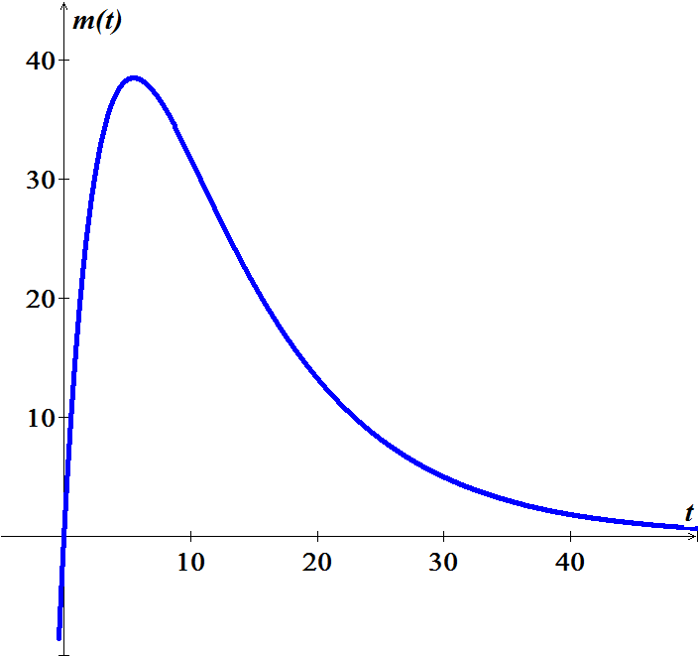





30 is an intermediate value between for both  and .

1. 



1. No, peak is 38.5 (using the graph)

***Exercise***

Determine whether the following functions are continuous at *a*. 

***Solution***



The function is continuous everywhere except @ 

***Exercise***

Determine whether the following functions are continuous at *a*. 

***Solution***

 **∴** *h* is discontinuous @ 3

***Exercise***

Determine whether the following functions are continuous at *a*.

***Solution***



**∴** *g* is discontinuous @ 4

***Exercise***

Find the intervals on which the following functions are continuous. Specify right- or left- continuity at the endpoints 

***Solution***



The function is continuous at −5 to the left and right of 

***Exercise***

Find the intervals on which the following functions are continuous. Specify right- or left- continuity at the endpoints 

***Solution***

The function is continuous at and to the right of 

***Exercise***

Find the intervals on which the following functions are continuous. Specify right- or left- continuity at the endpoints 

***Solution***

The function is continuous everywhere except at 

The function is continuous to the left of −5, then to the right of −5 to the left of 0, then to the right of 0 thru the left of 5 then to the tight of 5.

***Exercise***

Find the intervals on which the following functions are continuous. Specify right- or left- continuity at the endpoints 

***Solution***

The function is continuous everywhere.

***Exercise***

Let 

Determine values of the constants *a* and *b* for which  is continuous at 

***Solution***





***Solution*** ***Section* 1.6 – Precise Definition of Limits**

***Exercise***

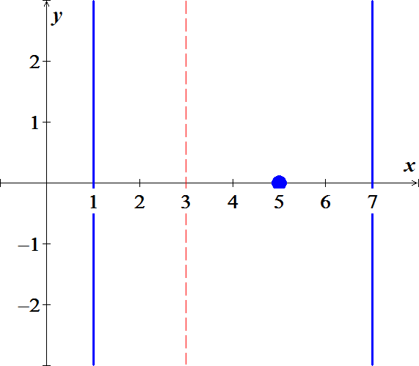Sketch the interval (*a, b*) on the *x*-axis with the point inside. Then find a value of δ > 0 such that for all *x*, for 

***Solution***









***Exercise***

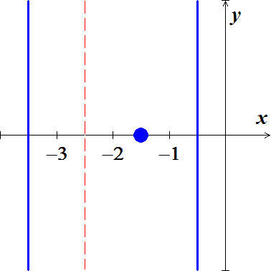Sketch the interval (*a, b*) on the *x*-axis with the point inside. Then find a value of δ > 0 such that for all *x*,  for 

***Solution***









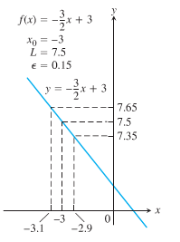

***Exercise***

Use the graph to find a *δ* > 0 such that for all *x*



***Solution***

***Given***: 









***Exercise***

Find an open interval about  on which the inequality holds. Then give a value for *δ* > 0 such that for all *x* satisfying  the inequality holds.



***Solution***



















***Exercise***

Find an open interval about  on which the inequality holds. Then give a value for *δ* > 0 such that for all *x* satisfying  the inequality holds.



***Solution***



















***Exercise***

Find an open interval about  on which the inequality holds. Then give a value for *δ* > 0 such that for all *x* satisfying  the inequality holds.



***Solution***



















***Exercise***

Find an open interval about  on which the inequality holds. Then give a value for *δ* > 0 such that for all *x* satisfying  the inequality holds.



***Solution***













***Exercise***

Find an open interval about  on which the inequality holds. Then give a value for *δ* > 0 such that for all *x* satisfying  the inequality holds.



***Solution***



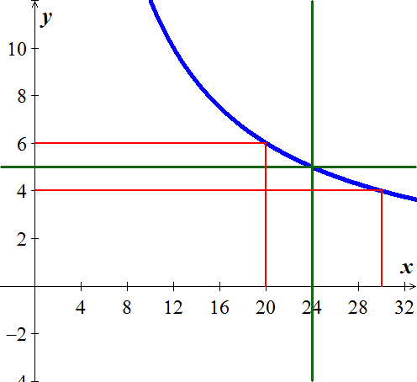 













***Exercise***

Prove that 

***Solution***



 ***divide by*** (−).











***Exercise***

Prove that 

***Solution***















***Exercise***

Prove that 

***Solution***













***Exercise***

Prove that 

***Solution***

For  



For  







***Exercise***

Prove that 

***Solution***













***Exercise***

Prove that 

***Solution***

Let  and let 

Suppose that 





 ***√***

***Exercise***

Prove that 

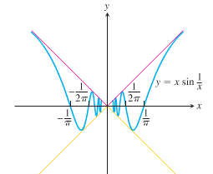

***Solution***



Then by the sandwich theorem, 