***Solution*** ***Section* 2.1 – Introducing the Derivative**

***Exercise***

Use the definition of the derivative to determine the slope of the curve . Find an equation of the line tangent to the curve  at *P*; then graph the curve and the tangent line.



***Solution***















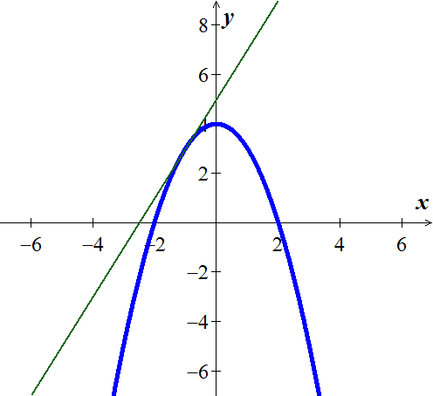

At (−1, 3) 





***Exercise***

Use the definition of the derivative to determine the slope of the curve . Find an equation of the line tangent to the curve  at *P*; then graph the curve and the tangent line.



***Solution***









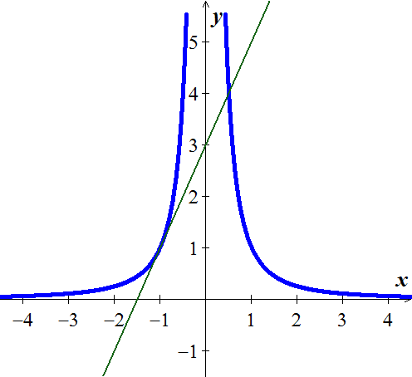 



. 





At (−1, 3) 





***Exercise***

Use the definition of the derivative to determine the slope of the curve . Find an equation of the line tangent to the curve  at *P*; then graph the curve and the tangent line.



***Solution***

















At (1, 2)  





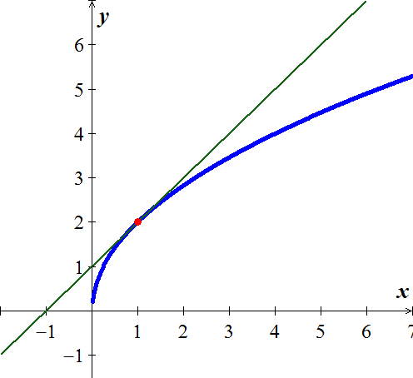

***Exercise***

Use the definition of the derivative to determine the slope of the curve . Find an equation of the line tangent to the curve  at *P*; then graph the curve and the tangent line.

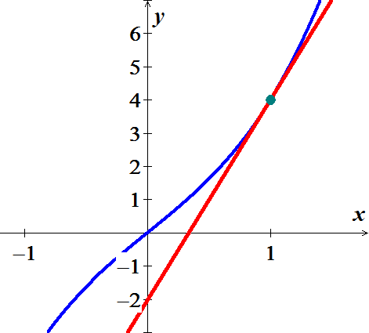

***Solution***











At 

 





***Exercise***

Use the definition of the derivative to determine the slope of the curve . Find an equation of the line tangent to the curve  at *P*; then graph the curve and the tangent line.



***Solution***













At 

 



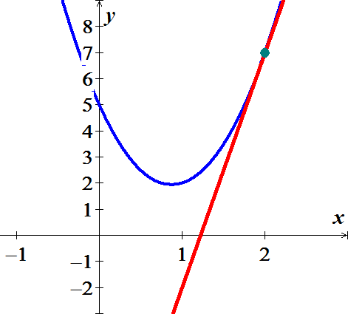

***Exercise***

Use the definition of the derivative to determine the slope of the curve . Find an equation of the line tangent to the curve  at *P*; then graph the curve and the tangent line.



***Solution***

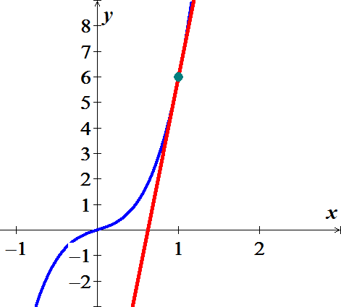











 



***Exercise***

Use the definition of the derivative to determine the slope of the curve . Find an equation of the line tangent to the curve  at *P*; then graph the curve and the tangent line.



***Solution***





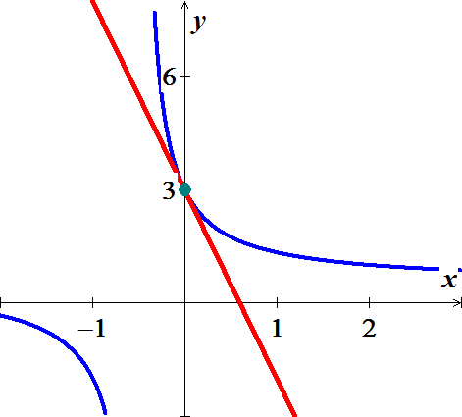 







 

***Exercise***

Use the definition of the derivative to determine the slope of the curve . Find an equation of the line tangent to the curve  at *P*; then graph the curve and the tangent line.



***Solution***



















 

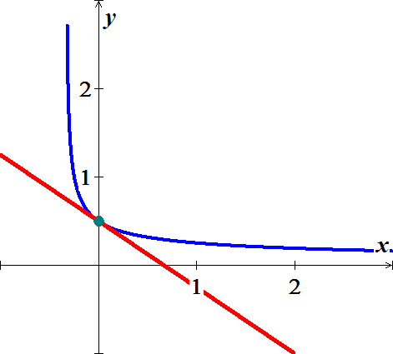

***Exercise***

Find the slope of the curve  at the point 

***Solution***















***Exercise***

Find the slope of the curve  at the point 

***Solution***















***Exercise***

Find the slope of the curve  at the point 

***Solution***















***Exercise***

Find equations of all lines having slope −1 that are tangent to the curve 

***Solution***





 ***Cross multiplication***















At  





***Exercise***

What is the rate of change of the area of a circle  with respect to the radius when the radius is ?

***Solution***















***Exercise***

Find the slope of the tangent to the curve  at the point where 

***Solution***





















***Exercise***

Fin the values of the derivatives of the function . Then find the values of 

***Solution***













  

***Exercise***

Fin the values of the derivatives of the function . Then find the values of 

***Solution***



























***Exercise***

Find the derivative of 

***Solution***















***Exercise***

Find the derivative of *y* with the respect to *t* for the function 

***Solution***















***Exercise***

Find the derivative of 

***Solution***













***Exercise***

Differentiate the function  and find the slope of the tangent line at the given value of the independent variable.

***Solution***

















***Exercise***

Find the equation of the tangent line to  that is parallel to 2*x* + *y* = 0

***Solution***

2*x* + *y* = 0 ⇒ *y* = −2*x* ⇒ slope = −2











⇒

The line equation is given by 





***Exercise***

Use the definition of limits to find the derivative: 

***Solution***

















***Exercise***

Use the definition of limits to find the derivative: 

***Solution***













***Exercise***

Suppose the height *s* of an object (in *m*) above the ground after *t* seconds is approximated by the function 

1. Make a table showing the average velocities of the object from time  to , for  .
2. Use the table in part (*a*) to estimate the instantaneous velocity of the object at .
3. Use limits to verify your estimate in part (*b*).

***Solution***

1. 







|  |  |
| --- | --- |
| *h* |  |
| 0.01 | 15.151 |
| 0.001 | 15.1951 |
| 0.0001 | 15.1995 |
| 0.00001 | 15.2 |
| 0.000001 | 15.2 |

1. 



1. 



***Exercise***

Suppose the following graph represents the number of bacteria in a culture *t* hours after the start of an experiment.

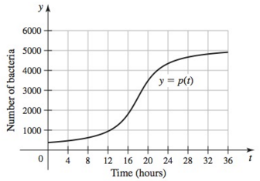

1. At approximately what time is the instantaneous growth rate the greatest, for ? Estimate the growth rate at this time.
2. At approximately what time is the instantaneous growth rate the least, for ? Estimate the growth rate at this time.
3. What is the average growth rate over the interval ?

***Solution***

1. 

Point the rate 





1. It is smallest at 





1. Growth rate 





***Solution*** ***Section* 2.2 – Differentiation Rules**

***Exercise***

Find the derivative of 

***Solution***





 

***Exercise***

Find the derivative of 

***Solution***



***Exercise***

Find the derivative of 

***Solution***





  

***Exercise***

Find the derivative of 

***Solution***



***Exercise***

Find the derivative of 

***Solution***







***Exercise***

Find the derivative of 

***Solution***



***Exercise***

Find the first derivative of 

***Solution***





***Exercise***

Find the derivative of 

***Solution***







***Exercise***

Find the derivative of 

***Solution***









***Exercise***

Find the derivative of 

***Solution***

 





***Exercise***

Find the derivative of 

***Solution***

 





***Exercise***

Find the derivative of 

***Solution***

 

***Exercise***

Find the derivative of 

***Solution***





***Exercise***

Find the derivative of 

***Solution***



***Exercise***

Find the derivative of 

***Solution***



***Exercise***

Find the derivative of 

***Solution***













***Exercise***

Find the derivative of 

***Solution***









***Exercise***

Find the derivative of 

***Solution***



***Exercise***

Find the derivative of 

***Solution***



***Exercise***

Find the derivative of 

***Solution***





***Exercise***

Find the derivative of 

***Solution***



***Exercise***

Find the derivative of 

***Solution***





***Exercise***

Find the derivative of 

***Solution***





***Exercise***

Find the derivative of 

***Solution***



***Exercise***

Find the derivative of 

***Solution***



***Exercise***

Find the ***first*** and ***second*** derivatives 

***Solution***





***Exercise***

Find the ***first*** and ***second*** derivatives 

***Solution***





***Exercise***

Find the ***first*** and ***second*** derivatives 

***Solution***

 





***Exercise***

Find the ***first*** and ***second*** derivatives 

***Solution***





***Exercise***

Find the ***first*** and ***second*** derivatives 

***Solution***





***Exercise***

Find the ***first*** and ***second*** derivatives 

***Solution***







***Exercise***

Find the derivative 

***Solution***





***Exercise***

Find the derivative 

***Solution***



***Exercise***

Find the derivative 

***Solution***





***Exercise***

Find the derivative 

***Solution***





***Exercise***

Find the derivative 

***Solution***



***Exercise***

Find the derivative 

***Solution***





***Exercise***

Find an equation for the line perpendicular to the tangent to the curve  at the point (2, 1).

***Solution***







 



***Exercise***

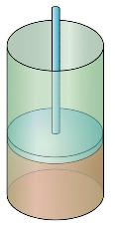If gas in a cylinder is maintained at a constant temperature *T*, the pressure *P* is related to the volume *V* by a formula of the form



In which *a*, *b*, *n*, and *R* are constants. Find 

***Solution***









***Exercise***

Show that if  is any point on the graph of , then the slope of the tangent line at that point is 

***Solution***









***Exercise***

Show that if  is any point on the graph of , then the slope of the tangent line at that point is 

***Solution***











***Exercise***

Let 

1. Show that , for all 
2. Is this property true for , where *a* is a nonzero real number?
3. Give a geometrical interpretation of this property.
4. Is this property true for ?

***Solution***

1. 











, for all 

1. 











, for all 

1. Line thru  and  is parallel to the tangent line and midpoint is between *x* and *y*.
2. 













 (***N*o**)

***Solution*** ***Section* 2.3 – Product and Quotient Rules**

***Exercise***

Find the derivative of 

***Solution***







***Exercise***

Find the derivative of 

***Solution***

 







***Exercise***

Find the derivative of 

***Solution***













***Exercise***

Find the derivative of 

***Solution***







 



***OR***







***Exercise***

Find the derivative of 

***Solution***

 



***Or***







***Exercise***

Find the derivative of 

***Solution***



 



***Or***











***Exercise***

Find the derivative of 

***Solution***



 

 





***Exercise***

Find the derivative of 

***Solution***









***Exercise***

Find the derivative of 

***Solution***







***Exercise***

Find the derivative of 

***Solution***









***Exercise***

Find the derivative of 

***Solution***

|  |  |
| --- | --- |
|  |  |

***Exercise***

Find the derivative of 

***Solution***

 



***Or***

  







***Exercise***

Find the derivative of 

***Solution***











***Exercise***

Find the derivative of 

***Solution***

 



***Or***

 









***Exercise***

Find the derivative of 

***Solution***





 



***Exercise***

Find the derivative of 

***Solution***

 





***Exercise***

Find the derivative of 

***Solution***

 



***Exercise***

Find the derivative of 

***Solution***

 





***Exercise***

Find the derivative of 

***Solution***

 



***Exercise***

Find the derivative of 

***Solution***







***Exercise***

Find the derivative of 

***Solution***

 



***Exercise***

Find the derivative of 

***Solution***





***Exercise***

Find the derivative of 

***Solution***





***Exercise***

Find the derivative of 

***Solution***







***Exercise***

Find the derivative of 

***Solution***

 



***Exercise***

Find the derivative of 

***Solution***









***Exercise***

Find the derivative of 

***Solution***

 

***Exercise***

Find the derivative of 

***Solution***

 

***Exercise***

Find the derivative of 

***Solution***

 

***Exercise***

Find the derivative of 

***Solution***

 



***Exercise***

Find the derivative of 

***Solution***

 



***Exercise***

Find the derivative of 

***Solution***

 



***Exercise***

Find the derivative of 

***Solution***

 



***Exercise***

Find the derivative of 

***Solution***

 



***Exercise***

Find the derivative of 

***Solution***

 



***Exercise***

Find the derivative of 

***Solution***

 

***Exercise***

Find the derivative of 

***Solution***

 

***Exercise***

Find the derivative of 

***Solution***

 

***Exercise***

Find the derivative of 

***Solution***

 

***Exercise***

Find the derivative of 

***Solution***

 



***Exercise***

Find the derivative of 

***Solution***

 



***Exercise***

Find the derivative of 

***Solution***

 



***Exercise***

Find the derivative of 

***Solution***

 



***Exercise***

Find the derivative of 

***Solution***

 

***Exercise***

Find the derivative of 

***Solution***

 



***Exercise***

Find the derivative of 

***Solution***

 



***Exercise***

Find the derivative of 

***Solution***

 



***Exercise***

Find the derivative of 

***Solution***

 



***Exercise***

Find the derivative of 

***Solution***

 

***Exercise***

Find the derivative of 

***Solution***

 

***Exercise***

Find the derivative of 

***Solution***

 



***Exercise***

Find the derivative of 

***Solution***

 



***Exercise***

Find the derivative of 

***Solution***

 



***Exercise***

Find the derivative of 

***Solution***

 



***Exercise***

Find the derivative of 

***Solution***

 



***Exercise***

Find the derivative of 

***Solution***

 



***Exercise***

Find the derivative of 

***Solution***

 



***Exercise***

Find the derivative of 

***Solution***

 





***Exercise***

Find the derivative of 

***Solution***

 



***Exercise***

Find the ***first*** and ***second*** derivative 

***Solution***

  









 





***Exercise***

Find : 

***Solution***











***Exercise***

For what value(s) of *x* is the line tangent to the curve  horizontal? Vertical?

***Solution***







 is a horizontal tangent line.

∴ The vertical tangent line inside the square root of *y*. 







***Exercise***

Find an equation of the tangent line to the graph of  when *x* = 0

***Solution***

 









 



***Solution*** ***Section* 2.4 –Derivatives of Trigonometric Functions**

***Exercise***

Find the derivative of 

***Solution***



***Exercise***

Find the derivative of 

***Solution***





***Exercise***

Find the derivative of 

***Solution***

 



***Exercise***

Find the derivative of 

***Solution***

 





***Exercise***

Find the derivative of 

***Solution***

|  |  |
| --- | --- |
|  |  |

***Exercise***

Find the derivative of 

***Solution***

|  |  |
| --- | --- |
|  |  |

***Exercise***

Find the derivative of 

***Solution***





 





***Exercise***

Find the derivative of 

***Solution***







***Exercise***

Find the derivative of 

***Solution***







***Exercise***

Find the derivative of 

***Solution***



***Exercise***

Find the derivative of 

***Solution***

 





***Exercise***

Find the derivative of 

***Solution***





***Exercise***

Find the derivative of 

***Solution***

 









***Exercise***

Find the derivative of 

***Solution***



 





***Exercise***

Find the derivative of 

***Solution***





***Exercise***

Find the derivative of 

***Solution***





***Exercise***

Find the derivative of 

***Solution***



***Exercise***

Find the derivative of 

***Solution***



***Exercise***

Find the derivative of 

***Solution***



***Exercise***

Find the derivative of 

***Solution***



***Exercise***

Find the derivative of 

***Solution***



***Exercise***

Find the derivative of 

***Solution***



***Exercise***

Find the derivative of 

***Solution***



***Exercise***

Find the derivative of 

***Solution***

 

***Exercise***

Find the derivative of 

***Solution***



***Exercise***

Find the derivative of 

***Solution***



***Exercise***

Find the derivative of 

***Solution***



***Exercise***

Find the derivative of 

***Solution***





***Exercise***

Find 

***Solution***

   

***Exercise***

Find 

***Solution***

   





***Exercise***

Find  

***Solution***









***Exercise***

Find 

***Solution***











***Exercise***

Assume that a particle’s position on the *x*-axis is given by 

1. Find the particle’s position when 
2. Find the particle’s velocity when 

***Solution***

1. 





1. 







***Exercise***

A weight is attached to a spring and reaches its equilibrium position . It is then set in motion resulting in a displacement of 

Where *x* is measured in centimeters and *t* is measured in seconds.

1. Find the spring’s displacement when 
2. Find the spring’s velocity when 

***Solution***

1. 



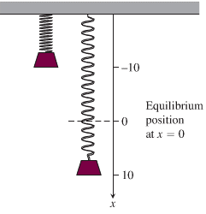



1. 







***Solution*** ***Section* 2.5 – Derivative as Rates of Change**

***Exercise***

The position  of a body moving on a coordinate line, with *s* in meters and *t* in seconds.

1. Find the body’s displacement and average velocity for the given time interval.
2. Find the body’s speed and acceleration at the endpoints of the interval.
3. When, if ever, during the interval does the body change direction?

***Solution***

1. Displacement: 





Average velocity = 

1. 





1. 

*v* is negative in the interval 

*v* is positive in the interval 

The body changes direction at 

***Exercise***

The position  of a body moving on a coordinate line, with *s* in meters and *t* in seconds.

1. Find the body’s displacement and average velocity for the given time interval.
2. Find the body’s speed and acceleration at the endpoints of the interval.
3. When, if ever, during the interval does the body change direction?

***Solution***

1. Displacement: 







Average velocity = 

1. 











1. 

*v* is never equal to zero ⇒ The body never changes direction.

***Exercise***

At time *t*, the position of a body moving along the *s*-axis is  ***m***.

1. Find the body’s acceleration each time the velocity is zero.
2. Find the body’s speed each time the acceleration is zero.
3. Find the total distance traveled by the body from *t* = 0 to *t* = 2.

***Solution***

1. 



The body is motionless but being accelerated left when *t* = 1, and motionless but being accelerated right when *t* = 3.

1. 



1. The body moves forward on 

The body moves backward on 

Total distance 

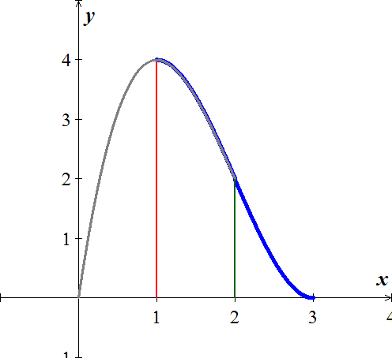

***Exercise***

A rock thrown vertically upward from the surface of the moon at a velocity of 24 *m/sec* (about 86 *km/h*) reaches a height of  *m* in *t* *sec*.

1. Find the rock’s velocity and acceleration at time *t*. (The acceleration in this case is the acceleration of gravity on the moon.)
2. How long does it take the rock to reach its highest point?
3. How high does the rock go?
4. How long does it take the rock to reach half its maximum height?
5. How long is the rock aloft?

***Solution***

1. 



1. 
2. 
3. Since the maximum high is 180 *m*, then half is 90 *m*:





It took 4.39 *sec* going up and 25.6 *sec* going down.

1. The rock took 30 sec to reach its highest point.

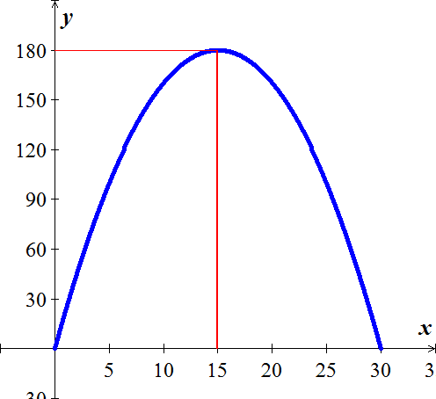

***Exercise***

Had Galileo dropped a cannonball from the Tower of Pisa, 179 *ft* above the ground, the ball’s height above the ground *t* *sec* into the fall would have been .

1. What would have been the ball’s velocity, speed, and acceleration at time *t*?
2. About how long would it have taken the ball to hit the ground?
3. What would have been the ball’s velocity at the moment of impact?

***Solution***

1. 





1. 



1. When t = 3.3 sec ⇒ 

***Exercise***

A toy rocket fired straight up into the air has height  after *t* seconds.

1. What is the rocket’s initial velocity (when )?
2. What is the acceleration when ?
3. At what time will the rocket hit the ground?
4. At what velocity will the rocket be traveling just as it smashes into the ground?

***Solution***

1. 



1. 
2. 

The rocket hit the ground at 

***Exercise***

A helicopter is rising straight up in the air. Its distance from the ground *t* seconds after takeoff is 

1. How long will it take for the helicopter to rise 20 *feet* ?
2. Find the velocity and the acceleration of the helicopter when it is 20 *feet* above the ground.

***Solution***

1. 



It will take 10 *sec*. for the helicopter to rise 20 *feet.*

1. 



***Exercise***

The position of a particle moving on a line is given by , where *t* is measured in *seconds* and *s* in *feet*.

1. What is the velocity after 3 *seconds* and after 6 *seconds*?
2. When the particle moving in the positive direction?
3. Find the total distance traveled by the particle during the first 7 *seconds*.

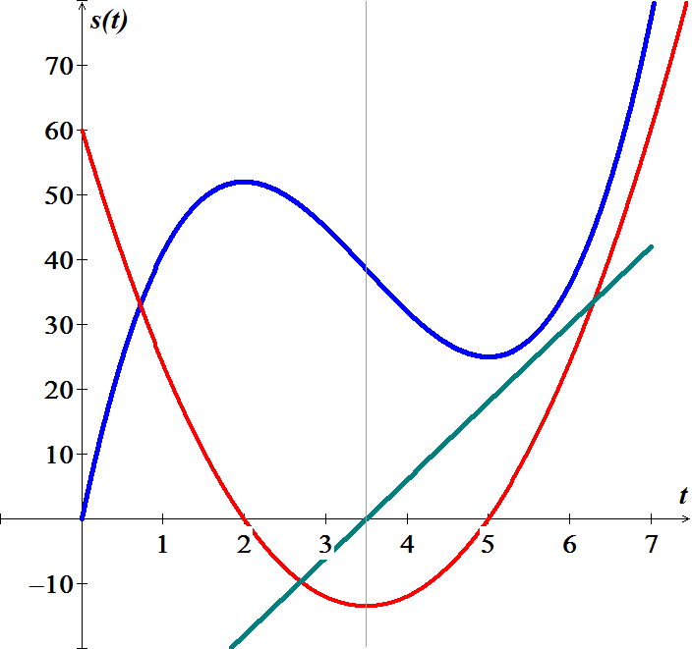***Solution***

1. 





1. 

The particle is moving in the positive direction at 3.5 *sec*

1. 

***Exercise***

A small probe is launched vertically from the ground. After it reaches its high point, a parachute deploys and the probe descends to Earth. The height of the probe the ground is



1. Graph the height function and describe the motion of the probe.
2. Find the velocity of the probe.
3. Graph the velocity function and determine the approximate time at which the velocity is a maximum.

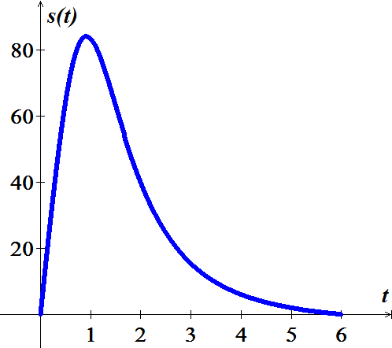***Solution***

1. 



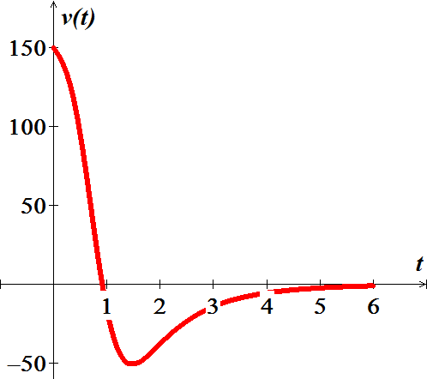 







The maximum height is 84.107 at 

1. 
2. 

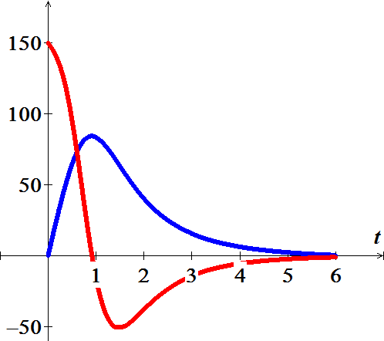 

The maximum velocity is 150

***Exercise***

Suppose the cost of producing *x* lawn mowers is 

1. Determine the average and marginal costs for  lawn mowers.
2. Interpret the meaning of your results in part (*a*)

***Solution***

1. Average Cost 







Marginal Cost 





1. The average cost of producing 3,000 lawmowers is $341.67 per mower.

The cost of producing the 3,001st lawmower is about $280.00

***Exercise***

Suppose a company produces fly rods. Assume  represents the cost of making *x* fly rods.

1. Determine the average and marginal costs for  fly rods.
2. Interpret the meaning of your results in part (*a*)

***Solution***

1. Average Cost 







Marginal Cost 





1. The average cost of producing 400 fly rods is $66.00 per fly rod.

The cost of producing the 401st flying rod is about $52.00

***Exercise***

Suppose  is the population of a city *t* years after 1950.

1. Determine the average rate of growth of the city from 1950 to 2000.
2. What was the rate of growth of the city in 1990?

***Solution***

From 1950 to 2000 

1. Average growth rate 





1. 





***Solution*** ***Section* 2.6 – Chain Rule**

***Exercise***

Find the derivative of 

***Solution***











***Exercise***

Find the derivative of 

***Solution***

 









***Exercise***

Find the derivative of 

***Solution***











***Exercise***

Find the derivative of 

***Solution***









***Exercise***

Find the derivative of 

***Solution***









***Exercise***

Find the derivative of 

***Solution***







***Exercise***

Find the derivative of 

***Solution***





















***Exercise***

Find the derivative of 

***Solution***

|  |  |
| --- | --- |
|  |  |

***Exercise***

Find the derivative of 

***Solution***

 

 



***Exercise***

Find the derivative of 

***Solution***







***Exercise***

Find the derivative of 

***Solution***













***Exercise***

Find the derivative of 

***Solution***

  





***Exercise***

Find the derivative of 

***Solution***









***Exercise***

Find the derivative of 

***Solution***











***Exercise***

Find the derivative of 

***Solution***







***Exercise***

Find the derivative of 

***Solution***







***Exercise***

Find the derivative of 

***Solution***







***Exercise***

Find the derivative of 

***Solution***

 







***Exercise***

Find the derivative of 

***Solution***







***Exercise***

Find the derivative of 

***Solution***

 







***Exercise***

Find the derivative of 

***Solution***







***Exercise***

Find the derivative of 

***Solution***











***Exercise***

Find the derivative of 

***Solution***

  





***Exercise***

Find the derivative of 

***Solution***











***Exercise***

Find the derivative of 

***Solution***







***Exercise***

Find the derivative of 

***Solution***









***Exercise***

Find the derivative of 

***Solution***







***Exercise***

Find the derivative of 

***Solution***















***Exercise***

Find the derivative of 

***Solution***











***Exercise***

Find the derivative of 

***Solution***



***Exercise***

Find the derivative of 

***Solution***

 







***Exercise***

Find the derivative of 

***Solution***





***Exercise***

Find the derivative of 

***Solution***



 



***Exercise***

Find the derivative of 

***Solution***





***Exercise***

Find the derivative of 

***Solution***



***Exercise***

Find the derivative of 

***Solution***



 



***Exercise***

Find the derivative of 

***Solution***



 



***Exercise***

Find the derivative of 

***Solution***



***Exercise***

Find the derivative of 

***Solution***



***Exercise***

Find the derivative of 

***Solution***



***Exercise***

Find the derivative of 

***Solution***



***Exercise***

Find the derivative of 

***Solution***





***Exercise***

Find the derivative of 

***Solution***





***Exercise***

Find the derivative of 

***Solution***







***Exercise***

Find the derivative of 

***Solution***



 



***Exercise***

Find the derivative of 

***Solution***

 



***Exercise***

Find the derivative of 

***Solution***

 



***Exercise***

Find the derivative of 

***Solution***

 



***Exercise***

Find the derivative of 

***Solution***

 



***Exercise***

Find the derivative of 

***Solution***

 





***Exercise***

Find the derivative of 

***Solution***

 





***Exercise***

Find the derivative of 

***Solution***

 





***Exercise***

Find the derivative of 

***Solution***

 



***Exercise***

Find the derivative of 

***Solution***







***Exercise***

Find the derivative of 

***Solution***









***Exercise***

Find the derivative of 

***Solution***



 



***Exercise***

Find the derivative of 

***Solution***









***Exercise***

Find the derivative of 

***Solution***









***Exercise***

Find the derivative of 

***Solution***









***Exercise***

Find the derivative of 

***Solution***









***Exercise***

Find the derivative of 

***Solution***













***Exercise***

Find the derivative of 

***Solution***











***Exercise***

Find the derivative of 

***Solution***

 











***Exercise***

Find the derivative of 

***Solution***

 

.







***Exercise***

Find the derivative of 

***Solution***











***Exercise***

Find the derivative of 

***Solution***

 









***Exercise***

Find the derivative of 

***Solution***













***Exercise***

Find the ***second*** derivative 

***Solution***





 

 















***Exercise***

Find the ***second*** derivative of 

***Solution***

 















***Exercise***

Find the ***second*** derivative of 

***Solution***













***Exercise***

Find the tangent line to the graph of  when *x* = 4.

***Solution***



















***Exercise***

Evaluate the limit 

***Solution***













***Exercise***

Evaluate the limit 

***Solution***











