***Exercise***

The endpoints of a movable rod of length 1 *meter* have coordinates  and . The position of the end on the  is

 where *t* is the time in *seconds*.

1. Find the time of one complete cycle of the rod.
2. What is the lowest point reached by the end of the rod on the ?
3. Find the speed of the  endpoint when the  endpoints is 

***Solution***

***Given***:  

1. 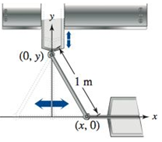Period: 
2. When 

∴ The lowest point 

1. When 







 











***Exercise***

Cars on a certain roadway travel on a circular arc of radius *r*. in order not to rely on friction alone to overcome to centrifugal force, the road is banked at an angle of magnitude *θ* from the horizontal. The banking angle must satisfy the equation , where *v* is the velocity of the cars and  is the acceleration due to gravity. Find the relationship between the related rates  and .

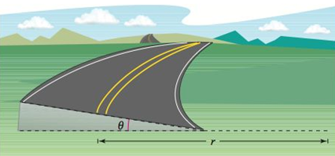***Solution***











***Exercise***

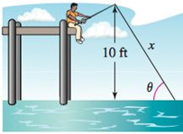A fish is reeled in at a rate of 1  from a point 10 *feet* above the water. At what rate is the angle *θ* between the line and the water changing when there is a total of 25 *feet* of line from the end of the rod to the water?

***Solution***

***Given***: 





 





***Exercise***

An airplane flies at an altitude of 5 *miles* toward a point directly over an observer. The speed of the plane is 600 . Find the rates at which the angle of elevation *θ* is changing when the angle is



***Solution***

***Given***: 







Le ***L*** be the distance from observer to the plane. 



 





1. 
2. 
3. 

***Exercise***

A patrol car is parked 50 *feet* from a long warehouse. The revolving light on top of the car turns at a rate of 30 *revolutions per minute*. How fast is the light beam moving along the wall when the beam makes angles of

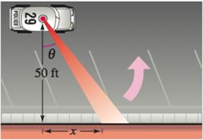 

With the perpendicular line from the light to the wall?

***Solution***

***Given***: 









1. 
2. 
3. 

***Exercise***

A wheel of radius 30 *cm* revolves at a rate of 10 *revolutions* per *second*. A dot is painted at a point *P* on the rim of the wheel.

1. Find  as a function of *θ*.
2. Graph the function.
3. When is the absolute value of the rate of change of *x* greatest?
4. When is it least?
5. 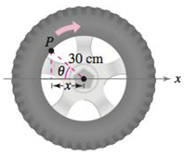Find  when  and 

***Solution***

***Given***: 

1. 







|  |  |  |  |  |  |  |  |  |  |  |  |  |  |  |
| --- | --- | --- | --- | --- | --- | --- | --- | --- | --- | --- | --- | --- | --- | --- |
| ***Amplitude***:  ***Period***:  ***Phase Shift***:  ***VT:*** | |  |  | | --- | --- | | ***x*** |  | |  | 0 | |  |  | |  | 0 | |  |  | |  | 0 | |  |

1.  is the greatest value , therefore 

∴ The greatest: 



1. The least when : 
2. 



***Exercise***

A security camera is centered 50 *feet* above a 100-*foot* hallway. It is easiest to design the camera with a constant angular rate of rotation, but this results in recording the images of the surveillance area at a variable rate. So, it is desirable to design a system with a variable rate of rotation and a constant rate of movement of the scanning beam along the hallway. Find a model for the variable rate of rotation when 

***Solution***

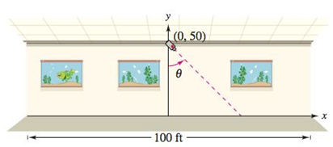***Given***: 











***Exercise***

A rotating beacon is located 1 *km* off a straight shoreline. The beacon rotates at a rate of . How fast (in ) does the beam of light appear to be moving to a viewer who is  down the shoreline?

***Solution***

***Given***: 

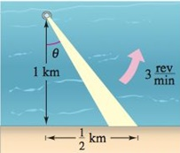









***Exercise***

A sandbag is dropped from a balloon at a height of 60 *m* when the angle of elevation to the sun is 30°. The position of the sandbag is



Find the rate at which the shadow of the sandbag is traveling along the ground when the sandbag is at height of 35 *m*.

***Solution***



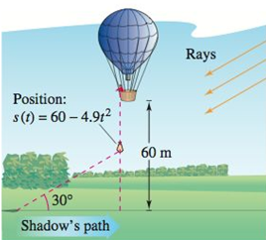















***Exercise***

The distance between the head of a piston and the end of a cylindrical chamber is given by  *cm*, for  (measured in seconds). The radius of the cylinder is 4 *cm*.

1. Find the volume of the chamber, for .
2. Find the rate of change of the volume  for .
3. Graph the derivative of the volume function. On what intervals is the volume increasing? Decreasing?

***Solution***

1. 





1.  

|  |  |  |  |  |  |  |  |
| --- | --- | --- | --- | --- | --- | --- | --- |
| |  |  | | --- | --- | |  |  | | 0 |  | | 1 |  | |  |

Since the rate of change of the volume is strictly positive, the volume function must be increasing for .

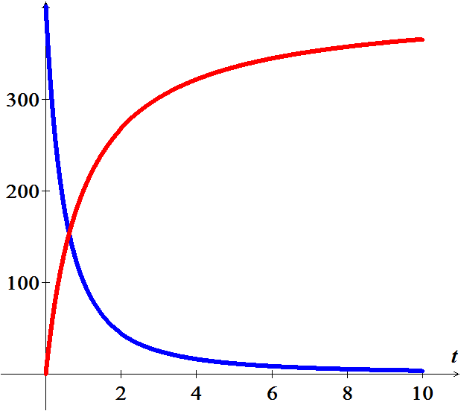

***Exercise***

Two boats leave a dock at the same time. One boat travels south at 30 *mi/hr* and the other travels east at 40 *mi/hr*. after half an hour, how fast is the distance between the boats increasing?

***Solution***

***Given***: 



 









***Exercise***

A spherical balloon is inflated at a rate of . At what rate is the diameter of the balloon increasing when the balloon has a diameter of 5 *cm*.

***Solution***

***Given***: 















***Exercise***

A rope is attached to the bottom of a hot-air balloon that is floating above the flat field. If the angle of the rope to the ground remains 65° and the rope is pulled in at 5 *ft/s*, how quickly is the elevation of the balloon changing?

***Solution***

***Given***: 











***Exercise***

Water flows into a conical tank at a rate of . If the radius of the top of the tank is 4 *feet* and the height is 6 *feet*, determine how quickly the water level is rising when the water is 2 *feet* deep in the tank.

***Solution***

***Given***: 

The water forms a cone with volume: 

From the triangles: 















***Exercise***

A jet flies horizontally 500 *feet* directly above a spectator at an air show at 450 *mi/hr*. How quickly is the angle of elevation (between the ground and the line from the spectator to the jet) changing 2 seconds later?

***Solution***

***Given***: 









 







***Exercise***

A man whose eyelevel is 6 *feet* above the ground walks toward a billboard at a rate of 2 *ft/s*. The bottom of the billboard is 10 *feet* above the ground, and it is 15 *feet* high. The man’s viewing angle is the angle formed by the lines between the man’s eyes and the top and bottom of the billboard. At what rate is the viewing angle changing when the man is 30 *feet* from the billboard?

***Solution***

***Given***: 







 















***Exercise***

A trough is shaped like a half cylinder with length 5 *m* and radius 1 *m*. The trough is full of water when a valve is opened and water flows out of the bottom of the trough at a rate of .

(***Hint***: Area of the sector =  , *r* is the radius of a sector of the circle subtended by an angle of *θ*)

1. How fast is the water level changing when the water level is 0.5 *m* from the bottom of the through?
2. What is the rate of change of the surface area of the water when the water is 0.5 *m* deep?

***Solution***











 area is 

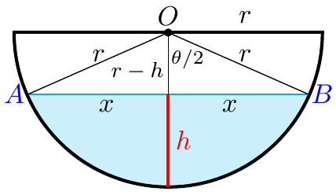



Area of sector *AOB* is 







Area of cross-sectional:



1. ***Given***: 





















1. Surface: 









***Exercise***

A conical tank with an upper radius of 4 *m* and a height of 5 *m* drains into a cylindrical tank with a radius of 4 *m* and a height of 5 *m*. If the water level in the conical tank drops at a rate of 0.5 *m/min*, at what rate does the water in the cylindrical tank rise when the water level in the conical tank is 3 *m*? 1 *m*?

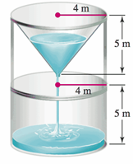***Solution***



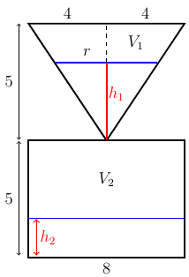







1. ***For*** 

***Given***: 







Volume of the lower tank:











1. ***For*** 













***Exercise***

Two cylindrical swimming pools are being filled simultaneously at the same rate (in *m*3/*min*). The smaller pool has a radius of 5 *m*, and the water level rises at a rate of 0.5 *m/min*. The larger pool has a radius of 8 *m*. How fast is the water level rising in the larger pool?

***Solution***

Small Pool:

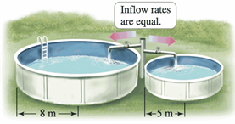









Large Pool:







Since 





***Exercise***

An observer is 20 *m* above the ground floor of a large hotel atrium looking at a glass enclosed elevator shaft that is 20 *m* horizontally from the observer. The angle of elevation of the elevator is the angle that the observer’s line of sight makes with the horizontal (it may be positive or negative).

1. Assuming that the elevator rises at a rate of 5 *m/s*, what is the rate of change of the angle of the angle of elevation when the elevator is 10 *m* above the ground?
2. When the elevator is 40 *m* above the ground?

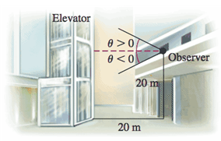***Solution***





1. ***Given***: 

At 

 

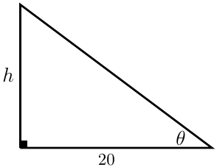





1. 40 *m* above the ground 



 





***Exercise***

A camera is set up at the starting line of a drag race 50 *ft*. from a dragster at the starting line (camera 1). Two seconds after the start race, the dragster has traveled 100 *ft*. and the camera is turning at 0.75 *rad/s* while filming the dragster.

1. What is the speed of the dragster at this point?
2. A second camera (camera 2) filming the dragster is located on the starting line 100 *ft*. away from the dragster at the start of the race. How fast is this camera turning 2 *sec* after the start of the race?

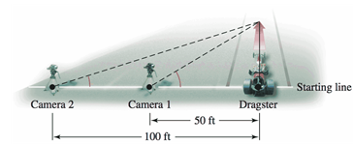***Solution***

1. 



***Given***: 



 

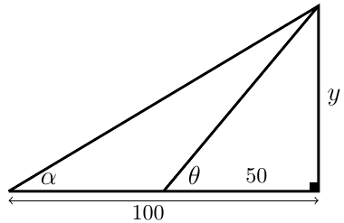



∴ Speed at  is 187.5 

1. 







 



 Speed of the camera 2.

***Exercise***

A port and a radar station are 2 *mi* apart on a straight shore running east and west. A ship leaves the port at noon traveling northeast at a rate of 15 *mi*/*hr*. If the ship maintains its speed and course, what is the rate of change of the tracking angle *θ* between the shore and the line between the radar station and the ship at 12:30 PM?

***Solution***





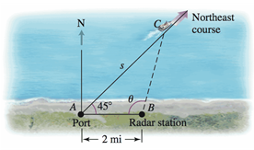 

















 



 





***Exercise***

A ship leaves port traveling southwest at a rate of 12 *mi/hr*. At noon, the ship reaches its closest approach to a radar station, which is on the shore 1.5 *mi* from the port. If the ship maintains its speed and course, what is the rate of change of the tracking angle ***θ*** between the radar station and the ship at 1:30 PM?

***Solution***

Let *x* be the distance the ship has traveled.



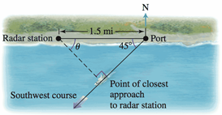 



















 



At 12:00: 

At 1:30: 





 



***Exercise***

A lighthouse stands 500 *m* off of a straight shore, the focused beam of its light revolving four times each minute. *P* is the point on shore closest to the lighthouse and *Q* is a point on the shore 200 *m* from *P*.

1. What is the speed of the beam along the shore when it strikes the point *Q*?
2. 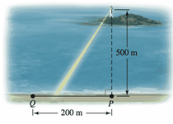Describe how the speed of the beam along the shore varies with the distance between *P* and *Q*. (neglect the height of the lighthouse)

***Solution***

1. 



At Point *Q*:

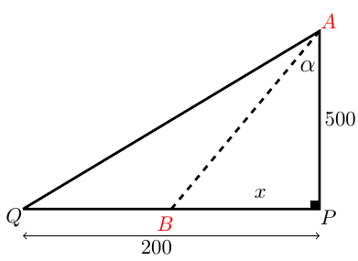

 

4 times each minute: 





1. The beam moves slower when *B* near *P*, and faster as it approaches *Q* (or further away from *P*)

***Exercise***

A boat leaves a port traveling due east at 12 *mi/hr*. At the same time, another boat leaves the same port traveling northeast at 15 *mi/hr*. The angle ***θ*** of the line between the boats is measured relative to due north.

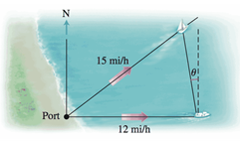

What is the rate of change of this angle 30 *min*. after the boats leave the port? 2 *hr*. after the boats leave the port?

***Solution***

***Given***: 

 (*Law of Sines*)

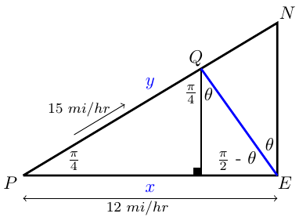











 



After **30** *min *  





After **2** *hrs.* 





***Exercise***

An observer stands 20 *m* from the bottom of a 10-*m* tall Ferris wheel on a line that is perpendicular to the face of the Ferris wheel. The wheel revolves at a rate of π *rad/min* and the observer’s line of sight with a specific seat on the wheel makes an angle ***θ*** with the ground. 40 *seconds* after that seat leaves the lowest point on the wheel, what is the rate of change of ***θ*** ?

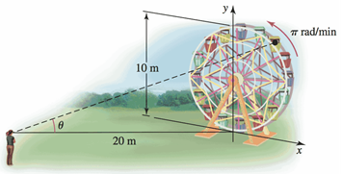

*Assume the observer’s eyes are level with the bottom of the wheel.*

***Solution***





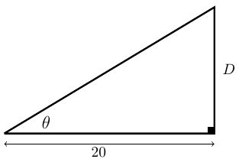 

 (*Law of Cosines*)







At 

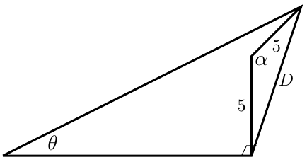Given: 

















***Exercise***

The bottom of a large theater screen is 3 *ft*. above your eye level and the top of the screen is 10 *ft*. above your eye level. Assume you walk away from the screen (perpendicular to the screen) at a rate of 3 *ft/s* while looking at the screen. What is the rate of change of the viewing angle ***θ*** when you are 30 *ft*. from the wall on which the screen hangs, assuming the floor is flat?

***Solution***

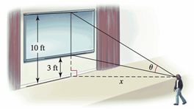









 









***Exercise***

A revolving searchlight, 100 *m* from the nearest point on the center line of a straight highway, casts a horizontal beam along a highway. The beam leaves the spotlight at an angle of  *rad* and revolves at a rate  *rad/s*. Let ***w*** be the width of the beam as it sweeps along the highway and ***θ*** be the angle that the center of the beam makes with the perpendicular to the highway. What is the rate of change of ***w*** when ? *Neglect the height of the lighthouse.*

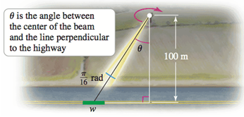

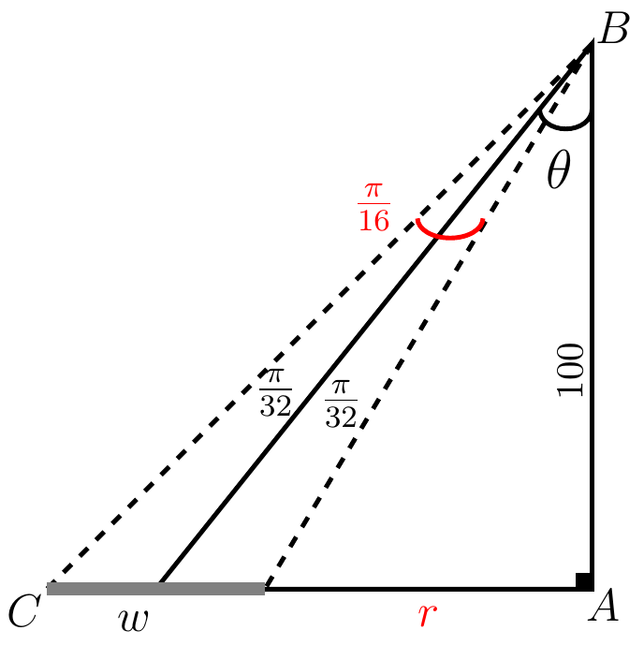***Solution***























***Exercise***

A piston is seated at the top of a cylindrical chamber with radius 5 *cm* when it starts moving into the chamber at a constant speed of 3 *cm/sec*. What is the rate of change of the volume of the cylinder when the piston is 2 *cm* from the base of the chamber?

***Solution***

 





