***Solution*** ***Section* 4.1 – Antiderivatives**

***Exercise***

Find each indefinite integral 

***Solution***



***Exercise***

Find each indefinite integral 

***Solution***



***Exercise***

Find each indefinite integral 

***Solution***





***Exercise***

Find each indefinite integral 

***Solution***





***Exercise***

Find each indefinite integral 

***Solution***





***Exercise***

Find each indefinite integral 

***Solution***

 



***Exercise***

Find each indefinite integral 

***Solution***









***Exercise***

Find each indefinite integral 

***Solution***





***Exercise***

Find each indefinite integral 

***Solution***







***Exercise***

Find each indefinite integral 

***Solution***





***Exercise***

Find each indefinite integral 

***Solution***









***Exercise***

Find each indefinite integral 

***Solution***



***Exercise***

Find each indefinite integral 

***Solution***











***Exercise***

Find each indefinite integral 

***Solution***







***Exercise***

Find each indefinite integral 

***Solution***







***Exercise***

Find each indefinite integral 

***Solution***







***Exercise***

Find each indefinite integral 

***Solution***









***Exercise***

Find each indefinite integral 

***Solution***



***Exercise***

Find each indefinite integral 

***Solution***



***Exercise***

Find each indefinite integral 

***Solution***



***Exercise***

Find each indefinite integral 

***Solution***





***Exercise***

Find each indefinite integral 

***Solution***



***Exercise***

Find each indefinite integral 

***Solution***

 

***Exercise***

Find each indefinite integral 

***Solution***



 







***Exercise***

Evaluate the integral 

***Solution***



***Exercise***

Evaluate 

***Solution***



***Exercise***

Evaluate 

***Solution***

 





***Exercise***

Find the integral

***Solution***









***Exercise***

Find the integral 

***Solution***



***Exercise***

Find the integral

***Solution***





***Exercise***

Find the integral 

***Solution***





***Exercise***

Find the integral

***Solution***







***Exercise***

Find the integral

***Solution***





***Exercise***

Find the integral

***Solution***



***Exercise***

Find the integral

***Solution***



***Exercise***

Find the integral

***Solution***



***Exercise***

Find the integral

***Solution***



***Exercise***

Find the integral

***Solution***



***Exercise***

Find the integral

***Solution***



***Exercise***

Find the integral

***Solution***



***Exercise***

Find the integral

***Solution***







***Exercise***

Find the integral

***Solution***







***Exercise***

Solve the initial value problem: 

***Solution***







At point (2, 0): 

  



***Exercise***

Solve the initial value problem: 

***Solution***













***Exercise***

Solve the initial value problem: 

***Solution***











***Exercise***

Solve the initial value problem: 

***Solution***

















***Exercise***

Derive the position function if a ball is thrown upward with initial velocity of 32 *feet* per second from an initial height of 48 *feet*. When does the ball hit the ground? With what velocity does the ball hit the ground?

***Solution***























 







The ball hits the ground in 3 seconds

The velocity: 



***Exercise***

Suppose a publishing company has found that the marginal cost at a level of production of *x* thousand books is given by



And that the fixed cost (the cost before the first book can be produced) is a $25,000. Find the cost function .

***Solution***













 Before the first (*x* = 0) costs 25,000





***Exercise***

Find the general solution of , and find the particular solution that satisfies the initial condition *F*(1) = 8.

***Solution***













 

***Exercise***

The marginal cost function for producing *x* units of a product is modeled by



It costs $40 to produce one unit. Find the cost of producing 200 units.

***Solution***





Cost $40 for one unit ⇒ C(x=1) = 40



K = 12.01







***Solution*** ***Section* 4.2 – Area under Curves**

***Exercise***

Use finite approximations to estimate the area under the graph of the function using



1. A lower sum with two rectangles of equal width
2. A lower sum with four rectangles of equal width
3. A upper sum with two rectangles of equal width
4. A upper sum with four rectangles of equal width

***Solution***

1. 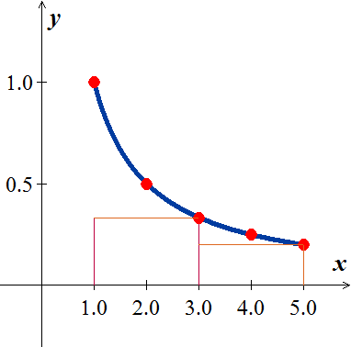Using 2 lower rectangles: 







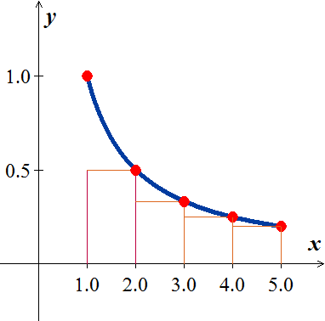 

1. Using 4 lower rectangles: 







1. 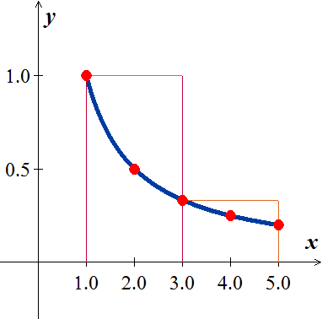Using 2 upper rectangles: 







1. 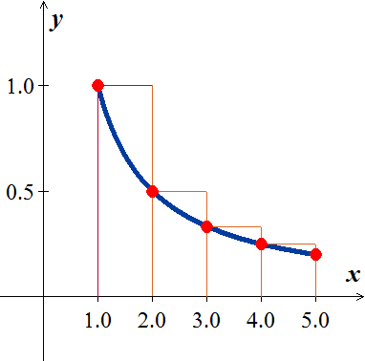Using 4 lower rectangles: 







***Exercise***

Use finite approximations to estimate the area under the graph of the function using



1. A lower sum with two rectangles of equal width
2. A lower sum with four rectangles of equal width
3. A upper sum with two rectangles of equal width
4. A upper sum with four rectangles of equal width

***Solution***

1. 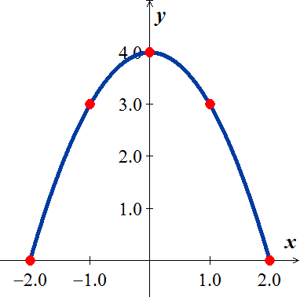Using 2 lower rectangles: 









1. Using 4 lower rectangles: 







1. Using 2 upper rectangles: 









1. Using 4 lower rectangles: 







***Exercise***

Use finite approximations to estimate the average value of *f* on the given interval by partitioning the interval into four subintervals of equal length and evaluating *f* at the subinterval midpoints.



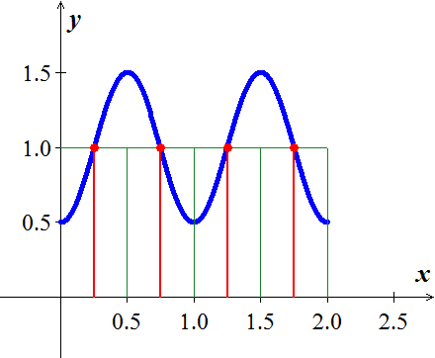***Solution***

















Average value 





***Exercise***

Use finite approximations to estimate the average value of *f* on the given interval by partitioning the interval into four subintervals of equal length and evaluating *f* at the subinterval midpoints.



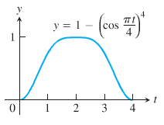***Solution***

















Average value 





***Exercise***

Write the sums without sigma notation. Then evaluate: 

***Solution***



***Exercise***

Write the sums without sigma notation. Then evaluate: 

***Solution***



***Exercise***

Write the sums without sigma notation. Then evaluate: 

***Solution***



***Exercise***

Write the sums without sigma notation. Then evaluate: 

***Solution***



***Exercise***

Write the following expression 1 + 2 + 4 + 8 + 16 + 32 in sigma notation

***Solution***





***Exercise***

Write the following expression 1 − 2 + 4 − 8 + 16 − 32 in sigma notation

***Solution***





***Exercise***

Write the following expression  in sigma notation

***Solution***



***Exercise***

Write the following expression  in sigma notation

***Solution***



***Exercise***

Suppose that . Find the value of 

***Solution***







***Exercise***

Evaluate the sums 

***Solution***







***Exercise***

Evaluate the sums 

***Solution***







***Exercise***

Evaluate the sums 

***Solution***







***Exercise***

Evaluate the sums 

***Solution***









***Exercise***

Evaluate the sums 

***Solution***







***Exercise***

Evaluate the sums 

***Solution***



***Exercise***

Evaluate the sums 

***Solution***

Let 













***Exercise***

Evaluate the sums 

***Solution***



***Exercise***

Graph the function  over the given interval [0, 2]. Partition the interval into four subintervals of equal length. Then add to your sketch the rectangles associated with the Riemann sum , given  is the

1. Left-hand endpoint
2. Right-hand endpoint
3. Midpoint of k*th* subinterval.

***Solution***

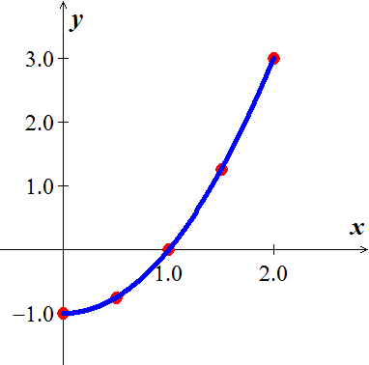

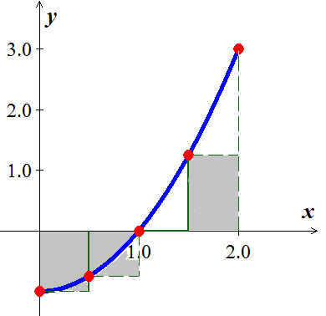 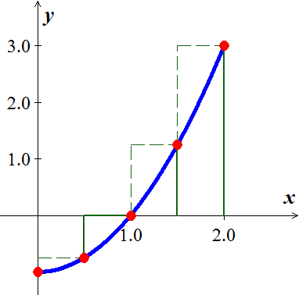 

***Solution*** ***Section* 4.4 – Fundamental Theorem of Calculus**

***Exercise***

Evaluate the integral 

***Solution***







***Exercise***

Evaluate the integral 

***Solution***









***Exercise***

Evaluate the integral 

***Solution***







***Exercise***

Evaluate the integral 

***Solution***







***Exercise***

Evaluate the integral 

***Solution***







***Exercise***

Evaluate the integral 

***Solution***









***Exercise***

Evaluate the integral 

***Solution***









***Exercise***

Evaluate the integral 

***Solution***













***Exercise***

Evaluate the integral 

***Solution***











***Exercise***

Evaluate the integral 

***Solution***













***Exercise***

Evaluate the integral 

***Solution***











***Exercise***

Evaluate the integral 

***Solution***















***Exercise***

Evaluate the integral 

***Solution***









***Exercise***

Evaluate the integral 

***Solution***









***Exercise***

Evaluate the integral 

***Solution***







***Exercise***

Evaluate the integral 

***Solution***



 



***Exercise***

Evaluate the integral 

***Solution***









***Exercise***

Evaluate the integral 

***Solution***







***Exercise***

Evaluate the integral 

***Solution***









***Exercise***

Evaluate the integral 

***Solution***







***Exercise***

Evaluate the integral 

***Solution***







***Exercise***

Evaluate the integral 

***Solution***









***Exercise***

Evaluate the integral 

***Solution***











***Exercise***

Evaluate the integral 

***Solution***









***Exercise***

Evaluate the integral 

***Solution***







***Exercise***

Evaluate the integral 

***Solution***









 

***Exercise***

Evaluate the integral 

***Solution***









***Exercise***

Evaluate the integral 

***Solution***











***Exercise***

Evaluate the integral 

***Solution***









***Exercise***

Evaluate the integral 

***Solution***









***Exercise***

Find the total area between the region and the *x*-axis 

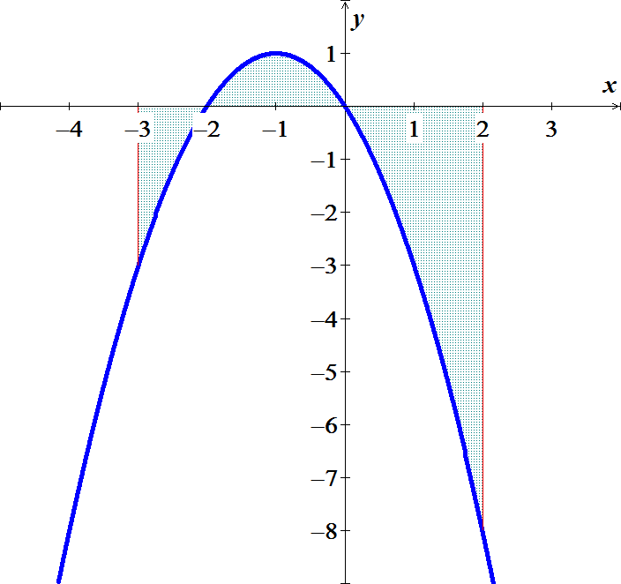***Solution***













***Exercise***

Find the total area between the region and the *x*-axis 

***Solution***











***Exercise***

Find the total area between the region and the *x*-axis 

***Solution***













***Exercise***

Find the total area between the region and the *x*-axis 

***Solution***













***Exercise***

Find the area of the region between the graph of  and the , for 

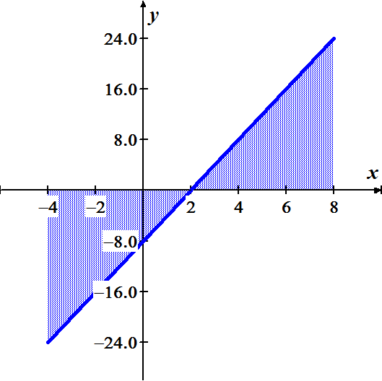***Solution***













***Exercise***

Find the area of the region between the graph of  and the , for 

***Solution***

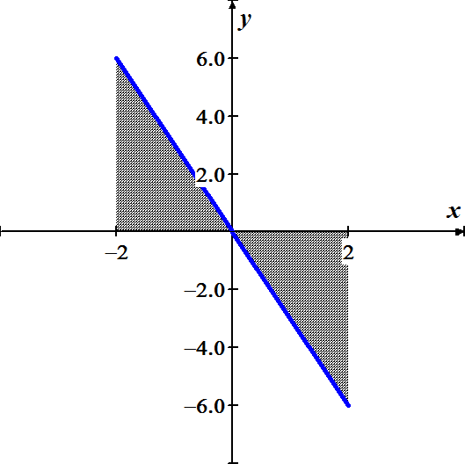











***Exercise***

Find the area of the region between the graph of  and the , for 

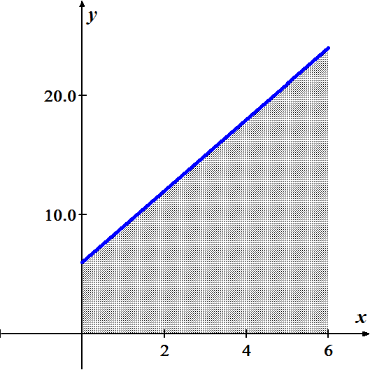***Solution***











***Exercise***

Find the area of the region between the graph of  and the , for 

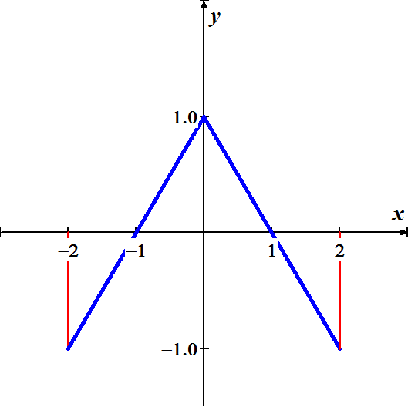***Solution***











***Exercise***

Find the area of the region above the  bounded by 

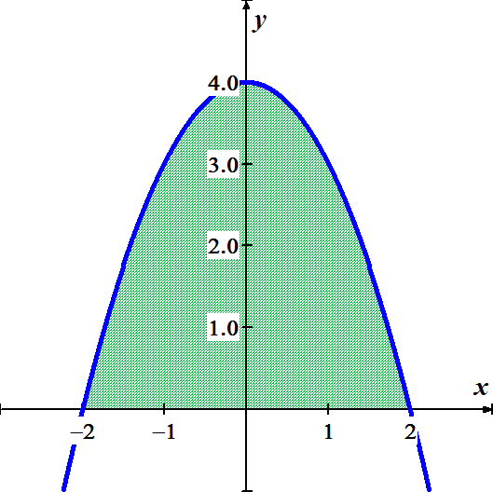***Solution***













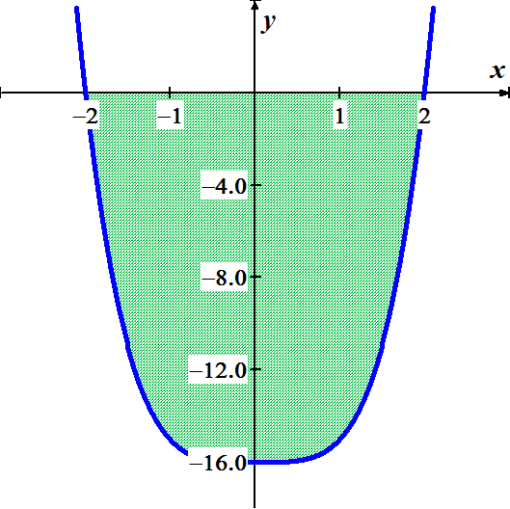***Exercise***

Find the area of the region above the  bounded by 

***Solution***











***Exercise***

Find the area of the region between the graph of  and the , for 

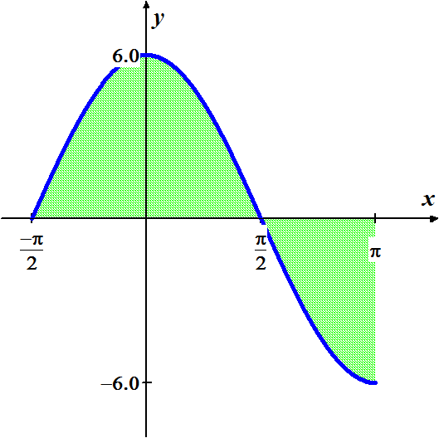***Solution***













***Exercise***

Find the area of the region between the graph of  and the , for 

***Solution***



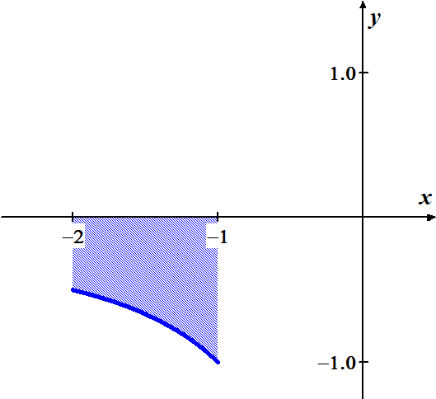 







***Exercise***

Find the area of the region bounded by the graph of 

***Solution***

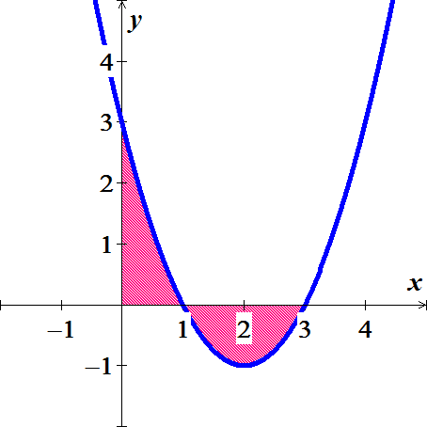









***Exercise***

Find the area of the region bounded by the graph of 

***Solution***

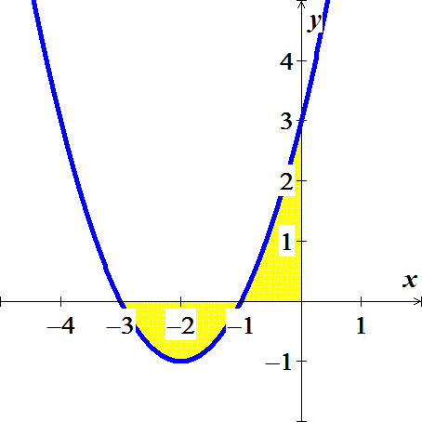









***Exercise***

Find the area of the region bounded by the graph of 

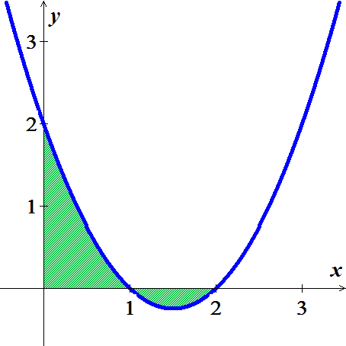***Solution***













***Exercise***

Find the area of the region bounded by the graph of 

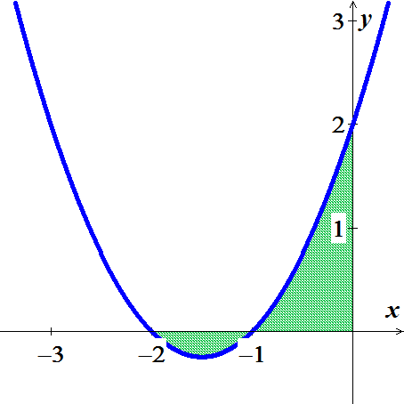***Solution***











***Exercise***

Find the area of the region bounded by the graph of 

***Solution***





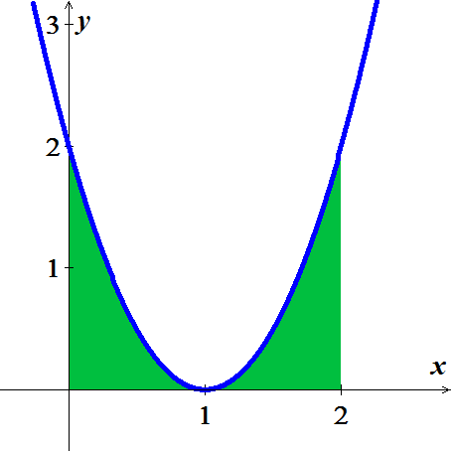 





***Exercise***

Find the area of the region bounded by the graph of 

***Solution***











***Exercise***

Archimedes, inventor, military engineer, physicist, and the greatest mathematician of classical times in the Western world, discovered that the area under a parabolic arch is two-thirds the base times the height. Sketch the parabolic arch , assuming that *h* and *b* are positive. Then use calculus to find the area of the region enclosed between the arch and the *x*-axis

***Solution***













***Exercise***

Suppose that a company’s marginal revenue from the manufacture and sale of eggbeaters is



Where *r* is measured in thousands of dollars and *x* in thousands of units. How much money should the company expect from a production run of *x* = 3 thousand eggbeaters? To find out, integrate the marginal revenue from *x* = 0 to *x* = 3.

***Solution***

 









***Exercise***

The height *H* (*feet*) of a palm tree after growing for *t* years is given by



1. Find the tree’s height when *t* = 0, *t* = 4, and *t* = 8.
2. Find the tree’s average height for 

***Solution***

1. 





1. Average height  









***Exercises Section* 4.5 – Working with Integrals**

***Exercise***

If *f* is an odd function, why is 

***Solution***

If *f* is an odd function then it is symmetric about the origin, which the region between −*a* and *a*, there is as much area above the axis and under *f* as there is below the axis and above *f*.

Therefore, the net area must be 0.

***Exercise***

If *f* is an even function, why is 

***Solution***

If *f* is an even function then it is symmetric about the *y-*axis, which the region that between −*a* and 0 has the same net area as the region between 0 and *a*.

So 

***Exercise***

Is  an even or odd function? Is  an even or odd function?

***Solution***

; therefore  is an even function

 is also an even function

***Exercise***

Use symmetry to evaluate the following integrals 

***Solution***

Because  is an odd function, then 

***Exercise***

Use symmetry to evaluate the following integrals 

***Solution***

Because  is an odd function, then 

***Exercise***

Use symmetry to evaluate the following integrals 

***Solution***

Because  is an even function, then









***Exercise***

Use symmetry to evaluate the following integrals 

***Solution***

***Odd*** ***Even***











***Exercise***

Use symmetry to evaluate the following integrals 

***Solution***

***Even*** ***Odd***









***Exercise***

Find the average value of the following functions on the given interval. 

***Solution***

Average value 

***Exercise***

Find the average value of the following functions on the given interval. 

***Solution***

Average value 







***Exercise***

Find the average value of the following functions on the given interval. 

***Solution***

Average value 







***Exercise***

Find the average value of the following functions on the given interval. 

***Solution***

Average value 









***Exercise***

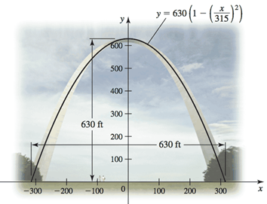The Gateway Arch in St. Louis is 630 *ft* high and has a 630-*ft* base. Its shape can be modeled by the parabola



Find the average height of the arch above the ground.

***Solution***

Average height 







***Exercise***

The planets orbit the Sun in elliptical orbits with the Sun at one focus. The equation of an ellipse whose dimensions are 2 *a* in the *x-*direction and 2 *b* in the *y*-direction is



1. Let  denote the square of the distance from a planet to the center of the ellipse at (0, 0). Integrate over the interval  to show that the average value of  is 
2. Show that in the case of a circle (*a* = *b* = *R*), the average value in part (*a*) is .
3. Assuming 0 < *b* < a, the coordinates of the Sun are . Let  denote the square of the distance from the planet to the Sun. Integrate over the interval  to show that the average value of  is .

***Solution***

1. 

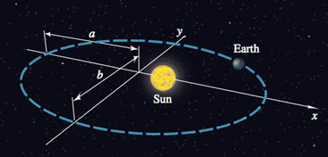



The average value of  









1. If 

The average value of 

1. 





The average value of 











***Solution Section* 4.6 – Substitution Rule**

***Exercise***

Evaluate the indefinite integrals by using the given substitutions to reduce the integrals to standard form



***Solution***

Let 







***Exercise***

Evaluate the indefinite integrals by using the given substitutions to reduce the integrals to standard form



***Solution***

Let 









***Exercise***

Evaluate the indefinite integrals by using the given substitutions to reduce the integrals to standard form



***Solution***

Let 







***Exercise***

Evaluate the indefinite integrals by using the given substitutions to reduce the integrals to standard form



***Solution***

Let 









***Exercise***

Evaluate the indefinite integrals by using the given substitutions to reduce the integrals to standard form



***Solution***

Let 







Let 









***Exercise***

Evaluate the integrals 

***Solution***

Let 







***Exercise***

Evaluate the integrals 

***Solution***

Let 







***Exercise***

Evaluate the integrals 

***Solution***

Let 









***Exercise***

Evaluate the integrals 

***Solution***

Let 







***Exercise***

Evaluate the integrals 

***Solution***

Let 







***Exercise***

Evaluate the integrals 

***Solution***

|  |  |
| --- | --- |
| Let |  |

***Exercise***

Evaluate the integrals 

***Solution***

Let 











***Exercise***

Evaluate the integrals 

***Solution***

Let 









***Exercise***

Evaluate the integrals 

***Solution***

Let 







***Exercise***

Evaluate the integrals 

***Solution***





***Exercise***

Evaluate the integrals 

***Solution***

|  |  |
| --- | --- |
| Let |  |

***Exercise***

Evaluate the integrals 

***Solution***

|  |  |
| --- | --- |
|  |  |

***Exercise***

Evaluate the integrals 

***Solution***

Let 







***Exercise***

Evaluate the integrals 

***Solution***

|  |  |
| --- | --- |
|  |  |

***Exercise***

Evaluate the integrals 

***Solution***

Let  







***Exercise***

Evaluate the integrals 

***Solution***

Let 













***Exercise***

Evaluate the integrals 

***Solution***

|  |  |
| --- | --- |
|  |  |

***Exercise***

Evaluate the integrals 

***Solution***

Let 











***Exercise***

Evaluate the integrals 

***Solution***

Let 











***Exercise***

Evaluate the integrals. 

***Solution***





***Exercise***

Evaluate the integrals 

***Solution***

 

***Exercise***

Evaluate the integrals 

***Solution***

 





***Exercise***

Evaluate the integrals 

***Solution***

 

 ***Substitute for x and dx***











***Exercise***

Find the integral

***Solution***





***Exercise***

Find the integral

***Solution***







***Exercise***

Find the integral

***Solution***





***Exercise***

Find the integral

***Solution***









***Exercise***

Find the integral

***Solution***





***Exercise***

Find the integral

***Solution***







***Exercise***

Find the integral

***Solution***

|  |  |
| --- | --- |
|  |  |

***Exercise***

Find the integral

***Solution***













***Exercise***

Find the integral 

***Solution***

 



***Exercise***

Find the integral

***Solution***

 



***Exercise***

Find the integral

***Solution***







***Exercise***

Find the integral

***Solution***







***Exercise***

Find the integral

***Solution***







***Exercise***

Evaluate the integrals 

***Solution***

 

















***Exercise***

Evaluate the integral 

***Solution***



 





***Exercise***

Evaluate 

***Solution***

Let 









***Exercise***

Evaluate 

***Solution***

 







***Exercise***

Evaluate 

***Solution***

 







***Exercise***

Evaluate 

***Solution***

 ***Using Completing the Square***











***Exercise***

Evaluate 

***Solution***



















***Exercise***

Find the integral

***Solution***





***Exercise***

Find the integral

***Solution***







***Exercise***

Find the integral

***Solution***





***Exercise***

Find the integral

***Solution***





***Exercise***

Find the indefinite integral.

***Solution***

|  |  |
| --- | --- |
|  |  |

***Exercise***

Evaluate the integral 

***Solution***

 







***Exercise***

Evaluate the integral 

***Solution***

Let 





 





***Exercise***

Evaluate the integral 

***Solution***



***Exercise***

Find the indefinite integral.

***Solution***





***Exercise***

Evaluate the integral 

***Solution***









***Exercise***

Evaluate the integral 

***Solution***





***Exercise***

Evaluate the integral 

***Solution***

|  |  |
| --- | --- |
|  |  |

***Exercise***

Find the integral

***Solution***





***Exercise***

Evaluate the integral 

***Solution***









***Exercise***

Find the integral

***Solution***

|  |  |
| --- | --- |
|  |  |

***Exercise***

Find the integral

***Solution***









***Exercise***

Find the integral

***Solution***

|  |  |
| --- | --- |
|  |  |

***Exercise***

Find the integral

***Solution***

 









***Exercise***

Find the integral

***Solution***





***Exercise***

Evaluate the integral 

***Solution***

|  |  |
| --- | --- |
|  |  |

***Exercise***

Find the integral

***Solution***













***Exercise***

Evaluate the integral 

***Solution***

Let 







***Exercise***

Find the integral

***Solution***

|  |  |
| --- | --- |
|  |  |

***Exercise***

Evaluate the integral 

***Solution***

Let 







***Exercise***

Evaluate the integral 

***Solution***



 





***Exercise***

Evaluate 

***Solution***

Let 









***Exercise***

Evaluate 

***Solution***



 





***Exercise***

Evaluate 

***Solution***



 





***Exercise***

Evaluate 

***Solution***



 





***Exercise***

Evaluate 

***Solution***





 

 





***Exercise***

Evaluate

***Solution***





 

 



***Exercise***

Evaluate 

***Solution***





 



 









/***Exercise***

Evaluate 

***Solution***



 



***Exercise***

Evaluate 

***Solution***





 





***Exercise***

Evaluate 

***Solution***









***Exercise***

Evaluate 

***Solution***

 



***Exercise***

Evaluate 

***Solution***

 



***Exercise***

Evaluate 

***Solution***









***Exercise***

Evaluate the integrals 

1. , followed by 
2. , followed by 
3. 

***Solution***

1. Let 























1. Let 

















1. Let 













***Exercise***

Evaluate: 

***Solution***

 









***Exercise***

Evaluate the integral 

***Solution***



 is a semi-circle with center (0, 0) and radius = 2

Since *x* from 0 to 2

⇒ Area = (Area of this circle)





***Exercise***

Evaluate the integral 

***Solution***

 









***Exercise***

Evaluate the integral 

***Solution***

 









***Exercise***

Evaluate the integral 

***Solution***

 







***Exercise***

Evaluate the integral 

***Solution***

 







***Exercise***

Evaluate the integral 

***Solution***

 







***Exercise***

Evaluate the integral 

***Solution***

 







***Exercise***

Evaluate the integral 

***Solution***

 







***Exercise***

Evaluate the integral 

***Solution***

|  |  |
| --- | --- |
| Let | ***OR*** |

***Exercise***

Evaluate the integral 

***Solution***

|  |  |
| --- | --- |
|  |  |

***Exercise***

Evaluate the integral 

***Solution***









***Exercise***

Evaluate the integral 

***Solution***

|  |  |
| --- | --- |
|  |  |

***Exercise***

Evaluate the integral 

***Solution***

Let 







***Exercise***

Evaluate the integral 

***Solution***

 







***Exercise***

Evaluate the integral 

***Solution***









***Exercise***

Evaluate the integral 

***Solution***

Let 











***Exercise***

Evaluate the integral 

***Solution***

Let 









***Exercise***

Evaluate the integral 

***Solution***















***Exercise***

Evaluate the integral 

***Solution***

 









***Exercise***

Evaluate 

***Solution***









***Exercise***

Evaluate the integral 

***Solution***















***Exercise***

Evaluate the integral 

***Solution***









***Exercise***

Evaluate the integral 

***Solution***













***Exercise***

Evaluate the integral 

***Solution***

















***Exercise***

Evaluate the integral 

***Solution***













***Exercise***

Evaluate the integral 

***Solution***









***Exercise***

Evaluate the integral 

***Solution***

Let 











***Exercise***

Evaluate the integral 

***Solution***

Let 













***Exercise***

Evaluate the integral 

***Solution***













***Exercise***

Evaluate the integral 

***Solution***









***Exercise***

Evaluate the integral 

***Solution***



 











***Exercise***

Evaluate the integral 

***Solution***



 











***Exercise***

Evaluate the integral 

***Solution***







***Exercise***

Evaluate the integral 

***Solution***









***Exercise***

Evaluate the integral 

***Solution***







 

***Exercise***

Evaluate 

***Solution***

Let:  

 









***Exercise***

Evaluate 

***Solution***

 

 









***Exercise***

Evaluate 

***Solution***

 

 







***Exercise***

Evaluate 

***Solution***









 

 









***Exercise***

Evaluate 

***Solution***

 











***Exercise***

Solve the initial value problem 

***Solution***



Let 















***Exercise***

Solve the initial value problem 

***Solution***



Let 

















***Exercise***

Verify the integration formula: 

***Solution***

If 











 **√** Which verifies the formula

***Exercise***

Verify the integration formula: 

***Solution***

If 













 **√** Which verifies the formula

***Exercise***

Find the area of the region bounded by the graphs of 

***Solution***

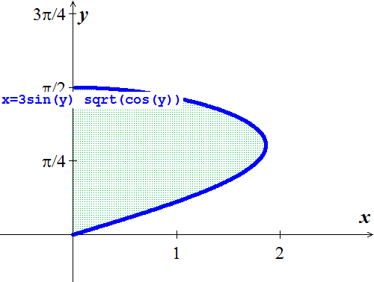 









***Exercise***

Find the area of the region bounded by the graph of 

***Solution***



 





***Exercise***

Find the area of the region bounded by the graph of  and the  between  and .

***Solution***









***Exercise***

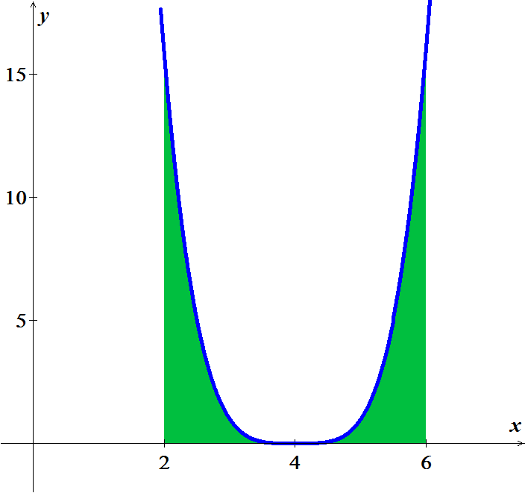Find the area of the region bounded by the graph of  and the  between  and .

***Solution***









***Exercise***

A company is considering a new manufacturing process in one of its plants. The new process provides substantial initial savings, with the savings declining with time *t* (in years) according to the rate-of-savings function



where  is in thousands of dollars per year. At the same time, the cost of operating the new process increases with time *t* (in years), according to the rate-of-cost function (in thousands of dollars per year)



1. For how many years will the company realize savings?
2. What will be the net total savings during this period?

***Solution***

1. For how many years will the company realize savings?

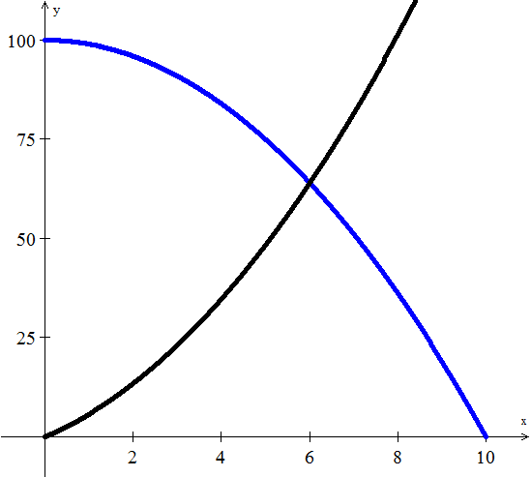









The company should use this type for 6 years.

***b***) What will be the net total savings during this period?

Total savings 









The company will save a total of $372,000. Over the 6-*year* period

***Exercise***

Find the producers’ surplus if the supply function for pork bellies is given by



Assume supply and demand are in equilibrium at 

***Solution***

The equilibrium price: 

Producer’s surplus 











The producers’ surplus is $12,931.66