Math 2413 – Calculus I ***Homework*** (sec 4.6)

Instructor: Khoury

Find each *indefinite* integral

|  |  |
| --- | --- |
|  |  |

1. Find the total ***areas*** of the shaded regions

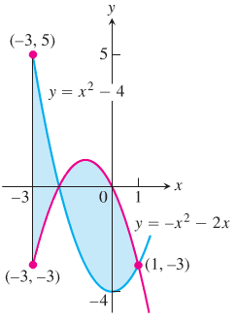

1. Find the ***area*** of the region bounded by the graphs of  and 
2. Find the area of the region bounded by the graph of  and the  between  and .