**Math 2414 – Calculus II** ***Exam* 1 *Review***

*Instructor*: Fred Khoury

1. The solid lies between planes perpendicular to the *x*-axis at *x* = 0 and *x* = 1. The cross-sections perpendicular to the *x*-axis between these planes are circular disks whose diameters run from the parabola  to the parabola . Find the volume of the solid.
2. The base of the solid is the region in the first quadrant between the line  and the parabola . The cross-sections of the solid perpendicular to the *x*-axis are equilateral triangles whose bases stretch from the line to the curve. Find the volume of the solid.
3. The solid lies between planes perpendicular to the *x*-axis at *x* = 0 and *x* = 6. The cross-sections between these planes are squares whose bases run from the *x*-axis up to the curve . Find the volume of the solid.

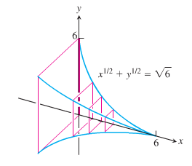

1. Find the volume of the solid generated by revolving the region bounded by  and the lines  about (***a***) the *x*-axis; (***b***) the *y*-axis; (***c***) the line *x* = 2; (***d***) the line *y* = 4.
2. Find the volume of the solid generated by revolving the region bounded by  and the lines  about the line *y =* 2.
3. The profile of a football resembles the ellipse. Find the football’s volume to the nearest cubic inch.

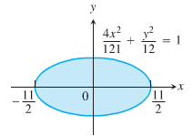

1. The region in the first quadrant that is bounded by the curve , on the left by the line , and below by the line *y* = 1 is revolved about the y-axis to generate a solid. Find the volume of the solid by
2. The *shell* method *b)* The *washer* method
3. Find the length of the curve  from *x* = 1 to *x* = 4
4. Find the length of the curve 
5. Find the area of the surface generated by 
6. Find the area of the surface generated by 
7. At points on the curve , line segments of length *h* = *y* are drawn perpendicular to the *xy*-plane. Find the area of the surface formed by these perpendiculars from 

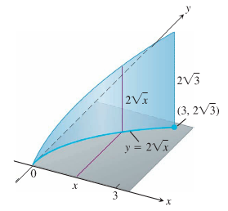

1. A rock climber is about to haul up 100 *N* (about 22.5 *lb.*) of equipment that has been hanging beneath her on 40 *m* rope that weighs 0.8 *N/m*. How much work will it take? (*Hint*: Solve for the rope and equipment separately, then add)
2. You drove an 800-*gal* tank truck of water from the base of a mountain to the summit and discovered on arrival that the tank was only half full. You started with a full tank, climbed at a steady rate, and accomplished the 4750-*ft* elevation change in 50 *min*. Assuming that the water leaked out at a steady rate, how much work was spent in carrying water to the top? Do not count the work done in getting yourself and the truck there. Water weighs 8 *lb/gal*.
3. A force of 200 *N* will stretch a garage door spring 0.8 *m* beyond its unstressed strength. How far will a 300-*N* force stretch the spring? How much work does it take to stretch the spring this far from its unstressed length?
4. You are under contract to build a solar station at ground level on the east-west line between the two buildings. How far from the taller building should you place the station to maximize the number of hours it will be in the sun on a day when passes directly overhead? Begin by observing that



Then find the value of *x* that maximizes *θ*.

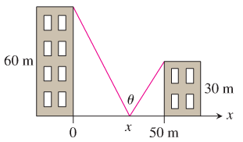

1. 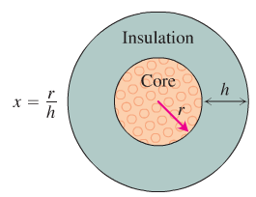A round underwater transmission cable consists of a core of copper wires surrounded by nonconducting insulation. If *x* denotes the ratio of the radius of the core to the thickness of the insulation, it is known that the speed of the transmission signal is given by the equation . If the radius of the core is 1 *cm*, what insulation thickness *h* will allow the greatest transmission speed?
2. Find the area of the triangular region bounded on the left by , on the right by , and above by 
3. Find the extreme values of  and find the area of the region enclosed by the graph of *f* and the *x*-axis.
4. Find the area of the region bounded by the curves and line
5. 

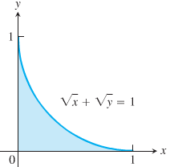

1. 

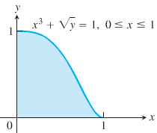

1. 
2. 
3. 
4. 

***Answer***

1. 
2. 
3. 
4. 



1. 
2. 
3. 
4. 
5. 
6. 
7. 
8. 
9. 
10. 
11. 
12. 
13. 
14. 
15. 
16. 
17. ***a*)**  ***b*)**  ***c)*** 

***d*)**  ***e*)**  ***f)*** 