**Math 2414 – Calculus II** ***Exam* 2 *Review***

*Instructor*: Fred Khoury

1. Evaluate the following using integration by parts.
2. 
3. 
4. 
5. 
6. Evaluate the integrals.

|  |  |  |
| --- | --- | --- |
|  |  |  |

1. Evaluate using a trigonometric substitution
2. 
3. 
4. 
5. 
6. Express the integrand as a sum of partial fractions and evaluate the integrals
7. 
8. 
9. 
10. 
11. Evaluate the improper integrals
12. 
13. 
14. 
15. 
16. 
17. Evaluate the integrals.
18. 
19. 
20. 
21. 
22. Solve the differential equation
23. 
24. 
25. 
26. 
27. 
28. Solve the differential equation
29. 
30. 
31. 
32. 
33. Find the length of the graph of the function 
34. The region in the first quadrant that is enclosed by the *x*-axis, the curve , and the lines  and  is revolved about the *x*-axis to generate a solid. Find the volume of the solid.
35. 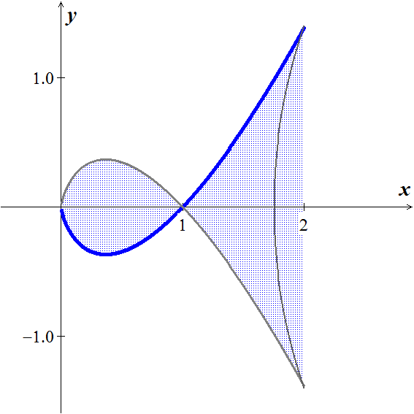The region between the *x*-axis and the curve



is revolved about the *x*-axis to generate the solid.

Find the volume of the solid.

1. A tank with a 2,000 *gal* capacity initially contains 500 *gal* of brine containing 100 *lbs*. of salt starting at time *t* = 0, brine containing 0.1 *lb/gal* of salt is added at a rate of 60 *gal/min* and the mixed solution is drained off at a rate of 40 *gal/min*. How much salt is in the tank when it reaches the point of over flowing?
2. An object of mass ***m*** is released from a balloon. Find the distance it falls in ***t*** seconds, if the force of resistance due to the air is directly proportional to the speed of the object.

***Solution***

1.  

 

1.  

  

1.  

 

1.  

 

1.     
2. 







1.   

 

1.  

 

1. 
2. 
3. 
4. 
5. 