**Math 2414 – Calculus II** ***Exam* 1 *Review***

*Instructor*: Fred Khoury

1. The solid lies between planes perpendicular to the *x*-axis at *x* = 0 and *x* = 1. The cross-sections perpendicular to the *x*-axis between these planes are circular disks whose diameters run from the parabola  to the parabola . Find the volume of the solid.
2. The base of the solid is the region in the first quadrant between the line  and the parabola . The cross-sections of the solid perpendicular to the *x*-axis are equilateral triangles whose bases stretch from the line to the curve. Find the volume of the solid.
3. The solid lies between planes perpendicular to the *x*-axis at *x* = 0 and *x* = 6. The cross-sections between these planes are squares whose bases run from the *x*-axis up to the curve . Find the volume of the solid.

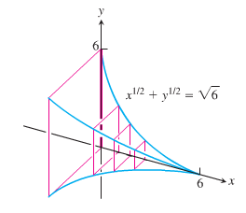

1. Find the volume of the solid generated by revolving the region bounded by  and the lines  about (***a***) the *x*-axis; (***b***) the *y*-axis; (***c***) the line *x* = 2; (***d***) the line *y* = 4.
2. Find the volume of the solid generated by revolving the region bounded by  and the lines  about the line *y =* 2.
3. The profile of a football resembles the ellipse. Find the football’s volume to the nearest cubic inch.

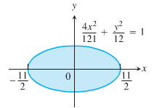

1. The region in the first quadrant that is bounded by the curve , on the left by the line , and below by the line *y* = 1 is revolved about the y-axis to generate a solid. Find the volume of the solid by
2. The *shell* method
3. The *washer* method
4. Find the length of the curve  from *x* = 1 to *x* = 4.
5. Find the length of the curve 
6. Find the area of the surface generated by 
7. Find the area of the surface generated by 
8. At points on the curve , line segments of length *h* = *y* are drawn perpendicular to the *xy*-plane. Find the area of the surface formed by these perpendiculars from 

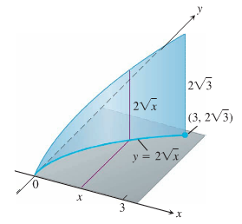

1. A rock climber is about to haul up 100 N (about 22.5 lb.) of equipment that has been hanging beneath her on 40 m rope that weighs 0.8 N/m. How much work will it take? (*Hint*: Solve for the rope and equipment separately, then add)
2. You drove an 800-gal tank truck of water from the base of a mountain to the summit and discovered on arrival that the tank was only half full. You started with a full tank, climbed at a steady rate, and accomplished the 4750-ft elevation change in 50 min. Assuming that the water leaked out at a steady rate, how much work was spent in carrying water to the top? Do not count the work done in getting yourself and the truck there. Water weighs 8 lb/gal.
3. A force of 200 N will stretch a garage door spring 0.8 m beyond its unstressed strength. How far will a 300-N force stretch the spring? How much work does it take to stretch the spring this far from its unstressed length?
4. Find the derivative of:
5. 
6. 
7. 
8. 
9. 
10. 
11. 
12. 
13. 
14. 
15. 
16. Evaluate the integrals
17. 
18. 
19. 
20. 
21. 
22. 
23. 
24. 
25. 
26. 
27. 
28. 
29. 
30. Use l’Hôpital Rule to find
31. 
32. 
33. 
34. 
35. 
36. 
37. 
38. You are under contract to build a solar station at ground level on the east-west line between the two buildings. How far from the taller building should you place the station to maximize the number of hours it will be in the sun on a day when passes directly overhead? Begin by observing that



Then find the value of *x* that maximizes *θ*.

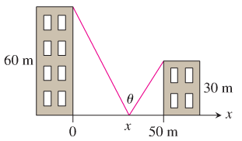

1. A round underwater transmission cable consists of a core of copper wires surrounded by nonconducting insulation. If x denotes the ratio of the radius of the core to the thickness of the insulation, it is known that the speed of the transmission signal is given by the equation . If the radius of the core is 1 cm, what insulation thickness *h* will allow the greatest transmission speed?

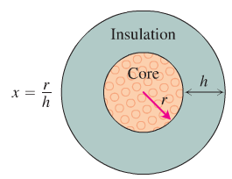

***Solution***

1. 
2. 
3. 
4. 



1. 
2. 
3. 
4. 
5. 
6. 
7. 
8. 
9. 
10. 
11. 
12. 









1. 





1. 
2. 
3. 