***Lecture Four − Parametric Equations and Polar Coordinates***

***Section* 4.1 – Parameterizations of Plane Curves**

***Definition***

If *x* and *y* are given as functions



Over an interval *I* as *t*−values, then the set of points  defined by these equations is a ***parametric curve***. The equations are ***parametric equations*** for the curve

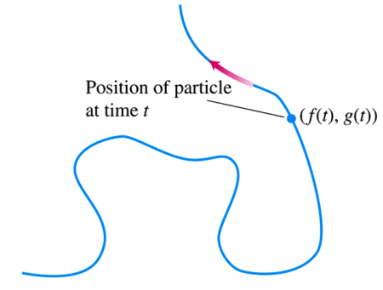

The variable *t* is a parameter for the curve, and its domain *I* is the parameter interval.

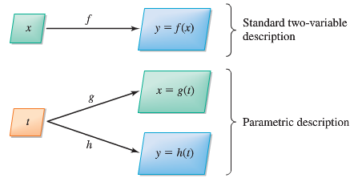

***Definition***

The direction in which a parametric curve is generated as the parameter increases is called the forward or positive orientation of the curve.

***Example***

Sketch the curve defined by the parametric equations



Then obtain an algebraic equation in *x* and *y*.

**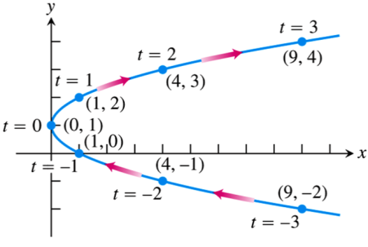*Solution***

|  |  |  |
| --- | --- | --- |
| *t* |  |  |
| −3 | 9 | −2 |
| −2 | 4 | −1 |
| −1 | 1 | 0 |
| 0 | 0 | 1 |
| 1 | 1 | 2 |
| 2 | 4 | 3 |
| 3 | 9 | 4 |



 ***represents a parabola***

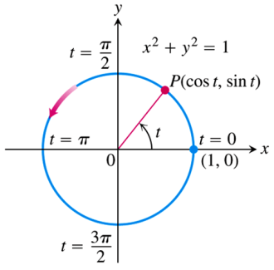***Example***

Graph the parametric curve 

***Solution***



This parametric curve lies along the unit circle .

As t increases from 0 to 2π, the point  starts at (1, 0) and traces the entire circle once counterclockwise.

***Example***

Graph the parametric curve 

***Solution***



This parametric curve lies along the unit circle .

As *t* increases from 0 to 2π, the point  starts at (*a*, 0) with a radius  and traces the entire circle once counterclockwise.

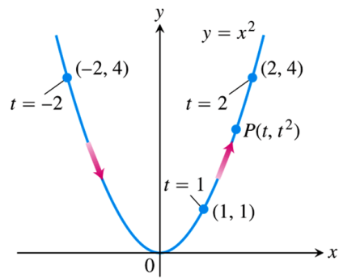***Example***

Graph the parametric curve 

***Solution***



***Example***

Find a parameterization for the line through the point (*a*, *b*) having slope *m*.

***Solution***

A Cartesian equation of the line is 

If 



That is, 

***Example***

Sketch the curve defined by the parametric equations 

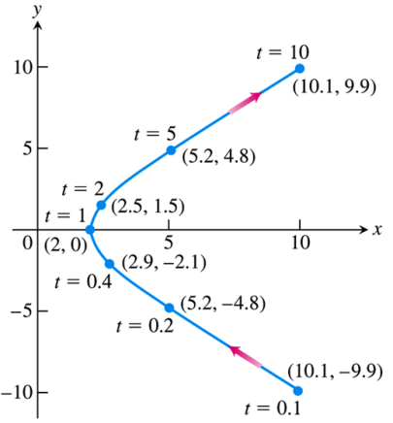Then obtain an algebraic equation in *x* and *y*.

***Solution***

|  |  |  |
| --- | --- | --- |
| *t* |  |  |
| .2 | 5.2 | −4.8 |
| .5 | 2.5 | −1.5 |
| 1 | 2 | 0 |
| 2 | 2.5 | 1.5 |
| 5 | 5.2 | 4.8 |





***Cycloids***

The problem with a pendulum clock whose bob swings in a circular arc is that the frequency of the swing depends on the amplitude of the swing.

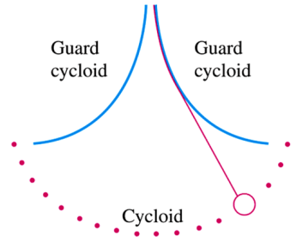

***Example***

A wheel of a radius *a* rolls along a horizontal straight line. Find parametric equations for the path traced by a point P on the wheel’s circumference. The path is called a cycloid.

***Solution***

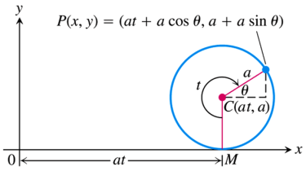 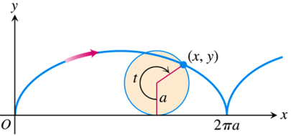

We take the line to be on the *x*-axis, mark a point *P* on the wheel, start the wheel with *P* at the origin, and roll the wheel. As parameter, we use the angle *t* through which the wheel turns, measured in radians. The wheel’s center C lies at  and the coordinates of *P* are



To express *θ* in terms of *t,* we observe that , so that 

That makes 



That implies to: 

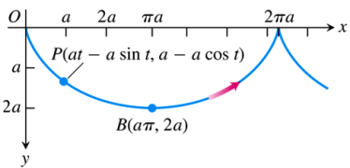 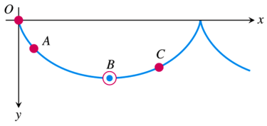

***Exercises*** ***Section* 4.1 – Parameterizations of Plane Curves**

Give parametric equations and parameter intervals for the motion of a particle in the *xy*-plane. Identify the particle’s path by finding a Cartesian equation for it. Graph the Cartesian equation.

|  |  |
| --- | --- |
|  |  |

1. Find parametric equation for the left half of the parabola , originating at 
2. Find parametric equation for the line that passes through the points  and , oriented in the direction of increasing *x*.
3. Find parametric equation for the lower half of the circle centered at  with radius 6, oriented in the counterclockwise direction.
4. Find parametric equation for the upper half of the parabola , originating at 
5. Find parametric equations (not unique) of an ellipse centered at the origin with major axis of length 6 on the  and minor axis of length 3 on the , generated counterclockwise. Graph the ellipse and find a description in terms of *x* and *y*.
6. Find parametric equations (not unique) of an ellipse centered at the origin with major axis of length 12 on the  and minor axis of length 2 on the , generated clockwise. Graph the ellipse and find a description in terms of *x* and *y*.
7. Find parametric equations (not unique) of an ellipse centered at  with major and minor axes of lengths 30 and 20, parallel to the  and , respectively. Graph the ellipse and find a description in terms of *x* and *y*.
8. Find a parametric equations and a parameter interval for the motion of a particle starting at the point (2, 0) and tracing the top half of the circle  four times.
9. Find a parametrization for the line segment joining points (0, 2) and (4, 0) using the angle *θ* in the accompanying figure as the parameter.

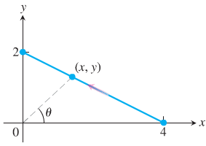

1. Find a parametrization for the circle  starting at (1, 0) and moving counterclockwise to the terminal point (0, 1), using the angle *θ* in the accompanying figure as the parameter.

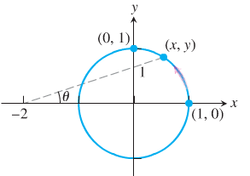

1. A common task is to parameterize curves given either by either Cartesian equations or by graphs. Find a parametric representation of the following curves.
2. The segment of the parabola 
3. The complete curve 
4. The piecewise linear path that connects  to  to  (in that order), where the parameter varies over the interval 
5. A projectile launched from the ground with an initial speed of 20 *m/s* and a launch angle *θ* follows a trajectory approximated by



Where *x* and *y* are the horizontal and vertical positions of the projectile relative to the launch point .

1. Graph the trajectory for various of *θ* in the range .
2. Based on your observations, what value of *θ* gives the greatest range (the horizontal distance between the launch and landing points)?
3. Many fascinating curves are generated by points on rolling wheels. The path of a light on the rim of a rolling when is a cycloid, which has the parametric equations



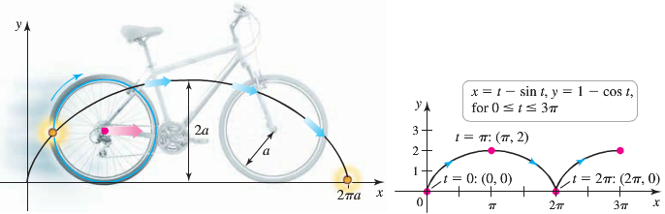

Where . Graph the cycloid with . On what interval does the parameter generate one arch of the cycloid?

(18−20) Find parametric equations that describe the circular path of the objects. Assume  denotes the position of the object relative to the origin at the center of the circle.

1. A go-cart moves counterclockwise with constant speed around a circular track of radius 400 *m*, completing in 1.5 *min*.
2. The tip of the 15-*in* second hand of a clock completes one revolution in 60 *sec*.
3. A Ferris wheel has a radius of 20 *m* and completes a revolution in the clockwise direction at constant speed in 3 *min*. Assume that *x* and *y* measure the horizontal and vertical positions of a seat on the Ferris wheel relative to a coordinate system whose origin is at the low point of the wheel. Assume the seat begins moving at the origin.
4. A plane traveling horizontally at 80 *m/s* over flat ground at an elevation of 3000 *m* releases an emergency packet. The trajectory of the packet is given by

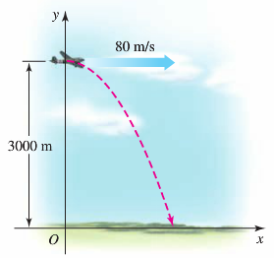



Where the origin is the point on the ground directly beneath the plane at the moment of the release. Graph the trajectory of the packet and find the coordinates of the point where the packet lands.

1. The path of a point on circle *A* with radius  that rolls on the inside of circle *B* with a radius *a* is an asteroid or hypocycloid. Its parametric equations are

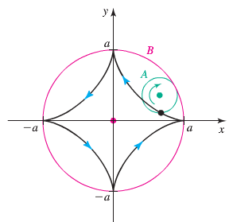



Graph the asteroid with  and find its equation in terms of *x* and *y*.

***Section* 4.2 – Calculus with Parametric Curves**

**Tangents and Areas**

A parametrized curve  and  is differentiable at *t* if *f* and *g* are differentiable at *t*.

**Parametric Formula for **

If all three derivatives exist and ,



The derivatives ,, and  are related by the Chain Rule 

**Parametric Formula for **

If the equations  ,  define *y* as a twice−differentiable function of *x*, then at any point where  and 



***Example***

Find the tangent to the curve , at the point , where 

**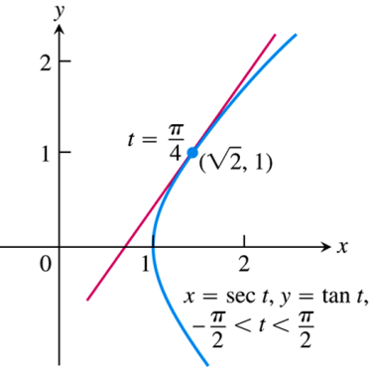*Solution***

The slope of the curve at *t* is:





The tangent line is







***Example***

Find  as a function of *t* if 

***Solution***



 













***Example***

Find the area enclosed by the asteroid: 

***Solution***

By symmetry, the enclosed area is 4 times the area beneath the curve in the first quadrant where .

 













 











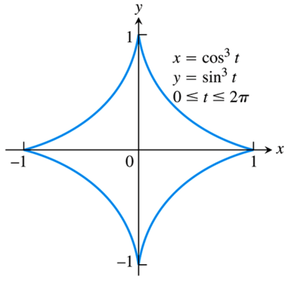

**Length of a Parametrically Defined Curve**

***Definition***

If a curve *C* is defined parametrically by  and , , where  and  are continuous and not simultaneously zero on [*a, b*], and *C* is traversed exactly once as *t* increases from  to , then the length of *C* is the definite integral



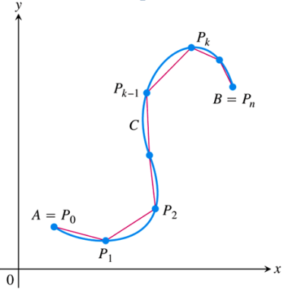 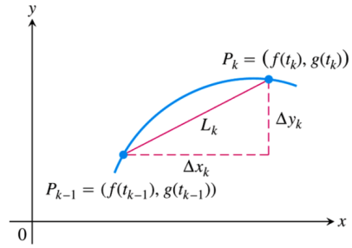

***Example***

Find the length of the circle of radius *r* defined parametrically by 

***Solution***















***Example***

Find the length of the asteroid: 

***Solution***

Because of the curve’s symmetry with respect to the coordinate axes, its length is 4 times the length of the first quadrant.







 

 



 

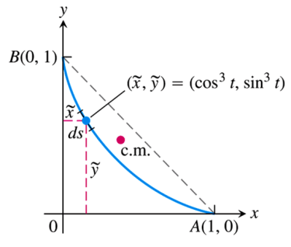 









**Area of Surface of Revolution for Parametrized Curves**

If a smooth curve  and , , is traversed exactly once as *t* increases from *a* to *b*, then the areas of the surfaces generated by revolving the curve about the coordinate axes are as follows.

1. **Revolution about the *x*−axis (*y* ≥ 0):**



1. **Revolution about the *y***−**axis (*x* ≥ 0):**



***Example***

The standard parametrization of the circle of radius 1 centered at the point (0, 1) in the *xy*−plane is



Use the parametrization to find the area of the surface swept out by revolving the circle about the x−axis.

***Solution***

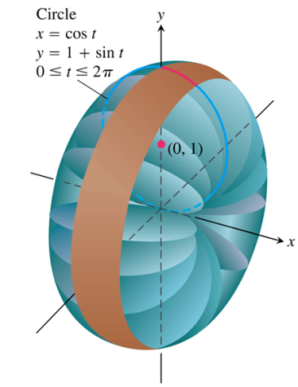















***Exercises*** ***Section* 4.2 – Calculus with Parametric Curves**

Find all the points at which the curve has the given slope.

|  |  |
| --- | --- |
|  |  |

Find an equation of the line tangent to the curve at the point corresponding to the given value of *t*.

|  |  |
| --- | --- |
|  |  |

Find the tangent to the curve at the point defined by the given value of *t*. Also find the value of  at this point

|  |  |
| --- | --- |
|  |  |

Find the equations of the tangent lines at the point where the curve crosses itself

|  |  |
| --- | --- |
|  |  |

Find the slope of the curve  at the given value of *t*. Define *x* and *y* as differentiable functions.

1. 
2. 
3. 
4. Consider Lissajous curve, estimate the coordinates of the points on the curve at which there is



1. A horizontal tangent line
2. A vertical tangent line.



1. Consider Lissajous curve, estimate the coordinates of the points on the curve at which there is



1. A horizontal tangent line
2. A vertical tangent line.



Find the area of the region

|  |  |
| --- | --- |
|  |  |
|  |  |

1. Find the area under one arch of the cycloid 
2. Find the area enclosed by the *y*−axis and the curve 
3. Find the area enclosed by the ellipse 

Find the area of the closed curve

|  |  |
| --- | --- |
|  |  |
|  |  |
|  |  |
|  |  |
|  |  |
|  |  |

Find the lengths of the curves

1. 
2. 
3. 
4. 
5. Hypocycloid perimeter curve: 
6. Circle circumference: 
7. Cycloid arch: 
8. Involute of a circle: 

Find the areas of the surfaces generated by revolving the curves

1. 
2. 
3. 
4. 
5. 
6. 
7. 
8. 
9. 
10. 

|  |  |
| --- | --- |
|  |  |

1. 

|  |  |
| --- | --- |
|  |  |

1. 

|  |  |
| --- | --- |
|  |  |

1. Use the parametric equations  to
2. Graph the curve on the interval .
3. Find  and 
4. Find the equation of the tangent line at the point 
5. Find the length of the curve
6. Find the surface area generated by revolving the curve about the 
7. Use the parametric equations 
8. Find  and 
9. Find the equation of the tangent line at the point where 
10. Find all points (if any) of horizontal tangency.
11. Determine where the curve is concave upward or concave downward.
12. Find the length of one arc of the curve
13. The involute of a circle is described by the endpoint *P* of a string that is held taut as it is unwound from a spool that does not turn.

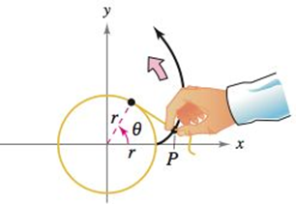

Show that a parametric representation of the involute is



1. The figure shows a piece of string tied to a circle with a radius of one unit. The string is just long enough to reach the opposite side if the circle.



Find the area that is covered when the string is unwounded counterclockwise.

***Section* 4.3 – Polar Coordinates and Graphs**

***Definition* of Polar Coordinates**

To define polar coordinates, let an ***origin*** *O* (called the ***pole***) and an ***initial ray*** from *O*. Then each point *P* can be located by assigning to it a ***polar coordinate pair***  in which r gives the directed from *O* to *P* and *θ* gives the directed angle from the initial ray to yay *OP*.

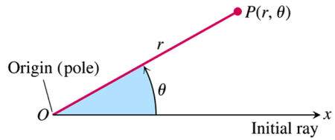

***Polar Coordinates***

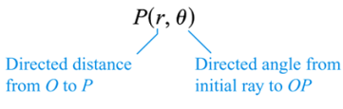

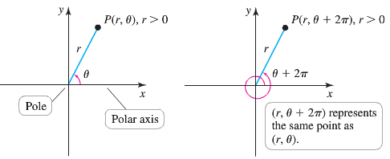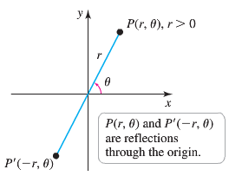 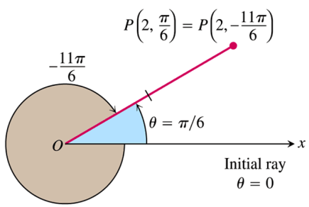

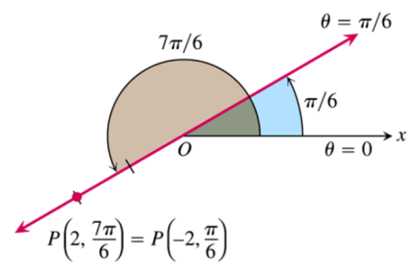***Example***

Find all the polar coordinates of the point 

***Solution***

For 

For 

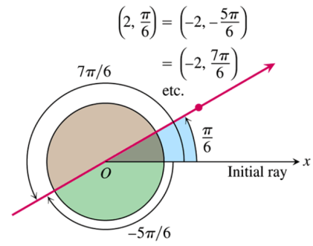The corresponding coordinate pairs of *P* are



And



**Polar Equations and Graphs**

|  |  |
| --- | --- |
| ***Equation*** | ***Graph*** |
|  | Circle of radius  centered at *O* |
|  | Line through *O* making an angle  with the initial ray |

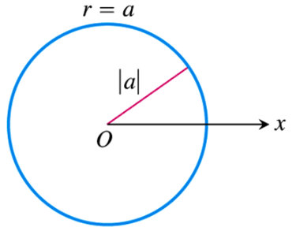

***Example***

Graph the polar coordinate 

***Solution***

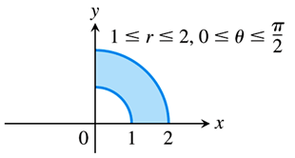

***Example***

Graph the polar coordinate 

***Solution***

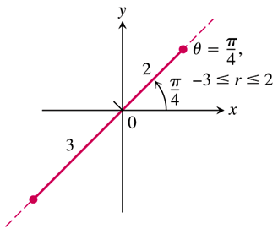

***Example***

Graph the polar coordinate 

***Solution***

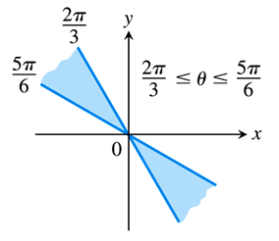

**Relating Polar and Cartesian Coordinates**

When we use both polar and Cartesian coordinates in a plane, we place the two origins together and take the initial polar ray as the positive *x-*axis. The ray  becomes the positive *y-*axis. The two coordinate systems are then related by the following equations

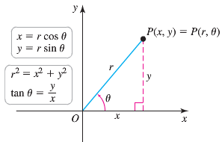

***Equations Relating Polar and Cartesian Coordinates***



|  |  |
| --- | --- |
| ***Polar equation*** | ***Cartesian equation*** |
|  |  |
|  |  |
|  |  |
|  |  |
|  |  |

***Example***

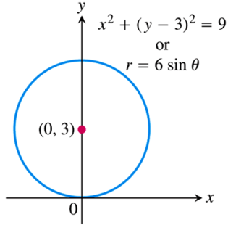Find a polar equation for the circle 

***Solution***





 





***Example***

Replace the polar equation by equivalent Cartesian equation and identify the graph: 

***Solution***



The graph: Vertical line through 

***Example***

Replace the polar equation by equivalent Cartesian equation and identify the graph: 

***Solution***









 The ***graph***: Circle with center (2, 0) and radius 2.

**Symmetry Test for Polar Graphs**

1. ***Symmetry about the x-axis***: If the point  lies on the graph, then the point  or  lies on the graph.

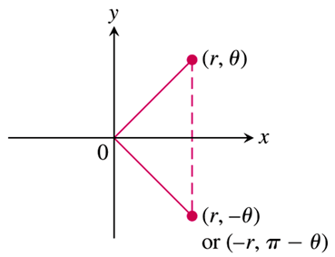

1. ***Symmetry about the y-axis***: If the point  lies on the graph, then the point  or  lies on the graph.

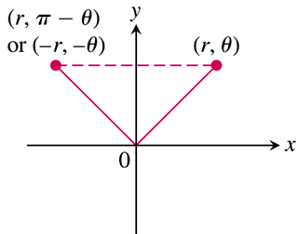

1. ***Symmetry about the origin***: If the point  lies on the graph, then the point  or  lies on the graph.

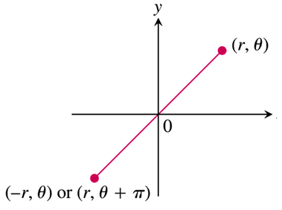

***Example***

Graph the curve 

***Solution***

The curve is symmetric about the *x*-axis:



|  |  |  |  |  |  |  |  |  |  |  |  |  |  |
| --- | --- | --- | --- | --- | --- | --- | --- | --- | --- | --- | --- | --- | --- |
| |  |  | | --- | --- | | *θ* |  | | 0 | 0 | |  |  | |  | 1 | |  |  | |  | 2 | |  |

***Example***

Graph the curve 

***Solution***

The curve is symmetric about the *x*-axis:







The curve is symmetric about the *origin*:







Therefore, the curve is also symmetric about the *y*-axis.



|  |  |  |  |  |  |  |  |  |  |  |  |  |  |
| --- | --- | --- | --- | --- | --- | --- | --- | --- | --- | --- | --- | --- | --- |
| |  |  | | --- | --- | | *θ* |  | | 0 |  | |  |  | |  |  | |  |  | |  | 0 | |  |

***A Technique for Graphing***

One way to graph a polar equation  is to make a table of  values, plot the corresponding points, and connect them in order of increasing.

Another method of graphing more reliable is

1. First graph  in the *Cartesian* ,
2. Then use the *Cartesian* graph as a table and guide to sketch the *polar coordinate* graph.

***Example***

Graph the *lemniscate* curve 

***Solution***

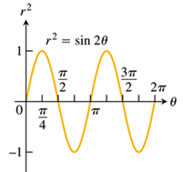 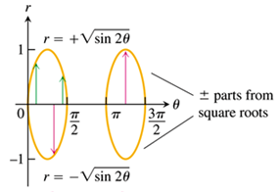

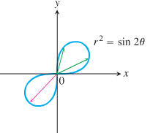

|  |  |  |  |  |  |  |  |
| --- | --- | --- | --- | --- | --- | --- | --- |
|  | 0 |  |  |  |  |  |  |
|  | 0 |  |  |  | 0 | 0 |  |

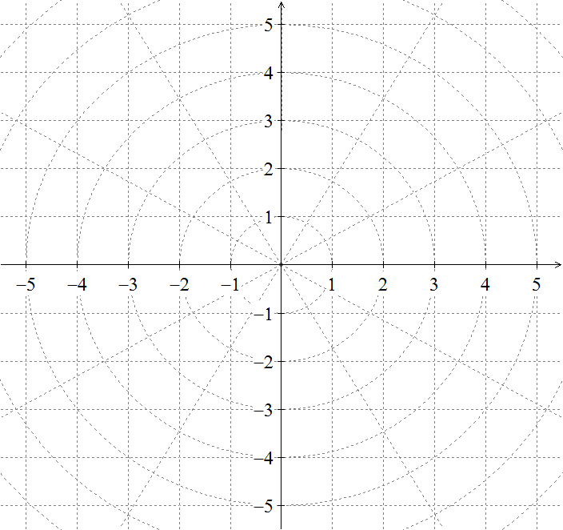

***Exercises Section* 4.3 – Polar Coordinates**

1. Find the Cartesian coordinates of the following points (given in polar coordinates)



1. Find the polar coordinates, , of the following points given in Cartesian coordinates



1. Find the polar coordinates, , of the following points given in Cartesian coordinates



Graph

|  |  |
| --- | --- |
|  |  |

Replace the polar equation with equivalent Cartesian equation and identify the graph

|  |  |  |
| --- | --- | --- |
|  |  |  |

Replace the Cartesian equation with equivalent polar equation

|  |  |  |
| --- | --- | --- |
|  |  |  |

1. ***a*)** Show that every vertical line in the *xy*−plane has a polar equation of the form 

***b*)** Find the analogous polar equation for horizontal lines in the *xy*−plane.

Identify the symmetries of the curves. Then sketch the curves.

|  |  |  |
| --- | --- | --- |
|  |  |  |

Graph the lemniscate. What symmetries do these curves have?

|  |  |  |
| --- | --- | --- |
|  |  |  |

Graph the limaçons is Old French for “snail”. Equations for limaçons have the form 

|  |  |  |
| --- | --- | --- |
|  |  |  |

Graph the equation

|  |  |  |  |
| --- | --- | --- | --- |
|  |  |  |  |

1. Graph the ***nephroid*** of ***Freeth*** equation 
2. Water flows in a shallow semicircular channel with inner and outer radii of 1 *m* and 2 *m*. At a point  in the channel, the flow is in the tangential direction (counterclockwise along circles), and it depends only on *r*, the distance from the center of the semicircles.

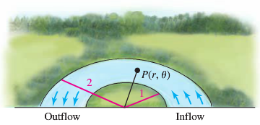

1. Express the region formed by the channel as a set in polar coordinates.
2. Express the inflow and outflow regions of the channel as sets in polar coordinates.
3. Suppose the tangential velocity of the water in *m/s* is given by , for . Is the velocity greater at  or ? Explain.
4. Suppose the tangential velocity of the water is given by , for . Is the velocity greater  or ? Explain.
5. The total amount of water that flows through the channel (across a cross section of the channel ) is proportional to . Is the total flow through the channel greater for the flow in part (*c*) or (*d*)?
6. A simplified model assumes that the orbits of Earth and Mars are circular with radii of 2 and 3, respectively, and that Earth completes one orbit in one year while Mars takes two years. When . Earth is at  and Mars is at ; both orbit the Sum (at ) in the counterclockwise direction.

The position of Mars relative to Earth is given by the parametric equations



1. Graph the parametric equations, for 
2. Letting , explain why the path of Mars relative to Earth is a limaçon.

***Section* 4.4 – Calculus in Polar Coordinates**

***Slope***

The slope of a polar curve  in the *xy-*plane is still given by , which is not 



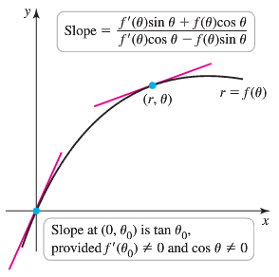







***Example***

Find the points on the interval  at which the cardioid  has a vertical or horizontal tangent line.

***Solution***

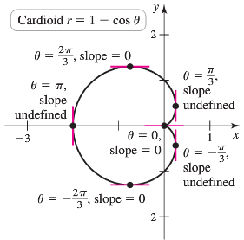











The points with a horizontal tangent line:



The points with a Vertical tangent line:









 Therefore, the curve has a slope of 0 at origin.

**Area in the plane**

The region OTS is bounded by the rays  and the curve .

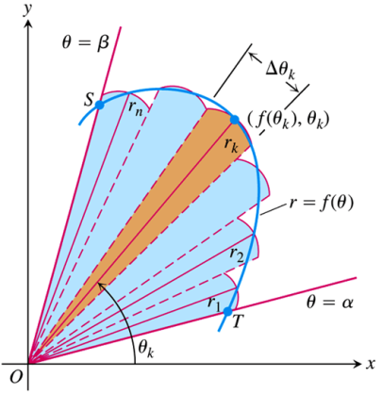

We approximate the region with *n* non-overlapping fan-shaped circular sectors based on a partition *P* of angle *TOS*. The typical sector has radius  and central angle of radian measure . Its area is  times the area of a circle of radius , or



***Area of the Fan-Shaped Region between the Origin and the curve*** 



This is the integral of the ***area differential***



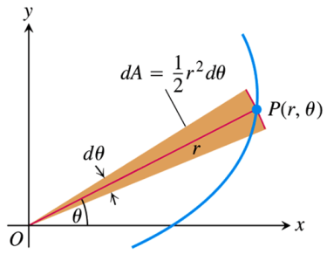

***Example***

Find the area of the region in the plane enclosed by the cardioid 

***Solution***

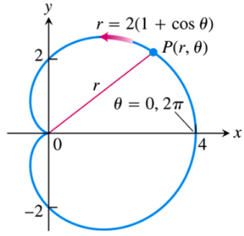













***Area of the Region ***



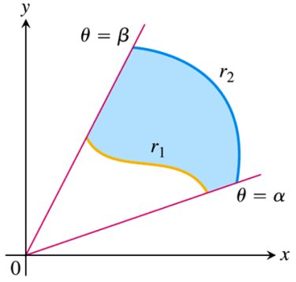

***Example***

Find the area of the region that lies inside the circle  and outside the cardioid 

***Solution***

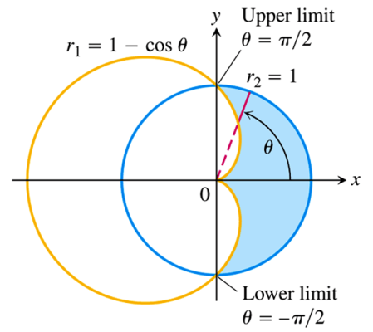













**Length of a Polar Curve**

If  has a continuous first derivative for  and if the point  traces the curve  exactly once as *θ* runs from *α* to *β*, then the length of the curve is



***Example***

Find the length of the cardioid 

***Solution***





 



 

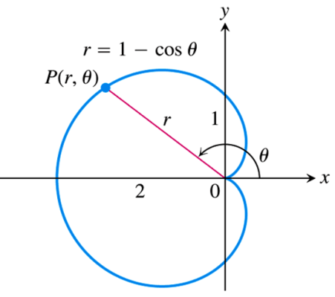 











**Area of a surface of Revolution**

***Theorem***

Let  be a function whose derivative is continuous on an interval  .

The area of the surface formed by revolving the graph of  about the indicated line





***Example***

Find the area of the surface formed by revolving the circle  about the line 

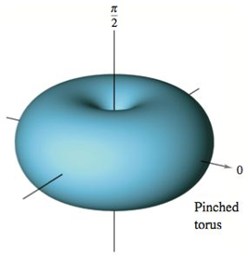 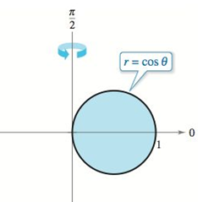

***Solution***











***Exercises*** ***Section* 4.4 – Calculus in Polar Coordinates**

Find the slopes of the curves at the given points. Sketch the curves along with their tangents at these points.

1. 
2. 
3. 
4. 
5. Find the area of the region bounded by the spiral 

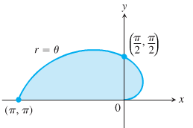

1. Find the area of the region bounded by the circle 



1. Find the area of the region inside one leaf of the three-leaved rose 

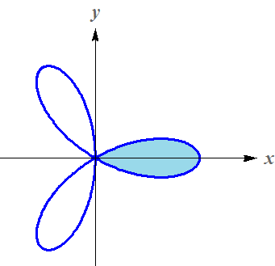

Find the area of the region inside the

|  |  |
| --- | --- |
| 1. Oval limaçon 2. Cardioid 3. Six-leaved rose 4. Curve 5. Right lobe of | 1. Cardioid 2. Limaçon 3. Circle  above the line 4. Inner loop 5. One leave of |

1. Find the area of the region shared by the circles 
2. Find the area of the region shared by the circle  and the cardioid 
3. Find the area of the region in the plane enclosed by the four-leaf rose 
4. Find the area of the region that lies inside the circle  and outside the cardioid 
5. Find the area of the region outside the circle  and inside the circle 
6. Find the area of the region outside the circle  and inside the curve 
7. Find the area of the region inside the circle  in  and inside the right lobe of 
8. Find the area of the region inside the rose  and inside the circle 
9. Find the area of the region inside the lemniscate  and outside the circle 
10. Find the area of the region inside all the leaves of the rose 
11. Find the area of the region inside one leaf of the rose 
12. Find the area of the region of a complete three-leaf rose 
13. Find the area of the region inside the rose  and outside the circle 
14. Find the area of the region bounded by the lemniscate 
15. Find the area of the region bounded by the limaçon 
16. Find the area of the region bounded by the limaçon 

Find the area of the given region

|  |  |
| --- | --- |
| 1. Inner loop of 2. Inner loop of 3. Inner loop of 4. Inner loop of 5. Between the loops 6. Between the loops | 1. Between the loops 2. Between the loops 3. Inside  and outside 4. Inside  and outside 5. Common interior of  and 6. Common interior of  and |

Find the area of the given region

1. Common interior of  and 
2. Common interior of 
3. Common interior of 
4. Common interior of 
5. Inside  and outside 
6. Inside  and outside 
7. Common interior of  and 
8. Common interior of  and , where 

Find the length of

|  |  |
| --- | --- |
|  |  |

Find the surface area bounded by

1. 
2. 
3. 
4. 
5. 
6. 
7. Find the surface area of the torus generated by revolving the circle given by  about the line 
8. Find the surface area of the torus generated by revolving the circle given by  about the line , where 
9. Let *a* and *b* be positive constants. Find the area of the region in the first quadrant bounded by the graph of the polar equation



1. The curve represented by the equation , where *a* and *b* are constants, is called a logarithmic spiral. The figure shows the graph of . . Find the area of the shaded region.

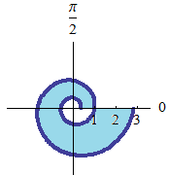

1. The larger circle in the figure is the graph of .

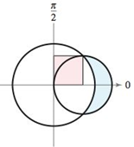

Find the polar equation of the smaller circle such that the shaded regrions are equal.

1. Find equations of the circles in the figure.

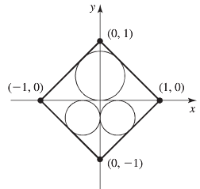

Determine whether the combined area of the circles is greater than or less than the area of the region inside the square but outside the circles.

1. A circular corral of unit radius is enclosed by a fence. A goat inside the corral is tied to the fence with a rope of length .

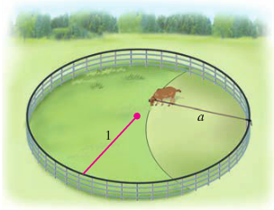

What is the area of the region (inside the corral) that the goat can graze? Check your answer with the special cases  and 

1. A circular concrete slab of unit radius is surrounded by grass. A goat is tied to the edge of the slab with a rope of length .

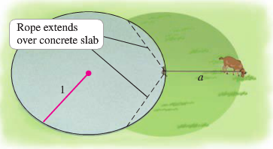

What is the area of the grassy region that the goat can graze? Note that the rope can extend over the concrete slab. Check your answer with the special cases  and 

1. When recording live performance, sound engineers often use a microphone with a cardioid pickup pattern because it suppresses noise from the audience. Suppose the microphone is placed 4 *m* from the front of the stage and the boundary of the optimal pickup region is given by the cardioid , where r if measured in meters and the microphone is at the pole.

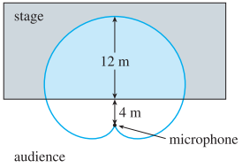

The musicians want to know the area they will have on stage within the optimal pickup range of the microphone, Answer their question.

1. The curve given by the parametric equations



1. Find the rectangular equation of the strophoid.
2. Find a polar equation of the strophoid.
3. Sketch a graph of the strophoid.
4. Find the equations of the two tangent lines at the origin.
5. Find the points on the graph at which the tangent lines are horizontal.