***Math* 2414- *Calculus* II *Homework Sec* 1.2 Name:**

1. Find the area of the region in the first quadrant bounded by  and  where  and 
2. Find the area of the region in the first quadrant bounded by  and 
3. Find the area of the regions  and  (separately) shown in the figure, which are formed by the graphs of  and 

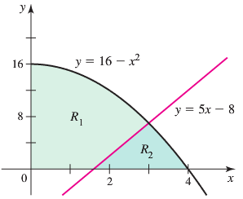

1. Find the area of the regions ,  and  (separately) shown in the figure, which are formed by the graphs of , , and 

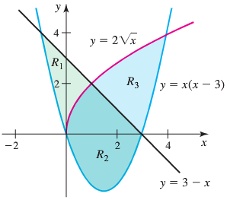

1. Find the area of the region between  and  on the interval 
2. Find the area of the region bounded by ,  and 
3. Find the area of the region in the first quadrant bounded by the curve 
4. Find the area of the region in the first quadrant bounded by  and 
5. Consider the functions  and , where . Find , the area of the region between the curves.