**Math 2415 – Calculus III** ***Exam* 1 *Review***

*Professor*: Fred Khoury

1. Let . Find the component form and the magnitude if the vector
2. 
3. 
4. 
5. Find the component form of the vector: The unit vector that makes an angle  with the positive *x*-axis
6. Find the component form of the vector: The vector 5 units long in the direction opposite to the direction of 
7. Express the velocity vector  in terms of its length and direction.
8. Find , the angle between ***v*** and ***u***, the scalar component of ***u*** in the direction of ***v***, and The vector 

|  |  |
| --- | --- |
|  |  |

1. Find the area of the parallelogram determined by vectors ***u*** and ***v***, then the volume of the parallelepiped determined by vectors ***u***, ***v*** and ***w***.
2. 
3. 
4. Suppose that ***n*** is normal to a plane and that ***v*** is parallel to the plane. Describe how you would find a vector ***n*** that is both perpendicular to ***v*** and parallel to the plane.
5. Find the distance from the point to the line

|  |  |
| --- | --- |
|  |  |

1. Find the distance from the point to the plane

|  |  |
| --- | --- |
|  |  |

1. Find the angle between the planes

|  |  |
| --- | --- |
|  |  |

1. 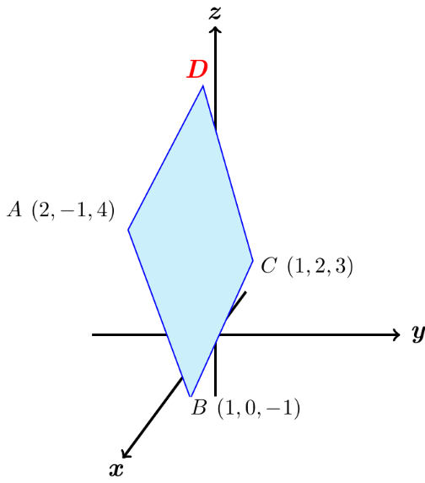The parallelogram has vertices at *A*(2, −1, 4), *B*(1, 0, −1), *C*(1, 2, 3) and *D*. Find
2. The coordinates of D,
3. The cosine of the interior angle of B
4. The vector projection of  onto ,
5. The area of the parallelogram,
6. An equation for the plane of the parallelogram,
7. The areas of the orthogonal projection of the parallelogram on the three coordinate planes.
8. *a*) Find the distance from the point  to the plane *P* having equation



*b*) What is the distance from  to the plane ?

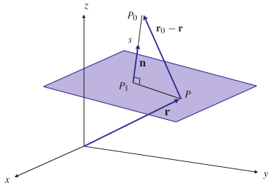

1. A 180-lb man stands on a hillside that makes an angle of 30° with the horizontal, producing a force of  lb.

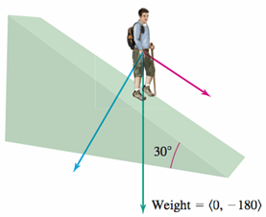

1. Find the component of his weight in the downward direction perpendicular to the hillside and in the downward parallel to the hillside.
2. How much work is done when the man moves 10 *ft* up the hillside?

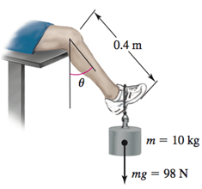

1. You do leg lifts with 10-*kg* weight attached to your foot, so the resulting force is *mg* ≈ 98N directed vertically downward. If the distance from your knee to the weight is 0.4*m* and her lower leg makes an angle of *θ* to the vertical, find the magnitude of the torque about your knee as your leg is lifted (as a function of *θ*). What is the minimum and maximum magnitude of the torque? Does the direction of the torque change as your leg is lifted.

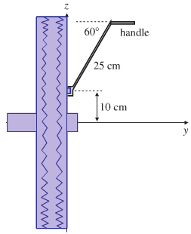

1. An automobile wheel has center at the origin and axle along the *y-*axis. One of the retaining nuts holding the wheel is at position . (Distances are measured in *cm*.) A bent tire wrench with arm 25 *cm* long and inclined at an angle of 60° to the direction of its handle is fitted to the nut in an upright direction. If the horizontal force  is applied to the handle of the wrench, what is its torque on the nut? What part (component) of this torque is effective in trying to rotate the nut about its horizontal axis? What is the effective torque trying to rotate the wheel?
2. Find the lengths of the curves
3. 
4. 
5. Find ***T***, ***N***, ***B***, τ, and κ at the given value of *t* for the plane curves
6. 
7. 
8. 
9. Write ***a*** of the motion  at *t* = 0 without finding ***T*** and ***N***.
10. 
11. 
12. Graph the curves and sketch their velocity and acceleration vectors at the given values of *t*. Then write ***a*** of the motion  without finding ***T*** and ***N***, and find the value of κ at the given values of *t*.
13. 
14. 
15. The position of a particle in the plane at time *t* is . Find the particle’s highest speed.
16. A particle traveling in a straight line located at the point  and has speed 2 at time t = 0. The particle moves toward the point  with constant acceleration . Find the position vector  at time *t*.
17. At point *P*, the velocity and acceleration of a particle moving in the plane are  and . Find the curvature of the particle’s path at *P*.
18. 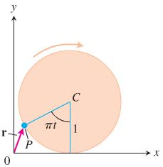A circular wheel with radius 1 *ft* and center *C* rolls to the right along the *x*-axis at a half-run per second. At time *t* seconds, the position vector of the point *P* on the wheel’s circumference is



1. Sketch the curve traced by *P* during the interval 
2. Find ***v*** and ***a*** at *t* = 0, 1, 2, and 3 and add these vectors to your sketch
3. At any given time, what is the forward speed of the topmost point of the wheel? Of *C*?
4. A shot leaves the thrower’s hand 6.5 *ft* above the ground at a 45° angle at 44 *ft/sec*. Where is it 3 *sec* later?
5. Find equations for the osculating, normal and rectifying planes of the curve  at the point (1, 1, 1).
6. Find the following for all values of *t* for which the given curve is defined by 
7. Find the tangent vector and the unit tangent vector
8. Find the curvature.
9. Find the principal unit normal vector.
10. Verify that 
11. Graph the curve and sketch ***T*** and ***N*** at two points.
12. Consider the position vector  of the moving objects
13. Find the normal and tangential components of the acceleration.
14. Graph the trajectory and sketch the normal and tangential components of the acceleration at two points on the trajectory. Show that their sum gives the total acceleration.

***Solution***

1.   
2. 
3. 
4. 
5. 



1.  
2. The desired vector is  or , since  is perpendicular to both ***n*** and ***v***, therefore, also parallel to the plane
3.  
4.  
5.  
6.      
7.  
8.  
9. 
10. 
11.  
12. 





1.  

|  |  |
| --- | --- |
|  |  |

1. 
2. 
3. 

|  |  |  |
| --- | --- | --- |
|  |  |  |

1. 66.27*ft* or 66 *ft*., 3 *in*
2.   
3. 







*e*)



1. 



