**Math 2415 – Calculus III** ***Exam* 3 *Review***

*Professor*: Fred Khoury

1. Evaluate the double integrals

|  |  |  |
| --- | --- | --- |
|  |  |  |

1. Find the area of the region enclosed by the line  and the parabola  in the *xy*-plane.
2. Find the area of the region enclosed by the lines 
3. Find the volume under the parabolic cylinder  above the region enclosed by the parabola  and the line  in the *xy*-plane
4. Evaluate the integral by changing to polar coordinates
5. 
6. 
7. Evaluate the integrals

|  |  |
| --- | --- |
|  |  |
|  |  |

1. Convert 
2. Rectangular coordinates with order of integration d*z*d*x*d*y*.
3. Spherical coordinates
4. Evaluate one of the integrals.
5. Set up an integral in rectangular coordinates equivalent to the integral



Arrange the order of integration to be *z* first, then *y*, then *x*.

1. Evaluate the spherical coordinate integral

|  |  |
| --- | --- |
|  |  |

1. Evaluate
2.  
3. 
4. 
5. Let *R* be the region bounded by the lines 

Evaluate the integral 

1. Let *R* be the region bounded by the square with vertices (0, 1), (1, 2), (2, 1), & (1, 0).

Evaluate the integral 

1. Evaluate  *D* is bounded by the planes:    and 
2. Find the center of mass (centroid) of the thin constant-density plates. The region bounded by  and  between  and 
3. Find the center of mass of the solid, assuming a constant density. The paraboloid bowl bounded by  and 
4. Find the coordinates of the center of mass of the solid with the upper half of a ball

 with density 

1. Find the volume of the solid that is bounded above by the cylinder , on the sides by the cylinder , and below by the *xy*-plane.

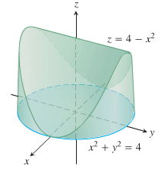

1. Find the volume of the prism in the first octant bounded by the planes 

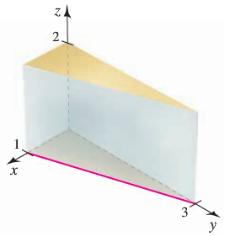

1. Find the volume of the prism in the first octant bounded by the planes



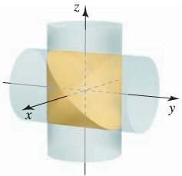

1. Find the volume of the cardioid of revolution



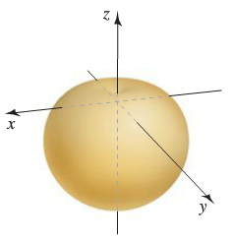

1. A cake is shaped like a solid cone with radius 4 and height 2, with its base on the *xy-*plane. A wedge of the cake is removed by making two slices from the axis of the cone outward, perpendicular to the *xy-*plane separated by an angle of *Q* radians, where 
2. Use a double integral to find the volume of the slice for . Use geometry to check your answer.
3. Use a double integral to find the volume of the slice for . Use geometry to check your answer.
4. A spherical fish tank with a radius of 1 *ft* is filled with water to a level 6 *in*. below the top of the tank.
5. Determine the volume and weight of the water in the fish tank. (The weight density of water is about 62.5 .)
6. How much additional water must be added to completely fill the tank?

***Solution***

1.       
2. 
3. 12 
4. 
5.  
6.    
7.   
8. 
9. 
10. 
11. 
12. 
13. 
14. 
15. 
16. 
17. 
18. 
19. 
20. 
21. 
22. 