***Lecture One* – Vectors and Vector-Values Functions**

***Section* 1.1 – Vectors**

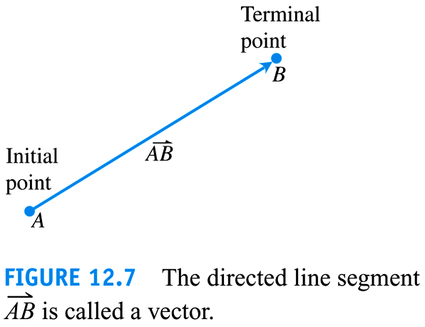

***Component Form***

A quantity such as force, or velocity is called a vector and is represented by a directed line segment.

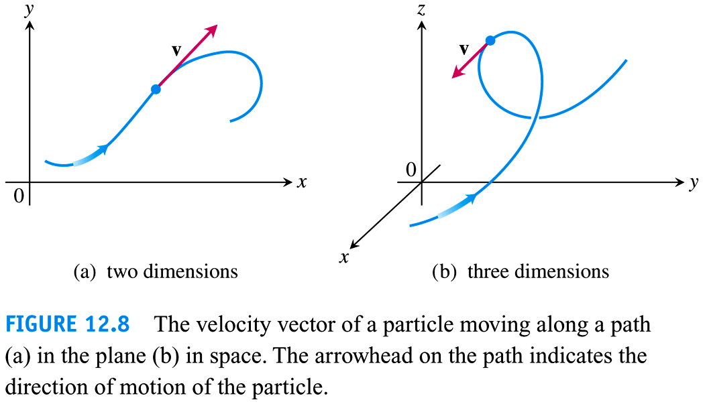 

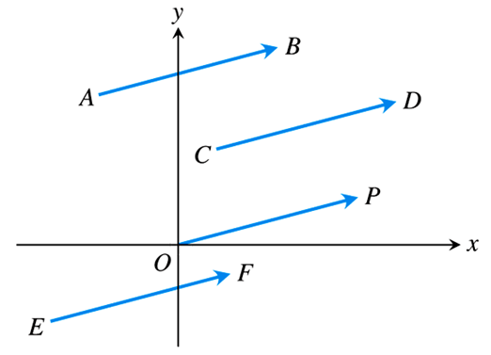

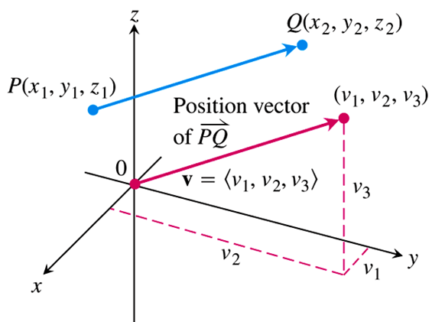***Definition***

The vector represented by the directed line segment  has initial point *P* and terminal point *Q* and its length is denoted by 

**Vector Algebra Operations**

***Definitions***

Let  and  be vectors with ***k*** a scalar

**Addition**: 

**Scalar multiplication**: 

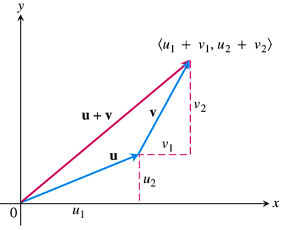 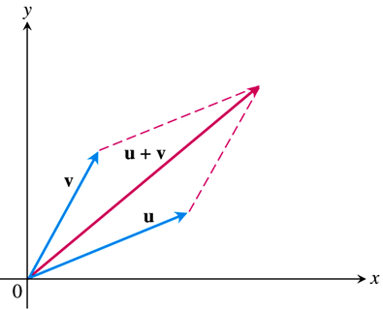

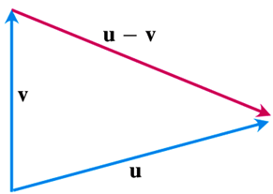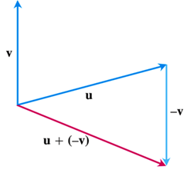 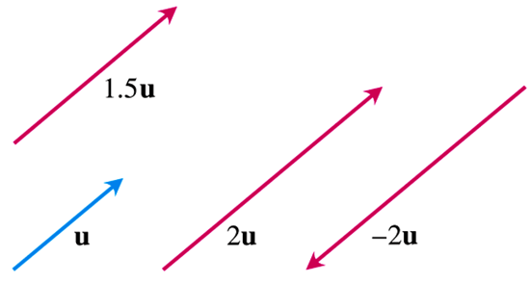

***Example***

Let  and . Find the components of

|  |  |  |
| --- | --- | --- |
|  |  |  |

***Solution***

1. 





1. 



1. 









**Proporties of Vector Operations**

Let ***u, v, w*** be vectors and *a, b* be scalars

1. 
2. 
3. 
4. 
5. 
6. 
7. 
8. 
9. 

***Definition***

If ***v*** is a **two-dimensional** vector in the plane equal to the vector with initial point at the origin and terminal point , then the ***component form*** of ***v*** is



If ***v*** is a **three-dimensional** vector in the plane equal to the vector with initial point at the origin and terminal point , then the ***component form*** of ***v*** is



The magnitude or length of the vector  is the nonegative number



The only vector with length 0 is the ***zero vector ***

***Example***

Find the component form and the length of the vector with initial point  and terminal point 

***Solution***

The component form of  is





The length is





***Unit Vectors***

A vector ***v*** of length 1 is called a ***unit vector***. The ***standard unit vectors*** are



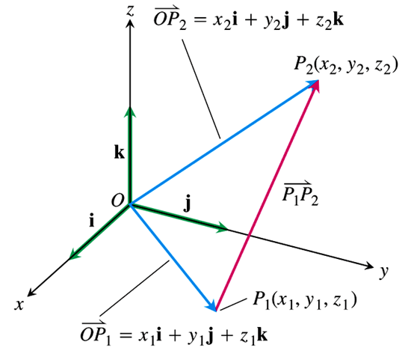

Any vector  can be written as a linear combination of the standard unit vectors as follows:









***Example***

Find a unit vector  in the direction of the vector from  to .

***Solution***

















***Example***

If  is a velocity vector, express  as a product of its speed times a unit vector in the direction of motion.

***Solution***

Speed is the magnitude (length) of :





The unit vector has the same direction as :







***Note***:

If , then

1.  is a unit vector in the direction of ;
2. The equation  expresses  as its length times its direction.

***Example***

A force of 6 *Newton* is applied in the direction of the vector . Express the force  as a product of its magnitude and direction.

***Solution***









**Midpoint of a Line Segment**

The midpoint M of the line segment joining points  and  is the point



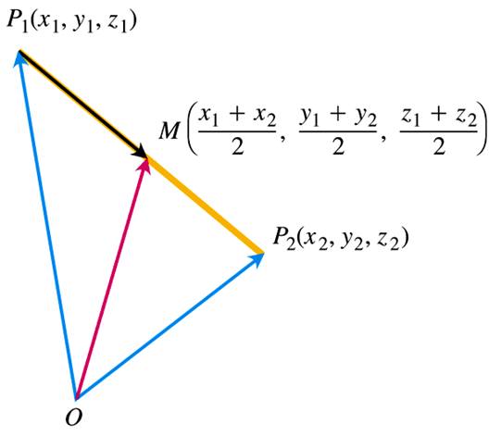

***Example***

Find the midpoint of the segment  and 

***Solution***





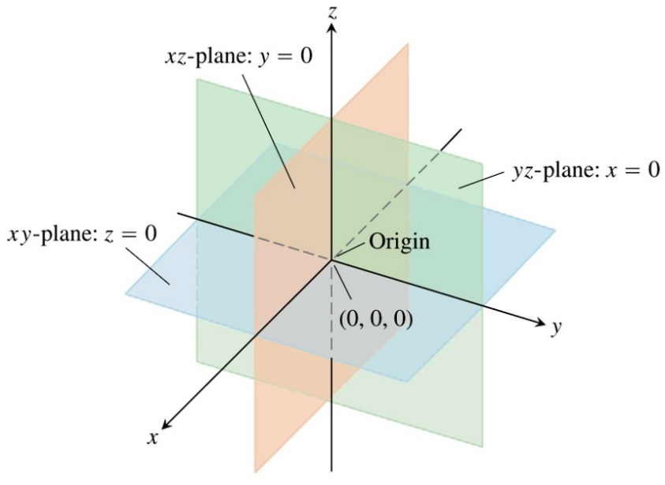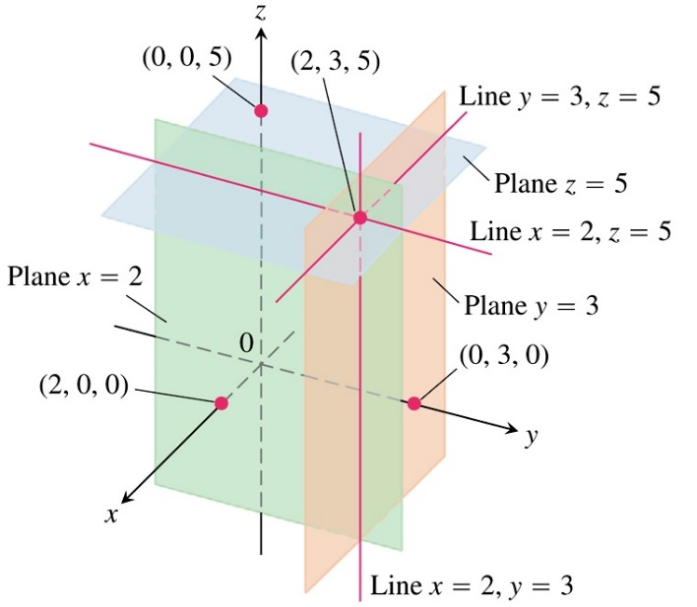

***Example***

What points  satisfy the equations 

***Solution***

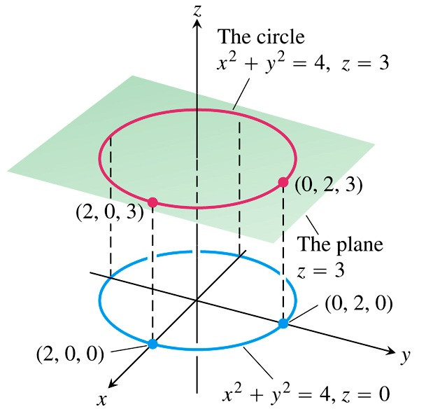

The point lie in the horizontal plane  and the circle .

The solution is the set of points: “the circle  in the plane ”

**Distance in Space**

The distance between  and  is



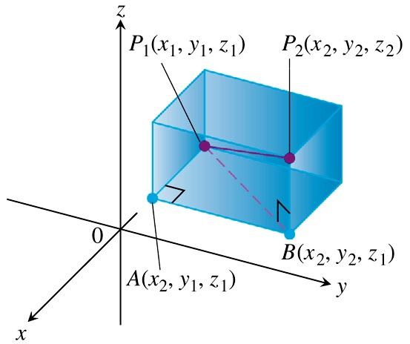

***Proof***







From the right triangles  and :











 *√*

***Example***

Find the distance between  and 

***Solution***









**The Standard Equation for the Sphere of Radius a and Center **



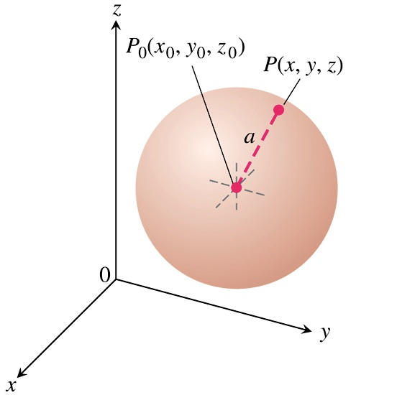

***Example***

Find the center and radius of the sphere 

***Solution***









Therefore; the center is  and the radius is 

***Applications***

***Example***

A jet airliner, flying due east at 500 *mph* in still air, encounters a 70-*mph* tailwind blowing in the direction 60° north of east. The airplane holds its compass heading due east but, because of the wind, acquires a new ground speed and direction. What are they?

***Solution***

 = the velocity of the airplane

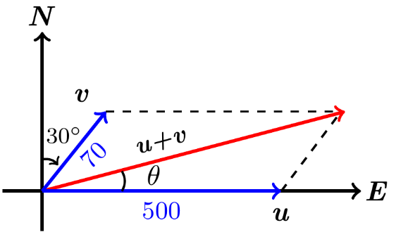******  = the velocity of the tailwind

***Given***: 

















The ground speed of the airplane is about 538.4 *mph*, and its direction is about 6.5° north of east.

***Example***

A small cart is being pulled along a 20-*lb* smooth horizontal floor with a force  making a 45° angle to the floor. What is the effective force moving the cart forward?

**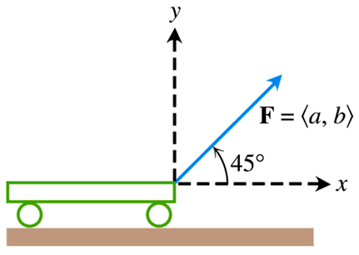*Solution***







***Example***

A 75-*N* weight is suspended by two wires.

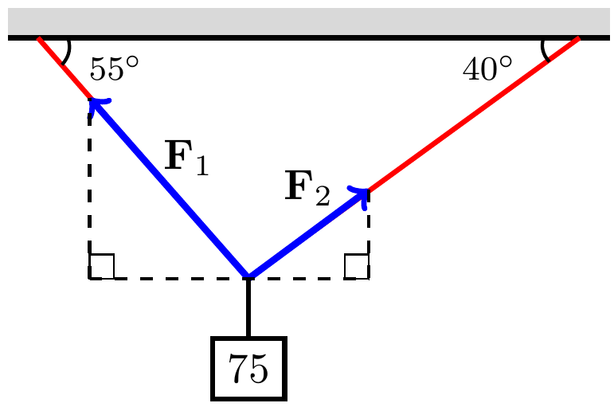

Find the forces  and  acting both wires

***Solution***



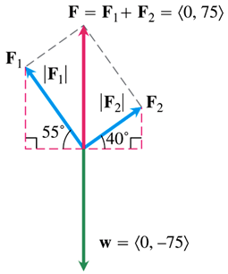





















The force vectors are then:













***Exercises*** ***Section* 1.1 – Vectors**

Give a geometric description of the set of points in space whose coordinates satisfy the given pairs of equations

|  |  |
| --- | --- |
|  |  |

Find the distance between points 

|  |  |
| --- | --- |
|  |  |

Find the center and radii of the spheres

1. 
2. 
3. 
4. Find a formula for the distance from the point  to *x*-axis
5. Find a formula for the distance from the point  to *xz*-plane.
6. Let . Find the component form and the magnitude if the vector
7. 
8. 
9. 
10. Let . Find the component form and the magnitude if the vector

|  |  |  |
| --- | --- | --- |
| 1. 3***u*** 2. ***u*** − ***v*** |  |  |

1. Find scalars *a, b*, and *c* such that 
2. Find the component form of the vector: The sum of  and  where



Find the component form of the vector:

1. The unit vector that makes an angle  with the positive *x*-axis
2. The unit vector obtained by rotating the vector  counterclockwise about the origin.
3. The unit vector obtained by rotating the vector  counterclockwise about the origin.
4. The unit vector that makes an angle  with the positive *x*-axis
5. The vector 5 units long in the direction opposite to the direction of 
6. Express the velocity vector  in terms of its length and direction.
7. Sketch the indicated vector

|  |  |
| --- | --- |
| 1. ***u*** − ***v*** |  |

1. An Airplane is flying in the direction 25° west of north at 800 *km/h*. Find the component form of the velocity of the airplane, assuming that the positive *x*-axis represents due east and the positive *y*-axis represents due north.
2. A jet airliner, flying due east at 500 *mph* in still air, encounters a 70-*mph* tailwind blowing in the direction 60° north of east. The airplane holds its compass heading due east but, because of the wind, acquires a new ground speed and direction. What speed and direction should the jetliner have in order for the resultant vector to be 500 *mph* due east?
3. Consider a 100-*N* weight suspended by two wires. Find the magnitudes and components of the force vectors 

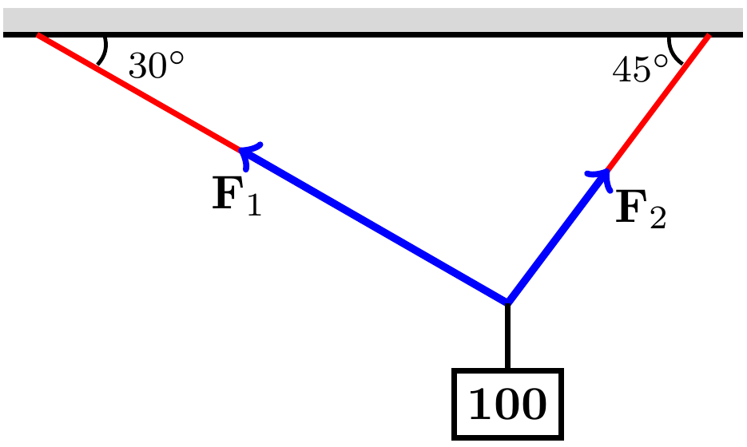

1. Consider a 50-*N* weight suspended by two wires, If the magnitude of vector , find the angle α and the magnitude of vector 

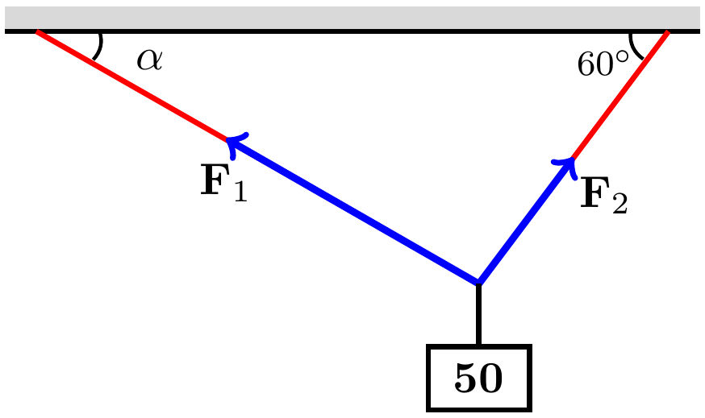

1. Consider a ***w***-*N* weight suspended by two wires, If the magnitude of vector , find ***w*** and the magnitude of vector 

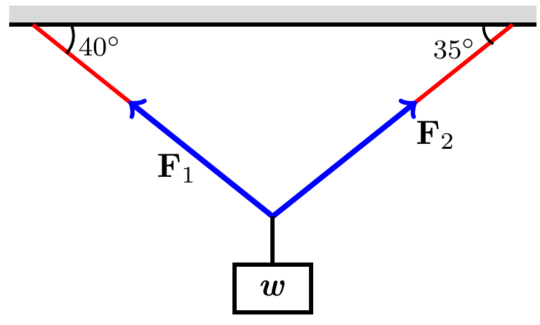

1. Consider a 25-*N* weight suspended by two wires, If the magnitude of vector are both 75 *N*, then angles α and β are equal. Find α.

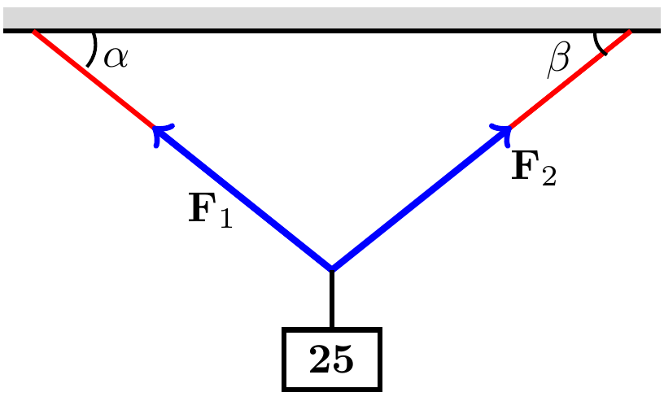

1. Consider a  weight suspended by two wires. Find the magnitudes and components of the force vectors 

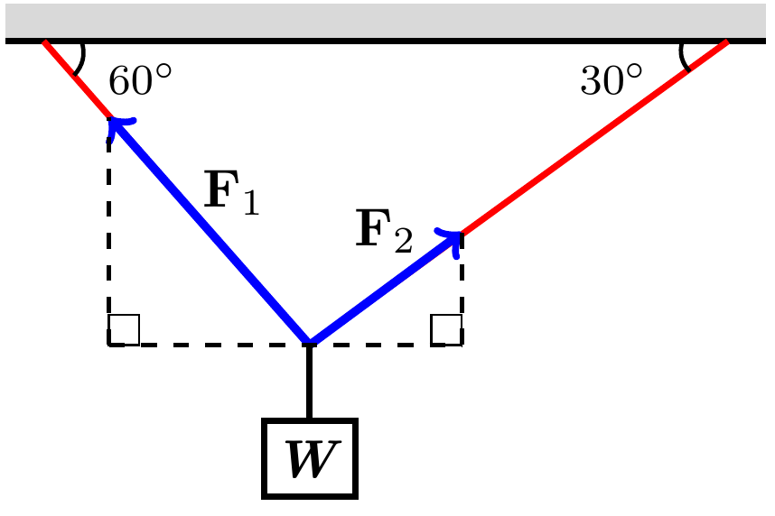

1. Consider a  weight suspended by two wires. Find the magnitudes and components of the force vectors 

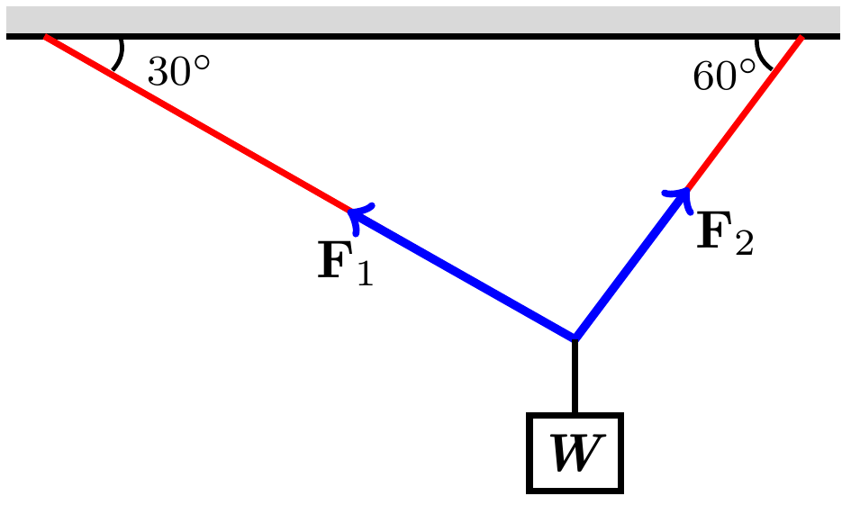

1. Consider a  weight suspended by two wires. Find the magnitudes and components of the force vectors 

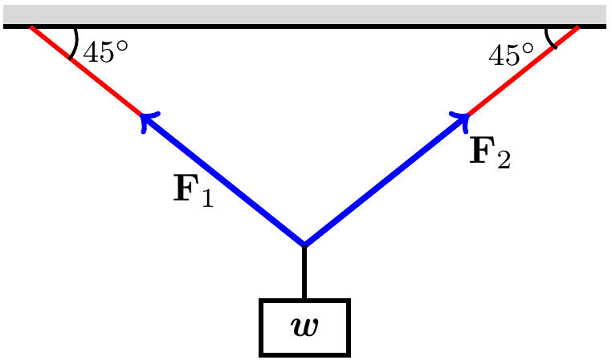

1. A bird flies from its nest 5 *km* in the direction 60° north east, where it stops to rest on a tree. It then flies 10 *km* in the direction due southeast and lands atop a telephone pole. Place an *xy*-coordinate system so that the origin is the bird’s nest, the *x*-axis points east, and the *y*-axis points north.
2. At what point is the tree located?
3. At what point is the telephone pole?
4. Suppose that *A*, *B*, and *C* are the corner points of the thin triangular plate of constant density.

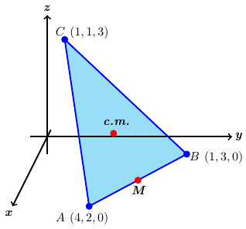

1. Find the vector from *C* to the midpoint *M* of side *AB*.
2. Find the vector from *C* to the point that lies two-thirds of the way from *C* to *M* on the median *CM*.
3. Find the coordinates of the point in which the medians of  intersect (this point is the plate’s center of mass).
4. Show that a unit vector in the plane can be expressed as , obtained by rotating  through an angle *θ* in the counterclockwise direction. Explain why this form gives ***every*** *unit vector* in the plane.
5. Assume the positive  points east and the positive  points north.
6. An airliner flies northeast at a constant altitude at 550 *mi/hr* in calm air. Find *a* and *b* such that it velocity may be expressed in the form 
7. An airliner flies northeast at a constant altitude at 550 *mi/hr* relative to the air in a southerly crosswind  . Find the velocity of the airliner relative to the ground.
8. Let  extended from  to 
9. Find the position vector equal to .
10. Find the midpoint *M* of the line segment . Then find the magnitude of 
11. Find a vector of length 8 with direction opposite that of 
12. An object at the origin is acted on by the forces , , and . Find the magnitude of the combined force and use a sketch to illustrate the direction of the combined force.
13. A remote sensing probe falls vertically with a terminal of 60 *m/s* when it encounters a horizontal crosswind blowing north at 4 *m/s* and an updraft blowing vertically at 10 *m/s*. find the magnitude and direction of the resulting velocity relative to the ground.
14. A small plane is flying north in calm air at 250 *mi/hr* when it is hit by a horizontal crosswind blowing northeast at 40 *mi/hr* and a 25 *mi/hr* downdraft. Find the resulting velocity and speed of the plane.