***Lecture One* – Vectors and Vector-Values Functions**

***Solution*** ***Section* 1.1 – Vectors**

***Exercise***

Give a geometric description of the set of points in space whose coordinates satisfy the given pairs of equations 

***Solution***

The circle  in the ***xz***-plane

***Exercise***

Give a geometric description of the set of points in space whose coordinates satisfy the given pairs of equations 

***Solution***

The circle  in the plane 

***Exercise***

Give a geometric description of the set of points in space whose coordinates satisfy the given pairs of equations 

***Solution***

The circle  in the ***yz***-plane

***Exercise***

Give a geometric description of the set of points in space whose coordinates satisfy the given pairs of equations 

***Solution***



The circle  in the ***xz***-plane

***Exercise***

Give a geometric description of the set of points in space whose coordinates satisfy the given pairs of equations 

***Solution***

The circle formed by the intersection of the sphere  and the plane 

***Exercise***

Find the distance between points 

***Solution***









***Exercise***

Find the distance between points 

***Solution***









***Exercise***

Find the distance between points 

***Solution***







***Exercise***

Find the distance between points 

***Solution***







***Exercise***

Find the center and radii of the spheres 

***Solution***







The center is at  and the radius is 

***Exercise***

Find the center and radii of the spheres 

***Solution***







The center is at  and the radius is 

***Exercise***

Find the center and radii of the spheres 

***Solution***









The center is at  and the radius is 

***Exercise***

Find a formula for the distance from the point  to *x*-axis

***Solution***

The distance between  and  is:





***Exercise***

Find a formula for the distance from the point  to *xy*-plane

***Solution***

The distance between  and  is:





***Exercise***

Let . Find the component form and the magnitude if the vector

|  |  |  |
| --- | --- | --- |
|  |  |  |

***Solution***

1. 



1. 



1. 



***Exercise***

Let . Find the component form and the magnitude if the vector

|  |  |  |  |  |
| --- | --- | --- | --- | --- |
| 1. 3 | 1. − |  |  |  |

***Solution***

1. 



1. 



1. 





1. 





1. 





***Exercise***

Find scalars *a, b*, and *c* such that 

***Solution***





  



***Exercise***

Find the component form of the vector: The sum of  and  where



***Solution***













***Exercise***

Find the component form of the vector: The unit vector that makes an angle  with the positive *x*-axis

***Solution***



***Exercise***

Find the component form of the vector: The unit vector obtained by rotating the vector  counterclockwise about the origin

***Solution***

The angle of unit vector  is 90°, this unit vector rotates 120° which makes an angle of  with the positive *x*-axis



***Exercise***

Find the component form of the vector: The unit vector obtained by rotating the vector  counterclockwise about the origin

***Solution***

The angle of unit vector  is 0°, this unit vector rotates 135° which makes an angle of  with the positive *x*-axis



***Exercise***

Find the component form of the vector: The unit vector that makes an angle  with the positive *x*-axis

***Solution***



***Exercise***

Find the component form of the vector: The vector 5 units long in the direction opposite to the direction of 

***Solution***





***Exercise***

Express the velocity vector  in terms of its length and direction.

***Solution***













*Direction* 





***Exercise***

Sketch the indicated vector

|  |  |  |
| --- | --- | --- |
|  |  |  |

***Solution***

|  |  |
| --- | --- |
|  |  |

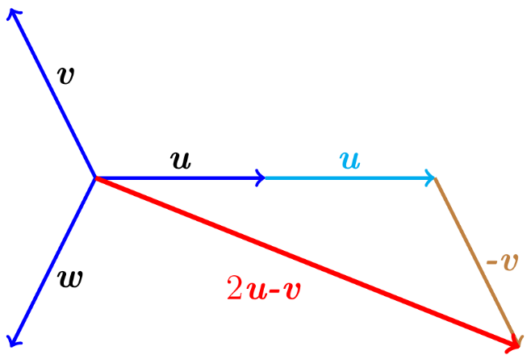

***Exercise***

An Airplane is flying in the direction 25° west of north at 800 *km/h*. Find the component form of the velocity of the airplane, assuming that the positive *x*-axis represents due east and the positive *y*-axis represents due north.

***Solution***

25° west of north is 25° + 90° = 115° north of east



***Exercise***

A jet airliner, flying due east at 500 *mph* in still air, encounters a 70-*mph* tailwind blowing in the direction 60° north of east. The airplane holds its compass heading due east but, because of the wind, acquires a new ground speed and direction. What speed and direction should the jetliner have in order for the resultant vector to be 500 *mph* due east?

***Solution***

= the velocity of the airplane;

 = the velocity of the tailwind



















The direction is  *south* of *east*

***Exercise***

Consider a 100-*N* weight suspended by two wires. Find the magnitudes and components of the force vectors 

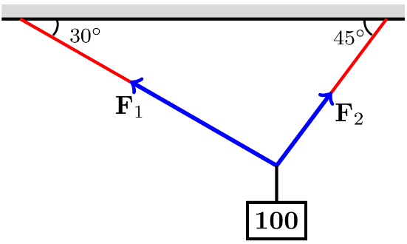***Solution***





























***Exercise***

Consider a 50-*N* weight suspended by two wires, If the magnitude of vector , find the angle α and the magnitude of vector 

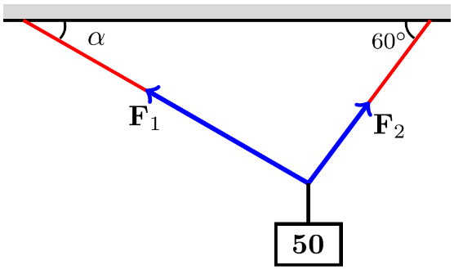***Solution***















 



















Since α > 0 













***Exercise***

Consider a ***w***-N weight suspended by two wires, If the magnitude of vector , find ***w*** and the magnitude of vector 

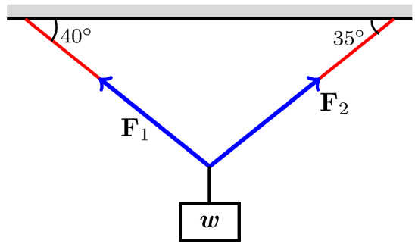***Solution***





























***Exercise***

Consider a 25-N weight suspended by two wires, If the magnitude of vector are both 75 N, then angles α and β are equal. Find α.

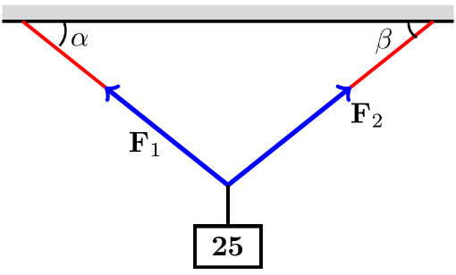***Solution***











 













***Exercise***

Consider a  weight suspended by two wires. Find the magnitudes and components of the force vectors 

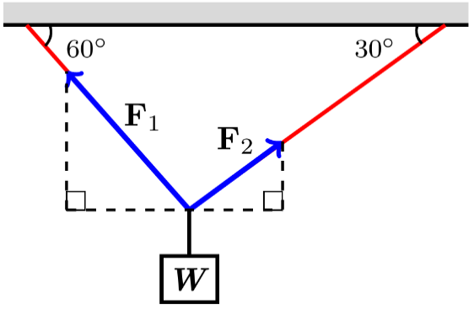***Solution***





























***Exercise***

Consider a  weight suspended by two wires. Find the magnitudes and components of the force vectors 

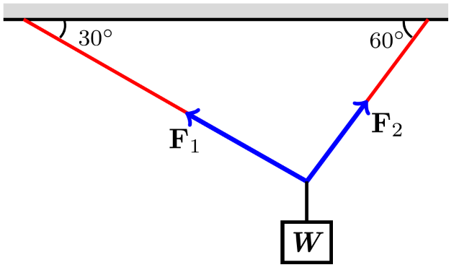***Solution***

























***Exercise***

Consider a  weight suspended by two wires. Find the magnitudes and components of the force vectors 

***Solution***

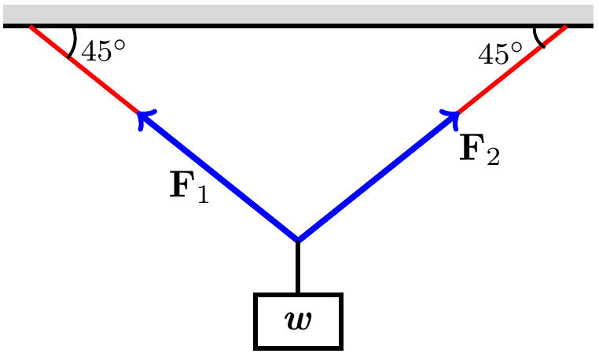



























***Exercise***

A bird flies from its nest 5 km in the direction 60° north east, where it stops to rest on a tree. It then flies 10 km in the direction due southeast and lands atop a telephone pole. Place an *xy*-coordinate system so that the origin is the bird’s nest, the *x*-axis points east, and the *y*-axis points north.

1. At what point is the tree located?
2. At what point is the telephone pole?

***Solution***

1. 



The tree is located at the point



1. 









The pole is located at the point 

***Exercise***

Suppose that *A*, *B*, and *C* are the corner points of the thin triangular plate of constant density.

1. Find the vector from *C* to the midpoint *M* of side *AB*.
2. Find the vector from *C* to the point that lies two-thirds of the way from *C* to *M* on the median *CM*.
3. Find the coordinates of the point in which the medians of  intersect (this point is the plate’s center of mass).

***Solution***

1. The midpoint of *AB* is:

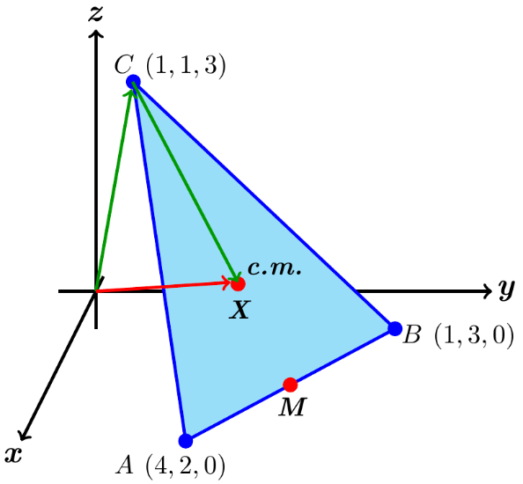







1. The desired vector is







1. The vector whose sum is the vector from the origin to *C* and the result of part (*b*) will terminate at the center of mass.







Therefore; the center of mass point is 

***Exercise***

Show that a unit vector in the plane can be expressed as , obtained by rotating  through an angle *θ* in the counterclockwise direction. Explain why this form gives ***every*** *unit vector* in the plane.

***Solution***

Let  be any unit vector in the plane.

If  is positioned so that its initial point and terminal point is at , then  makes an angle *θ* with , measured in the *ccw* direction.

Since 

That implies to: 

Since   is any unit vector in the plane; this holds for every unit vector in the plane.

***Exercise***

Assume the positive  points east and the positive  points north.

1. An airliner flies northeast at a constant altitude at 550 *mi/hr* in calm air. Find *a* and *b* such that its velocity may be expressed in the form 
2. An airliner flies northeast at a constant altitude at 550 *mi/hr* relative to the air in a southerly crosswind  . Find the velocity of the airliner relative to the ground.

***Solution***

1. 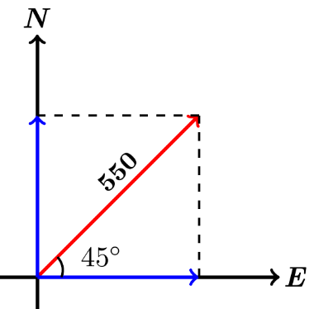





1. 



***Exercise***

Let  extended from  to 

1. Find the position vector equal to .
2. Find the midpoint *M* of the line segment . Then find the magnitude of .
3. Find a vector of length 8 with direction opposite that of .

***Solution***

1. 



1. 









1. 







***Exercise***

An object at the origin is acted on by the forces , , and . Find the magnitude of the combined force and use a sketch to illustrate the direction of the combined force.

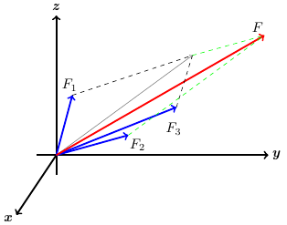***Solution***













***Exercise***

A remote sensing probe falls vertically with a terminal of 60 *m/s* when it encounters a horizontal crosswind blowing north at 4 *m/s* and an updraft blowing vertically at 10 *m/s*. find the magnitude and direction of the resulting velocity relative to the ground.

***Solution***

The velocity relative to the ground is:



*Magnitude*: 



*Direction* 



Below the horizontal in the northerly horizontal direction.

***Exercise***

A small plane is flying north in calm air at 250 *mi/hr* when it is hit by a horizontal crosswind blowing northeast at 40 *mi/hr* and a 25 *mi/hr* downdraft. Find the resulting velocity and speed of the plane.

***Solution***

*Velocity vector* 

*Crosswind* 



*Downdraft* 

*Resulting velocity* 



*Speed* 







