***Section* 1.2 – Dot Products**

If a force ***F*** is applied to a particle moving along a path, we often need to know the magnitude of the force and the direction of motion.

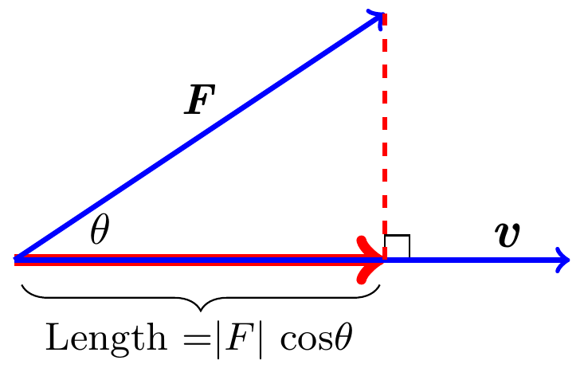

To calculate the angle between two vectors directly from their component, called the ***dot product***, also called *inner* or *scalar* products.

**Angle between Vectors**

***Theorem***

The angle *θ* between two nonzero vectors  is given by



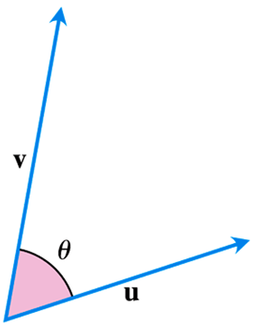

***Definition***

The dot product of vector  is



***Example***

Find the dot product:

|  |  |
| --- | --- |
|  |  |

***Solution***

1. 



1. 



***Example***

Find the angle between 

***Solution***





















***Example***

Find the angle *θ* of the triangle *ABC* determined by the vertices 

***Solution***



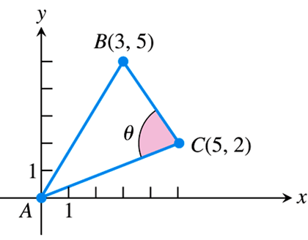



















**Perpendicular (*Orthogonal*) Vectors**

***Definition***

Vectors  and  are orthogonal (*or* perpendicular) *iff* 

***Example***

Determine if the two vectors are orthogonal

1. 
2. 

***Solution***

1. 



∴ The two vectors are orthogonal

1. 



∴ The two vectors are orthogonal

**Dot Product Properties and Vector Projection**

**Properties of the Dot Product**

If ***, *** and  are any vectors and *c* is a scalar, then

|  |  |
| --- | --- |
|  |  |

The vector projection of  onto a nonzero vector  is the vector  determined by dropping a perpendicular from *Q* to the line *PS*.

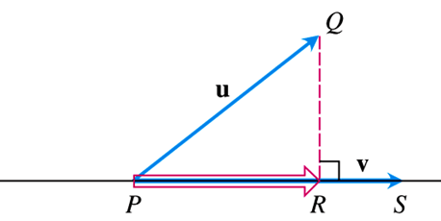 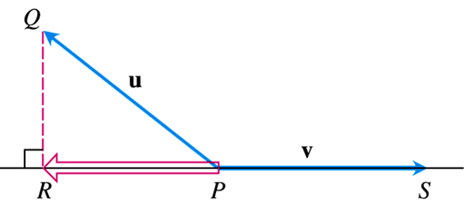

The notation for this vector is



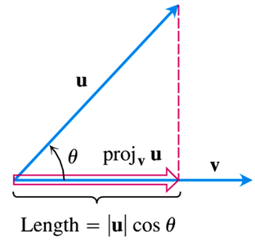 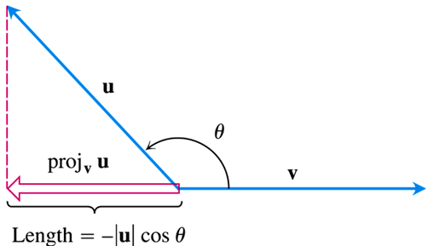





The scalar component of  in the direction of  is the scalar: 

***Example***

Find the vector projection of  and the scalar component of in the direction of.

***Solution***





















***Example***

Find the vector projection of a force  and the scalar component of  in the direction of .

***Solution***

















***Work***

The work is done by a constant force of magnitude ***F*** in moving an object through a distance ***d*** as .

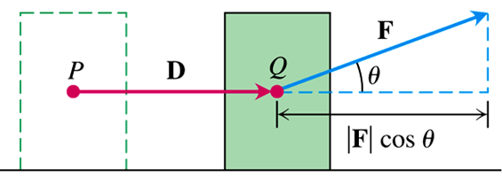







***Definition***

The work done by a constant force  acting through a displacement  is



***Example***

If  find the work done by  in acting from *P* to *Q*.

***Solution***









***Exercises*** ***Section* 1.2 – Dot Products**

(**1 − 5**) Find

1. 
2. The cosine of the angle between  and 
3. The scalar component of  in the direction of 
4. The vector 
5. 
6. 
7. 
8. 
9. 
10. Find the angles between the vectors 
11. Find the angles between the vectors 
12. Find the angles between the vectors 
13. Consider , 
14. Find the angle between  and .
15. Compute  and 
16. Compute  and 
17. Consider , 
18. Find the angle between  and .
19. Compute  and 
20. Compute  and 
21. The direction angles *α*, *β*, and *γ* of a vector  are defined as follows:

α is the angle between ***v*** and the positive *x*-axis 

β is the angle between ***v*** and the positive *y*-axis 

γ is the angle between ***v*** and the positive *z*-axis 

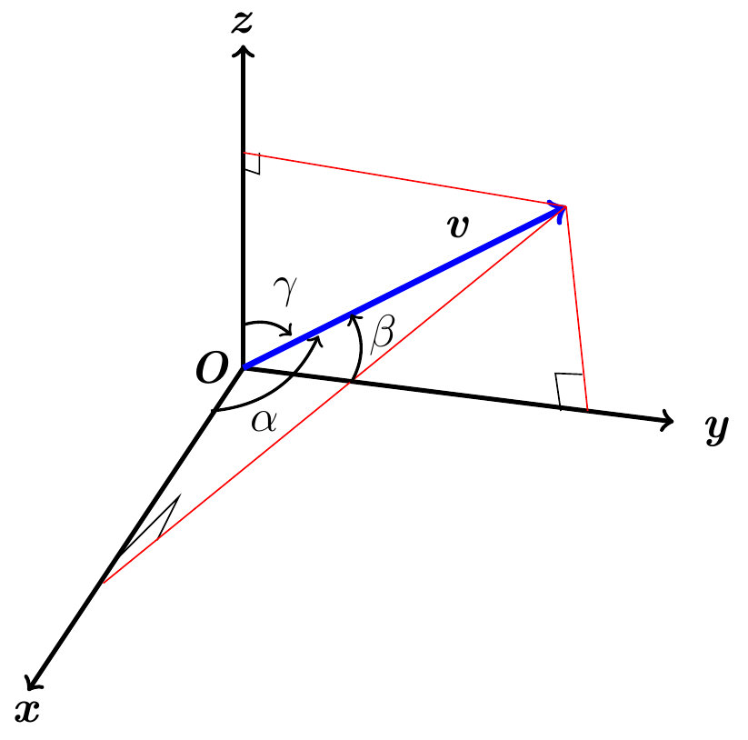

1. Show that and  . These cosines are called the direction cosines of .
2. Show that if  is a unit vector, then *a, b*, and *c* are the direction cosines of .
3. A water main is to be constructed with 20% grade in the north direction and a 10% grade in the east direction. Determine the angle *θ* required in the water main for the turn from north to east.

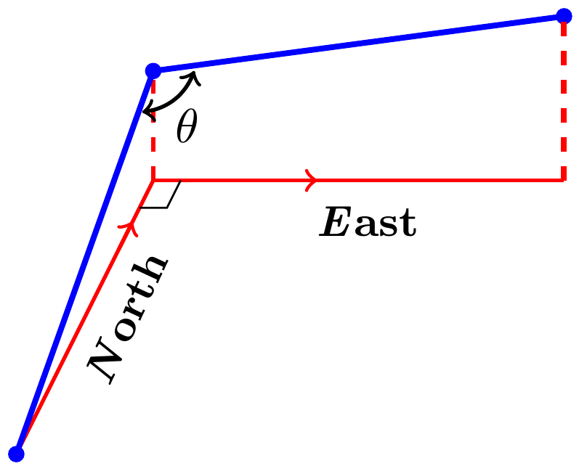

1. A gun with muzzle velocity of 1200 *ft/sec* is fired at an angle of 8° above the horizontal. Find the horizontal and vertical components of the velocity.
2. Suppose that a box is being towed up an inclined plane. Find the force ***w*** needed to make the component of the force parallel to the indicated plane equal to 2.5 *lb*.

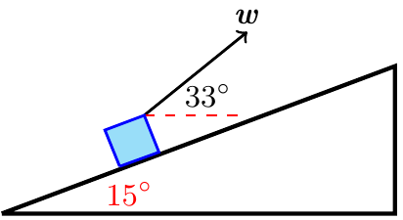

1. Find the work done by a force  (magnitude 5 *N*) in moving an object along the line from the origin to the point (1, 1) (distance in meters)
2. How much work does it take to slide a crate 20 *m* along a loading dock by pulling on it with a 200 *N* force at an angle of 30° from the horizontal?
3. The wind passing over a boat’s sail exerted a 100-*lb* magnitude force *F*. How much work did the wind perform in moving the boat forward 1 *mile* ? Answer in foot-pounds.

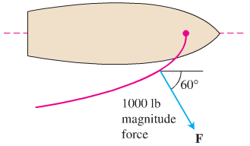

1. Use a dot product to find an equation of the line in the *xy-*plane passing through the point  perpendicular to the vector .
2. A 180*-lb* man stands on a hillside that makes an angle of 30° with the horizontal, producing a force of  *lb*s.

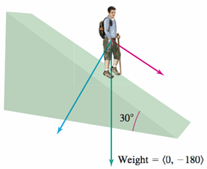

1. Find the component of his weight in the downward direction perpendicular to the hillside and in the downward parallel to the hillside.
2. How much work is done when the man moves 10 *ft* up the hillside?