***Solution*** ***Section* 1.2 – Dot Products**

***Exercise***

Find for 

1. 
2. The cosine of the angle between  and 
3. The scalar component of  in the direction of 
4. The vector 

***Solution***

1. 



















1.  



1. 



1. 







***Exercise***

Find for 

1. 
2. The cosine of the angle between  and 
3. The scalar component of  in the direction of 
4. The vector 

***Solution***

1. 















1. 





1. 
2. 





***Exercise***

Find for 

1. 
2. The cosine of the angle between  and 
3. The scalar component of  in the direction of 
4. The vector 

***Solution***

1. 

















1. 





1. 



1. 





***Exercise***

Find for 

1. 
2. The cosine of the angle between  and 
3. The scalar component of  in the direction of 
4. The vector 

***Solution***

1. 











1. 





1. 



1. 



***Exercise***

Find for 

1. 
2. The cosine of the angle between  and 
3. The scalar component of  in the direction of 
4. The vector 

***Solution***

1. 

















1. 







1. 





1. 





***Exercise***

Find the angles between the vectors 

***Solution***

 







***Exercise***

Find the angles between the vectors 

***Solution***

 







***Exercise***

Find the angles between the vectors 

***Solution***

 







***Exercise***

Consider , 

1. Find the angle between  and .
2. Compute  and 
3. Compute  and 

***Solution***

1.  







1.  



 

1.  



 

***Exercise***

Consider , 

1. Find the angle between  and .
2. Compute  and 
3. Compute  and 

***Solution***

1.  









1.  



 



1.  



 



***Exercise***

The direction angles *α*, *β*, and *γ* of a vector  are defined as follows:

is the angle between  and the positive *x*-axis 

is the angle between  and the positive *y*-axis 

is the angle between  and the positive *z*-axis 

1. Show that and  . These cosines are called the direction cosines of .
2. Show that if  is a unit vector, then *a, b*, and *c* are the direction cosines of .

***Solution***

1. 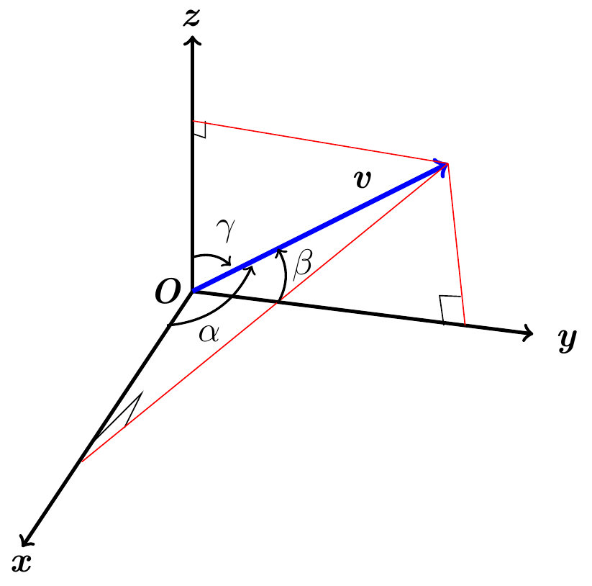



























1. If  is a unit vector 

 are the direction cosines of.

***Exercise***

A water main is to be constructed with 20% grade in the north direction and a 10% grade in the east direction. Determine the angle *θ* required in the water main for the turn from north to east.

***Solution***

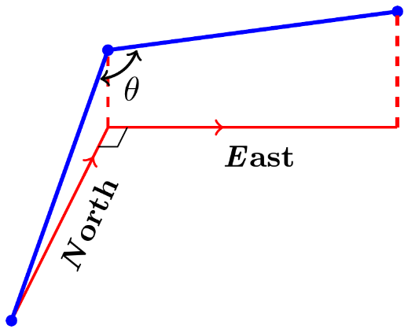20% grade in the north direction





Let  be parallel to the pipe in the north direction.

 be parallel to the pipe in the east direction.

 





***Exercise***

A gun with muzzle velocity of 1200 *ft/sec* is fired at an angle of 8° above the horizontal. Find the horizontal and vertical components of the velocity.

***Solution***

Horizontal component: 

Vertical component: 

***Exercise***

Suppose that a box is being towed up an inclined plane. Find the force ***w*** needed to make the component of the force parallel to the indicated plane equal to 2.5 *lb*.

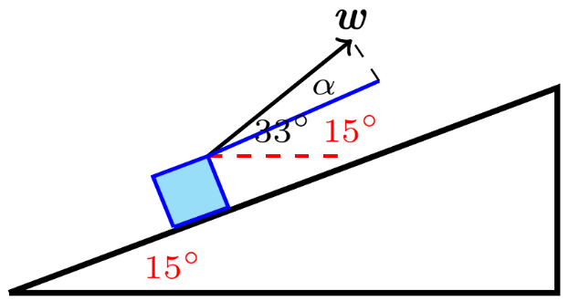***Solution***











***Exercise***

Find the work done by a force  (magnitude 5 *N*) in moving an object along the line from the origin to the point (1, 1) (distance in meters)

***Solution***









***Exercise***

How much work does it take to slide a crate 20 *m* along a loading dock by pulling on it with a 200 *N* force at an angle of 30° from the horizontal?

***Solution***







***Exercise***

The wind passing over a boat’s sail exerted a 1000-*lb* magnitude force *F*. How much work did the wind perform in moving the boat forward 1 *mi*? Answer in foot-pounds.

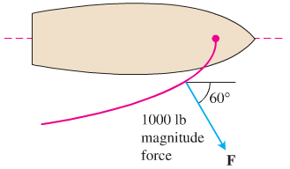***Solution***







***Exercise***

Use a dot product to find an equation of the line in the *xy-*plane passing through the point  perpendicular to the vector .

***Solution***





***Exercise***

A 180*-lb* man stands on a hillside that makes an angle of 30° with the horizontal, producing a force of  *lbs*.

1. Find the component of his weight in the downward direction perpendicular to the hillside and in the downward parallel to the hillside.
2. How much work is done when the man moves 10 *ft* up the hillside?

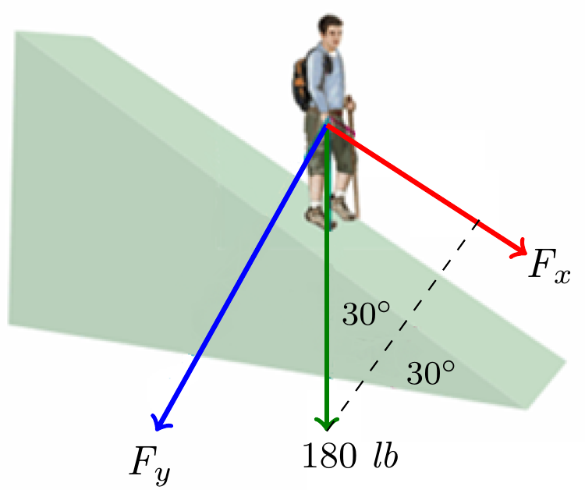***Solution***

1. 











1. 



