***Section* 1.3 – Cross Products**

**The *Cross* Product**

To find a vector in 3-space that is perpendicular to two vectors; the type of vector multiplication that facilities this construction is the cross product.

We start with two nonzero vectors and in space. If and are no parallel, they determine a plane. We select a unit vector perpendicular to the plane by the ***right-hand rule***. Then the cross product  (“***cross*** ”) is the vector defined as follows

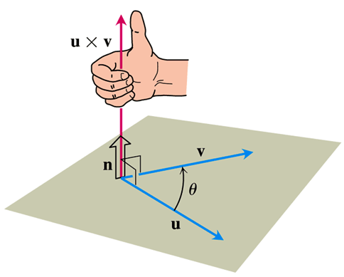

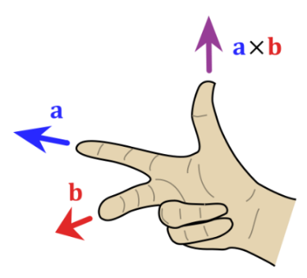 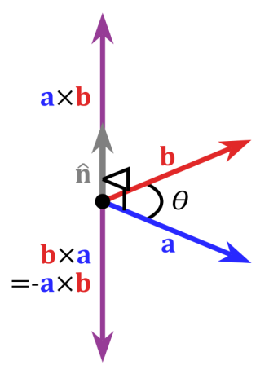 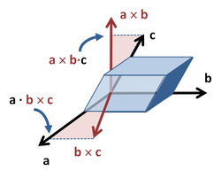

***Definition***



**Parallel Vectors**

Nonzero vectors and are parallel iff 

**Properties of the Cross Product**

If ***u, v*** and ***w*** are any vectors and *r, s* are scalars, then

1. 
2. 
3. 
4. 
5. 
6. 
7. 

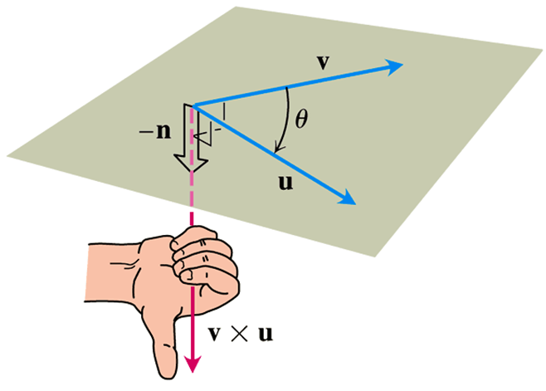

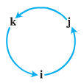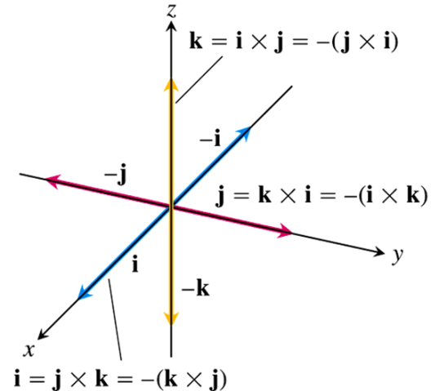***Note***:

* 
* 
* 
* 
* 
* 

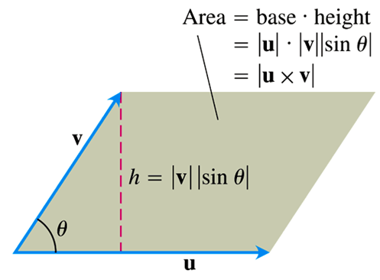

** Is the *Area* of the Parallelogram**

Because ***n*** is a unit vector, the magnitude of  is



**Determinant Formula for** 

***Definition***

The cross product of  and  is the vector









***Example***

Find  and  if  and 

***Solution***











***Example***

1. Find a vector perpendicular to the plane of 
2. Find the area of the triangle with vertices *P, Q*, and *R*.
3. Find a unit vector perpendicular to the *P, Q*, and *R*

***Solution***

1. The vector  is perpendicular to the plane.

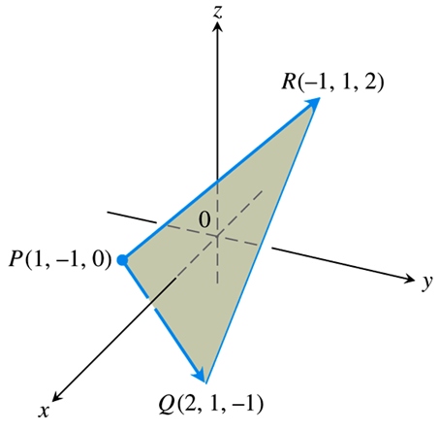









1. The area of the triangle is equal half the parallelogram determined by *P, Q*, and *R*.



Area of the triangle:





1. Since  is perpendicular to the plane, its direction *n* is a unit vector ⊥ to the plane







***Torque***

When we turn a bolt by applying a force  to a wrench, we produce a torque that causes the bolt to rotate. The ***torque vector*** points in the direction of the axis of the bolt according to the right-hand rule (*ccw*).

***Magnitude of torque vector*** 

***Torque vector*** 

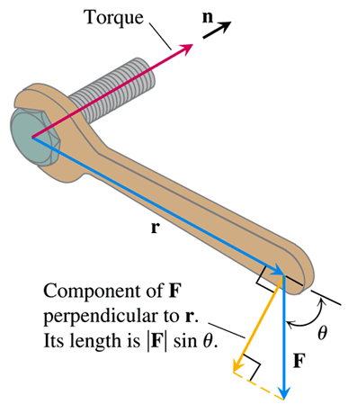

***Example***

Find the magnitude of the torque generated by force  at the pivot point *P*.

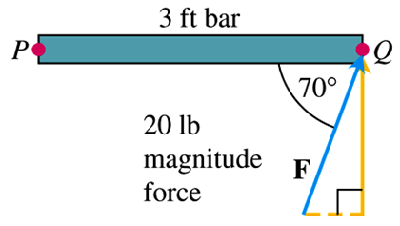

***Solution***







***Triple Scalar* or Box Product**

The product  is called the triple scalar product of ***,*** , and  (in that order).



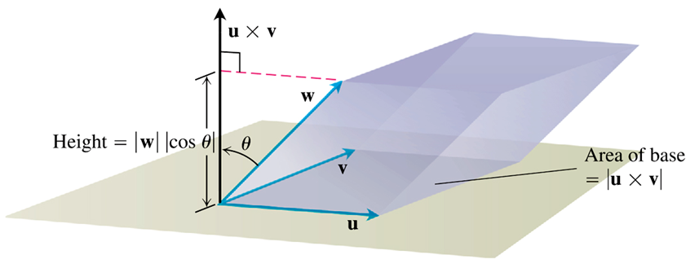

***Volume***

The Volume of the Parallelepiped is













***Example***

Find the volume of the box (parallelepiped) determined by   and 

***Solution***









The volume is 23 *units cubed*.

***Exercises Section* 1.3 – Cross Products**

(**1− 4**) Find the length and direction of 

|  |  |
| --- | --- |
|  |  |

1. Sketch the coordinate axes and then include the vectors , , and  as vectors starting origin for 
2. Sketch the coordinate axes and then include the vectors , , and  as vectors starting origin for 
3. Find the area of the triangle determined by the points *P, Q*, and *R*, and then find a unit vector perpendicular to plane *PQ* *R*. 
4. Find the area of the triangle determined by the points *P, Q*, and *R*, and then find a unit vector perpendicular to plane *PQ* *R*. 
5. Find the area of the triangle determined by the points *P, Q*, and *R*, and then find a unit vector perpendicular to plane *PQ* *R*. 
6. Verify that  and find the volume of the parallelepiped determined by 

(**11− 12**) Find , the angle between and , the scalar component of  in the direction of , and the vector 

|  |  |
| --- | --- |
|  |  |

(**13− 14**) Find the area of the parallelogram determined by vectors  and , then the volume of the parallelepiped determined by vectors,and .

1. 
2. 

(**15− 16**) Find the volume of the parallelepiped determined by

1. 
2. 
3. Find the magnitude of the torque force exerted by  on the bolt at *P* if  and 

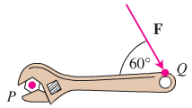

1. Find the magnitude of the torque force exerted by  on the bolt at *P* if  and 

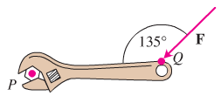

(**19− 25**) Find the area of the parallelogram whose vertices are

1. 
2. 
3. 
4. 
5. 
6. , , and 
7. , , and 

(**26− 29**) Find the area of the triangle whose vertices are

1. 
2. 
3. 
4. 
5. Find the volume of the parallelepiped if four of its eight vertices are:



1. Let  and 
2. Compute 
3. Compute 
4. Find the unit vector with the same direction as 
5. Find a vector parallel to  with length 20.
6. Compute  and the angle between  and .
7. Compute , 
8. Find the area of the triangle with vertices , , and 
9. Find a unit vector normal to the vectors  and 
10. Find the angle between  and  using the dot product then the cross product.
11. You do leg lifts with 10-*kg* weight attached to your foot, so the resulting force is *mg* ≈ 98*N* directed vertically downward. If the distance from your knee to the weight is 0.4*m* and her lower leg makes an angle of *θ* to the vertical, find the magnitude of the torque about your knee as your leg is lifted (as a function of *θ* ).

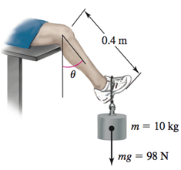

1. What is the minimum and maximum magnitude of the torque?
2. Does the direction of the torque change as your leg is lifted?
3. An automobile wheel has center at the origin and axle along the *y-*axis. One of the retaining nuts holding the wheel is at position . (Distances are measured in *cm*.)

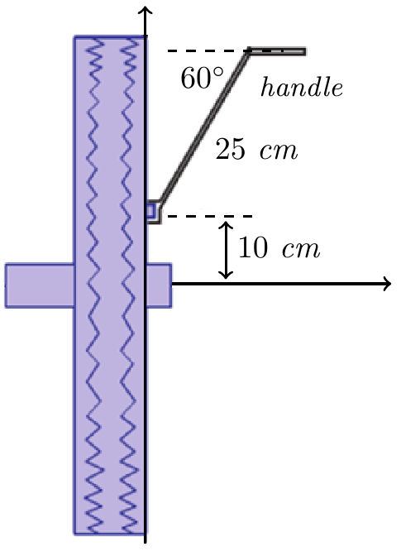

A bent tire wrench with arm 25 *cm* long and inclined at an angle of 60° to the direction of its handle is fitted to the nut in an upright direction. If the horizontal force  is applied to the handle of the wrench, what is its torque on the nut? What part (component) of this torque is effective in trying to rotate the nut about its horizontal axis? What is the effective torque trying to rotate the wheel?