***Solution Section* 1.3 – Cross Products**

***Exercise***

Find the length and direction of : 

***Solution***





*Length*:





*Direction*: 





*Length*:





*Direction*: 

***Exercise***

Find the length and direction of : 

***Solution***





*Length*: 

*Direction*: ***No direction***



*Length*: 

*Direction*: ***No direction***

***Exercise***

Find the length and direction of : 

***Solution***



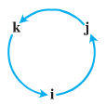 



*Length*: 

*Direction*: 





*Length*: 

*Direction*: 

***Exercise***

Find the length and direction of : 

***Solution***





*Length*:







*Direction*: 







*Length*: 

*Direction*: 

***Exercise***

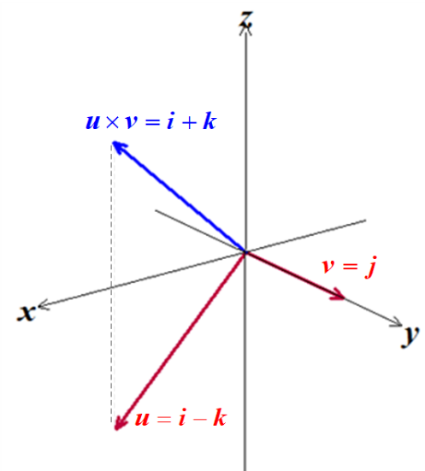Sketch the coordinate axes and then include the vectors , , and  as vectors starting origin for 

***Solution***





***Exercise***

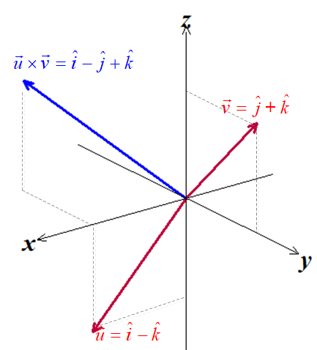Sketch the coordinate axes and then include the vectors , , and  as vectors starting origin for 

***Solution***





***Exercise***

Find the area of the triangle determined by the points *P, Q*, and *R*, and then find a unit vector perpendicular to plane *PQ* *R*. 

***Solution***



























***Exercise***

Find the area of the triangle determined by the points *P, Q*, and *R*, and then find a unit vector perpendicular to plane *PQ* *R*. 

***Solution***



























***Exercise***

Find the area of the triangle determined by the points *P, Q*, and *R*, and then find a unit vector perpendicular to plane *PQ* *R*. 

***Solution***



















***Exercise***

Verify that  and find the volume of the parallelepiped determined by 

***Solution***

Let 







Which all have the same absolute value, by interchanging the rows the determinant does not change its absolute value.







***Exercise***

Find , the angle between and , the scalar component of  in the direction of , and the vector 



***Solution***



























 





 



***Exercise***

Find , the angle between and , the scalar component of  in the direction of , and the vector 



***Solution***





























 





 



***Exercise***

Find the area of the parallelogram determined by vectors  and , then the volume of the parallelepiped determined by vectors,and .



***Solution***













***Exercise***

Find the area of the parallelogram determined by vectors  and , then the volume of the parallelepiped determined by vectors,and .



***Solution***











***Exercise***

Find the volume of the parallelepiped determined by



***Solution***







***Exercise***

Find the volume of the parallelepiped determined by



***Solution***







***Exercise***

Find the magnitude of the torque force exerted by  on the bolt at *P* if  and 

***Solution***

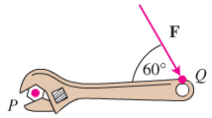





***Exercise***

Find the magnitude of the torque force exerted by  on the bolt at *P* if  and 

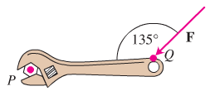***Solution***







***Exercise***

Find the area of the parallelogram whose vertices are: 

***Solution***

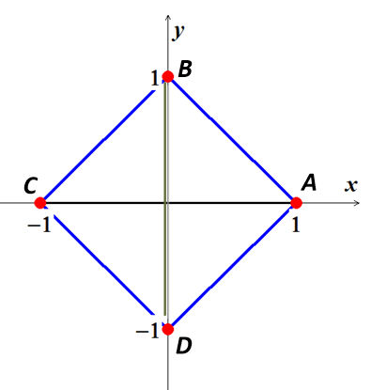











***Exercise***

Find the area of the parallelogram whose vertices are: 

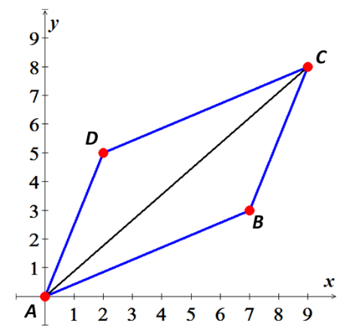***Solution***













***Exercise***

Find the area of the parallelogram whose vertices are:



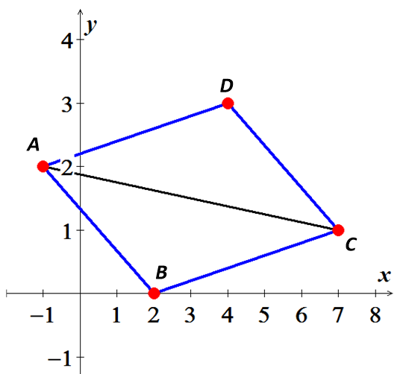***Solution***













***Exercise***

Find the area of the parallelogram whose vertices are:



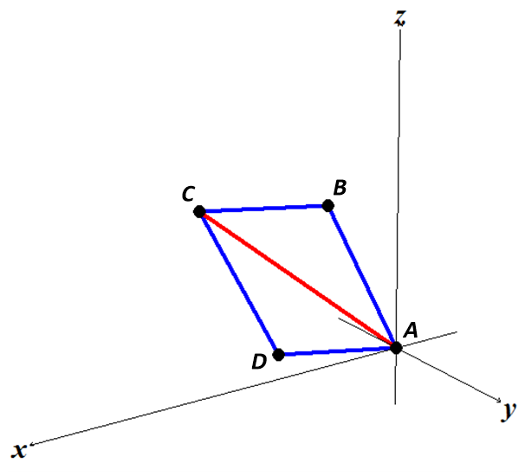***Solution***



 is parallel to 



 is parallel to 











***Exercise***

Find the area of the parallelogram whose vertices are:



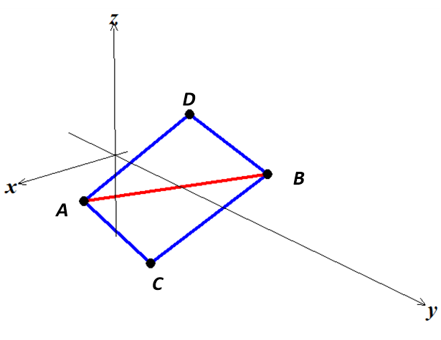***Solution***













***Exercise***

Find the area of the parallelogram with vertices , , and 

***Solution***















***Exercise***

Find the area of the parallelogram with vertices , , and 

***Solution***

















***Exercise***

Find the area of the triangle whose vertices are: 

***Solution***











***Exercise***

Find the area of the triangle whose vertices are: 

***Solution***











***Exercise***

Find the area of the triangle whose vertices are: 

***Solution***











***Exercise***

Find the area of the triangle whose vertices are: 

***Solution***













***Exercise***

Find the volume of the parallelepiped if four of its eight vertices are:



***Solution***











***Exercise***

Let  and 

1. Compute 
2. Compute 
3. Find the unit vector with the same direction as 
4. Find a vector parallel to  with length 20.
5. Compute  and the angle between  and .
6. Compute , 
7. Find the area of the triangle with vertices , , and 

***Solution***

1. 





1. 







1. unit vector of 







1. 







The desired vector parallel to  with length 20 is:





1. 





 



1. 





1. Area of the triangle with vertices , , and 









***Exercise***

Find a unit vector normal to the vectors  and 

***Solution***













Unit normal 



***Exercise***

Find the angle between  and  using the dot product then the cross product.

***Solution***







 



















***Exercise***

You do leg lifts with 10-*kg* weight attached to your foot, so the resulting force is *mg* ≈ 98 *N* directed vertically downward. If the distance from your knee to the weight is 0.4*m* and her lower leg makes an angle of *θ*  to the vertical, find the magnitude of the torque about your knee as your leg is lifted (as a function of *θ* ).

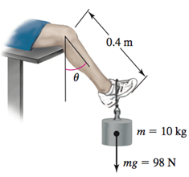

1. What is the minimum and maximum magnitude of the torque?
2. Does the direction of the torque change as your leg is lifted?

***Solution***

1.  





The maximum torque is  when 

The minimum torque is  when 

1. The direction of the torque does not change as the knee is lifted

***Exercise***

An automobile wheel has center at the origin and axle along the *y-*axis. One of the retaining nuts holding the wheel is at position . (Distances are measured in *cm*.) A bent tire wrench with arm 25 *cm* long and inclined at an angle of 60° to the direction of its handle is fitted to the nut in an upright direction. If the horizontal force  is applied to the handle of the wrench, what is its torque on the nut? What part (component) of this torque is effective in trying to rotate the nut about its horizontal axis? What is the effective torque trying to rotate the wheel?

***Solution***

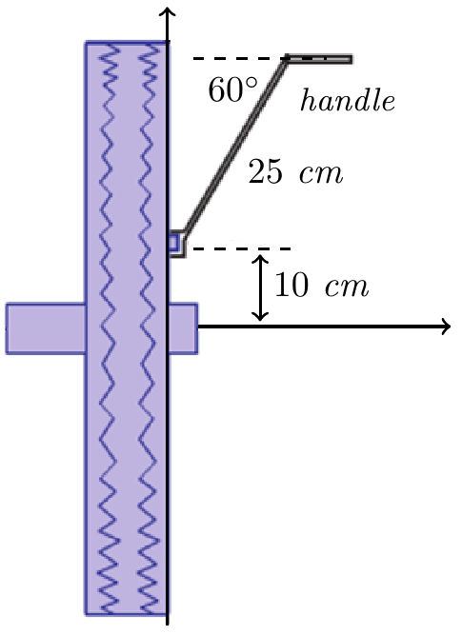





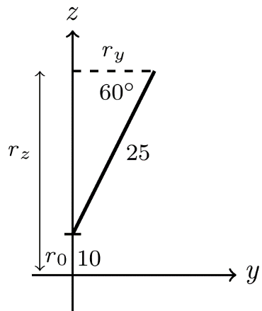 









Since the torque is effective in turning horizontally that implies .

The effective torque  :

